TRANSPORTATION POOLED FUND PROGRAM
QUARTERLY PROGRESS REPORT

Lead Agency: Utah Department of Transportation

INSTRUCTIONS:
Project Managers and/or research project investigators should complete a quarterly progress report for each calendar quarter during which the projects are active. Please provide a project schedule status of the research activities tied to each task that is defined in the proposal; a percentage completion of each task; a concise discussion (2 or 3 sentences) of the current status, including accomplishments and problems encountered, if any. List all tasks, even if no work was done during this period.

Transportation Pooled Fund Program Project #  TPF-5(272) |  | Transportation Pooled Fund Program - Report Period:  Quarter 1 (January 1 – March 31, 2014)  _ Quarter 2 (April 1 – June 30, 2014)  X Quarter 3 (July 1 – September 30, 2014)  _ Quarter 4 (October 1 – December 31, 2014)
Project Title:
Evaluation of Lateral Pile Resistance Near MSE Walls at a Dedicated Wall Site

Name of Project Manager(s):  Jason Richins | Phone Number:  801-360-4985 |  | E-Mail  jtrichins@utah.gov
Lead Agency Project ID:  5H07203H, 42053, ePM PIN 11075  UDOT PIC No. UT11.404 | Other Project ID (i.e., contract #):  UDOT Contract No. 148434 |  | Project Start Date:  December 2, 2013
Original Project End Date:  September 30, 2016 | Current Project End Date:  September 30, 2016 |  | Number of Extensions:

Project schedule status:

X On schedule _ On revised schedule _ Ahead of schedule _ Behind schedule

Overall Project Statistics:
Total Project Budget | Total Cost to Date for Project | Percentage of Work  Completed to Date
$204,500.00 (current contract)  $292,000.00 (total committed) | $48,800.00 | 24%

Quarterly Project Statistics:
Total Project Expenses  and Percentage This Quarter | Total Amount of Funds  Expended This Quarter | Total Percentage of  Time Used to Date
$0, 0% | $0 | 31%

Project Description:

Pile foundations for bridges with integral abutments must resist lateral loads produced by earthquakes and thermal expansion or contraction. Increasingly, right-of-way constraints are also leading to vertical mechanically stabilized earth (MSE) walls at abutment faces. Currently, there is relatively little guidance for engineers in assessing the lateral resistance of piles located close to these MSE walls. As a result, some designers assume that the soil provides no resistance whatsoever which leads to larger pile diameters and increased foundation cost. Other designers locate the abutment piles six to eight pile diameters behind a wall face to minimize the interaction and use conventional design approaches. However, this approach increases the bridge span and the cost of the bridge structure. Still other designers position the pile close to the wall face and reduce the lateral pile resistance using engineering judgment. However, the appropriate reduction factor to use as a function of pile spacing is not well defined.

Recent testing conducted by Rollins et al (2013) and Pierson et al (2008) indicate that lateral resistance decreases substantially as pile spacing from the wall decreases; however, reinforcing can reduce this effect. Rollins et al also found that p-multipliers defined as a function normalized spacing and reinforcement length seemed to provide reasonable agreement with measured pile response. Furthermore, Rollins et al found that the tensile force in the reinforcements owing to the lateral load on the pile could be estimated for design purposes using a correlation with pile load, spacing behind the wall, and distance transverse from the pile load.

Although the tests to date provide a framework for understanding the mechanisms involved and likely design approaches, the available data is too limited to make firm design recommendations. To improve our understanding of pile-MSE wall interaction, this project will involve construction of a test embankment approximately 80 ft long and 20 ft tall where it will be possible to conduct a number of lateral pile load tests on different pile types behind an MSE wall with both strip and grid type steel reinforcements. Additional contributions to the project will consist of in-kind donations from various contractors and material suppliers.

Objectives for this study include:

1. Measure reduced lateral pile resistance vs. displacement curves for circular, square, and H piles behind an MSE wall with steel strips and grid reinforcement.
2. Measure the increase and distribution of tensile force in the MSE reinforcement induced by lateral pile loading.
3. Measure effect of special pile head geometry (e.g. corrugated pipe sleeves, double plastic sheeting) on lateral pile resistance.
4. Develop design rules (e.g. p-multipliers) to account for reduced pile resistance as a function of spacing and reinforcement.
5. Develop equation to predict reinforcement force induced by pile loading.
6. Develop design equations to account for pile shape and pile head geometry.

Tasks for this study include:

1. Instrument test piles and reinforcements.
2. Drive test piles and construct MSE wall to height of 15 ft.
3. Perform lateral load tests on piles with 15 ft high MSE wall.
4. Reduce data and develop report on the testing for the 15 ft high wall.
5. Determine p-multipliers and reinforcement force equations for 15 ft high wall test results.
6. Perform lateral load tests on piles with 20 ft high MSE wall.
7. Reduce data and develop report on the testing for the 20 ft high wall. (Not funded in original contract.)
8. Determine p-multipliers and reinforcement force equations for 20 ft high wall test results. (Not funded in original contract.)
9. Develop design recommendations to account for pile sleeves and plastic sheeting effects. (Not funded in original contract.)
10. Prepare final report with recommendations based on all tests. (Not funded in original contract.)
11. Hold Technical Advisory Committee (TAC) meetings.
12. Present results of the study at AASHTO, TRB, and ASCE meetings. (Not funded in original contract.)

Dr. Kyle Rollins of BYU is the Principal Investigator for this research project. The technical advisory committee (TAC) includes representatives from UT, FL, IA, KS, MA, MN, MT, NY, OR, and TX DOTs.

Progress this Quarter (includes meetings, work plan status, contract status, significant progress, etc.):

Task 1 – 100% complete.
Task 2 – 100% complete.
Task 3 – Completed testing for the piles at the 15-ft wall height.
Task 4 – Work has started.
Task 5 – Work has started.
Task 6 – Completed testing for the piles at the 20-ft wall height.
Task 7 – Funding is available. Working on Amendment to the contract.
Task 8 – Funding is available. Working on Amendment to the contract.
Task 9 – Funding is available. Working on Amendment to the contract.
Task 10 – Funding is available. Working on Amendment to the contract.
Task 11 – 10% complete. Follow-up teleconferences were held with suppliers of the MSE wall panels and reinforcements, UDOT staff, and Dr. Rollins to discuss options for including surcharge at the top of the wall, behind the piles.
Task 12 – Funding is available. Working on Amendment to the contract.
Contract – Additional funding transfers from state partners were received, including our new partner Massachusetts DOT. Working on amendment to the contract.

Anticipated work next quarter:

Task 1 – Completed.
Task 2 – Completed.
Task 3 – Completed.
Task 4 – Data reduction will continue for the 15-ft pile testing.
Task 5 – p-multipliers will be back-calculated based on the results of the test.
Task 6 – Completed.
Task 7 – Data reduction will continue for the 20-ft pile testing.
Task 8 – p-multipliers will be back-calculated based on the results of the test.
Task 9 – Work will begin.
Task 10 – Work will begin.
Task 11 – Plan a date for a TAC meeting to review test results.
Task 12 – None planned.
Contract – The contract will be amended to include funding recently transferred from partner states, for Tasks 7 through 10 and 12, and to address MSE wall design and construction changes.

Significant Results:

During the past quarter, field testing was completed both for test piles at the 15 ft wall elevation and for test piles at the 20 ft wall elevation. A photograph of the completed 20 ft wall is provided in Fig. 1. Fig.2 provides a plot of pile head load vs. deflection curves for square, pipe and H reaction piles located 23 ft behind the wall. The piles were loaded transverse to the wall face. Although the pipe and square piles have about the same moment of inertia, the square piles have higher resistance for a given displacement than the pipe pile. This suggests that the square shape of the pile is producing higher lateral resistance presumably due to increased side friction, although increased normal resistance could also be occurring. The lateral resistance of the H pile is significantly lower than the pipe pile because the pile is loaded about the weak axis. However, preliminary back-analysis with LPILE suggests that the H pile resistance is also higher than would be expected if it were a round pile with the moment of inertia of the H section.

Fig. 3 provides a photograph showing the arrangement of 24 precast concrete blocks (2’x2’x6’) to simulate the surcharge provided by a 5 ft thick abutment above the MSE wall. A strut was placed behind the hydraulic jack which loaded the pile laterally to react against the 3 ft deep steel beam, which was located behind the MSE reinforcements to eliminate any interactions. During the testing, a Digital Image Correlation (DIC) camera system was used to monitor wall deflection as shown in Fig. 4. The wall was speckled with high contrast paint to allow the camera to track thousands of points on the wall during a test. Fig. 5 shows a color contour plot of wall displacement at the maximum load for one of the pile tests behind a vertical joint in the MSE wall. The image provides a wealth of displacement information which will be useful in tracking reinforcement performance and wall behavior during pile loading.

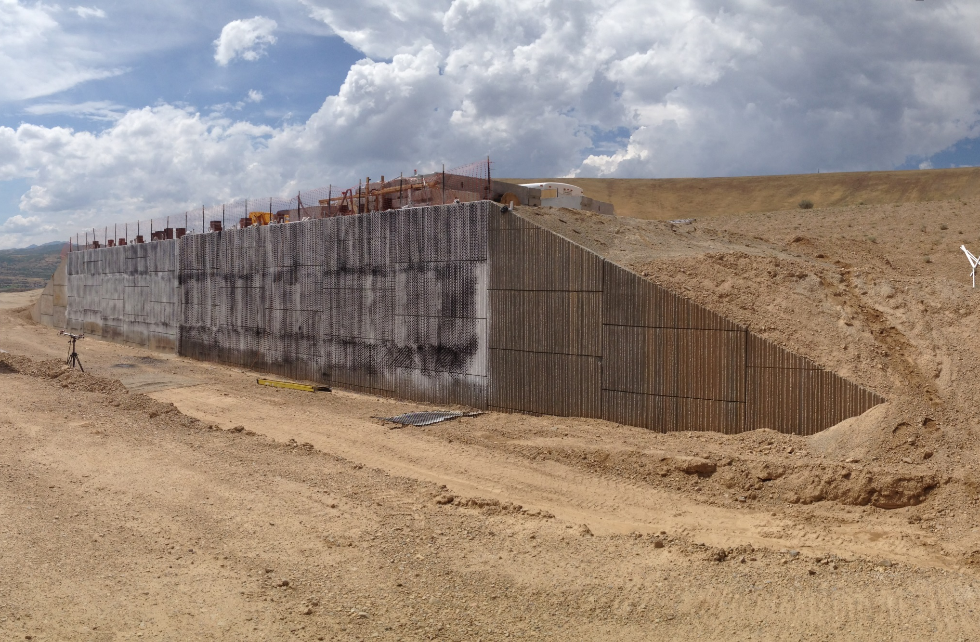
Fig. 1 Photograph of the completed MSE “abutment” wall at 20 ft height with 25 test piles behind the wall.

Fig. 2 Measured pile head load versus deflection curves for two square piles, a pipe pile and an H pile loaded on its weak axis.

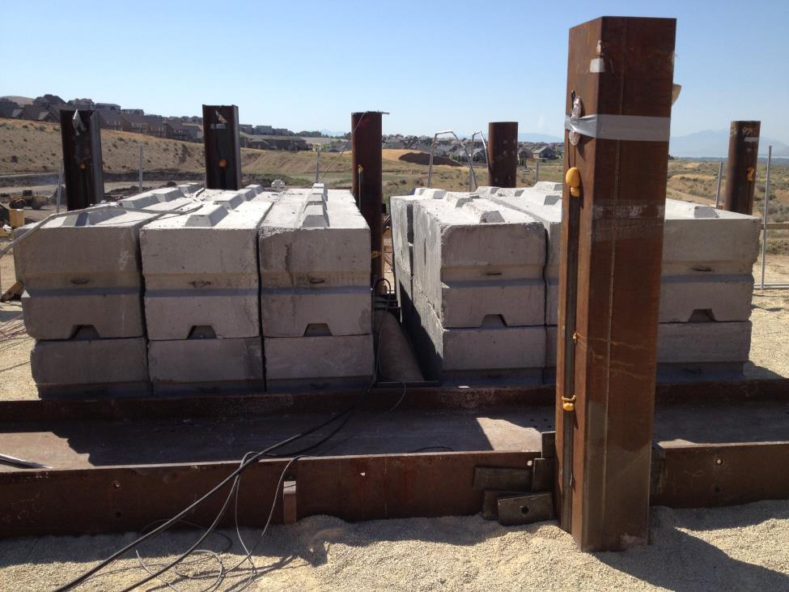
Fig. 3 Photograph of pre-cast concrete blocks to create a surcharge simulating the weight of a concrete abutment wall above the MSE wall. Hydraulic jack loads the test pile laterally and reacts against reaction beam.

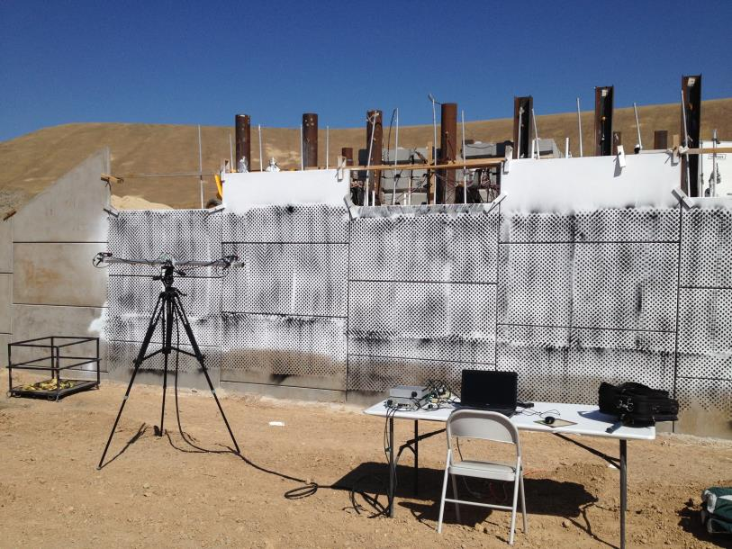
Fig. 4 Photograph of Digital Image Correlation cameras attached to computer data acquisition system to monitor movement of the “textured” MSE wall panels.
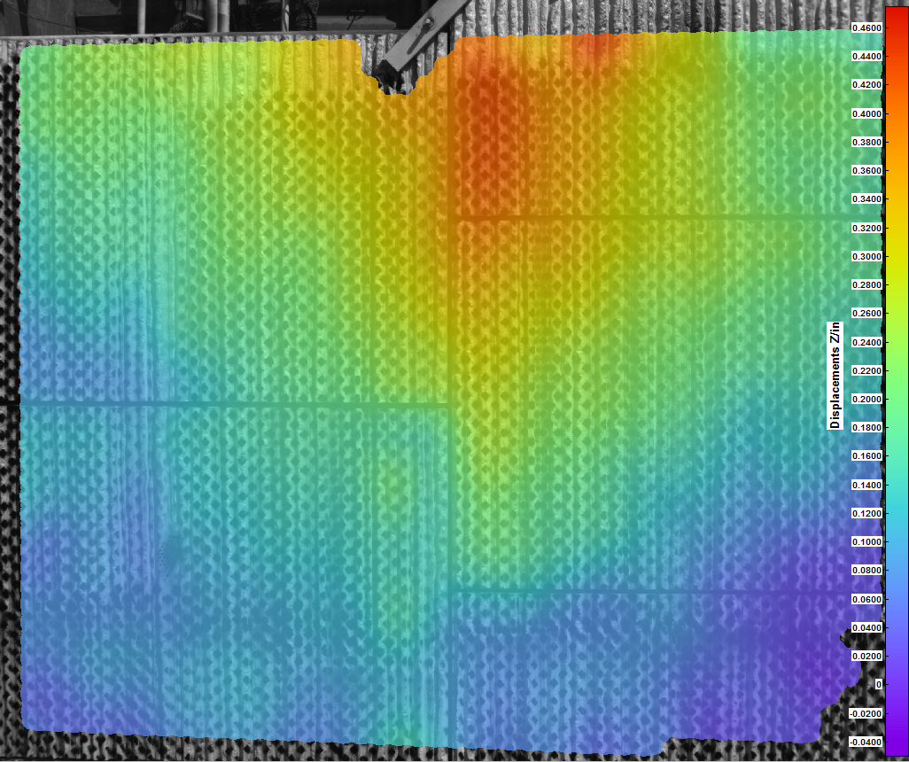
Fig. 5 Color contour plot of the wall displacement at maximum load during a lateral pile load test located near a vertical joint behind the MSE wall.

Fig. 6 and Fig. 7 provide plots of pile head load versus deflection curves for sets of four pipe piles at different distances behind the MSE wall. In both cases, the pile tests are for a wall height of 15 ft plus surcharge with 18 ft long reinforcements. Considering the surcharge effect, the L/H ratio is about 0.90. Fig. 6 provides results for the tests with the welded wire reinforcements, while Fig. 7 provides results for the ribbed strip reinforcements. Results from the load tests on the pipe reaction pile located 23 ft behind the wall are also shown for comparison. Initially, the curves for the pile farthest from the wall are similar to the curve for the reaction pile, but as displacement increases the load for the pile near the wall decreases relative to the reaction pile. We believe that this is a result of lower compaction for the piles near the wall. Compaction near the wall was limited to plate compactors and lift thicknesses were decreased to 6 inches; however, densities were still somewhat lower than back from the wall, where compaction was performed with a vibratory roller compactor. Generally, the lateral resistance decreases as the piles are loaded closer to the wall, but there are some abnormalities. These variations from expected behavior could be a result of local variations in compaction efficiency near the wall face although the compaction was monitored to be uniform.

Fig. 8 shows preliminary back-calculated p-multipliers as a function of pile spacing obtained using the computer program LPILE. Soil parameters for the backfill were first selected to fit the measured load-deflection curve for the pile farthest back from the wall. Afterwards, these same soil properties were used to analyze the piles at other spacing, and a constant p-multiplier was back-calculated for each test to provide the best agreement with the measured response. The p-multipliers obtained from this study are in very good agreement with the p-multipliers obtained from the previous tests conducted at bridge sites in Utah where the reinforcement length to height ratios were between 0.9 and 1.2. P-multipliers were found to be 1.0 (no wall interaction effects) when the pile was located more than about 3.75 pile diameters behind the wall. P-multipliers decreased approximately linearly as pile spacing behind the wall increased and became about 0.2 at a normalized spacing of 1.5 pile diameters.

Fig. 6 Pile head load vs. deflection curves for piles at four spacings near the 15 ft high MSE wall with welded wire reinforcement. The load vs. deflection curve for the reaction pile 23 ft away from the wall is also shown.

Fig. 7 Pile head load vs. deflection curves for piles at four spacings near the 15 ft high MSE wall with ribbed strip reinforcement. The load vs. deflection curve for the reaction pile 23 ft away from the wall is also shown.

Fig. 8 Back-calculated p-multipliers as a function of pile spacing behind the MSE wall for eight lateral pile load tests conducted during this study along with eight lateral load tests conducted previously at three bridge sites in Utah. SSL reinforcements are welded wire, while RECo reinforcements are ribbed strips.

Circumstance affecting project or budget. (Please describe any challenges encountered or anticipated that
might affect the completion of the project within the time, scope and fiscal constraints set forth in the
agreement, along with recommended solutions to those problems).

None to report.

Potential Implementation:

