
Validation of Hot-Poured Crack Sealant Performance-Based Guidelines

CIVIL ENGINEERING STUDIES
Illinois Center for Transportation Series No. xx-xxx
UILU-ENG-xxxx-xxxx
ISSN: 0197-9191

Volume II:
Crack Sealant Field Installation Guidelines

Imad l. Al-Qadi
Founder Professor of Engineering
Director, Illinois Center for Transportation
Department of Civil and Environmental Engineering
University of Illinois at Urbana-Champaign
Hasan Ozer
Research Assistant Professor
Department of Civil and Environmental Engineering
University of Illinois at Urbana-Champaign
Seyed Saleh Yousefi
Graduate Research Assistant
Department of Civil and Environmental Engineering
University of Illinois at Urbana-Champaign
Project Manager
Kevin K. McGhee, P.E., Virginia Transportation Research Council

An interim report of the findings of
FHWA TPF-5 (225)
Validation of Hot-Poured Crack Sealant Performance Based Guidelines, Pooled Fund Study
Illinois Center for Transportation
April, 2014

Table of Contents

1 Scope 2
2 Planning and Design 2
2.1 Primary Considerations 2
2.2 Crack Treatment Selection 5
2.3 Material Selection 6
3 Procedures and Equipment 7
3.1 Crack Cutting 9
3.2 Crack Cleaning and Drying 12
3.3 Material handling and preparation 14
3.4 Crack Sealant Installation 16
3.4.1 Derivatives of Sealant Configuration Selection 16
3.4.2 Sealant Installation Procedures 17
3.5 Blotting 20
References 21
Appendix A - Forms 23

Acknowledgment
This study is based upon work supported by the FHWA under pool fund award No. TPF-5 (225) “Validation of Hot-Poured Crack Sealant Performance-Based Guidelines.” Virginia
Department of Transportation managed the project. The contribution of the participating states (Minnesota, Virginia, Wisconsin, New York, Colorado, New Hampshire, Michigan, and Rhode Island), Ontario province, and industry is greatly appreciated. The contents of this report reflect the views of the authors, who are responsible for the facts and the accuracy of the data presented herein. The content does not necessarily reflect the official views or policies of the pool fund-participating departments of transportation or the Federal Highway Administration. This report does not constitute a standard, specification, or regulation. Special thanks are extended to Aaron Coenen, James Meister, Guillermo Elizalde, Catalina Arboleda Gonzalez, and Khaled Hasiba.

The authors also acknowledge the guidance and input of the technical advisory committee consisting of the following members (listed with their respective state, city, or agency): Kevin McGhee (Virginia), William R. Bailey III (Virginia), Beran Black (New Hampshire), Tom Kane (New York), James McGraw (Minnesota), Eddie Johnson (Minnesota), Andy Bennett (Michigan), Colin Franco (Rhode Island), Imran Bashir (Ontario), Roberto De Dios (Colorado), and Paulette Hanna (Wisconsin).

Scope
This guideline document is prepared to guide pavement maintenance personnel in the selection, installation, and evaluation of materials for hot-poured crack sealant treatments for flexible pavements. The information provided in this guideline is based on the field performance of 17 conventional sealants installed at five different sites in North America.
The document covers the following phases:
- Planning and design considerations;
- Treatment and sealant selection;
- Installation equipment and procedures.
Key components of each phase and best practices are summarized.

Planning and Design

Primary Considerations

Climatic Condition
Prior to sealant installation, information from the closest weather data station should be obtained. The ambient temperature should be greater than 40°F and lower than 80°F for proper crack sealing installation. Spring and fall are the best time of the year for crack sealing, when the cracks are not at their extreme closures or openings.

Pavement Initial Condition
Pavement and cracks initial condition should be evaluated to determine the best treatment for cracked pavement. Pavement type, rehabilitation history, traffic, climate, and overlay condition of pavement should be reported. The pavement evaluation report should include pavement distresses; pavement condition index, condition rating score, or IRI; and crack type, density, and severity. A sample survey form to report ambient temperature, traffic, and pavement and cracks initial condition is presented in appendix A.
The selection of strategies based on crack density and average level of crack deterioration (percentage of crack length) as presented by the SHRP study is still valid. Figure 1 presents various maintenance strategies adopted by the SHRP study (Smith and Romine 1999).

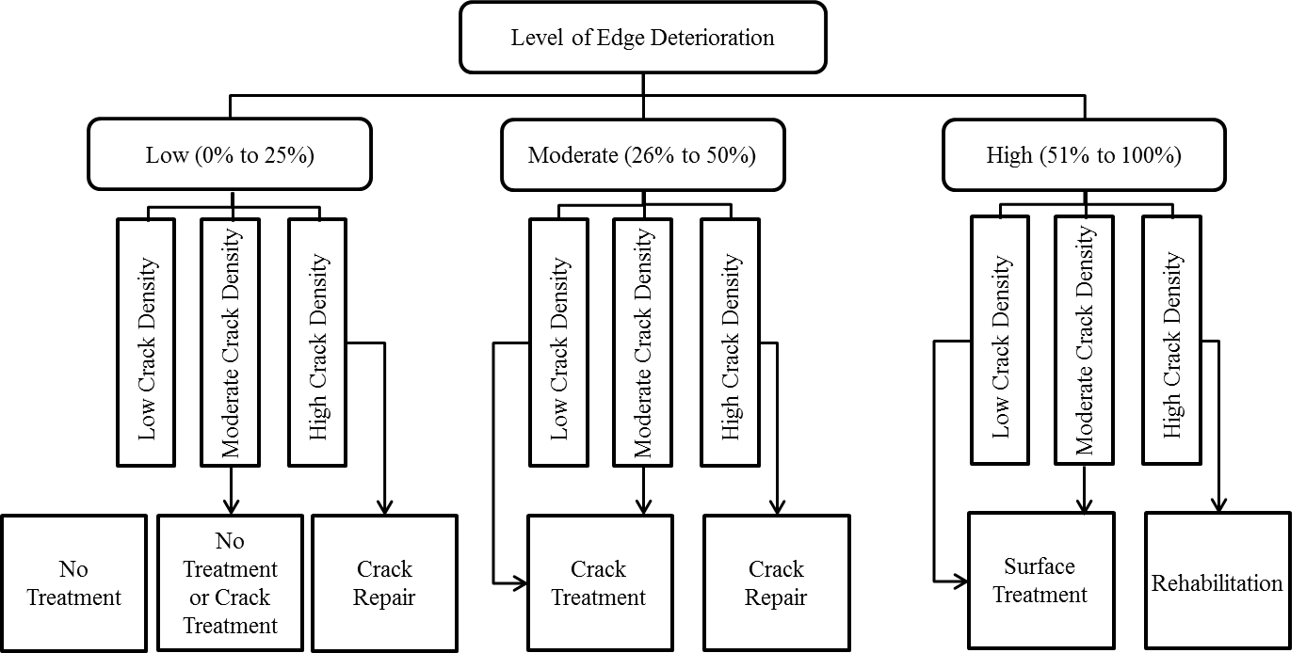
*Low Crack Density: Linear crack length per 100m pavement section to be less than 10m
*Moderate Crack Density: Linear crack length per 100m pavement section to be from 10 to 135m
*High Crack Density: Linear crack length per 100m pavement section to be more than 135m
Figure 1. Guidelines to select the type of maintenance (after Smith and Romine, 1999)
Crack sealant treatment is suitable for pavements with transverse and longitudinal cracking. Crack sealant treatment must be applied to cracks with little or no branching. Cracks shall not be a part of web cracks. Crack sealant treatments are not recommended for cracks wider than 25 mm. Figure 2 illustrates some examples of acceptable and unacceptable crack patterns. In addition, pavements exhibiting severe fatigue cracking are not recommended for crack sealant treatment.

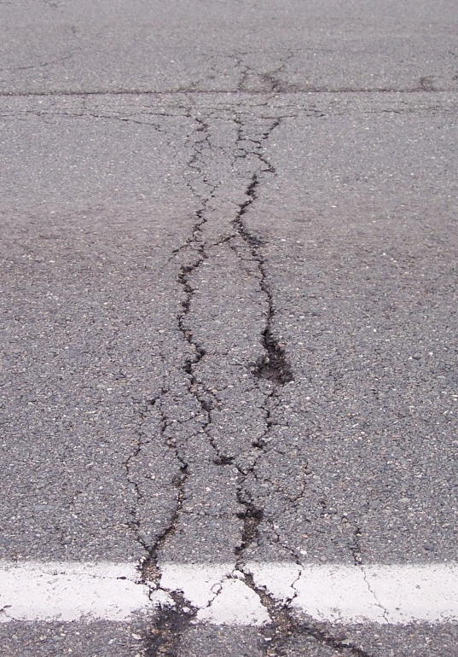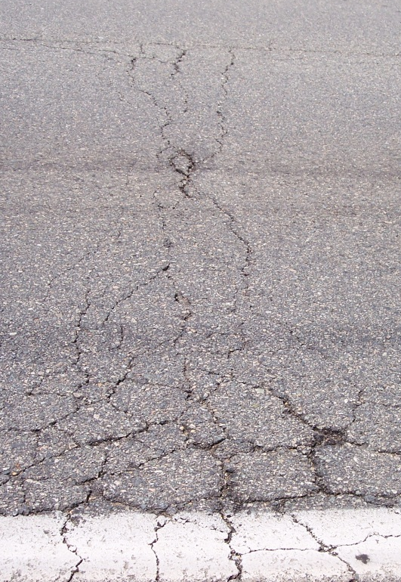
(a)
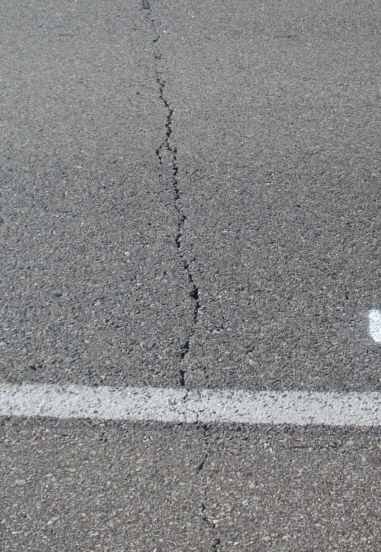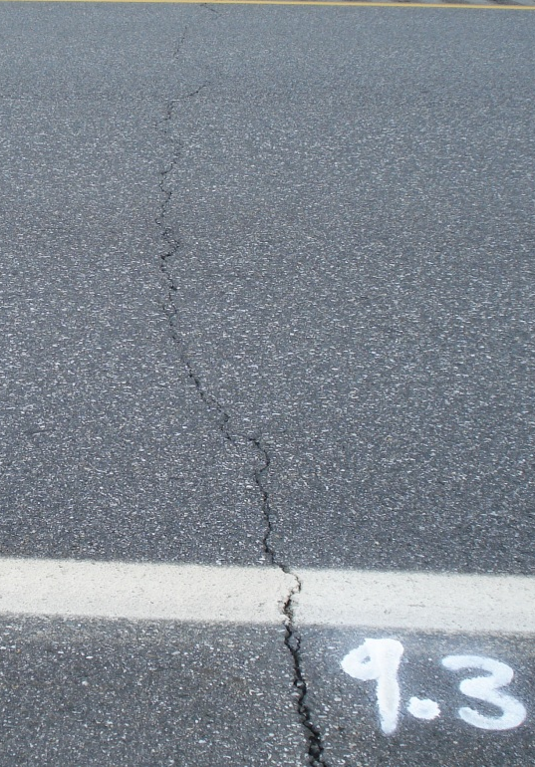
(b)
Figure 2. Various crack patterns to be considered in the selection of surface or crack treatments: (a) Cracks with severe branching and spalling (not recommended for crack sealing or filling, (b) Cracks with no branching and spalling are appropriate for crack sealing or filling

Safety
The safety hazards of sealants and equipment used during preparation and sealant installation should be presented to the workers. The crew should be well trained on the equipment use and material handling in accordance with the material safety data sheets (MSDS).
Traffic Control
Traffic control measures should be taken to ensure the safety of the workers and passing traffic. Traffic closure and opening time should be adjusted per sealant requirements to gain sufficient strength prior to traffic passage. It is recommended to open the section to traffic at least 15 minutes after crack sealing to prevent early sealant tracking or debris intrusion into sealant.

Crack Treatment Selection
Once a decision is made to perform crack sealant treatment, two types of crack sealant treatment is available for selection based on the initial condition of pavement and crack type. These treatment types follow.
Crack Sealing: This method is defined as the application of hot-poured crack sealant in pre-routed and cleaned reservoir. This method is recommended for cracks exhibiting significant vertical and horizontal movements, often referred as working cracks. Working cracks are defined as cracks with annual horizontal movement more than 3 mm. Types of cracks that might be considered as working cracks are transverse thermal cracks, transverse reflective cracks, longitudinal reflective cracks, and longitudinal cold-joint cracks.
Cracks Filling: This method is defined as the direct injection of hot-poured crack sealant in a cleaned crack. This method is recommended for non-working cracks. Non-working cracks are defined as cracks with annual horizontal movement of 3 mm or less. Types of cracks that might be considered as non-working cracks are longitudinal reflective cracks, longitudinal cold-joint cracks, longitudinal edge cracks, and thermal or reflective transverse cracks with minimal movements.
Table 1. Recommended criteria for treatment selection (after Smith and Romine, 1999)
Crack Characteristics | Crack Treatment Activity
Crack Characteristics | Crack Sealing | Crack Filling
Width, mm | 5 to 19 | 5 to 25
Edge Deterioration (i.e., spalls, secondary cracks) | Minimal to None  (≤25 percent of crack length) | Moderate to none  (≤50 percent of crack length)
Annual Horizontal Movement, mm | ≥ 3 | ˂ 3
Type of Crack | Transverse Thermal Cracks  Transverse Reflective Cracks  Longitudinal Reflective Cracks  Longitudinal Cold-Joint Cracks | Longitudinal Reflective Cracks  Longitudinal Cold-Joint Cracks  Longitudinal Edge Cracks  Distantly Spaced Block Cracks

Material Selection
There are many different crack treatment materials available. Table 2 is a summary of hot-applied thermoplastic materials available for crack sealing and filling. Currently, most of the agencies’ preferred method of material selection is based on ASTM standards. According to these standards, crack sealants can be categorized in four groups; type I, type II, type III, and type IV. ASTM classifications are related to sealants penetration resistance, softening point, bonding strength, and asphalt compatibility. Agencies often make a decision on material choice based on the modulus characteristics of sealants. Low modulus sealants (likely to be ASTM Type II to IV) are often preferred in wet-freeze zones whereas high modulus products (likely to be ASTM Type I to II) are preferred dry-no freeze climatic regions. The recommended application for each sealant type is also mentioned in Table 2. Generally, crack filling requires selection of a product with slightly higher modulus for the same climatic region.
Table 2.Summary of asphalt concrete crack treatment materials
Material type | Application Specification | Recommended Application
Asphalt Emulsion | ASTM D 977, AASHTO M 140, ASTM D 2397, AASHTO M 208 | Filling
Asphalt Cement | ASTM D 3381, AASHTO M 20, AASHTO M 226 | Filling
Fiberized Asphalt | Manufacturer’s recommended specificati | Filling
Polymer-Modified Emulsion | ASTM D 9777, AASHTO M 140, ASTM D 2397, AASHTO M 208 | Filling (possibly sealing)
Asphalt Rubber | State specs, ASTM D 5078 | Sealing (possibly filling)
Rubberized Asphalt | ASTM D 1190, AASHTO M 173, Fed SS-S-164 | Sealing
Rubberized Asphalt | ASTM D 3405, AASHTO M 301, Fed SS-S-1401 | Sealing
Low-Modulus Rubberized Asphalt | State-modified ASTM D 3405 specs | Sealing
Self-Leveling Silicone | ASTM D 5893 | Sealing

Recently, performance-based guidelines were developed as a systematic procedure to select hot-poured bituminous crack sealants. A “Sealant Grade” (SG) system to select hot-poured crack sealant based on environmental conditions is used. The Sealant standards are as follows (attached):
SC-1, Guidelines for Graded Hot-poured Bituminous Sealants (to be prepared as standards at the end of the current pooled fund study).
AASTHTO, TP 85-10, Test Method for Measuring Apparent Viscosity of Hot-poured Crack Sealant Using Brookfield Rotational Viscometer RV Series Instrument
AASTHTO, TP 86-10, Method for the Accelerated Aging of Bituminous Sealants
SC-4, Method for Evaluation of the Tracking Resistance of Bituminous Sealants and Fillers by Dynamic Shear Rheometry.
AASTHTO, TP 87-10, Method to Measure Low Temperature Sealant Flexural Creep Stiffness at Low Temperature by Bending Beam Rheometer.
AASTHTO, TP 88-10, Method to Evaluate Sealant Extensibility at Low Temperature by Direct Tension Test
AASTHTO, TP 90-10, Blister Method to Measure the Adhesion of Bituminous Sealants.
These aforementioned laboratory tests allow for measuring hot-poured bituminous-based crack sealant’s rheological and mechanical properties over a wide range of service temperatures. Thresholds for each test were identified to ensure desirable field performance. For example, SG 52-34 suggests that sealant can be used at a high service temperature of 52°C and a low service temperature of -34°C. Hence, using the developed laboratory tests, a proper crack sealant can be selected systematically based on expected service temperature. Figure 3 shows different zones for the pavement’s low temperature in North America that can be used to select the proper sealant based on its SG.

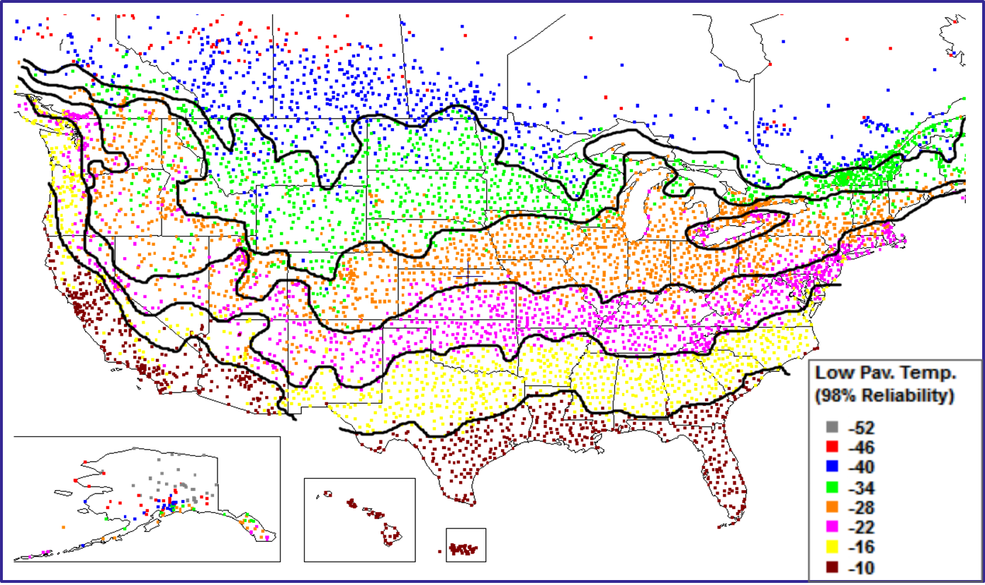
Figure 3. North America low pavement temperature zones (according to LTPPBind V3.1)

Procedures and Equipment
The following steps are suggested for crack sealant installation (details of each step follows)::
Step 1 – Crack routing: Cracks are cut to specific reservoir geometry using a router. This step is only used in crack sealing treatment.
Step 2 – Crack cleaning and drying: Cracks or prepared reservoirs are cleaned from debris and dried by applying hot-air. This step is used for both crack sealing and crack filling treatment. A hot air lance equipped with compressed air is commonly used for cleaning and drying.
Step 3 – Material handling and preparation: Sealant materials are placed in the kettle for melting prior to installation. The materials are heated up to the recommended installation temperatures.
Step 4 – Crack sealant installation: Melted and homogenized sealant material in the kettle is injected to fill crack or reservoir.
Step 5 – Blotting (optional): After the application of sealant, sealant surface can be protected from direct application of trafficking using chemicals or simply paper towels.
The list of equipment required for crack sealing is presented in Table 3. Details of crack sealant installation steps are discussed next.
Table 3. List of equipment needed for crack sealing and filling
Equipment | Primary Use | Picture
Router | Making reservoirs at different sizes for sealant application | 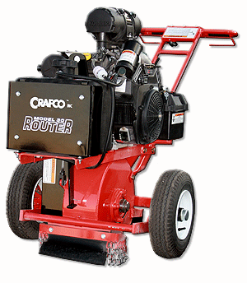
Hot air lance | Drying routs’ walls. | 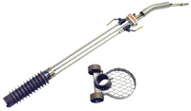
Leaf Blower | Cleaning dust and debris out of the routs and pavement surface. | 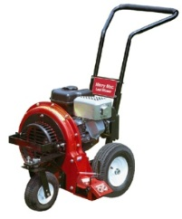
Kettle | Heating and melting the sealant up to installation temperature. | 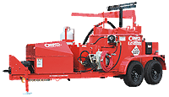
Applicator | Pouring sealant into routs. | 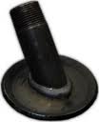
Squeegee | Forming overband sealant. | 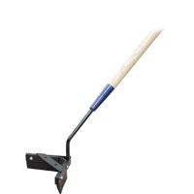

Crack Routing
Crack routing (cutting) is required to provide the sealant material sufficient pavement surface to adhere. The cracks can be cut as square or rectangular geometry using a saw or router (Figure 4). Routs must be square or rectangular. Rounded and V-shaped routs, often results because of using worn blades or misalignment of blades, must be avoided. It is recommended to make trial cuts before cutting the cracks specified for the job. Rout geometry should be checked to make sure they have correct width and depth (Figure 5). Blades spacing should be adjusted as needed to ensure the routing size (Figure 6). Routing and sealing should be extended to shoulders.
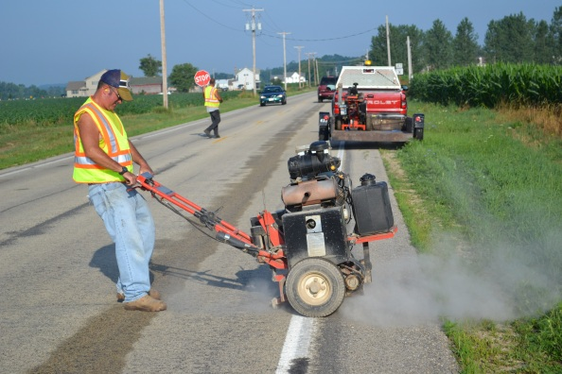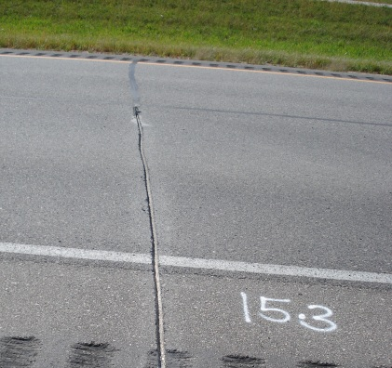
Figure 4. A router used for cutting a crack (left) and a properly routed crack (right)
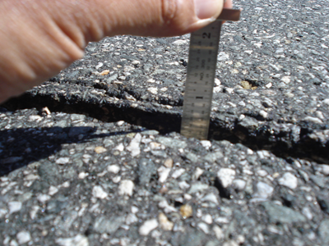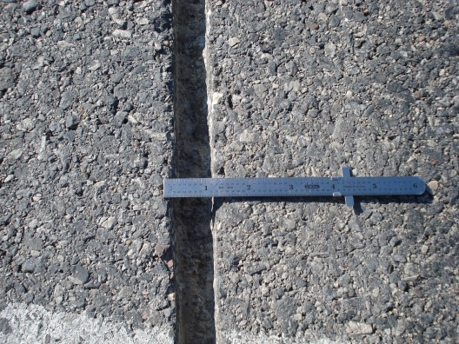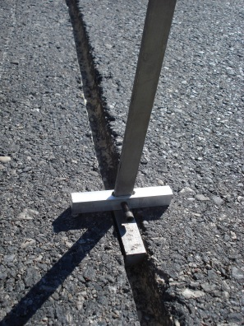
Figure 5. Controlling the rout size
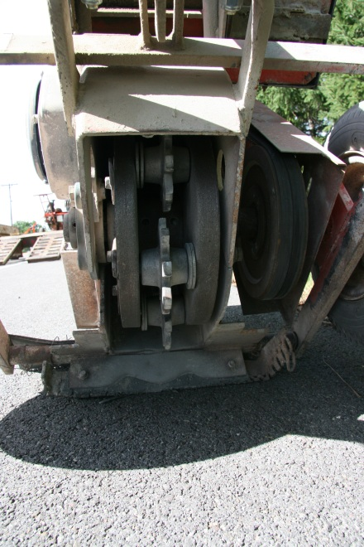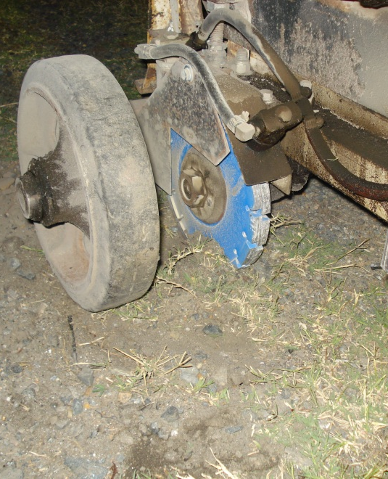
Figure 6. Rotary impact router (left) and diamond saw (right) with close-up up of blade
Properly prepared reservoirs are critical for sealant performance. Workmanship is critical in preparation of good quality routs; therefore, router operators should be well trained. Most of the problems associated with rout preparation can be controlled by good workmanship. In some occasions, however, different method of treatment may be preferred to avoid rout related problems. There are number of issues that can affect the quality of routing. Cracking pattern, partially developed cracks and surface texture of asphalt mixtures can pose significant challenges to achieve desired shape and quality of reservoirs. Three scenarios that a router may face during routing and must pay special attention to are described below:
Wavy Cracks: Extra attention should be paid to wavy cracks by routers to improve accuracy. Wavy cracks pose challenges since they can be missed by the router, who may cut the pavement instead. This may lead to spalling of the pieces left between rout and crack as shown in Figure 7.
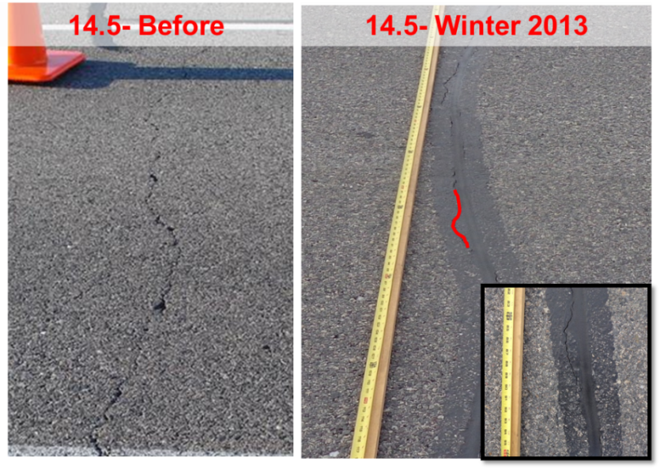
Figure 7. Wavy cracks that can be missed by routers
Zigzag Cracks: This require more than improving workmanship; the router may increase rout width to capture crack pattern with a greater accuracy or use crack filling technique instead of crack sealing. Cracks with sharp edges and torturous patterns (frequent zigzags) can create significant challenges to the routing operation. Surface texture and asphalt mixture type is the primary cause of the cracking patterns, significant amounts of spalling can occur as a result of routs not following the crack patterns as shown in Figure 8. The amount of spalling in such cracks can be 10-20% of total crack length.
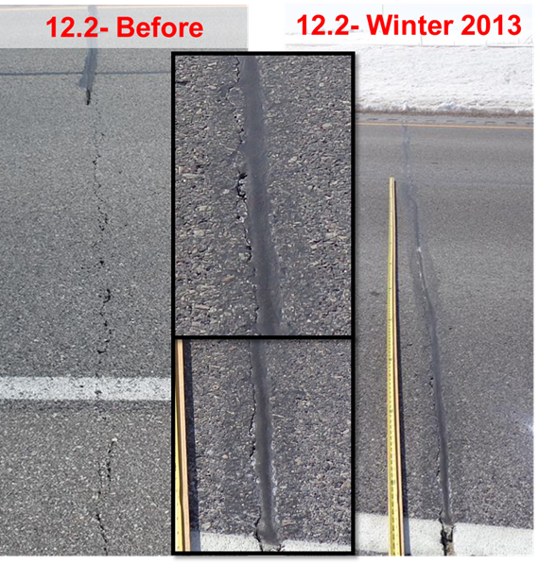
Figure 8. Cracks with torturous pattern leading to spalling
Partially-Developed Crack: This can be addressed through partial rout and sealing of the crack length appears on the pavement surface. Partial cracks are defined as the cracks that are not fully developed on the pavement surface covering only a certain percentage of lane width. In some occasions, routs are cut for the full lane width even though crack appears partially on the surface. It is very likely that crack may develop elsewhere on the surface not matching the initially prepared rout (Figure 9).
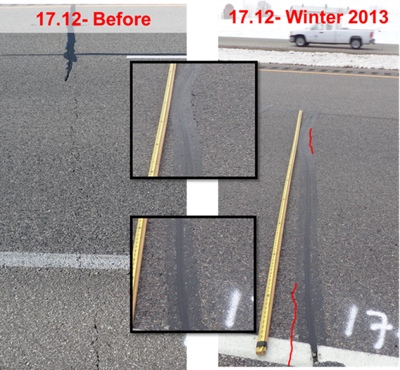
Figure 9. Partially-developed cracks

Crack Cleaning and Drying

The routing operation shall be immediately followed by cleaning and sealant installation. It is critically important to clean and dry the cracks to improve adhesion between sealants and crack wall. It is recommended to perform a multi-staged cleaning to obtain a clean reservoir free from dust and debris. It is recommended to avoid sealant installation when pavement is wet. The cleaning operations shall be completed in four steps:
- Pavement surface and inside the rout must be cleaned. Pavement surface must be cleaned of dust, dirt, debris, any foreign material, and loose edges from the sawing/routing operations (Figure 10). A mechanical sweeper, a large vacuum system, or simply a leaf blower can be used to perform first stage cleaning of the pavement surface. This will prevent dust and debris blowing back into the rout due the movement of construction vehicles and workers.
- Cleaning shall take place right before sealant placement. A compressor or vacuum cleaning system shall be used to clean inside the rout and immediate surroundings. The compressor shall be equipped with oil and moisture filters and providing at least 100 psi (690 kPa) pressure at the nozzle and minimum blast flow of 150 ft³/min. Oil and moisture filters shall facilitate the operation with dry air and free of oil. Filters must be inspected for cleanliness/damage prior to the operation and shall be replaced if damaged or not clean.
- Rout cleanliness should be checked visually after cleaning. Duct tape shall be used to check cleanliness of the routs. Press the sticky surface of about 3 ft of duct tape on to rout walls. When removed, there should be none to very little residue on the tape. Further cleaning shall be applied if the result is unsatisfactory.
- A hot-air-lance (HAL) shall be used immediately (not to exceed 2 min) before the placement of sealant. This will serve to ensure crack wall dryness and heating. HAL temperature must be kept below 500°C to minimize pavement damage. Care should be paid not to burn, scorch, or ignite the adjoining pavement (Figure 11).

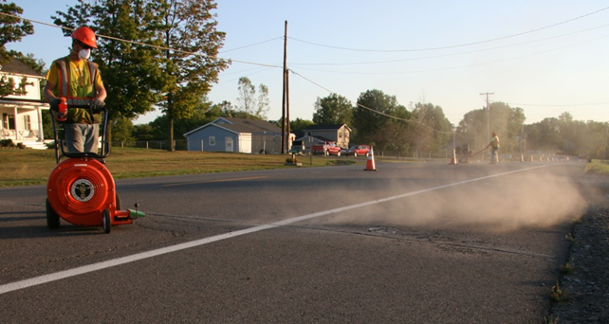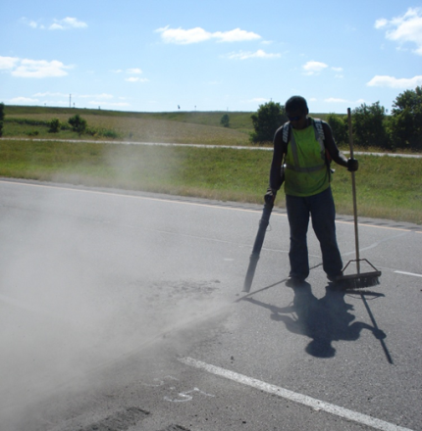
Figure 10. First stage: Cleaning of pavement surface and rout using a leaf blower

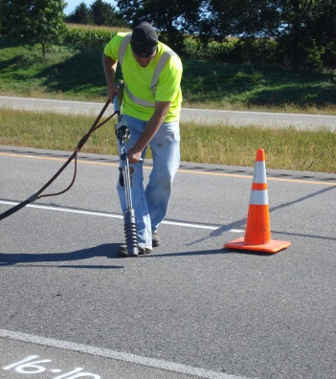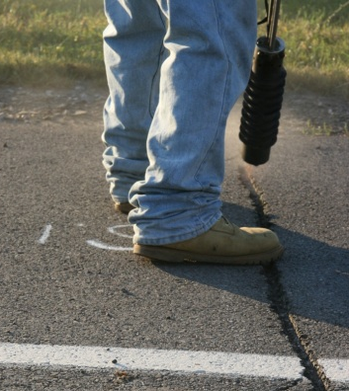
Figure 11. Second stage: Cleaning and drying using a hot-air lance equipped with compressed air

Material handling and preparation
Heating of sealant materials in preparation for installation is one of the critical steps to ensure good quality sealant treatments. Sealants are usually heated in hot-oil driven and agitated kettles with automated temperature controls. Recommended temperature for melting sealant block varies from 340-400°F depending on the type and composition of the product. The duration and temperature inside the kettles are critical for sealant’s integrity. Therefore, it is critical to follow manufacturer’s recommended temperatures and not to overheat the material, which may cause degradation. It may take up to 2 hrs to reach recommended temperatures after placing the sealant blocks in the kettle.
Figure 12 illustrates temperature history of a sealant material in a fully automated kettle. The measurements were taken using thermocouples inside the kettle at various locations and from the kettle’s control panel. The heating duration may vary based on the amount of material placed in the kettle and type of the heating system. Therefore, it is recommended to prepare a calibration record for each equipment to estimate the safe time to start installation.

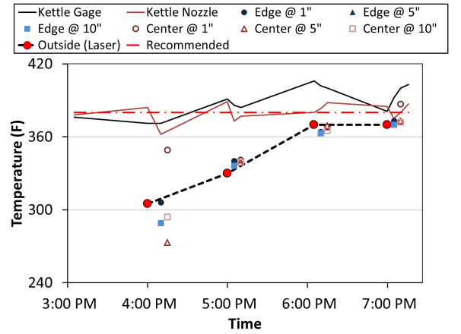 | 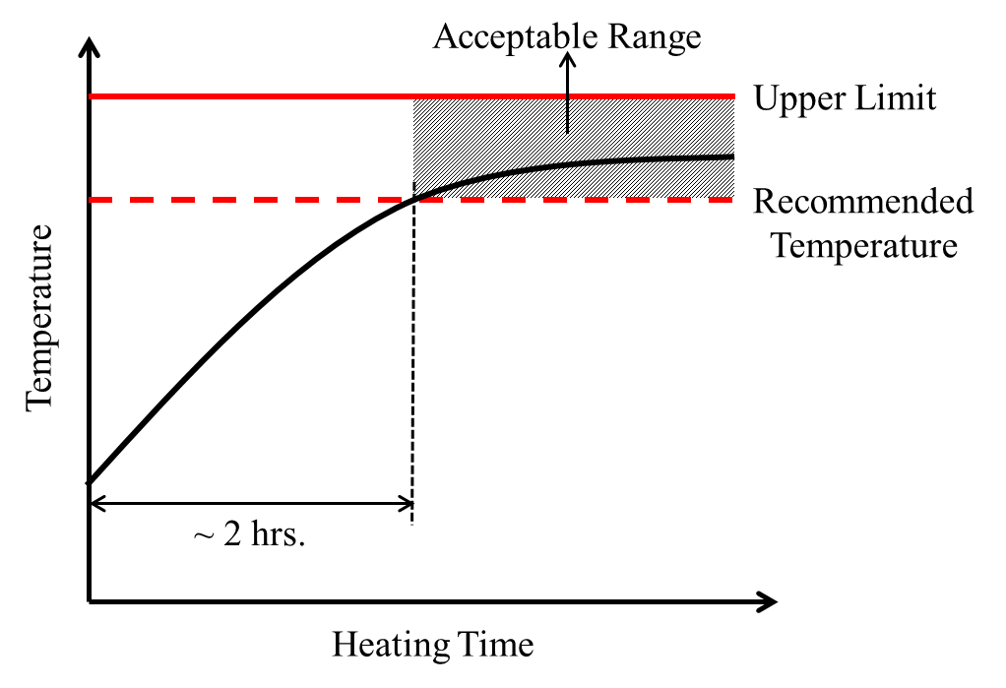
(a) Monitored temperature history for a material | (b) Expected temperature history for a calibrated sealant kettle
Figure 12. Typical temperature history of a sealant material
The kettle calibration procedures are outlined below:
- Fill the kettle to three-quarters full position with a typical material used in the installation
- Start recording temperatures every 10 min using the kettle’s control panel
- Using a long probe with calibrated thermocouples at the tip (Figure 13), record temperature every 10 min starting 30 min after the placement of blocks
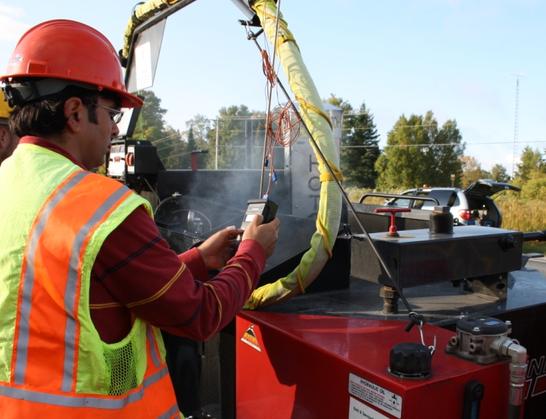
Thermocouple Probe
Thermo-reader
Figure 13. External temperature recording using a long probe with thermocouples at the tip
- After the control panel reached the recommended temperature, take a sample from the kettle in a small quart. Immediately measure the temperature inside the can using a small probe calibrated thermocouple. Continue taking samples at every 10 min until the temperature in the can and inside the kettle reach the recommended temperatures.
- Record the time (±10 minutes) when recommended temperature is reached after placing the sealant in the kettle. This would be the safe starting time for installation.
- Compare the readings from external probes and kettle’s control panel reading after the equilibrium is reached. Calculate a correction factor to adjust kettle’s control panel reading to external readings taken by calibrated thermocouples.
The calibration protocol should be repeated every year or prior to the season of installation. A sample form presented in Appendix A can be used for temperature recording.
The kettle should be at least three-quarter full. Sealant installation should start at the safe starting time. After sealant installation starts, the temperature should be adjusted frequently by using kettle control panel to avoid overheating. It is possible that new sealant blocks be added to the kettle during the installation to maintain same amounts of material in the kettle. This will regularize temperature control feedback mechanism and reduce overheating.
At the end of the day, the material inside the kettle should be drained to start the next day with unheated materials. Reheating the sealants may reduce its quality.

Crack Sealant Installation

Derivatives of Sealant Configuration Selection

Following the aforementioned procedures in preparation of cracks for sealant treatment, sealant is installed in the routs or directly in the cracks. The configuration for sealant installation will not only dictate the amount of materials used in a sealing job but also the lifetime of sealant treatment. The commonly applied configurations for sealant placement are shown in Figure 14 and Figure 15Figure 15 and listed below:
- Flush fill
- Reservoir
- Overband
- Combination (reservoir and overband)

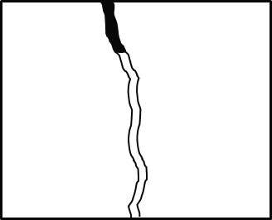 | 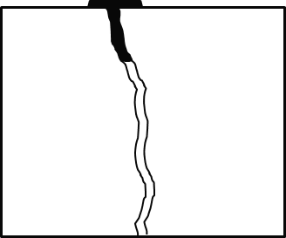
(a) Flush fill | (b) Overband
Figure 14. Crack filling common configurations

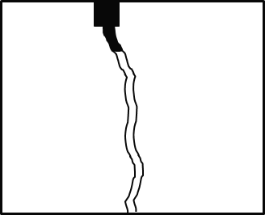 | 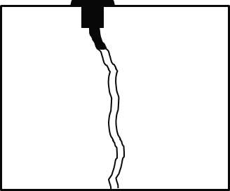
(a) Reservoir | (b) Combination
Figure 15. Crack sealing common configurations
Several factors need to be considered for selection of sealant placement configuration. Based on the SHRP study (Smith and Romine, 1999) and field evaluations of the pooled fund study (TPF-5 (225) - Validation of Hot-Poured Crack Sealant Performance-Based Guideline), Table 4 is recommended to be used to select the placement configuration for sealant materials.
Table 4. Derivatives of Considerations for Sealant Placement Configuration.
Consideration | Crack Filling | Crack Sealing
Type and Extent of Operation | No crack cutting operation; hence, duration of operation can be shorter. Can be preferable when traffic closures are a concern. | Duration of operation is greater due to routing and cleaning. Requires more traffic closure time.
Traffic | Overband wear is similar to crack seal configurations; however, the impact on sealant in the crack is less severe. | Overband configurations experience wear and, subsequently, high tensile stresses directly above the crack edge, leading to internal rupture.
Crack Characteristics | Overband configurations are more appropriate for cracks having a considerable amount of edge deterioration (>10% of crack length), because the overband simultaneously fills and covers the deterioration segments in the same pass.
Material Type | Material such as emulsion, asphalt cement, and silicone must be placed unexposed to traffic due to serious tracking or abrasion problems.
Desired Performance | For long-term sealant performance, flush, reservoir, and recessed band-aid configurations should be considered.
Cost | Filling configurations require minimal material than reservoir configurations, resulting in lower costs. | Combination configurations require significantly more material than reservoir configurations, resulting in higher costs.

Sealant Installation Procedures
Melted and homogenized sealants are poured in the crack or the precut reservoir using an applicator attached to the end of the nozzle. Different types of applicators are used for sealant installation to control the amount of sealant injected into a rout or crack. Some of the common applicators are horse shoe, disk or, flush fill (Figure 16).

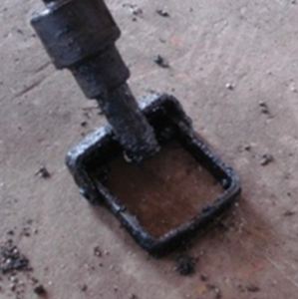 | 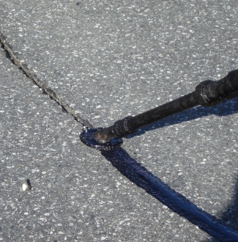 | 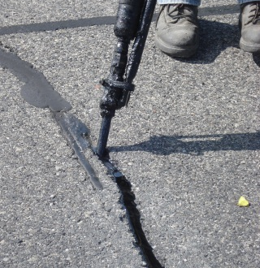
(a) Horse shoe | (b) Disk | (c) Flush fill
Figure 16. Various sealing applicators
Depending on the reservoir configuration selected for the project, a V-shape squeegee can be used to apply a uniform overband right after pouring the material (Figure 17).
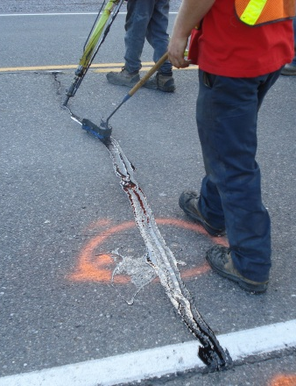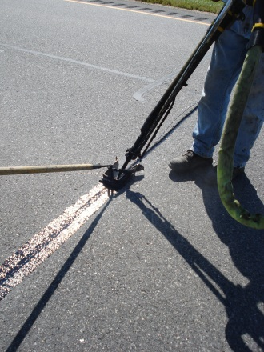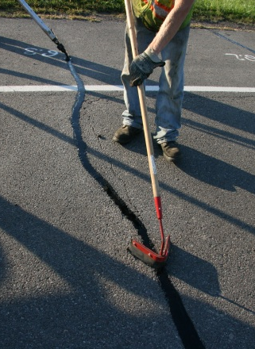
Figure 17. Using a squeegee for overband application

It is recommended to use overband configuration for crack filling and sealing treatments. A typical overband configuration for a crack filling treatment is shown in Figure 18. The effectiveness of overbanding was shown in earlier studies (Solanki et. al., 2014). The overband width is recommended to be 3 to 4 in and it should not be more than 0.1 in above the pavement surface. Thick overband contributes to pavement noise and also increases the likelihood of being picked up by plow trucks during the winter time.

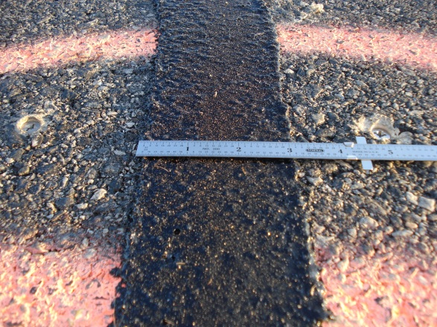
Figure 18. An example of overband configuration for crack filling (width should be within 3 to 4in)
If crack sealing is chosen as the sealant treatment method for a project, it is recommended to use a combination configuration (reservoir and overband) for crack sealing. Using the overband will reduce the amount of sealant failure during the service life and prolong service life of sealant treatment. Some examples of overband application for routed and sealed cracks are shown in Figure 19.

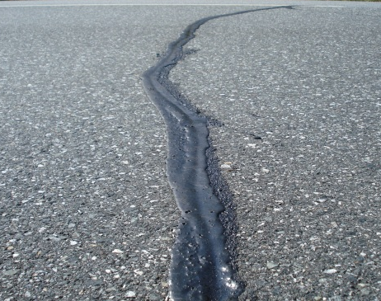 | 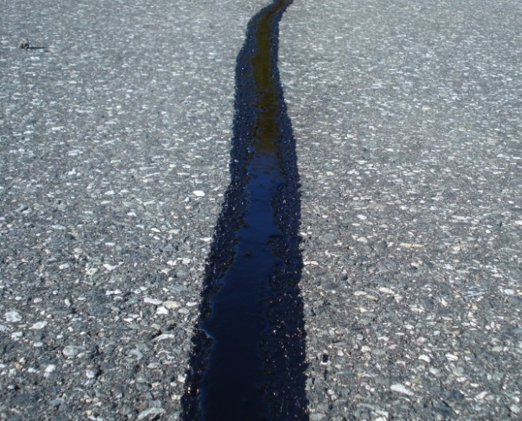
(a) | (b)
Figure 19. Two examples of overband applications for crack sealing treatment: (a) Poor application of an overband, (b) Proper application of an overband
Low modulus sealants show a recessed shape after installation and cooling process. An example of such configurations is shown in Figure 21. This can increase the pavement noise and cause premature adhesion failure of sealants. To prevent recessed configuration, it is recommended to seal the routed cracks in two steps. At the first step sealant is injected into the reservoir to fill it up to 2/3 of the rout depth. At the second step the route is sealed with overband application as shown in Figure 21.
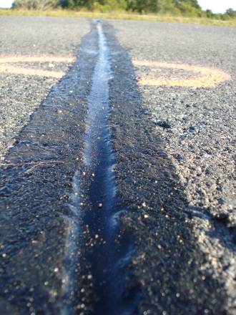
Figure 20. Recessed configuration due to application of low modulus sealant
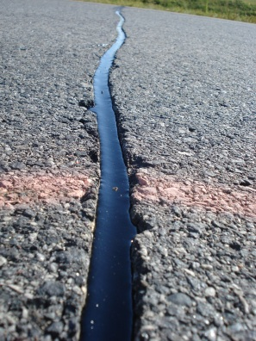 | 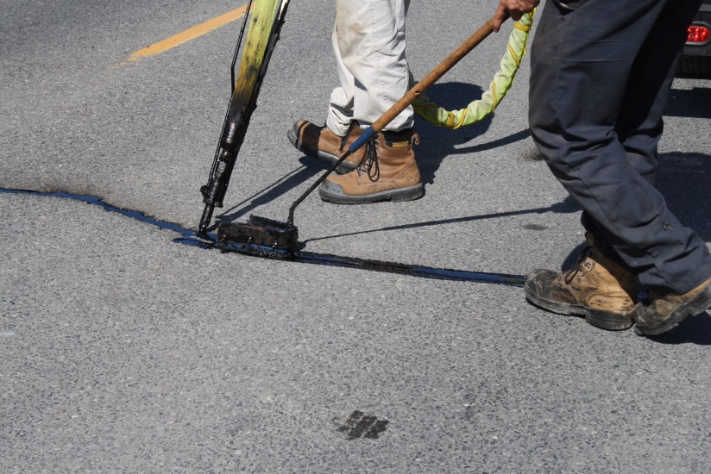
(a) | (b)
Figure 21. Two-step crack sealing to avoid recessed configuration: (a) Flush filling of the reservoir in the first step and (b) Application of overband with filling the remaining part of the reservoir after flush filled sealant gained some stiffness

Blotting
Sealed cracks require a certain time to be cured so they will not track under traffic. Blotting is sometimes used if early traffic opening is required. Paper towels, sand, and chemicals are some of techniques used for blotting. The effect of chemicals to reduce surface adhesive properties on sealants is unknown. Application of sand particles may increase the amount of debris intrusion into sealant surface which may lead to cohesive type of failure as the sealant experience elongation due to crack opening. The application of paper towel may seem to be the least intrusive method for blotting; however, papers may be picked up by cars and scatter around.

References
American Association of State Highway and Transportation Officials, TP 85-10. Apparent Viscosity of Hot-Poured Bituminous Crack Sealant Using Brookfield Rotational Viscometer RV Series Instrument, AASHTO, Washington, DC, 2010

American Association of State Highway and Transportation Officials, TP 86-10. Accelerated Aging of Bituminous Sealants and Fillers with a Vacuum Oven, AASHTO, Washington, DC, 2010

American Association of State Highway and Transportation Officials, TP 87-10. Measuring Low-Temperature Flexural Creep Stiffness of Bituminous Sealants and Fillers by Bending Beam Rheometer (BBR), AASHTO, Washington, DC, 2010

American Association of State Highway and Transportation Officials, TP 88-10.Evaluation of the Low-Temperature Tensile Property of Bituminous Sealants by Direct Tension Test, AASHTO, Washington, DC, 2010

American Association of State Highway and Transportation Officials, TP 89-10. Measuring Adhesion of Hot-Poured Crack Sealant Using Direct Tension Test, AASHTO, Washington, DC, 2010

American Association of State Highway and Transportation Ofﬁcials, TP 90-10. Measuring Interfacial Fracture Energy of Hot-Poured Crack Sealant Using a Blister Test, AASHTO, Washington, DC, 2010

Al-Qadi, I.L, S.-H. Yang, S. Dessouky, J.-F. Masson, A. Loulizi, and M.A. Elseifi. Development of Crack Sealant Bending Beam Rheometer (CSBBR) Testing to Characterize Hot-Poured Bituminous Crack Sealant at Low Temperature. Journal of AAPT, Vol. 76, 2007, pp. 85-122.

Al-Qadi, I.L., E.H. Fini, H.D. Figueroa, J.-F. Masson, and K.K. McGhee. Adhesion Testing
Procedure for Hot-Poured Crack Sealants, Final Report, Illinois Center for Transportation, Report No. ICT-08-026, Rantoul, IL, December 2008(a).

Al-Qadi, I.L., E.H. Fini, J.-F. Masson, A. Loulizi, K.K. McGhee, and M.A. Elseifi. Development of Apparent Viscosity Test for Hot-Poured Crack Sealants, Final Report, Illinois Center for Transportation, No. ICT-08-027, Rantoul, IL, December 2008(b).

Al-Qadi, I.L., S.-H. Yang, J.-F. Masson, and K.K. McGhee. Characterization of Low Temperature Mechanical Properties of Crack Sealants Utilizing Direct Tension Test, Final Report, Illinois Center for Transportation, No. ICT-08-028, Rantoul, IL, December
2008(c)

Al-Qadi, I.L., S.-H. Yang, M.A. Elseifi, S. Dessouky, A. Loulizi, J.-F. Masson, and K.K. McGhee. Characterization of Low Temperature Creep Properties of Crack Sealants 30 Using Bending Beam Rheometry, Final Report, Illinois Center for Transportation, No. ICT-08-029, Rantoul, IL, December 2008(d).

Al-Qadi, I.L., J.-F. Masson, S.-H. Yang , E.H. Fini, and K.K. McGhee. Development of Performance Guidelines for Selection of Bituminous-based Hot-poured Pavement Crack Sealant: An Executive Summary Report, An Executive Summary Report, Virginia Transportation Research Council, 2009.

Belangie, M.C., and D.I. Anderson. Crack Sealing Methods and Materials for Flexible Pavements. Final Report, FHWA-UT-85-1, Utah Department of Transportation, Salt Lake City, UT, 1985.

Chong, G.J., and W.A. Phang. Consequences of Deferred Maintenance Treatment on Transverse Cracks in Cold Regions, Proceedings of Paving in Cold Areas Mini-Workshop, Ottawa, Ontario, Canada, 1987, pp. 638-686.

Chong, G. J., and W.A. Phang. Improved Preventive Maintenance: Sealing Cracks in Flexible Pavements in Cold Regions. Final Report, PAV-87-01, Ontario Ministry of Transportation, Downsview, ON, 1987.

Masson, J.-F., and M.A. Lacasse. Effect of Hot-Air Lance on Crack Sealant Adhesion. Journal of Transportation Engineering, ASCE, Vol. 125, No. 4, 1999, pp. 357-363.

National Research Council (NRC). Guidelines for Sealing and Filling Cracks in Asphalt Concrete Pavements, 2003. http://www.nrc-nrc.gc.ca/obj/irc/doc/pubs/nrcc46289/nrcc46289.pdf

Solanki, P., Ozer, H., Yousefi, S.S., Al-Qadi, I.L., Field Validation of Laboratory-Predicted Low-Temperature Performance of Hot-Poured Crack Sealants. 93th Transportation Research Borad Annual Meeting, Washington, DC, 2014.

Smith, K. L., D.G. Peshkin. E.H. Rmeili, T.V. Dam, K.D. Smith, and M.J. Darter. Innovative Materials and Equipment for Pavement Surface Repairs, Volume 1. Strategic Highway Research Program, Nation

Smith, K.L., Romine, A.R., Materials and Procedures for Sealing and Filling Cracks in Asphalt-Surfaced Pavements, FHWA-RD-99-147, Federal Highway Administration, U.S. Department of Transportation, McLean, VA1999.

Yildirim, Y., Qatan, A., Prozzi, J., ”Field Manual for Crack Sealing in Asphalt Pavements”, Texas Department of Trasportation, Austin, TX, 2006.

Appendix A - Forms

FigureA-1. Survey form for pavement and cracks evaluation
Figure A-2. Kettle temperature monitoring form
Figure A-3. Work journal form

