TRANSPORTATION POOLED FUND PROGRAM
QUARTERLY PROGRESS REPORT

Lead Agency: Utah Department of Transportation

INSTRUCTIONS:
Project Managers and/or research project investigators should complete a quarterly progress report for each calendar quarter during which the projects are active. Please provide a project schedule status of the research activities tied to each task that is defined in the proposal; a percentage completion of each task; a concise discussion (2 or 3 sentences) of the current status, including accomplishments and problems encountered, if any. List all tasks, even if no work was done during this period.

Transportation Pooled Fund Program Project #  TPF-5(264) |  | Transportation Pooled Fund Program - Report Period:  x Quarter 1 (January 1 – March 31, 2014)  _ Quarter 2 (April 1 – June 30, 2014)  _ Quarter 3 (July 1 – September 30, 2014)  _ Quarter 4 (October 1 – December 31, 2014)
Project Title:
Passive Force-Displacement Relationships for Skewed Abutments

Name of Project Manager(s):  David Stevens | Phone Number:  801-589-8340 |  | E-Mail  davidstevens@utah.gov
Lead Agency Project ID:  5H07052H, 42051, ePM PIN 10903  UDOT PIC No. UT11.406 | Other Project ID (i.e., contract #):  UDOT Contract No. 138123 |  | Project Start Date:  August 13, 2012
Original Project End Date:  September 30, 2014 | Current Project End Date:  September 30, 2014 |  | Number of Extensions:  1 (scope, budget)

Project schedule status:

_ On schedule _ On revised schedule _ Ahead of schedule X Behind schedule

Overall Project Statistics:
Total Project Budget | Total Cost to Date for Project | Percentage of Work  Completed to Date
$255,000.00 | $121,200.00 | 55%

Quarterly Project Statistics:
Total Project Expenses  and Percentage This Quarter | Total Amount of Funds  Expended This Quarter | Total Percentage of  Time Used to Date
$11,200, 4% | $11,200 | 76%

Project Description:

At present, about 40% of the 600,000 bridges in the FHWA database are constructed at a skew angle (Silas Nichols, Personal Communication). There is considerable uncertainty about the passive force on skewed abutments where the passive force develops at an angle relative to the longitudinal axis of the bridge structure. Although current design codes (AASHTO 2011) consider that the ultimate passive force will be the same for a skewed abutment as for a non-skewed abutment, numerical analyses performed by Shamsabadi et al. (2006) indicate that the passive force will decrease substantially as the skew angle increases. Reduced passive force on skewed abutments would be particularly important for bridges subject to seismic forces or integral abutments subject to thermal expansion. Unfortunately, there have not been any physical test results for skewed abutments reported in the literature which could guide engineers in making appropriate adjustments for skewed conditions. Nevertheless, some field evidence has clearly shown poorer performance of skewed abutments during seismic events and distress to skewed abutments due to thermal expansion (Shamsabadi et al. 2006, Steinberg and Sargand 2010).

This study builds on previous pooled fund testing conducted by Rollins and his students at BYU to evaluate passive force-deflection relationships for non-skewed abutments (TPF-5(122), Dynamic Passive Pressure on Abutments and Pile Caps, Rollins et al, 2010). The test facilities can readily be modified to allow for the test program with relatively small additional costs because of the test fixtures (reaction shafts, reaction walls, and pile supported cap) which are already constructed at the site. Results from this study can be compared with previous testing to assess overall performance.

Four objectives are outlined for this new study:
- Determine static passive force-displacement curves for skewed abutments with and without wingwalls from large scale tests.
- Provide comparisons of behavior of skewed abutments with that of normal abutments.
- Evaluate the effect of wingwalls on skewed abutment response.
- Develop design procedures for calculating passive force-displacement curves for skewed abutments.

The scope of work consists of twelve specific tasks, including new tasks 7 through 12:
- Literature Review and Collection of Existing Test Data
- Perform Laboratory Passive Force-Deflection Tests on 2 ft High Wall with Skew Angles of 0º, 15º, 30º, and 45º
- Perform Field Passive Force-Deflection Tests on 5.5 ft High Wall with Skew Angles of 0º, 15º, and 30º and Transverse Wingwalls
- Perform Field Passive Force-Deflection Tests on 5.5 ft High Abutment with Skew angles of 0º, 15º, 30º and MSE Wingwalls
- Calibrate Computer Model and Conduct Parametric Studies
- Preparation of Final Report
- Perform Additional Field Passive Force-Deflection Tests on 5.5 ft High Abutment with a Skew Angle of 45º with and without MSE Wingwalls
- Perform Field Passive Force-Deflection Tests on 3.0 ft High Unconfined Backfill with Skew Angles of 0º and 30º
- Perform Field Passive Force-Deflection Tests on 5.5 ft High Pile Cap with Concrete Wingwalls and Skew Angles of 0º and 45º
- Perform Field Passive Force-Deflection Tests on 3.5 ft High Unconfined Gravel Backfill with Skew Angles of 0º and 30º
- Perform Field Passive Force-Deflection Tests on 3.5 ft High GRS Gravel Backfill with Skew Angles of 0º and 30º
- Present the Results of the Study at TRB and AASHTO Meetings

Dr. Kyle Rollins of BYU is the Principal Investigator for this research project. Individual task reports will be prepared for Tasks 1 through 5 and 7 through 11 when these are completed. Up to two in-person meetings with the multi-state technical advisory committee (TAC) are planned to be held in Salt Lake City, Utah during the project. Other TAC meetings will be tele-conference or web meetings.

Progress this Quarter (includes meetings, work plan status, contract status, significant progress, etc.):

Task 1 – 100% complete.
Task 2 – 100% complete.
Task 3 – 100% complete.
Task 4 – 100% complete.
Task 5 – 50% complete. BYU continued data analysis and worked on task report.
Task 6 – 10% complete. Combining portions of other task reports for the Final Report.
Task 7 – 80% complete. BYU continued data analysis and worked on task reports. They submitted a preliminary task report, which was shared with the TAC.
Task 8 – 80% complete. BYU continued data analysis and worked on task reports. They submitted a preliminary task report, which was shared with the TAC.
Task 9 – 50% complete. BYU continued data analysis and worked on task reports.
Task 10 – 50% complete. BYU continued data analysis and worked on task reports.
Task 11 – 50% complete. BYU continued data analysis and worked on task reports.
Task 12 – 30% complete. BYU provided presentation slides from the June 2013 AASHTO SCOBS Meeting, T-3 Committee, in Portland, OR.
TAC Meetings – A web-conference TAC meeting was held in January to review and discuss the additional results from the new testing and analysis. Wisconsin DOT participated with the existing TAC members and indicated interest in joining the study. Some suggestions for new modeling and field tests were received from the TAC.
Contract – Wisconsin DOT joined the study and committed funds.

Anticipated work next quarter:

Task 1 – None.
Task 2 – None.
Task 3 – None.
Task 4 – None.
Task 5 – BYU will work with Anoosh Shamsabadi of Caltrans to adjust their numerical models and help interpret the results. Complete the task report.
Task 6 – Combining portions of other task reports for the Final Report.
Task 7 – Complete the full task report (the revised Tasks 3 and 4 reports).
Task 8 – Complete the full task report.
Task 9 – Complete the preliminary task report.
Task 10 – Complete the preliminary task report.
Task 11 – Complete the preliminary task report.
Task 12 – Dr. Rollins will present more findings from the study at the June AASHTO SCOBS Meeting, T-3 Committee, in Columbus, OH.
TAC Meetings – None.
Contract – UDOT and BYU will work with the TAC to identify what additional work is of highest priority and will then amend the contract with the new available funding.

Significant Results:

In connection with Task 5, three-dimensional finite element (FE) analyses have been performed this quarter to better understand the behavior observed in the field testing and to allow parametric studies to examine behavior for different soil and geometric conditions. The work to this point has been aimed at modeling the behavior observed in the field within reasonable accuracy. The FE analyses were performed using the computer program Plaxis. The sand backfill properties were initially selected based on back-calculated parameters from a log-spiral analysis approach. Soil parameters included a friction angle of 40 degrees, a 100 psf cohesion, a moist unit weight of 115 pcf, and a dilation angle of 10 degrees. The FE model uses interface elements to model the interaction between the pile cap and the surrounding soil. These elements were given a wall friction angle equal to approximately 70% of the friction angle of the backfill. Images of the FE models for the 0 and 30 degree skew tests are provided in Fig. 1. The pile cap was loaded incrementally using a longitudinal displacement control to a maximum displacement of 3.5 inches. The pile cap was restrained to zero displacement vertically, but was free to move transverse to the specified longitudinal direction. Plots showing a comparison of the measured and computed passive force vs. deflection curves for the 0º and 30º skew backfill tests are provided in Figs. 2 and 3, respectively.
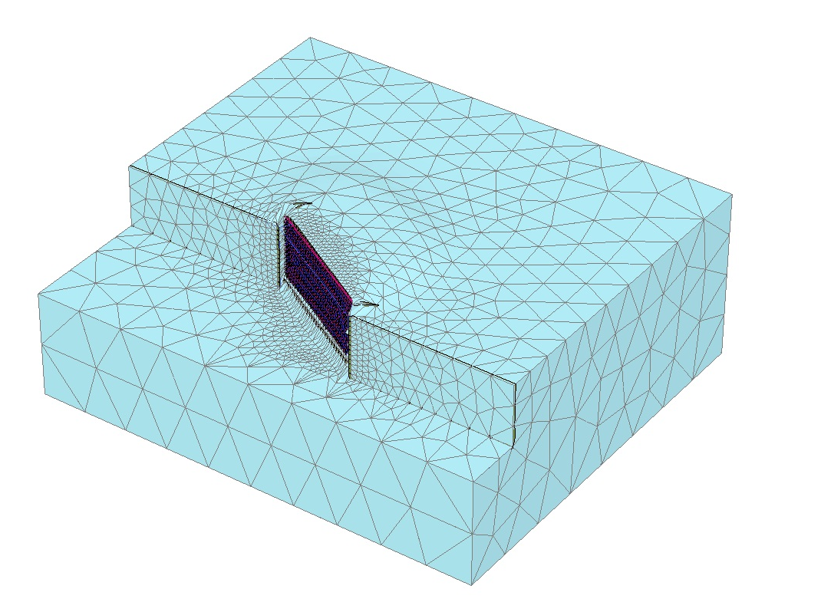
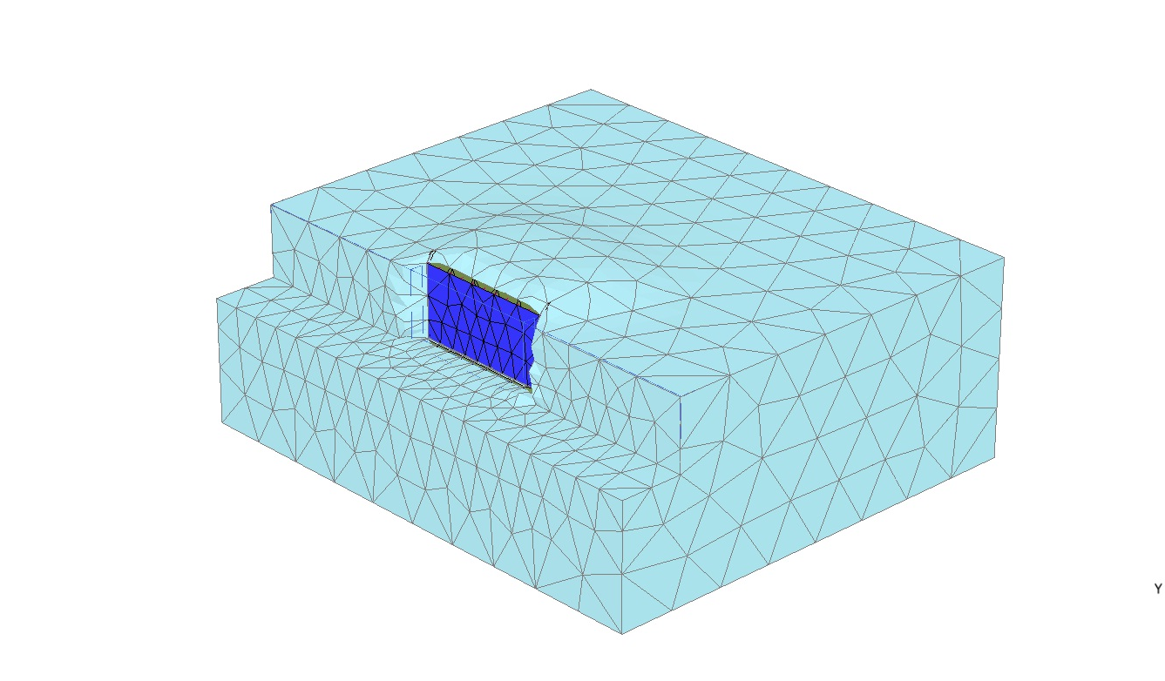

Fig. 1 Images of the FE models for the 0º and 30º skew backfill tests.

Fig. 2 Comparison of measured and computed passive force vs. displacement for the 0º skew tests

Generally agreement between measured and computed response was quite good with errors less than 10 to 15%. To improve agreement it was necessary to adjust the soil stiffness parameters upward from our initial estimates. Transverse displacements were generally quite small and limited for skew angles of 0º to 30º, however, when the skew angle reached 45º, the wall began sliding continually towards the left as the loading was applied. Because displacement was not constrained in the transverse direction this behavior is likely realistic and indicates that if the pile foundations had not been in place during the field tests, the pile cap would have slid westward when the longitudinal force was applied. Because of the sliding, the pile cap in the computer model did not develop the full passive force measured in the field load test. When the pile cap was restrained in the transverse direction to prevent lateral movement, the computed passive force increased above that measured in the field indicating that this was also an unreasonable restraint. Additional work will be necessary to better model this situation.

Fig. 3 Comparison of measured and computed passive force vs. displacement for the 30º skew tests.
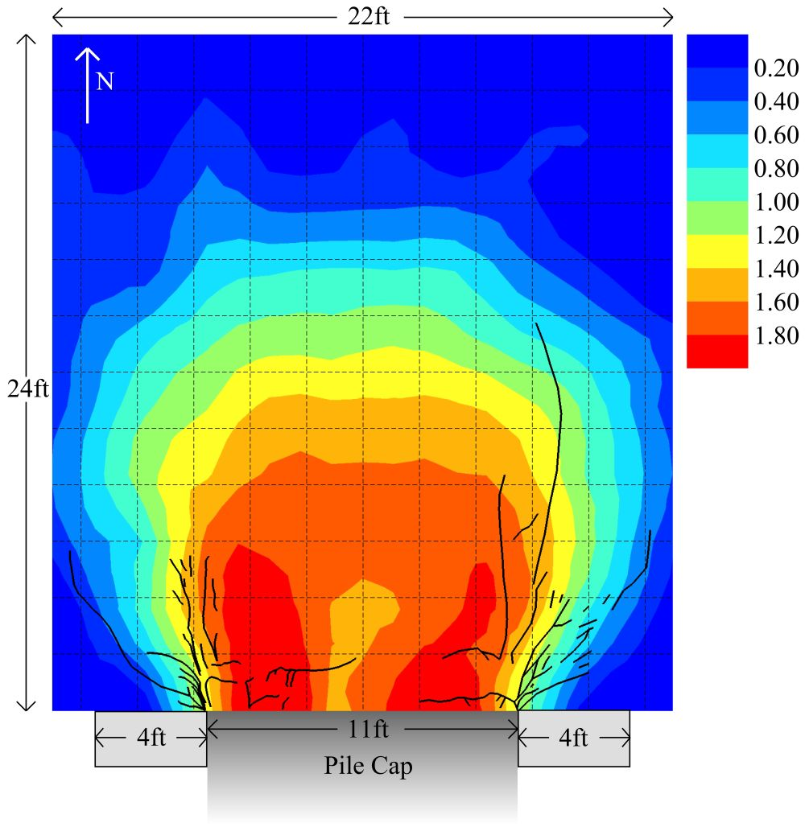
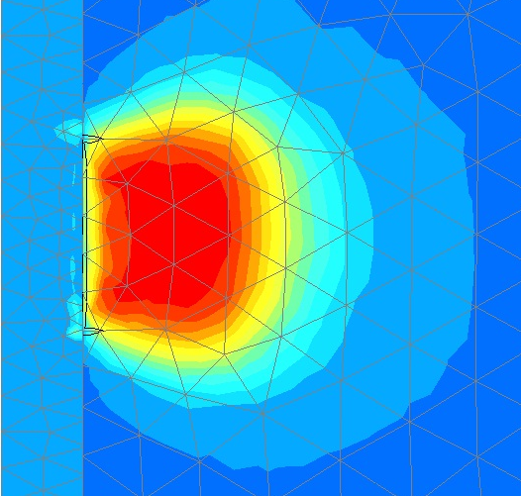

Fig. 4. Comparison of measured and computed heave patterns for the 0º skew load test.
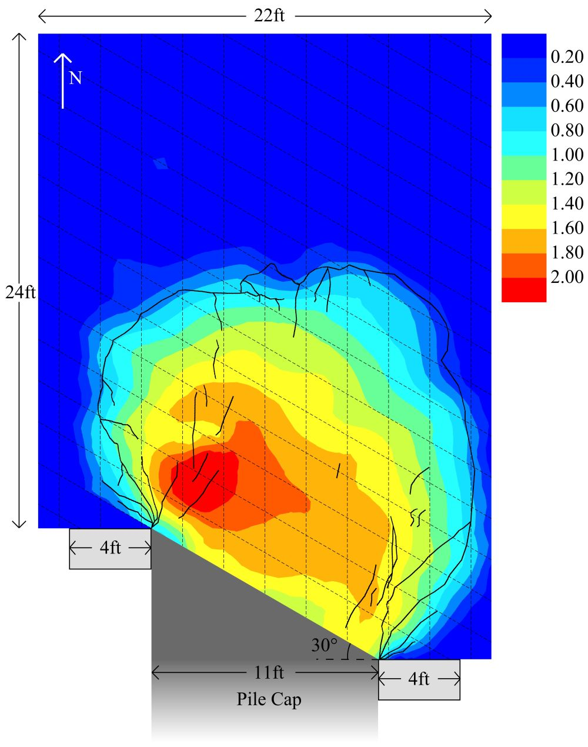

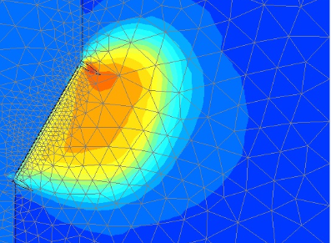

Fig. 5. Comparison of measured and computed heave patterns for the 30º skew load test.

Comparison of the measured and computed heave patterns for the 0º and 30º skew load tests from a plan view perspective are provided in Figs. 4 and 5, respectively. The pattern of agreement is very good on both cases. The heave pattern is generally very symmetric about the centerline of the pile cap for the 0º skew case, base is skewed towards the acute corner of the abutment (pile cap) for the 30º skew case. As evidenced by both the field and numerical results, the maximum heave does not occur at the face of the pile cap but occurs 2 to 4 feet back from the wall. Field measurements indicate that soil within the first 2 feet of the wall experiences significant compressive strain while the compressive strain is low behind this point. This behavior leads to heave concentrating in the zone behind the zone of high compression as observed.

Three-dimensional surfaces of equal longitudinal displacement for the 30º skew tests are presented in Fig. 6 which help illustrate the displacement patterns in the backfill soil during loading. It becomes clear that the displacement pattern varies substantially along with width of the pile cap. Fig. 7 shows three cross-sections cut normal to the abutment wall at the acute side, the middle and the obtuse side of the cap. Color contours of longitudinal displacement are superimposed over each cross-section. The cross-sections in Fig. 7 illustrate the length of the failure surface decreases substantially at the obtuse side, while the typical log spiral failure shape is evident at the acute side of the cap.

Plots of normal stress in the backfill soil behind the cap (not shown in this report) indicate that the pressure on the back face of the wall is not uniform but is lower in the middle of the cap and increases towards the edges of the cap. This behavior is consistent with expectations based on elastic theory and this same pattern was also observed from the pressure cells located across the width of the pile cap. Generally, the analyses indicate that the soil pressure on the cap increases with depth but the rate of increase decreases somewhat near the base.

In the next quarter we are planning to produce additional comparative plots and investigate the effect of friction angle on the measured reduction in passive force as a function of skew angle.

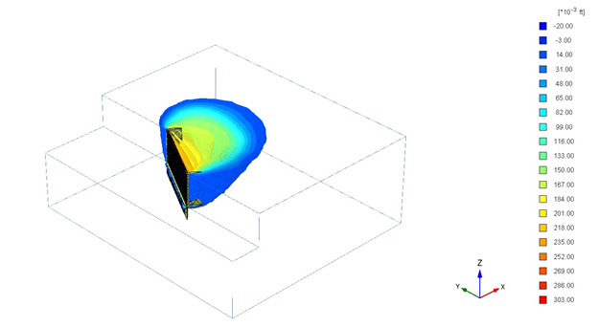
Fig. 6 Isosurfaces of constant total displacement in the longitudinal direction for the 30º skew test.

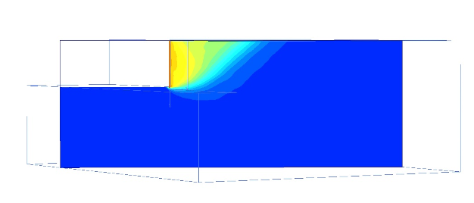

Cross-section near acute edge of abutment

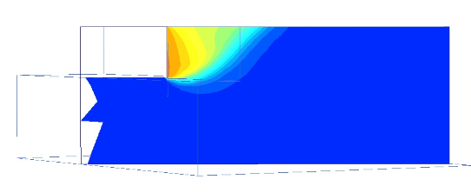

Cross-section near center of abutment

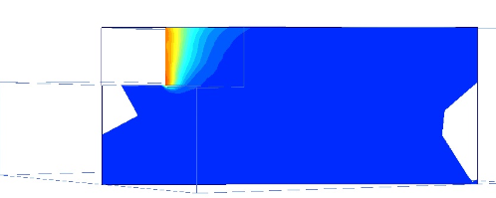

Cross-section near obtuse edge of abutment

Fig. 7 Cross-sections normal to the backwall of the abutment for the 30º skew tests showing contours of total longitudinal displacement.

Circumstance affecting project or budget. (Please describe any challenges encountered or anticipated that
might affect the completion of the project within the time, scope and fiscal constraints set forth in the
agreement, along with recommended solutions to those problems).

It is anticipated the modified scope of work can be completed within the original contract schedule.

Potential Implementation:

UDOT is considering early adoption of the skew reduction factor for passive force based on the laboratory and field test results, but no final decision has been made at this point. In June 2013 Dr. Rollins presented the results of the research to date to two technical committees at the AASHTO Subcommittee on Bridges and Structures Annual Meeting in Portland, Oregon on behalf of the project TAC. This interaction is intended by the TAC and Dr. Rollins to prepare the way for design code revisions once the research is completed. Caltrans is also promoting use of the research results in their design methods.

