TRANSPORTATION POOLED FUND PROGRAM
QUARTERLY PROGRESS REPORT

Lead Agency: Utah Department of Transportation

INSTRUCTIONS:
Project Managers and/or research project investigators should complete a quarterly progress report for each calendar quarter during which the projects are active. Please provide a project schedule status of the research activities tied to each task that is defined in the proposal; a percentage completion of each task; a concise discussion (2 or 3 sentences) of the current status, including accomplishments and problems encountered, if any. List all tasks, even if no work was done during this period.

Transportation Pooled Fund Program Project #  TPF-5(264) |  | Transportation Pooled Fund Program - Report Period:  _ Quarter 1 (January 1 – March 31, 2013)  _ Quarter 2 (April 1 – June 30, 2013)  _ Quarter 3 (July 1 – September 30, 2013)  x Quarter 4 (October 1 – December 31, 2013)
Project Title:
Passive Force-Displacement Relationships for Skewed Abutments

Name of Project Manager(s):  David Stevens | Phone Number:  801-589-8340 |  | E-Mail  davidstevens@utah.gov
Lead Agency Project ID:  5H06852H, 42051, ePM PIN 10903  UDOT PIC No. UT11.406 | Other Project ID (i.e., contract #):  UDOT Contract No. 138123 |  | Project Start Date:  August 13, 2012
Original Project End Date:  September 30, 2014 | Current Project End Date:  September 30, 2014 |  | Number of Extensions:  1 (scope, budget)

Project schedule status:

_ On schedule _ On revised schedule _ Ahead of schedule X Behind schedule

Overall Project Statistics:
Total Project Budget | Total Cost to Date for Project | Percentage of Work  Completed to Date
$255,000.00 | $110,000.00 | 50%

Quarterly Project Statistics:
Total Project Expenses  and Percentage This Quarter | Total Amount of Funds  Expended This Quarter | Total Percentage of  Time Used to Date
$0, 0% | $0 | 64%

Project Description:

At present, about 40% of the 600,000 bridges in the FHWA database are constructed at a skew angle (Silas Nichols, Personal Communication). There is considerable uncertainty about the passive force on skewed abutments where the passive force develops at an angle relative to the longitudinal axis of the bridge structure. Although current design codes (AASHTO 2011) consider that the ultimate passive force will be the same for a skewed abutment as for a non-skewed abutment, numerical analyses performed by Shamsabadi et al. (2006) indicate that the passive force will decrease substantially as the skew angle increases. Reduced passive force on skewed abutments would be particularly important for bridges subject to seismic forces or integral abutments subject to thermal expansion. Unfortunately, there have not been any physical test results for skewed abutments reported in the literature which could guide engineers in making appropriate adjustments for skewed conditions. Nevertheless, some field evidence has clearly shown poorer performance of skewed abutments during seismic events and distress to skewed abutments due to thermal expansion (Shamsabadi et al. 2006, Steinberg and Sargand 2010).

This study builds on previous pooled fund testing conducted by Rollins and his students at BYU to evaluate passive force-deflection relationships for non-skewed abutments (TPF-5(122), Dynamic Passive Pressure on Abutments and Pile Caps, Rollins et al, 2010). The test facilities can readily be modified to allow for the test program with relatively small additional costs because of the test fixtures (reaction shafts, reaction walls, and pile supported cap) which are already constructed at the site. Results from this study can be compared with previous testing to assess overall performance.

Four objectives are outlined for this new study:
- Determine static passive force-displacement curves for skewed abutments with and without wingwalls from large scale tests.
- Provide comparisons of behavior of skewed abutments with that of normal abutments.
- Evaluate the effect of wingwalls on skewed abutment response.
- Develop design procedures for calculating passive force-displacement curves for skewed abutments.

The scope of work consists of twelve specific tasks, including new tasks 7 through 12:
- Literature Review and Collection of Existing Test Data
- Perform Laboratory Passive Force-Deflection Tests on 2 ft High Wall with Skew Angles of 0º, 15º, 30º, and 45º
- Perform Field Passive Force-Deflection Tests on 5.5 ft High Wall with Skew Angles of 0º, 15º, and 30º and Transverse Wingwalls
- Perform Field Passive Force-Deflection Tests on 5.5 ft High Abutment with Skew angles of 0º, 15º, 30º and MSE Wingwalls
- Calibrate Computer Model and Conduct Parametric Studies
- Preparation of Final Report
- Perform Additional Field Passive Force-Deflection Tests on 5.5 ft High Abutment with a Skew Angle of 45º with and without MSE Wingwalls
- Perform Field Passive Force-Deflection Tests on 3.0 ft High Unconfined Backfill with Skew Angles of 0º and 30º
- Perform Field Passive Force-Deflection Tests on 5.5 ft High Pile Cap with Concrete Wingwalls and Skew Angles of 0º and 45º
- Perform Field Passive Force-Deflection Tests on 5.5 ft High Unconfined Gravel Backfill with Skew Angles of 0º and 30º
- Perform Field Passive Force-Deflection Tests on 5.5 ft High GRS Gravel Backfill with Skew Angles of 0º and 30º
- Present the Results of the Study at TRB and AASHTO Meetings

Dr. Kyle Rollins of BYU is the Principal Investigator for this research project. Individual task reports will be prepared for Tasks 1 through 5 and 7 through 11 when these are completed. Up to two in-person meetings with the multi-state technical advisory committee (TAC) are planned to be held in Salt Lake City, Utah during the project. Other TAC meetings will be tele-conference or web meetings.

Progress this Quarter (includes meetings, work plan status, contract status, significant progress, etc.):

BYU worked on reports for Tasks 7 through 11. BYU continued data reduction and analysis for Tasks 5 and 7 through 11. BYU worked on a report for Task 5.

Anticipated work next quarter:

BYU will complete reports for Tasks 7 through 11 and share these with the TAC for review. BYU will continue data reduction and analysis for Tasks 5 and 7 through 11. BYU will complete a report for Task 5 and share this with the TAC for review.

A web/video-conference TAC meeting will be held to review and discuss the additional results from the new testing and analysis.

Significant Results:

In connection with Task 10 passive force displacement curves were measured for the pile cap with a 3.5 ft thick backfill composed of gravel rather than sand. The objective of these tests was to determine how the reduction in passive force with skew might be affected by different backfill materials. The tests were based on a 3.5 ft backfill height because the resistance of the gravel was too high to allow a test at 0º skew to be completed within the 1200 kip capacity of the two hydraulic actuators. The gravel backfill was A-1-a material and had a maximum Proctor density of 141 pcf at an optimum moisture content of 6%. The backfill was compacted to approximately 96% of the Proctor maximum density. Fig. 1 shows contours of ground surface heave (inches) for the tests with 0º and 30º skews. As shown in Fig. 1, both tests were carried out with “wingwalls” that were transverse to the direction of loading and the fill was “unconfined” meaning that shear surfaces could extend beyond the width of the backwall. Heave patterns are relatively symmetric for the 0 skew case but exhibit greater heaving towards the acute side of the wall for the 30º skew case.

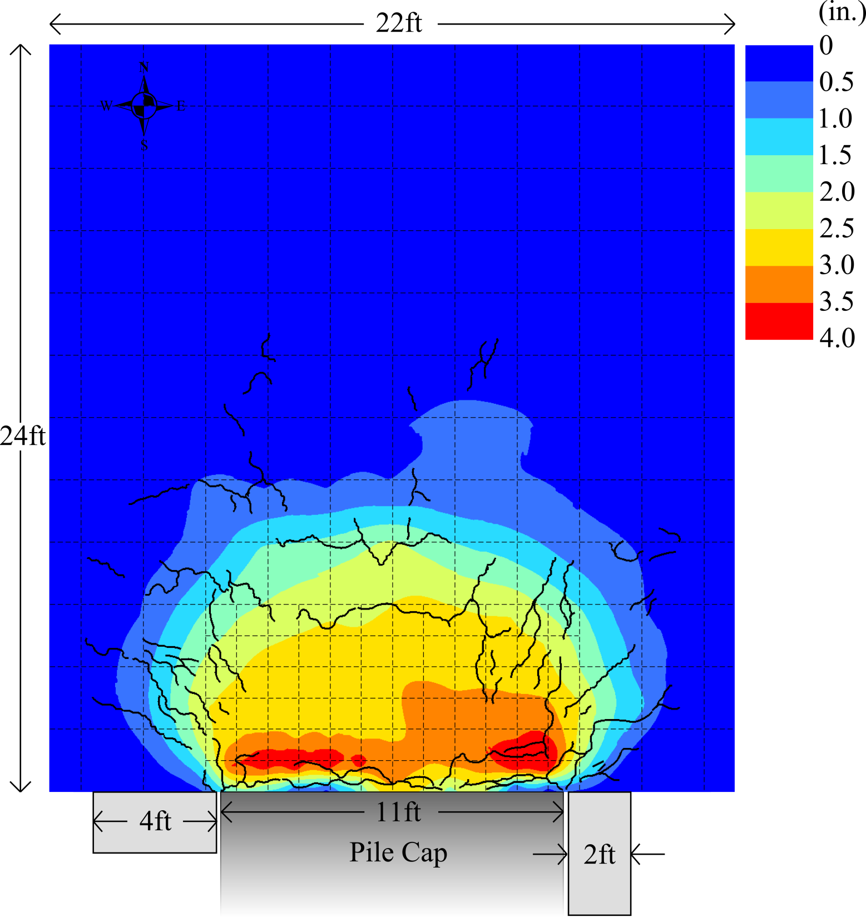
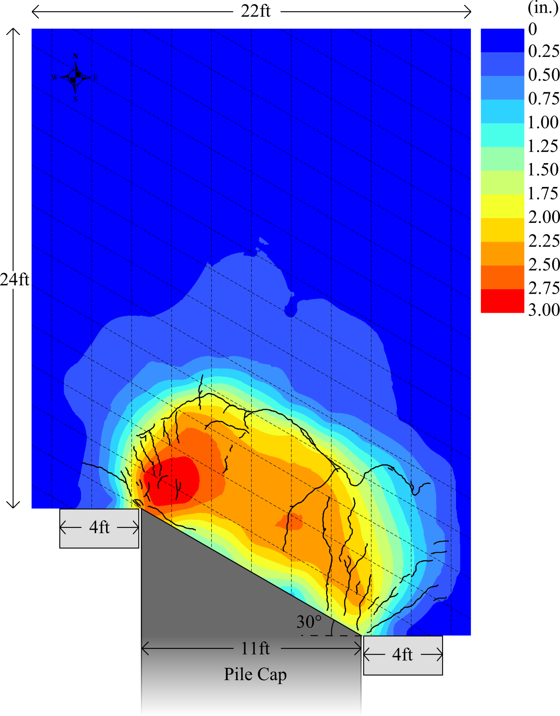

Fig. 1 Plot showing contours of surface heave (in inches) for 0 and 30 degree skew test with 3.5 ft gravel backfill.

Passive force-deflection curves for the tests on the gravel are plotted in Fig. 2. Once again there is a substantial decrease in the passive force measured for the 30º relative to the 0º case. The ultimate passive force for the 30º skew case is only 56% of that for the 0º skew case. This is a little higher than the 50% value predicted by the Rollins and Jesse relationship, but is within the range of scatter observed for all the tests.

Fig. 2. Comparison of passive force-deflection curves for 0º and 30º skew tests with 3.5 ft thick gravel backfill

For Task 11 passive force tests were also performed on a 3.5 ft thick GRS backfill with pile cap skews of 0 and 30. The geosynthetic fabric was a Mirafi RS 380i with a tensile strength of 2500 lbs/ft. The fabric was laid down in two lengths which overlapped about 3 feet at the longitudinal center of the test as shown in Fig. 3. The geosynthetic sheets were wrapped around each layer at the interface with the pile cap as shown in Fig. 3b so that the fabric created an interface between the concrete backwall and the gravel backfill. The bottom sheet of fabric was positioned about 0.5 ft below the base of the pile cap and additional sheets were placed at 1 ft vertical intervals as fill was placed. The backfill consisted of the same A-1-a gravel used for the tests in Task 10. The gravel was once again compacted in six inch layers to approximately 96% of the maximum Proctor density of 141 lbs/ft³.

Passive force-deflection curves for the tests at 0º and 30º skew angles are plotted in Fig. 4. Once again a substantial reduction in passive force is observed for the test at 30º skew relative to the 0º skew case. In this particular case the passive resistance for the 30º skew is about 60% of that for the 0º skew case which again is somewhat higher than for the predicted relationship but within acceptable scatter around the curve.

(a) (b)

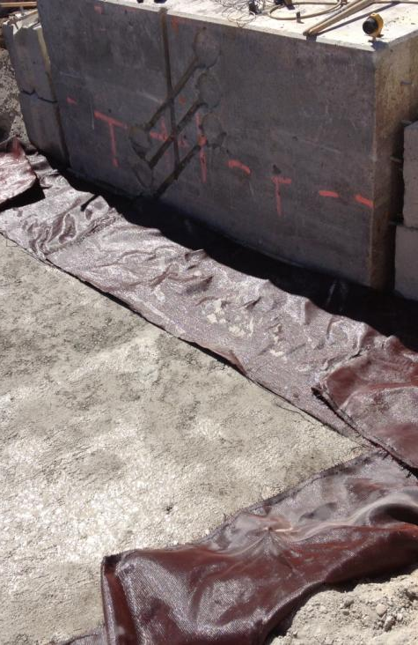
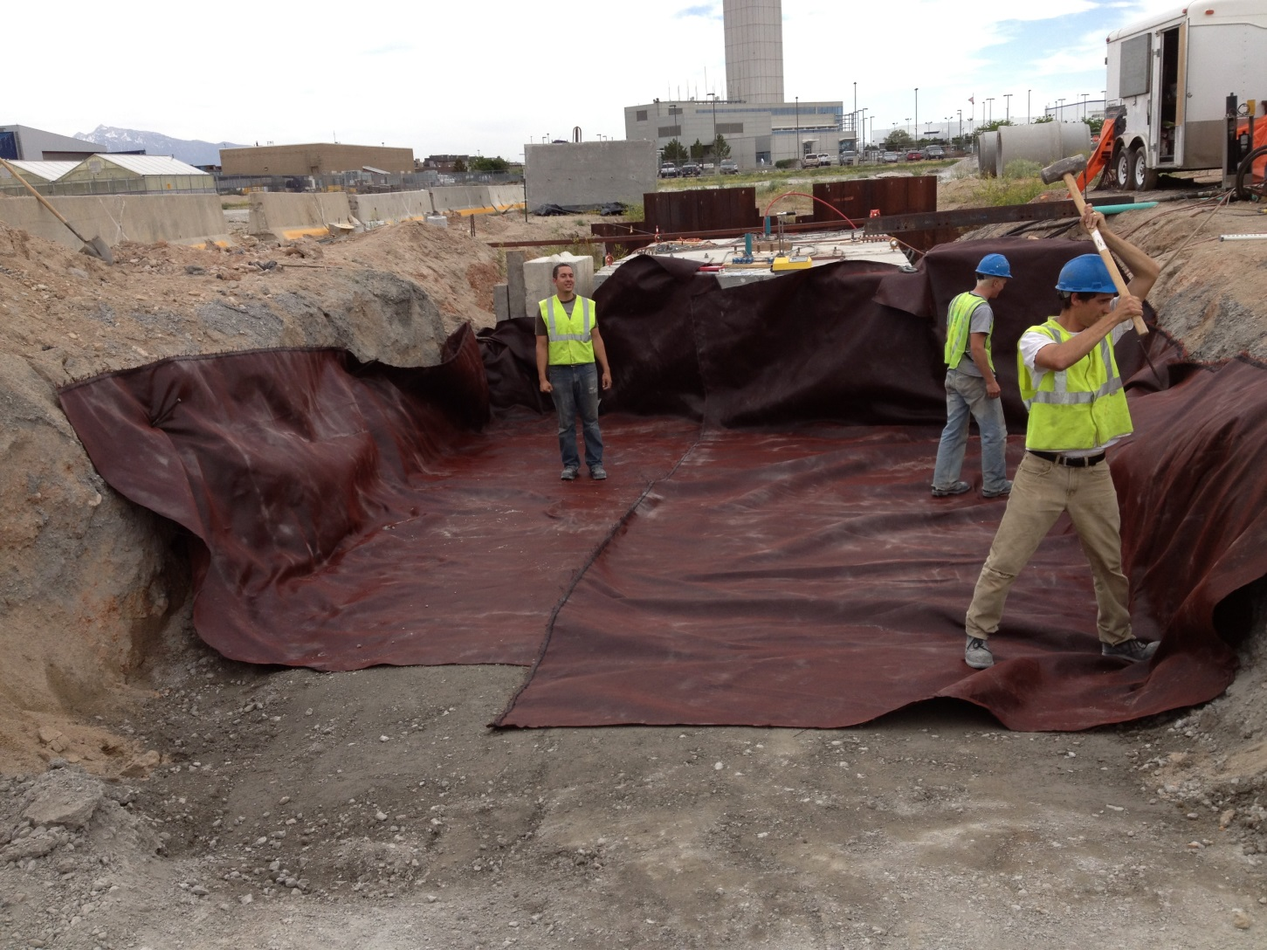
Fig. 3. Photographs showing placement of geosynthetic fabric between gravel layers in backfill at test site. (a) fabric sheets were overlapped in the longitudinal direction and (b) fabric sheets were wrapped around the backfill at wall interface.

It was expected that the addition of the geotextile fabric would increase the measured passive force because the failure surface would have to shear through the geotextile fabric as well as the gravel backfill. However, a comparison of the measured passive force for the tests involving only gravel backfill (Fig. 2) and the tests involving GRS backfill shows that there is actually a reduction in the passive force for the GRS backfill relative to the conventional gravel backfill. The reduction in passive resistance is about 20% for both tests. While the cause of the reduction is not fully understood at this point, our working hypothesis is that the reduction in interface friction on the vertical wall of the pile cap is likely responsible for the decreased passive force. The log-spiral theory indicates that the passive force is strongly correlated with the interface or wall friction between the abutment wall and the adjacent soil. The presence of the fabric at this interface likely decreased the interface friction, thereby decreasing the passive force. Nevertheless, a 20% reduction in passive force seems rather small considering the potential reduction in friction on the interface. It may be that the geosynthetic layers actually did increase the strength on the passive failure plane and partially compensated for the reduction in passive force resulting from a reduced interface friction angle. Additional interface friction angle testing would be desirable to better understand the mechanisms involved.

Fig 4. Comparison of passive force-deflection curves for 0º and 30º skew tests with 3.5 ft thick GRS backfill

A summary plot of all the measured reduction factor values back-calculated from the field tests conducted in 2012 and 2013 is provided in Fig. 5. The design curve proposed by Rollins and Jessee (2013) based on the results from the initial laboratory tests performed for this study is also shown in Fig. 5. The data points generally scatter about the original design curve although some minor modifications may be necessary. The biggest outlier is the data point at a 45 degree skew associated with the tests involving the reinforced concrete wingwalls. It seems likely that the concrete wingwalls are contributing additional longitudinal resistance as a result of increased pressure on the walls developed when the walls slide transversely into the fill. The data points for the gravel curves shown in Fig. 5 have been corrected relative to data shown in the January 2014 TAC meeting based on where some errors in selecting the appropriate baseline curves were detected. Nevertheless, the results from the gravel tests still fall somewhat above the tentative design curve. This may be a result of increased wall friction for the gravel relative to the sand backfill and may possibly account for variations in this parameter which may also be encountered in engineering practice depending on the backfill material and the density to which it is compacted.

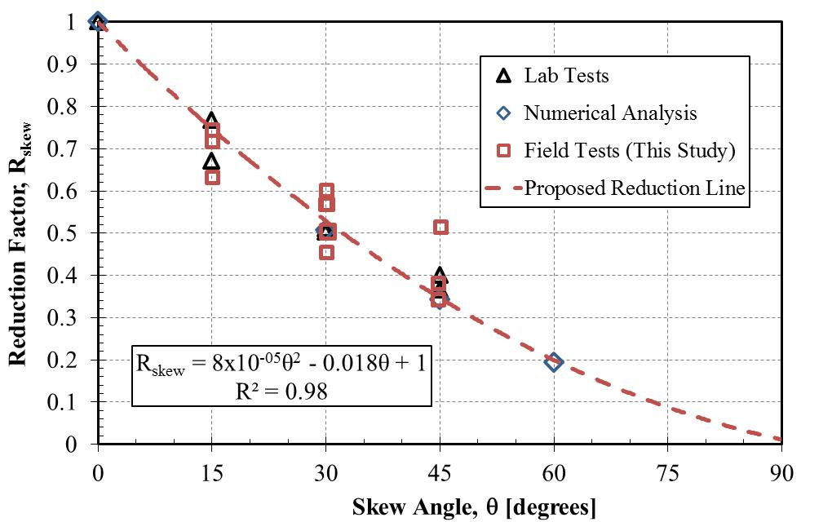

Fig. 5 Passive force reduction factor, R_{skew}, relative to field tests from this study.

Circumstance affecting project or budget. (Please describe any challenges encountered or anticipated that
might affect the completion of the project within the time, scope and fiscal constraints set forth in the
agreement, along with recommended solutions to those problems).

It is anticipated the modified scope of work can be completed within the original contract schedule.

Potential Implementation:

UDOT is considering early adoption of the skew reduction factor for passive force based on the laboratory and field test results, but no final decision has been made at this point. In June 2013 Dr. Rollins presented the results of the research to date to two technical committees at the AASHTO Subcommittee on Bridges and Structures Annual Meeting in Portland, Oregon on behalf of the project TAC. This interaction is intended by the TAC and Dr. Rollins to prepare the way for design code revisions once the research is completed. Caltrans is also promoting use of the research results in their design methods.

