TRANSPORTATION POOLED FUND PROGRAM
QUARTERLY PROGRESS REPORT

Lead Agency: Utah Department of Transportation

INSTRUCTIONS:
Project Managers and/or research project investigators should complete a quarterly progress report for each calendar quarter during which the projects are active. Please provide a project schedule status of the research activities tied to each task that is defined in the proposal; a percentage completion of each task; a concise discussion (2 or 3 sentences) of the current status, including accomplishments and problems encountered, if any. List all tasks, even if no work was done during this period.

Transportation Pooled Fund Program Project #  TPF-5(264) |  | Transportation Pooled Fund Program - Report Period:  _ Quarter 1 (January 1 – March 31, 2013)  _ Quarter 2 (April 1 – June 30, 2013)  x Quarter 3 (July 1 – September 30, 2013)  _ Quarter 4 (October 1 – December 31, 2013)
Project Title:
Passive Force-Displacement Relationships for Skewed Abutments

Name of Project Manager(s):  David Stevens | Phone Number:  801-589-8340 |  | E-Mail  davidstevens@utah.gov
Lead Agency Project ID:  5H06852H, 42051, ePM PIN 10903  UDOT PIC No. UT11.406 | Other Project ID (i.e., contract #):  UDOT Contract No. 138123 |  | Project Start Date:  August 13, 2012
Original Project End Date:  September 30, 2014 | Current Project End Date:  September 30, 2014 |  | Number of Extensions:  1 (scope, budget)

Project schedule status:

X On schedule _ On revised schedule _ Ahead of schedule _ Behind schedule

Overall Project Statistics:
Total Project Budget | Total Cost to Date for Project | Percentage of Work  Completed to Date
$255,000.00 | $110,000.00 | 50%

Quarterly Project Statistics:
Total Project Expenses  and Percentage This Quarter | Total Amount of Funds  Expended This Quarter | Total Percentage of  Time Used to Date
$0, 0% | $0 | 52%

Project Description:

At present, about 40% of the 600,000 bridges in the FHWA database are constructed at a skew angle (Silas Nichols, Personal Communication). There is considerable uncertainty about the passive force on skewed abutments where the passive force develops at an angle relative to the longitudinal axis of the bridge structure. Although current design codes (AASHTO 2011) consider that the ultimate passive force will be the same for a skewed abutment as for a non-skewed abutment, numerical analyses performed by Shamsabadi et al. (2006) indicate that the passive force will decrease substantially as the skew angle increases. Reduced passive force on skewed abutments would be particularly important for bridges subject to seismic forces or integral abutments subject to thermal expansion. Unfortunately, there have not been any physical test results for skewed abutments reported in the literature which could guide engineers in making appropriate adjustments for skewed conditions. Nevertheless, some field evidence has clearly shown poorer performance of skewed abutments during seismic events and distress to skewed abutments due to thermal expansion (Shamsabadi et al. 2006, Steinberg and Sargand 2010).

This study builds on previous pooled fund testing conducted by Rollins and his students at BYU to evaluate passive force-deflection relationships for non-skewed abutments (TPF-5(122), Dynamic Passive Pressure on Abutments and Pile Caps, Rollins et al, 2010). The test facilities can readily be modified to allow for the test program with relatively small additional costs because of the test fixtures (reaction shafts, reaction walls, and pile supported cap) which are already constructed at the site. Results from this study can be compared with previous testing to assess overall performance.

Four objectives are outlined for this new study:
- Determine static passive force-displacement curves for skewed abutments with and without wingwalls from large scale tests.
- Provide comparisons of behavior of skewed abutments with that of normal abutments.
- Evaluate the effect of wingwalls on skewed abutment response.
- Develop design procedures for calculating passive force-displacement curves for skewed abutments.

The scope of work consists of twelve specific tasks, including new tasks 7 through 12:
- Literature Review and Collection of Existing Test Data
- Perform Laboratory Passive Force-Deflection Tests on 2 ft High Wall with Skew Angles of 0º, 15º, 30º, and 45º
- Perform Field Passive Force-Deflection Tests on 5.5 ft High Wall with Skew Angles of 0º, 15º, and 30º and Transverse Wingwalls
- Perform Field Passive Force-Deflection Tests on 5.5 ft High Abutment with Skew angles of 0º, 15º, 30º and MSE Wingwalls
- Calibrate Computer Model and Conduct Parametric Studies
- Preparation of Final Report
- Perform Additional Field Passive Force-Deflection Tests on 5.5 ft High Abutment with a Skew Angle of 45º with and without MSE Wingwalls
- Perform Field Passive Force-Deflection Tests on 3.0 ft High Unconfined Backfill with Skew Angles of 0º and 30º
- Perform Field Passive Force-Deflection Tests on 5.5 ft High Pile Cap with Concrete Wingwalls and Skew Angles of 0º and 45º
- Perform Field Passive Force-Deflection Tests on 5.5 ft High Unconfined Gravel Backfill with Skew Angles of 0º and 30º
- Perform Field Passive Force-Deflection Tests on 5.5 ft High GRS Gravel Backfill with Skew Angles of 0º and 30º
- Present the Results of the Study at TRB and AASHTO Meetings

Dr. Kyle Rollins of BYU is the Principal Investigator for this research project. Individual task reports will be prepared for Tasks 1 through 5 and 7 through 11 when these are completed. Up to two in-person meetings with the multi-state technical advisory committee (TAC) are planned to be held in Salt Lake City, Utah during the project. Other TAC meetings will be tele-conference or web meetings.

Progress this Quarter (includes meetings, work plan status, contract status, significant progress, etc.):

BYU worked on abbreviated field test reports for Tasks 7 through 11. BYU continued data reduction and analysis for Tasks 5 and 7 through 11. BYU worked on a detailed draft report for Task 5.

Anticipated work next quarter:

BYU will complete abbreviated field test reports for Tasks 7 through 11 and share these with the TAC for review. BYU will continue data reduction and analysis for Tasks 5 and 7 through 11. BYU will complete a detailed draft report for Task 5 and share this with the TAC for review.

A web/video-conference TAC meeting will be held to review and discuss the additional results from the new testing and analysis.

Significant Results:

For Task 9, two abutments were tested with reinforced concrete wingwalls that extended approximately 6 ft into the backfill as shown in Fig. 1. One abutment had no skew and the other had a skew of 45 degrees. Passive force versus deflection curves for the two abutments are presented in Fig. 2. In both cases the backfill soil was 5.5 ft high and consisted of sand compacted to a relative compaction of about 96%. Once again, as for the tests with no wingwalls and with MSE wingwalls, there is a clear decrease in passive resistance for the skewed abutment relative to the non-skewed abutment. The passive force-deflection curve for the skewed abutment appears to be somewhat bi-linear in nature while the curve for the non-skewed abutment has a more hyperbolic, that has characteristically been seen for similar tests on non-skewed abutments. The passive resistance for the abutment with the 45 degree skew is about 60% of the passive resistance for the zero skew case.
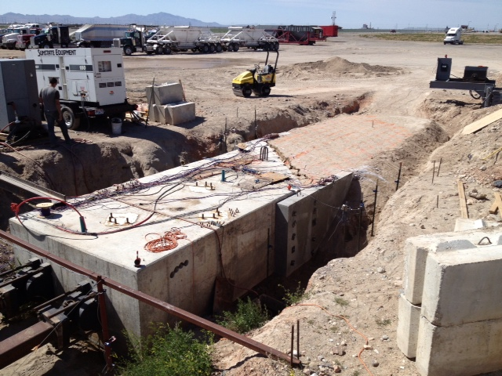
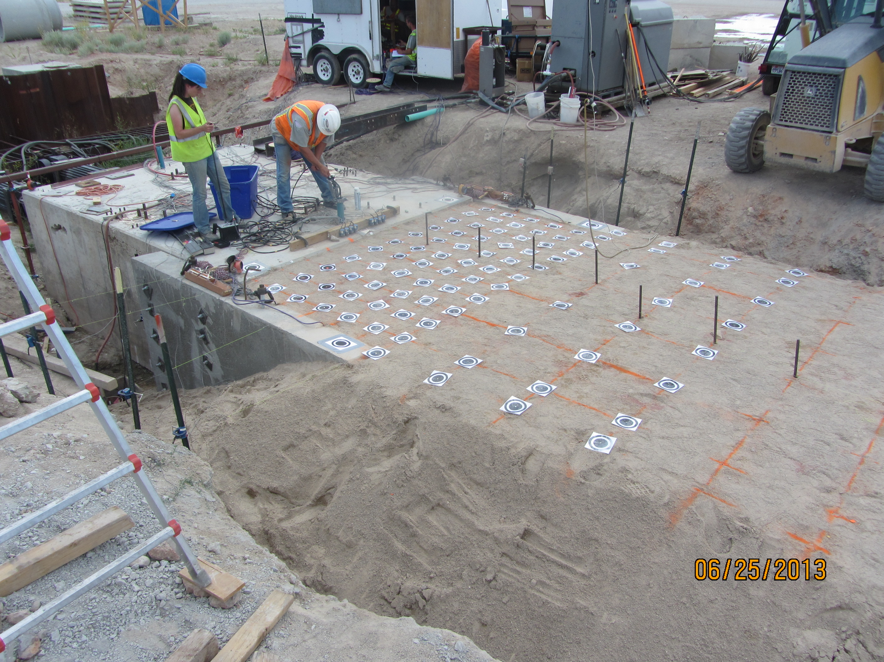
Fig. 1. Photos of abutment tests with reinforced concrete wingwalls for skew angles of 0 and 45 degrees.

The reduction factors obtained from the tests shown in Fig. 1 and Fig. 2 are plotted in Fig. 3 along with the results from the previous testing. Based on previous testing a reduction factor of 0.35 to 0.4 might be expected for a skew angle of 45 degrees. However, the measured reduction factor of 0.61 is significantly higher than would be expected for a skew angle of 45 degrees. One possible explanation for the discrepancy is likely the resistance to longitudinal movement provided by the wingwalls themselves in this geometry. For the zero skew geometry some longitudinal resistance would be expected owing to skin friction on the wingwall, primarily. This skin friction would likely remain relatively constant for the 45 degree skew case even if the passive resistance on the abutment face decreased as expected. Therefore, this effect would lead to a higher ratio of force than normal. In addition, as the 45 degree skew abutment moves longitudinally and slides horizontally, increased longitudinal resistance might be expected from the wedge of soil caught between the abutment and the wingwall. This could potentially lead to greater resistance for this case than for the zero skew condition. Both of these effects would become less significant as the width of the abutment increased so that the proportion of load carried by the wing wall decreased. However, for the current geometry of the test wall, the wingwalls appear to have a more pronounced effect. In the analysis of the test results, we plan to consider this issue more carefully and try to separate out the influence of the wingwalls on the longitudinal force.

Fig. 2. Passive force versus deflection curves for abutments with identical reinforced concrete wingwalls but skew angles of 0 and 45 degrees.

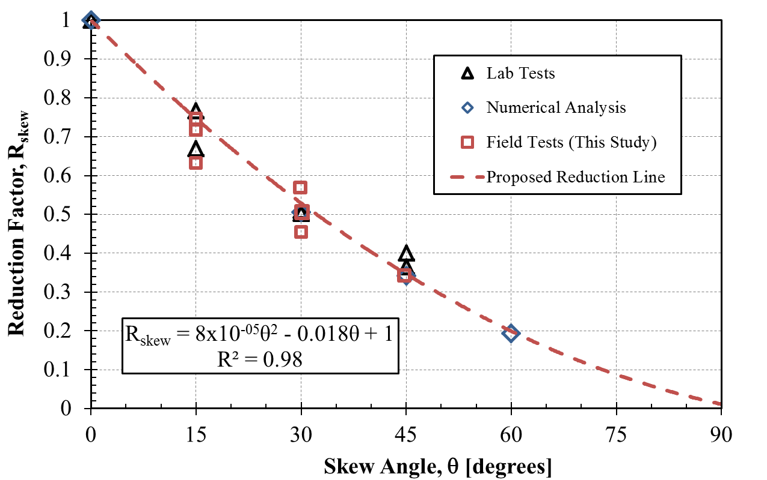
Results from RC wingwall tests

Fig. 3. Reduction in passive force relative to passive force at zero skew angle for results from lab, field and numerical analyses. Results for the reinforced concrete wingwall tests are shown with a star.

Circumstance affecting project or budget. (Please describe any challenges encountered or anticipated that
might affect the completion of the project within the time, scope and fiscal constraints set forth in the
agreement, along with recommended solutions to those problems).

It is anticipated the modified scope of work can be completed within the original contract schedule.

Potential Implementation:

UDOT is considering early adoption of the skew reduction factor for passive force based on the laboratory and field test results, but no final decision has been made at this point. In June 2013 Dr. Rollins presented the results of the research to date to two technical committees at the AASHTO Subcommittee on Bridges and Structures Annual Meeting in Portland, Oregon on behalf of the project TAC. This interaction is intended by the TAC and Dr. Rollins to prepare the way for design code revisions once the research is completed.

