TRANSPORTATION POOLED FUND PROGRAM
QUARTERLY PROGRESS REPORT

Lead Agency: Utah Department of Transportation

INSTRUCTIONS:
Project Managers and/or research project investigators should complete a quarterly progress report for each calendar quarter during which the projects are active. Please provide a project schedule status of the research activities tied to each task that is defined in the proposal; a percentage completion of each task; a concise discussion (2 or 3 sentences) of the current status, including accomplishments and problems encountered, if any. List all tasks, even if no work was done during this period.

Transportation Pooled Fund Program Project #  TPF-5(264) |  | Transportation Pooled Fund Program - Report Period:  _ Quarter 1 (January 1 – March 31, 2013)  x Quarter 2 (April 1 – June 30, 2013)  _ Quarter 3 (July 1 – September 30, 2013)  _ Quarter 4 (October 1 – December 31, 2013)
Project Title:
Passive Force-Displacement Relationships for Skewed Abutments

Name of Project Manager(s):  David Stevens | Phone Number:  801-589-8340 |  | E-Mail  davidstevens@utah.gov
Lead Agency Project ID:  5H06852H, 42051, ePM PIN 10903  UDOT PIC No. UT11.406 | Other Project ID (i.e., contract #):  UDOT Contract No. 138123 |  | Project Start Date:  August 13, 2012
Original Project End Date:  September 30, 2014 | Current Project End Date:  September 30, 2014 |  | Number of Extensions:  1 (scope, budget)

Project schedule status:

X On schedule _ On revised schedule _ Ahead of schedule _ Behind schedule

Overall Project Statistics:
Total Project Budget | Total Cost to Date for Project | Percentage of Work  Completed to Date
$255,000.00 | $110,000.00 | 50%

Quarterly Project Statistics:
Total Project Expenses  and Percentage This Quarter | Total Amount of Funds  Expended This Quarter | Total Percentage of  Time Used to Date
$40,000.00, 16% | $40,000.00 | 42%

Project Description:

At present, about 40% of the 600,000 bridges in the FHWA database are constructed at a skew angle (Silas Nichols, Personal Communication). There is considerable uncertainty about the passive force on skewed abutments where the passive force develops at an angle relative to the longitudinal axis of the bridge structure. Although current design codes (AASHTO 2011) consider that the ultimate passive force will be the same for a skewed abutment as for a non-skewed abutment, numerical analyses performed by Shamsabadi et al. (2006) indicate that the passive force will decrease substantially as the skew angle increases. Reduced passive force on skewed abutments would be particularly important for bridges subject to seismic forces or integral abutments subject to thermal expansion. Unfortunately, there have not been any physical test results for skewed abutments reported in the literature which could guide engineers in making appropriate adjustments for skewed conditions. Nevertheless, some field evidence has clearly shown poorer performance of skewed abutments during seismic events and distress to skewed abutments due to thermal expansion (Shamsabadi et al. 2006, Steinberg and Sargand 2010).

This study builds on previous pooled fund testing conducted by Rollins and his students at BYU to evaluate passive force-deflection relationships for non-skewed abutments (TPF-5(122), Dynamic Passive Pressure on Abutments and Pile Caps, Rollins et al, 2010). The test facilities can readily be modified to allow for the test program with relatively small additional costs because of the test fixtures (reaction shafts, reaction walls, and pile supported cap) which are already constructed at the site. Results from this study can be compared with previous testing to assess overall performance.

Four objectives are outlined for this new study:
- Determine static passive force-displacement curves for skewed abutments with and without wingwalls from large scale tests.
- Provide comparisons of behavior of skewed abutments with that of normal abutments.
- Evaluate the effect of wingwalls on skewed abutment response.
- Develop design procedures for calculating passive force-displacement curves for skewed abutments.

The scope of work consists of twelve specific tasks, including new tasks 7 through 12:
- Literature Review and Collection of Existing Test Data
- Perform Laboratory Passive Force-Deflection Tests on 2 ft High Wall with Skew Angles of 0º, 15º, 30º, and 45º
- Perform Field Passive Force-Deflection Tests on 5.5 ft High Wall with Skew Angles of 0º, 15º, and 30º and Transverse Wingwalls
- Perform Field Passive Force-Deflection Tests on 5.5 ft High Abutment with Skew angles of 0º, 15º, 30º and MSE Wingwalls
- Calibrate Computer Model and Conduct Parametric Studies
- Preparation of Final Report
- Perform Additional Field Passive Force-Deflection Tests on 5.5 ft High Abutment with a Skew Angle of 45º with and without MSE Wingwalls
- Perform Field Passive Force-Deflection Tests on 3.0 ft High Unconfined Backfill with Skew Angles of 0º and 30º
- Perform Field Passive Force-Deflection Tests on 5.5 ft High Pile Cap with Concrete Wingwalls and Skew Angles of 0º and 45º
- Perform Field Passive Force-Deflection Tests on 5.5 ft High Unconfined Gravel Backfill with Skew Angles of 0º and 30º
- Perform Field Passive Force-Deflection Tests on 5.5 ft High GRS Gravel Backfill with Skew Angles of 0º and 30º
- Present the Results of the Study at TRB and AASHTO Meetings

Dr. Kyle Rollins of BYU is the Principal Investigator for this research project. Individual task reports will be prepared for Tasks 1 through 5 and 7 through 11 when these are completed. Up to two in-person meetings with the multi-state technical advisory committee (TAC) are planned to be held in Salt Lake City, Utah during the project. Other TAC meetings will be tele-conference or web meetings.

Progress this Quarter (includes meetings, work plan status, contract status, significant progress, etc.):

The contract was modified based on the approved revised work plan, adding new tasks 7 through 12. Total cost of the contract on this project is now $255,000, equal to the total funding commitments from the pooled fund partners.

BYU prepared a detailed draft report for Task 4, and this was shared with the TAC for review. BYU continued data reduction and analysis for Tasks 4 and 5. BYU conducted the new field testing for Tasks 7 through 11 in May and June.

In June Dr. Rollins presented the results of the research to date to two technical committees at the 2013 AASHTO Subcommittee on Bridges and Structures Annual Meeting in Portland, Oregon on behalf of the project TAC.

Anticipated work next quarter:

BYU will prepare abbreviated field test reports for Tasks 7 through 11 and share these with the TAC for review. BYU will continue data reduction and analysis for Tasks 5 and 7 through 11. BYU will prepare a detailed draft report for Task 5 and share this with the TAC for review.

A web/video-conference TAC meeting will be held to review and discuss the additional results from the new testing and analysis.

Significant Results:

Passive force versus deflection curves for abutments with skew angles of 0, 30 and 45 degrees are shown in Figure 1. In all three cases the backfill soil was 3 ft high and consisted of sand compacted to a relative compaction of about 96%. In-situ direct shear tests indicate that this sand has a friction angle of 42 degrees and a cohesion of about 150 psf at the compaction moisture content of 8%. In contrast to the tests performed in phase 1 where the backfill width to height ratio was 2.0, in these tests the width to height ratio was 3.66. There is a clear decrease in passive resistance as the skew angle increases as was observed in previous tests performed during phase 1. The passive resistance for the 30 and 45 degree skews is 45% and 34% respectively of the passive for the zero skew case.

Fig. 1. Passive force versus deflection curves for abutments with skew angles of 0, 30 and 45 degrees with a 3 ft high backfill. Backfill width to height ratio is 3.6

The reduction factors obtained from the tests shown in Fig. 1 are plotted in Fig. 2 along with the results from the previous testing. Despite the differences in the backfill height and the width to height ratio, the reduction factors are still consistent with the results from the tests in phase 1 research. The results from the laboratory tests, field tests, and numerical analyses are all generally consistent with the proposed reduction factor curve defined from the original laboratory testing as shown in Fig. 2 with some scatter associated with the various test geometries.

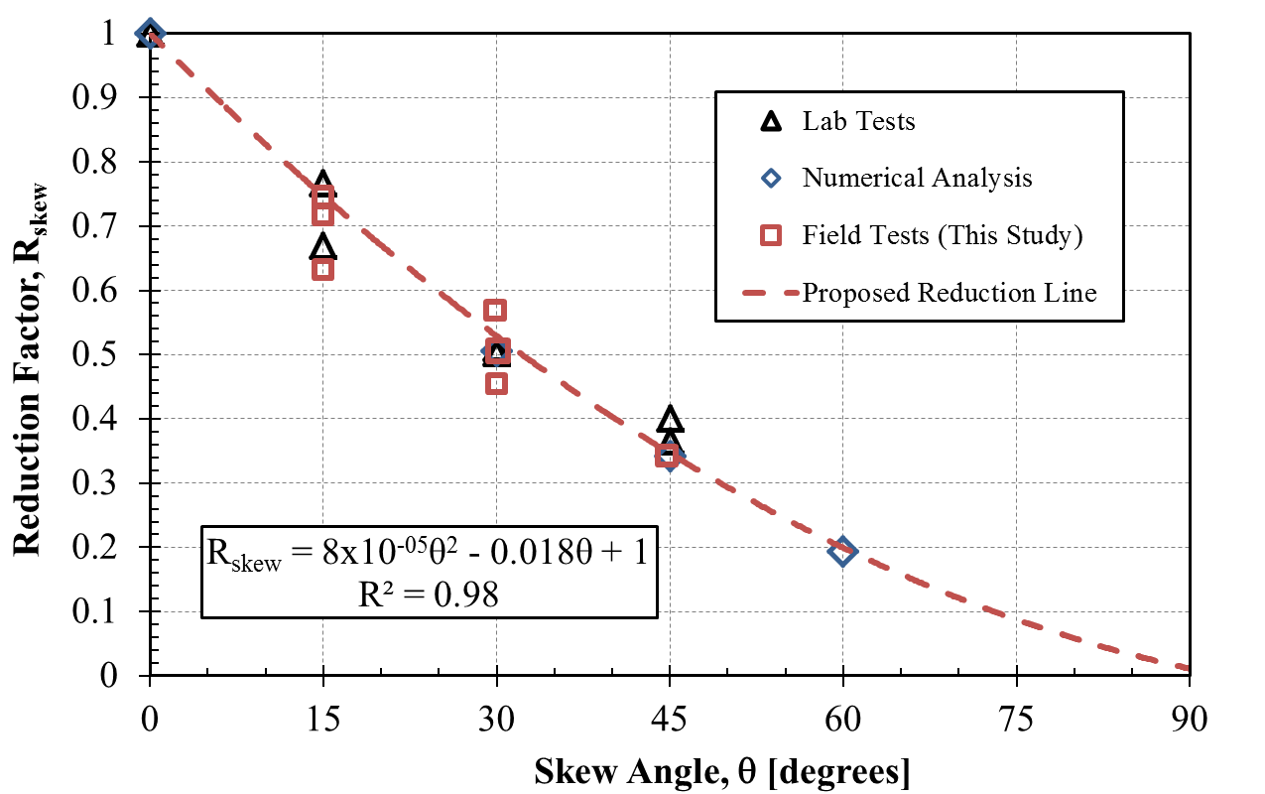

Fig. 2 Reduction in passive force relative to passive force at zero skew angle for results from lab, field and numerical analyses.

Circumstance affecting project or budget. (Please describe any challenges encountered or anticipated that
might affect the completion of the project within the time, scope and fiscal constraints set forth in the
agreement, along with recommended solutions to those problems).

It is anticipated the modified scope of work can be completed within the original contract schedule.

Potential Implementation:

UDOT is considering early adoption of the skew reduction factor for passive force based on the laboratory and field test results, but no final decision has been made at this point. In June 2013 Dr. Rollins presented the results of the research to date to two technical committees at the AASHTO Subcommittee on Bridges and Structures Annual Meeting in Portland, Oregon on behalf of the project TAC. This interaction is intended by the TAC and Dr. Rollins to prepare the way for design code revisions once the research is completed.

