Investigation of Low Temperature Cracking in Asphalt Pavements
National Pooled Fund Study – Phase II

Task 5- Modeling of Asphalt Mixtures Contraction and Expansion Due to Thermal Cycling

Hassan Tabatabaee
Raul Velasquez
Amir Arshadi
Hussain Bahia

University of Wisconsin-Madison

January 2012
table of contents
Introduction 8
Objectives 9
Background 9
Materials and Experimental Methods 10
Asphalt Binders and Mixtures 10
Test Methods 11
Glass Transition (T_{g}) Test Procedure for Asphalt Binders 11
Asphalt Thermal Cracking Analyzer (ATCA) 13
Experimental Evaluation of Thermal Response of Asphalt Binders and Mixtures During Cooling and Heating (Objective 1) 16
Thermo-Volumetric Response of Asphalt Binders and Mixtures during Thermal Cycles 16
Thermal Stress Response of Asphalt Binders and Mixtures during Thermal Cycles 21
Thermal Stress Buildup and Relaxation 23
Micromechanical Simulation of Thermo-Volumetric Properties in Asphalt Mixtures (Objective 2) 29
Background 29
Thermal Expansion/Contraction Coefficient of Composites 30
General Description of FEM Simulation 32
Importance of Aggregate Structure on Thermal Properties of the Mixture 33
Finite Element Modeling of Asphalt Mixture Binary Images 34
Models for Estimation of α_{l} and α_{g} of Asphalt Mixtures 39
Sensitivity Analysis of Thermo-Volumetric Parameters Through Modeling (Objective 3) 43
Model Input and Assumptions 43
Thermo-Volumetric Behavior and Glass Transition of Asphalt Mixtures 43
Physical Hardening in Asphalt Binders and Mixtures 44
Prediction of Thermal Stress Buildup and Relaxation 46
Sensitivity Analysis 50
Summary of Findings and Conclusions 54
Conclusions 54
Recommendations and Potential Applications for DOTs 56
References 56
List of Figures
Figure 1. Dilatometric system used to measure glass transition temperature (Tg) of asphalt binders. 12
Figure 2. Typical results from glass transition temperature (Tg) test of asphalt binders. 12
Figure 3.(a) Illustration of the Asphalt Thermal Cracking Analyzer (ATCA) system; (b) restrained beam setup, (c) unrestrained beam setup, and (d) restrained beam after failure. 13
Figure 4. (a) Typical T_{g} result for asphalt mixtures, (b) Typical result of the stress buildup. 14
Figure 5.(a) Cutting of SGC sample for thermal cycling testing of mixtures in ATCA. (b) Sample gluing setup. 15
Figure 6. ATCA results and calculated relaxation modulus curve. 15
Figure 7. Glass transition temperature of binders and mixtures. 17
Figure 8. Change in glass transition temperature of base binder FH PG 64-22 with volume fraction (φ) for different fillers (LS2-limestone, DS2-dolomite, GS2-granite) (24). 18
Figure 9. Change in glass transition temperature with volume fraction, PG 64-22 mixed with granite filler at φ=0, 10, 40% (24). 18
Figure 10. Stress buildup vs. temperature for full thermal cycle (a) Experimental, and (b) Modeled. 19
Figure 11. Thermal strain in MnROAD Cell 20 in the cooling cycles. 19
Figure 12. Thermal strain for MnROAD Cell 20 sample during one cooling and heating cycle. 20
Figure 13.Thermal strain in asphalt mixture beam (WI) in 3 consecutive cycles. 20
Figure 14. Stress buildup curves under thermal cycling for MnROAD Cell 20. 21
Figure 15. Stress buildup curves under thermal cycling and isothermal conditioning for MnROAD Cell 33. 22
Figure 16. Stress buildup in restrained MnROAD Cell 33 beam using the ATCA, with and without the isothermal conditioning step. 23
Figure 17. Thermal stress in asphalt mixtures after 5 and 10 hrs of isothermal conditioning. 24
Figure 18. Comparison of thermal stress and strain during cooling and isothermal conditions at 0.1 and 1°C/min cooling rates. 25
Figure 19. ATCA restrained beam fracture during isothermal conditions (MN County Road 112-Valero). 27
Figure 20. ATCA restrained beam fracture under isothermal conditions (MN County Road 112-CITGO). 27
Figure 21. Comparison of physical hardening susceptibility of two asphalt binders of identical Superpave performance grades. The field section using mixture of source “A” cracked two times more than mixture of source “B”. 28
Figure 22. Composite under temperature shrinkage in x-direction (Case 1) 30
Figure 23. Composite under temperature shrinkage in x-direction (Case 2) 30
Figure 24. 2D asphalt mixture model showing the boundary conditions. 32
Figure 25. (a) Random structure (b) First structure (c) Second structure. 33
Figure 26. CTE versus temperature. 34
Figure 27. Gradation of mixtures for FEM. 35
Figure 28. Binary representation of asphalt mixtures (a) lowest number of contact zones (b) highest number of contact zones. 36
Figure 29. CTE of three different mastics. 37
Figure 30. Stiffness of three different mastics 37
Figure 31. CTE vs. number of contact zones/points for mixtures with Mastic 1. 38
Figure 32. CTE vs. number of contact zones/points for mixtures with Mastic 2. 38
Figure 33. CTE vs. number of contact zones/points for mixtures with Mastic 3. 39
Figure 34. α_{l} from FEM vs. prediction using proposed model. 41
Figure 35. α_{g} from FEM vs. prediction using proposed model. 41
Figure 36. Comparison of α_{l} from FE simulations and using proposed model. 42
Figure 37. Comparison of α_{g} from FE simulations and using proposed model. 42
Figure 38. 3-D representation of the physical hardening model for a glass transition temperature of -20°C. 45
Figure 39. (a) Isothermal strain rate in asphalt mixture beam plotted against conditioning time, and (b) strain in the same asphalt mixture beam plotted against speciment temperature. 46
Figure 40. Concept of incremental stress buildup and relaxation in viscoelastic material. 47
Figure 41. Thermal stress calculation with and without using time-dependent strain and accounting for physical hardening (PH) as a function of time (a), and temperature (b). 48
Figure 42. Calculated and measured thermal stress buildup plotted against time and temperature at cooling rates of 0.1°C/min (a, b) and 1°C/min (c, d). 49
Figure 43. Sensitivity analysis of calculated mixture stress buildup with and without accounting for physical hardening, by changing (a) T_{g}, (b) R, (c) α_{l}, and (d) α_{g}. 51
Figure 44. Variation of thermal stress at -20°C, by changing thermal parameters by ±20% (X± shown in the chart indicates that parameter X has been changed by ±20%) 52
Figure 45. Comparison of effect of different assumptions for CTE on (a) thermal stress curves, and (b) stress at -30°C normalized to stress at when both α_{l} and α_{g} are considered. 53
Figure 46. Sensitivity analysis of calculated mixture stress reduction during heating with and without accounting for physical hardening, by changing (a) T_{g}, (b) R, (c) α_{l}, and (d) α_{g}. 54

List of Tables
Table 1. Asphalt binders selected for Task 2. 11
Table 2. Asphalt binder and mixture thermal strain model parameters during cooling 16
Table 3. Asphalt binder and mixture thermal strain model parameters during Heating 16
Table 4. Microstructural analysis of mixtures 35
Table 5. Analysis matrix used for the sensitivity analysis 50
Table 6. Parameter values used for the sensitivity analysis 50
Introduction

This report summarizes a comprehensive experimental and modeling investigation on the contraction and expansion of asphalt mixtures due to thermal cycles. As part of this study, a model was developed for thermal stress analysis during cooling/heating cycles using different cooling rates and isothermal conditioning periods. The model accounts for the asphalt mixture glass transition and physical hardening, and it can be used to investigate which thermo-volumetric parameters (e.g, coefficients of thermal expansion/contraction, glass transition temperature, etc) significantly affect the asphalt mixture response during cooling and heating cycles. The thermal stress model uses relaxation modulus master curves, the William-Landal-Ferry equation, Boltzmann superposition principle, and a sub-model describing the isothermal contraction of asphalt materials as a continuous function of conditioning time and temperature. Using the model predictions it is shown that thermal stress relaxation and stress build-up induced by physical hardening can continuously affect thermal stress throughout the cooling process. Cooling rate also affected the amount of delayed stress buildup occurring after the temperature has stabilized at isothermal condition due to physical hardening.
The thermal stress model was validated with experimental thermal cyclic results using the recently introduced Asphalt Thermal Cracking Analyzer (ATCA). Mixture testing performed in the ATCA at different cooling rates and isothermal conditions supported the theoretical predictions. The findings show clearly that the effect of physical hardening on stress build-up in mixtures is measurable and important.
A semi-empirical micromechanical model for the estimation of mixture coefficient of thermal contraction/expansion above and below the glass transition temperature (T_{g}) based on the commonly used Hirsch model and Finite Element Modeling (FEM) is also introduced in this report. Almost all the published models, including those used in the Mechanistic Empirical Pavement Design Guide (MEPDG), consider a single value for the coefficient of thermal expansion/contraction. Many models use a default coefficient value or a formula that was introduced in the 1960s derived empirically based on testing a relatively small set of mixtures. The only justification for this over-simplification is the difficulty of measuring the coefficient of contraction and expansion and the lack of sufficient knowledge about effects of various mixture variables on these coefficients. Results in this study show the importance of the proper estimation of the thermo-volumetric properties of asphalt mixtures in the prediction of thermal cracking of pavements and proposes a method for estimating the coefficient based on the thermo-volumetric properties of the asphalt binder and the internal structure of the mixture.
Finally, as part of the Task 5 objectives, the aforementioned thermal cycling model for representing the contraction/expansion of mixtures was used to study the statistical importance of the material thermo-volumetric properties on the thermal stress response of the mixture.
Objectives

According to the project work plan the main objectives to be addressed in Task 5 are:

- Expand the database for thermo-volumetric properties of asphalt binders and mixtures to a wider range of modified asphalts and types of mixtures to fully quantify the effects of binders and aggregates in the asymmetrical thermo-volumetric behavior (i.e., glass transitions and contraction/expansion coefficients).

- Develop a micromechanical numerical model that can be used to estimate the glass transition temperatures and coefficients from mixture variables commonly measured for binder grading and for mixture design.

- Conduct thermal cracking sensitivity analysis to determine which of the glass transition parameters are statistically important for cracking, which ones need to be measured, and the effect of using estimated values rather than measured values.

In this report these objectives are investigated and results discussed in the stated order.
Background

Low temperature cracking is a major distress in many regions with cold climates. It is believed that the excessive brittleness due to the increase in stiffness and decrease in the ability to relax stress leads to the buildup of thermally induced stress and ultimately cracking of mixtures in pavements.
Visco-elastic materials such as asphalt mixtures can relax stress by viscous flow. Asphalt pavements are restrained from significant movement, thus thermally induced contraction can lead to significant stress buildup in the pavement. Due to the time dependent behavior of visco-elastic materials, the higher the capability of the material to relax stress, the lower the thermal stress buildup will be at a given temperature, and consequently the pavement can withstand lower temperatures before fracture (1, 2). Thus, stress relaxation has been considered an important factor in the thermal cracking resistance of asphalt pavements (3). Researchers also consider factors such as the rate of cooling, coefficients of expansion/contraction, glass transition temperature, shape of master curve at low temperatures and the tensile strength to affect the critical cracking temperature (2). Measuring all these factors in a controlled laboratory environment has been exceedingly difficult; therefore theoretical calculations of thermal stress have often utilized simplifying assumptions in place of many of the aforementioned factors. Furthermore, current methods have not consider thermal cycling in the analysis as it is assumed that thermal cracking occurs in a single cold temperature event.
Monismith et al. (4) developed a theoretical calculation method for the thermally induced stress in asphalt pavements. This method is currently used for the estimation of critical cracking temperature by researchers and designers in many procedures. However, this method does not take into account the glass transition behavior and physical hardening observed in asphalt binders, instead utilizing a constant coefficient of thermal expansion/contraction (CTE).
The change in behavior near or below the glass transition temperature and physical hardening in asphalt materials has been noted by many researchers in recent years (5-16); the increase in brittleness as well as the time dependent behavior of the material in this temperature range can have a detrimental effect on actual performance. Bouldin et al. (2) reported that the midpoint of the binder’s glass transition, typically referred to as the “glass transition temperature”, is in the vicinity of the pavement critical cracking temperature. Kriz et al. (10) showed that physical hardening can affect the position of the glass transition temperature in asphalt binders. Furthermore, change in relaxation properties has been noted in asphalt and many polymers during physical hardening (9, 10, and 12).
Researchers have noted the effect of isothermal conditioning, typically referred to as “physical hardening” or “physical aging”, in amorphous material for many years. Struik described physical hardening in polymers as a type of thermo-reversible relaxation process, taking place in the glass transition region of amorphous materials (12). The first comprehensive study on physical hardening in asphalt binders was reported during SHRP (5, 6). Physical hardening is usually explained by the free volume theory proposed by Struik (12) and Ferry (13). However, some researchers have also associated physical hardening with the crystalline domain and wax fraction of the asphalt binder (7, 8, and 10).
Researchers such as Shenoy (17) have claimed that stress relaxation in the binder can cancel out any effect of physical hardening in mixtures, thus believing the phenomenon to be of no practical importance. Recent studies by others such as Falchetto et al. (18), Falchetto and Marasteanu (19) and Evans and Hesp (16) have concluded otherwise. Falchetto and his co-workers measured the increase in stiffness in both binder and mixture BBR beams, showing that the semi-empirical Hirsch model can be used to predict the hardening of the mixture beams based on the binder beam hardening (18, 19). Evan and Hesp (16) showed that binders that had higher BBR grade loss after 72 hrs of conditioning retained more residual stress after relaxation.
Materials and Experimental Methods
Asphalt Binders and Mixtures
For this task, the seven binders and the corresponding loose mixes described in Task 2 and shown in Table 1 were tested using the binder and mixture glass transition temperature tests. All binders were subjected to short-term aging using the Rolling Thin Film Oven (RTFO) in an attempt to match the short term aging of the asphalt loose mixture.

Table 1. Asphalt binders selected for Task 2.

Binder | Location | Description
PG 58-34 PPA | MnROAD 33 | Modified with Poly-phosphoric Acid (PPA)
PG 58-34 SBS+Acid | MnROAD 34 | Modified with Styrene-Butadiene Styrene (SBS) +PPA
PG 58-34 SBS | MnROAD35 | Modified with SBS
PG 58-34 Elvaloy +Acid | MnROAD 77 | Modified with PPA + Elvaloy
PG 58-28 | MnROAD 20 | Neat
PG 58-34 | MnROAD 22 | Unknown Modification
Wisconsin | Wisconsin | Binder used in construction of SMA pavement
PG 64-22 – New York | New York | Typical binder used in New York

Asphalt mixtures prepared with the asphalt binders presented in Table 1 as well as samples used as part of the NCHRP 9-10 project (21) were tested in the Asphalt Thermal Cracking Analyzer (ATCA) to obtained thermal stress as a function of core temperature and testing time for different thermal loading history. Mixture testing in ATCA included single cooling events, extended isothermal conditioning, and thermal cycling.
Test Methods
Glass Transition (T_{g}) Test Procedure for Asphalt Binders

A dilatometric system was used to measure the glass transition temperature and the coefficients of thermal contraction/expansion of the asphalt binders. Currently, no formal standard for this device is available and therefore the test was performed following the procedure developed by Bahia and Anderson (22) and later modified by Nam and Bahia (23). The concept behind the procedure is based on precise measurements of volume change in time for an asphalt binder specimen, as temperature is decreased at a constant rate. The binder sample is prepared by pouring 10 g of hot asphalt into a circular silicone rubber mold with a diameter of 40 mm and a height of 8.0 mm.
The dilatometric cell is connected to a vertical capillary tube with φ = 1 mm and its top end open. The volume changes in the sample are calculated by estimating the change in the height of the ethyl alcohol column inside the capillary tube. The system uses a very precise pressure transducer (Figure 1) to measure the changes in ethyl alcohol column height.
Calculation of the glass transition temperature (T_{g}) is based on a non-linear model proposed originally by Bahia (22) and later used by Nam and Bahia (23). Figures 1 and 2 show the dilatometric system and typical results for T_{g} measurements, respectively.

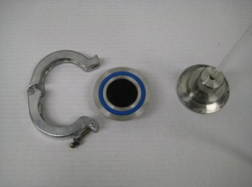 | 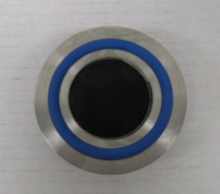
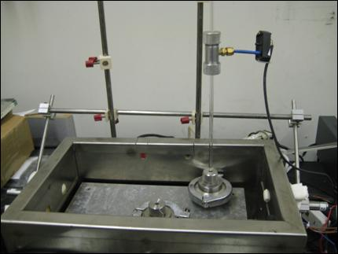

Figure 1. Dilatometric system used to measure glass transition temperature (Tg) of asphalt binders.

Figure 2. Typical results from glass transition temperature (Tg) test of asphalt binders.

Asphalt Thermal Cracking Analyzer (ATCA)

In an effort to address issues in existing thermal cracking testing setups, a device was developed that simultaneously tests two asphalt mixture beams; one unrestrained, and the other with restrained ends. The unrestrained beam is used to measure the change in volumetric properties with temperature, and consequently the glass transition temperature (T_{g}) and coefficients of expansion/contraction above (α_{l}) and below (α_{g}) glass transition temperature. The restrained beam is used to capture the induced thermal stress buildup due to prevented contraction. This device is currently being referred to as the Asphalt Thermal Cracking Analyzer (ATCA).
In this device both tested beams are obtained from the same asphalt mixture gyratory compacted sample or core, and both are exposed to the same temperature regime. The system is schematically shown in Figure 3.
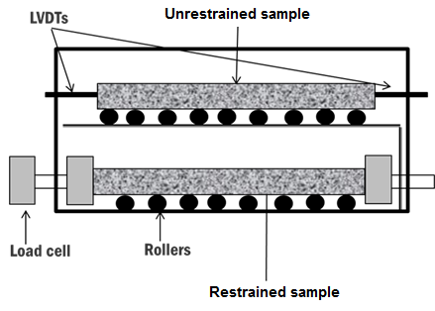
(a)
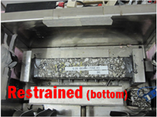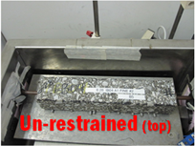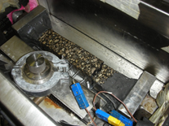
(b) (c) (d)
Figure 3.(a) Illustration of the Asphalt Thermal Cracking Analyzer (ATCA) system; (b) restrained beam setup, (c) unrestrained beam setup, and (d) restrained beam after failure.

Figure 4 shows typical output results obtained from the ATCA system when temperature is decreased at the rate of 1°C/min from 30 to -70°C.
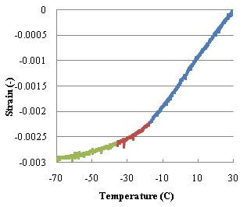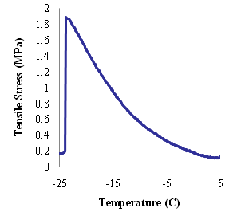
(a) (b)
Figure 4. (a) Typical T_{g} result for asphalt mixtures, (b) Typical result of the stress buildup.

The unrestrained and restrained samples are produced from one Superpave gyratory compacted sample using a masonry saw. Four prismatic beams of 5 by 5-cm in cross section and 15 cm long are cut from 17 cm gyratory samples. Two of these beams are sawed in half to produce four 7.5 cm blocks. By gluing a 7.5 cm block to each end of the two 15 cm blocks, two 30 cm beams are produced (Figure 5). As both beams are produced from the same sample and both are exposed to the same thermal history, the stress buildup, glass transition temperature, α_{l} and α_{g} can be used to get a comprehensive picture of the low temperature performance of the asphalt mixture.
Due to the temperature control flexibility possible with the ATCA system, many complex experiments, such as thermal cycling with isothermal steps and measurement of thermal stress relaxation are possible. Using the ATCA, a thermal stress relaxation experiment was designed in which the chamber temperature was reduced to a predefined low temperature at a controlled cooling rate (e.g., 0.1 to 1 °C/min), continuously monitored using temperature probes within the chamber and the core of the asphalt beams. The temperature was then kept at the predefined temperature for prolonged periods, between 1 to 10 hours, and the stress buildup in the restrained specimen, as well as thermal strain in the unrestrained sample were measured continuously. The results were used to plot curves of thermal stress as a function of core temperature and testing time, both during cooling and heating and during the extended isothermal conditioning.
Results from the ATCA can also be used to calculate relevant low temperature material properties, most notably, the relaxation modulus. The relaxation modulus convolution integral can be solved numerically by directly measuring both thermal stress (i.e., restrained beam) and strain (i.e., unrestrained beam) as function of time and temperature. An example of ATCA results and the calculated relaxation modulus curve are shown in Figure 6.
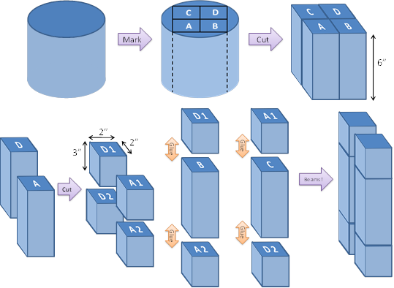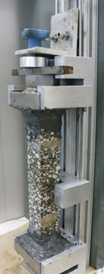
(a) (b)
Figure 5.(a) Cutting of SGC sample for thermal cycling testing of mixtures in ATCA. (b) Sample gluing setup.

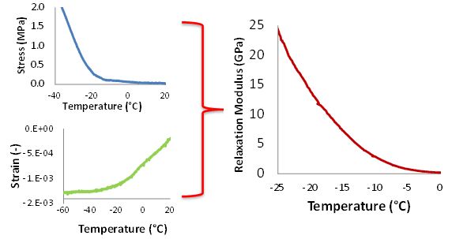
Figure 6. ATCA results and calculated relaxation modulus curve.

Experimental Evaluation of Thermal Response of Asphalt Binders and Mixtures During Cooling and Heating (Objective 1)

Thermo-Volumetric Response of Asphalt Binders and Mixtures during Thermal Cycles
The main objective of Task 5 was to expand the database of thermo-volumetric properties of asphalt binders and mixtures in both cooling and heating. Toward achieving this objective, the research team performed glass transition temperature tests in cooling and heating on the binders listed in Table 1 and their corresponding mixtures, as well as the binders and mixtures used in the validation sections of Task 6 (i.e., MN County Road 112). The results were fitted using the non-linear model proposed by Bahia and Anderson (22) and the resulting parameters are reported in Tables 2 and 3.

Table 2. Asphalt binder and mixture thermal strain model parameters during cooling
 | Binder |  |  |  |  | Mixture
Cell | C_{v} (-) | Tg (°C) | R (-) | α_{l} (1/°C) | α_{g} (1/°C) | C_{v} (-) | Tg (°C) | R (-) | α_{l} (1/°C) | α_{g} (1/°C)
20 | 0.003 | -17.4 | 6.9 | 7.9E-04 | 1.8E-04 | -0.002 | -20.5 | 4.9 | 5.0E-05 | 1.4E-05
22 | -0.023 | -20.2 | 2.7 | 7.7E-04 | 3.3E-04 | -0.003 | -28.7 | 2.6 | 4.9E-05 | 9.4E-06
33 | -0.032 | -18.4 | 3.1 | 6.9E-04 | 3.4E-04 | -0.002 | -26.8 | 6.0 | 5.1E-05 | 6.9E-06
34 | 0.007 | -20.7 | 13.1 | 9.6E-04 | 4.9E-04 | -0.002 | -22.2 | 6.2 | 5.1E-05 | 1.3E-05
35 | -0.030 | -17.8 | 4.5 | 6.9E-04 | 2.6E-04 | -0.003 | -25.6 | 3.5 | 5.0E-05 | 1.4E-05
77 | -0.030 | -21.9 | 6.6 | 7.6E-04 | 5.7E-05 | -0.003 | -19.5 | 6.9 | 5.4E-05 | 1.5E-05
WI | -0.033 | -19.1 | 2.8 | 7.1E-04 | 3.8E-04 | -0.002 | -21.1 | 4.7 | 4.8E-05 | 1.4E-05
NY | -0.031 | -18.3 | 4.7 | 6.8E-04 | 2.7E-04 | N/A | N/A | N/A | N/A | N/A
MTN CR112 | -0.017 | -17.6 | 5.3 | 6.3E-04 | 2.3E-04 | N/A | N/A | N/A | N/A | N/A
VAL CR112 | -0.036 | -22.9 | 6.8 | 8.4E-04 | 2.0E-05 | -0.002 | -22.3 | 7.0 | 4.3E-05 | 6.9E-06
CAN CR112 | -0.013 | -17.4 | 3.0 | 7.0E-04 | 2.9E-04 | N/A | N/A | N/A | N/A | N/A
CIT CR112 | -0.025 | -16.5 | 5.8 | 7.3E-04 | 6.8E-05 | -0.002 | -19.3 | 4.0 | 4.3E-05 | 1.3E-05

Table 3. Asphalt binder and mixture thermal strain model parameters during Heating
 | Binder |  |  |  |  | Mixture
Cell | C_{v} (-) | Tg (°C) | R (-) | α_{l} (1/°C) | α_{g} (1/°C) | C_{v} (-) | Tg (°C) | R (-) | α_{l} (1/°C) | α_{g} (1/°C)
20 | 0.003 | -17.4 | 6.9 | 7.9E-04 | 1.8E-04 | N/A | -21.2 | N/A | 4.5E-05 | 6.5E-07
22 | 0.004 | -20.4 | 5.4 | 8.6E-04 | 2.7E-04 | N/A | -19.5 | N/A | 4.9E-05 | 5.4E-06
33 | 0.006 | -24.1 | 6.3 | 8.9E-04 | 2.9E-04 | N/A | -13.5 | N/A | 5.0E-05 | 1.1E-05
34 | 0.007 | -14.6 | 1.0 | 7.4E-04 | 4.1E-04 | N/A | -16.2 | N/A | 5.0E-05 | 9.3E-06
35 | 0.005 | -21.3 | 6.0 | 8.0E-04 | 2.2E-04 | N/A | -13.3 | N/A | 5.4E-05 | 8.6E-06
77 | 0.007 | -17.2 | 5.8 | 8.3E-04 | 3.2E-04 | N/A | -11.5 | N/A | 5.1E-05 | 1.5E-05
WI | 0.008 | -18.9 | 3.5 | 8.9E-04 | 4.8E-04 | N/A | -14.3 | N/A | 4.7E-05 | 9.2E-06
NY | 0.004 | -20.7 | 6.6 | 8.3E-04 | 2.4E-04 | N/A | N/A | N/A | N/A | N/A
Although direct comparison of the T_{g} results from the binders and mixtures is difficult due to variation in the volumetrics of the mix, aggregate properties, and gradation from sample to sample, it was generally noted that the asphalt mixture have glass transition temperatures up to 8°C lower than the T_{g} of the binder, with an average difference of 3.5°C (Figure 7).

Figure 7. Glass transition temperature of binders and mixtures.

The research team conducted a detailed study on the effect of aggregate internal structure and mixture volumetric properties on the glass transition temperature of mixtures (Objective 2). The study showed that although these factors significantly affect the coefficients of thermal contraction and expansion both above and below the glass transition temperature, the actual position of the glass transition temperature is not changed by variation in these factors. The observed reduction in the glass transition temperature was attributed to the chemical interaction between the binder and the mineral filler, based on a recent study conducted by Clopotel et al. (24), as shown in Figures 8 and 9.
Figures 8 and 9 show that as filler content increased the glass transition of the mastic decreased. The extent of this reduction could not be explained using mechanical theories, but was shown to be dependent on filler mineralogy.

Figure 8. Change in glass transition temperature of base binder FH PG 64-22 with volume fraction (φ) for different fillers (LS2-limestone, DS2-dolomite, GS2-granite) (24).

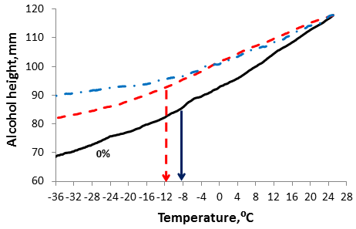
40%
10%
Figure 9. Change in glass transition temperature with volume fraction, PG 64-22 mixed with granite filler at φ=0, 10, 40% (24).

The evolution of the mixture thermal response during a full cooling and heating cycle was investigated by subjecting beam samples to full thermal cycles using the ATCA. During such thermal cycles the behavior shown in Figure 10 was typically observed for all tested material. The asymmetric stress behavior during cooling and heating is believed to be due to the asymmetry in the rate at which the time-dependent strain (i.e., physical hardening) builds up and decreases in the glass transition region. During heating the time-dependent strain is minimal and thus is not different from the strain due to temperature. This behavior results in the trend seen in Figure 10. This concept is used to develop the model proposed in this study to calculate thermal strain and stress during cooling and differentiated from that during heating cycles.

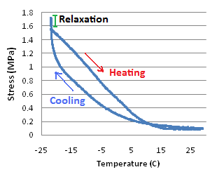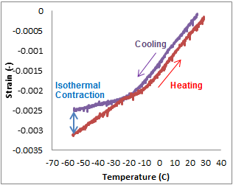
(a) (b)
Figure 10. Stress buildup vs. temperature for full thermal cycle (a) Experimental, and (b) Modeled.

The thermo-volumetric response of the MnROAD mixtures was investigated using the ATCA. The unrestrained samples did not significantly change from cycle to cycle, as indicated in Figures 11 and 12. However, heating and cooling curves in each cycle are slightly different as shown in Figure 12.
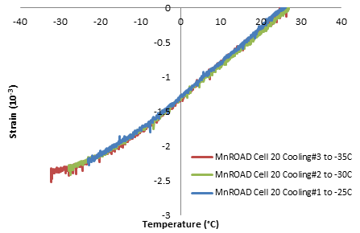
Figure 11. Thermal strain in MnROAD Cell 20 in the cooling cycles.
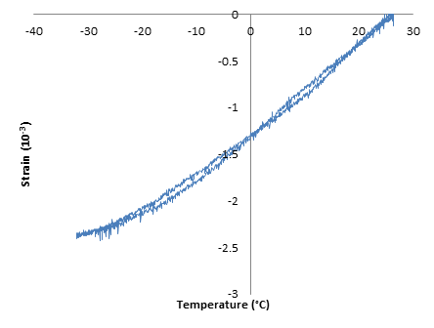
Figure 12. Thermal strain for MnROAD Cell 20 sample during one cooling and heating cycle.

Figure 13 shows the thermal strain in an asphalt beam prepared with the WI binder. The temperature was cycled between +30°C and -70°C three times. No significant change in coefficients of thermal contraction/expansion and the glass transition temperature was observed between one cycle and the next. However, the coefficient of contraction below T_{g} is significantly different than the coefficient of expansion.
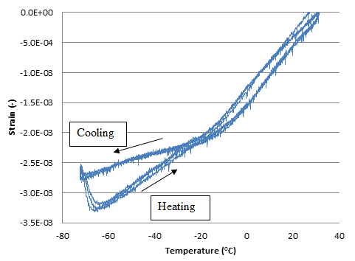
Figure 13.Thermal strain in asphalt mixture beam (WI) in 3 consecutive cycles.

Thermal Stress Response of Asphalt Binders and Mixtures during Thermal Cycles

To better understand the thermal stress response of asphalt mixtures during a thermal cycle, the research team conducted an additional study on a number of thermal cycling tests on restrained specimens, measuring thermal stress in the process.
Figure 14 shows the results of stress buildup measured for MnROAD Cell 20. The sample was cycled between 30 and -20°C three times before progressively decreasing the lower limit by 5°C increments to -35°C. The trend in the stress buildup shows a very sudden drop in thermal stress when the sample was cooled toward -25°C in the 4th cycle, while subsequent cycles failed to buildup significant stress. Visual inspection of the sample after cyclic testing showed no visible crack or failure in the sample, thus it was concluded that significant damage had occurred during the first 4 cycles, leading to an internal structural failure in the sample.

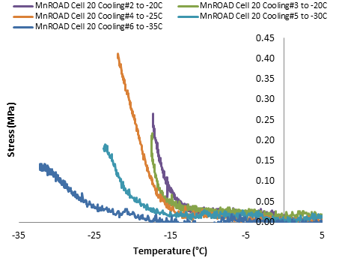
Figure 14. Stress buildup curves under thermal cycling for MnROAD Cell 20.

Figure 15 shows thermal cycles for MnROAD Cell 33 with isothermal conditioning in last cycle. It can be seen that the area of the loop (i.e., hysteresis) decreases after each cycle. Furthermore, the area of the loop significantly decreases when the specimen is subjected to isothermal conditioning at the end of the cooling step. These results indicate the importance of taking into account isothermal conditioning (i.e., physical hardening) when estimating thermal cracking susceptibility of asphalt mixtures subjected to cooling and heating cycles.

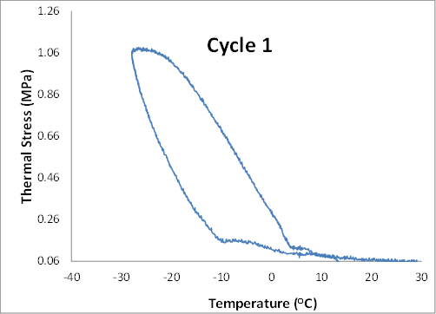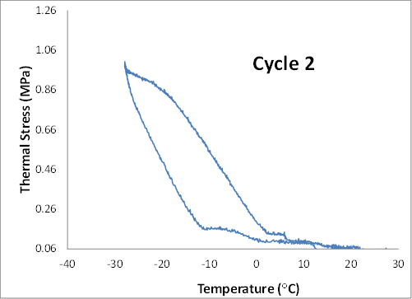

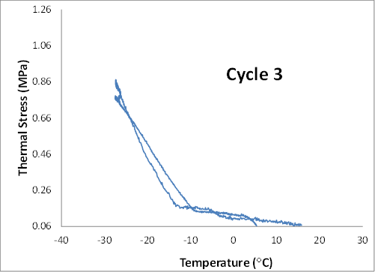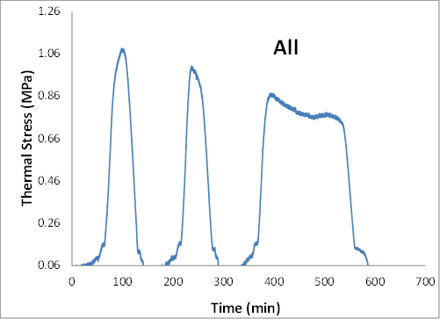
Figure 15. Stress buildup curves under thermal cycling and isothermal conditioning for MnROAD Cell 33.

Figure 16 shows a fourth cycle of thermal loading applied to the restrained beam to bring it to complete failure. It can be seen that the trend of stress buildup for cycle 4 in which the temperature was decreased at a constant rate down to the point of cracking varies from the cycles including an isothermal conditioning step. It can be seen that the maximum thermal stress observed in cycle 2 with isothermal conditioning was reached 12°C earlier in comparison to the cooling cycle 4 with no isothermal conditioning. This observation is extremely important if one considers that the common Thermal Stress Restrained Specimen Test (TSRST) measures the cracking temperature by cooling at a constant rate without taking isothermal conditioning or thermal cycles into account.

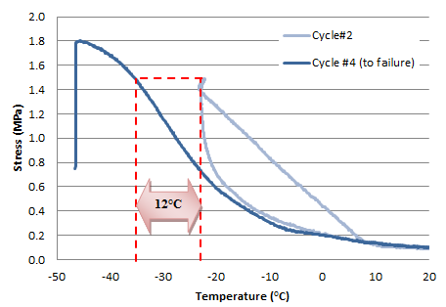
Figure 16. Stress buildup in restrained MnROAD Cell 33 beam using the ATCA, with and without the isothermal conditioning step.

Thermal Stress Buildup and Relaxation

This study also investigated thermal stress relaxation of asphalt mixtures based on a limited number of asphalt samples tested. Using the ATCA, cooling and relaxation experiments were carried out at different rates, isothermal temperatures, and isothermal relaxation times. For all experiments thermal stress was observed to build up as the temperature decreased in the restrained beam. Temperature reduction was stopped at a predefined temperature to start the isothermal stage. Although the temperature measured at the core of the asphalt sample was kept constant, the sample stress continued to build up even after the core temperature had stabilized. Isothermal contraction was also observed simultaneously in the unrestrained beam. As the isothermal conditioning continued, the stress gradually started to relax. This trend was observed for all asphalt mixture samples tested, as shown in Figure 17 in which two identical samples were cooled to -20°C and then held isothermally for 5 and 10 hours, respectively. It is observed that after the initial isothermal stress buildup, the rate of build-up gradually decreases, followed by a relaxation of stress until stabilizing at a constant value over time.
Isothermal Conditions
Stress Relaxation
Isothermal Stress Build-up
Figure 17. Thermal stress in asphalt mixtures after 5 and 10 hrs of isothermal conditioning.

Furthermore, it is noted that the amount of isothermal stress (Figure 18b) and strain (Figure 18a) buildup is dependent on the rate of cooling. When a rate of 0.1°C/min (6°C/hr) was used as much as 10% of the ultimate stress continued to build up after achieving a stable core temperature (Figure 18b). When rate was increased to an extremely fast cooling rate of 1°C/min, most of the ultimate stress is reached after achieving a stable core temperature, although the specimen ultimately reached the same stress levels as with the slower rate as indicated in Figure 18. Tests performed at an intermediate rate of 0.5°C/min resulted in isothermal stress buildup in between the two extreme cooling rates.
Researchers in earlier studies have used many cooling rates to test and model field conditions. Bouldin et al. (2) used 3°C/hr to match studied field sections, while suggesting that resulting cracking temperature may be “bumped” up or down for faster and slower rates, respectively. Modeling by Bahia et al. (8) for rates lower than 10°C/hr showed that reducing cooling rate corresponded to a shift in thermal stress buildup toward lower temperatures. SHRP researchers reported that although typical field cooling rates seldom exceed 2.7°C/hr, most TSRST tests are done at cooling rates of 10°C/hr or higher to reduce testing time (1). Tests conducted during SHRP showed a decrease in fracture temperature as the cooling rate varied between 1 to 5°C/hr, while the effect on tensile strength varied for different samples. They noted that previous researchers reported little or no effect on fracture temperature and tensile strength for cooling rates higher than 5°C/hr. They concluded that although these cooling rates do not necessarily match typical field conditions, they are sufficient to assess relative performance of specimens.

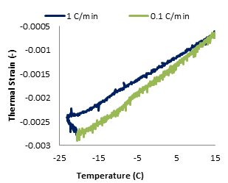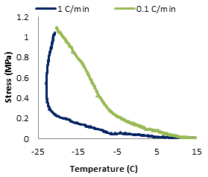
(a) (b)
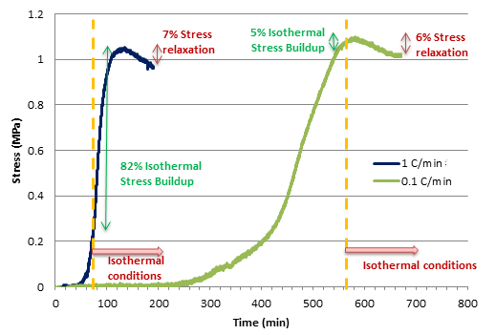
(c)
Figure 18. Comparison of thermal stress and strain during cooling and isothermal conditions at 0.1 and 1°C/min cooling rates.

In this study, it is hypothesized that the observed isothermal behavior is due to the time-dependent nature of thermal contraction as temperature approaches the glass transition region. The complete explanation of the mechanism of glass transition and physical hardening is beyond the scope of this report and can be found in Bahia and Anderson (22), Tabatabaee et al. (25) and Bahia and Velasquez (11).
If cooling rate is sufficiently slow, the specimen has ample time to fully contract; but as the cooling rate increases, although core of samples can reach conditioning temperature, the amount of delayed contraction increases. The delayed contraction takes place over time after sample core reaches isothermal contraction, hence causing the specimen to buildup thermal stress while at a constant temperature. After sufficient time has passed, all samples will achieve full contraction, thus ultimately building up the same amount of thermal stress. This behavior is shown in Figures 18(a) and 18(b).
An important consequence of the observed behavior is that thermal stress will build up at slower rate during cooling if the cooling rate is high enough to not allow for complete contraction during the cooling period, as shown in Figure 18(c). Although at first glance this seems counter intuitive, it must be pointed out that for sufficiently slow cooling rates in which full contraction is taking place during cooling, the trend will be opposite, as the slower cooling rates will allow for more thermal stress relaxation and consequently a lower rate of stress build up during cooling. It is important to note that relaxation and time-dependent strain happen continuously and simultaneously during thermal loading. Depending on the relative rate of these two competing phenomenon at any given time, temperature, and cooling rate, one or the other will be dominant. Thus, an increase in thermal stress will result when time-dependent strain is accumulating at a rate higher than the decreasing effect of modulus relaxation, and vice versa.
Another important observation made during isothermal conditioning of various mixtures is shown in Figures 19 and 20. It is observed that during isothermal conditions, mixture samples can reach a critical value of thermal stress that result in sample fracture. The importance of this observation becomes more apparent when considering that under continuous constant cooling these samples would not have built up this level of stress until temperatures well below the current fracture temperature. This experimental observation can explain discrepancy between predicted low temperature cracking temperatures and observed under- performance in the field, underscoring the importance of considering the potential of isothermal contraction and time-dependent strain in asphalt mixtures when selecting appropriate material for specific climatic conditions.
The possible effect of different levels of isothermal physical hardening of asphalt binders in mixtures was observed when comparing the performance of field sections constructed for the validation effort in Task 6. Mixtures prepared using asphalt binders of identical Superpave performance grades (i.e., PG 58-28) were used in the construction of Task 6 validation sections. After being exposed to identical climatic conditions, one of the sections was observed to have cracked two times more than the others. Although various performance tests failed to differentiate the asphalt binders significantly, physical hardening tests using both the Bending Beam Rheometer (BBR) for the asphalt binders and the ATCA for the mixture showed that one of the asphalt binders has considerably higher susceptibility to isothermal contraction than the others. This asphalt corresponds to the worse field performance, as indicated in Figure 21.
Isothermal Stress Build-up
Fracture
Isothermal Conditions
Figure 19. ATCA restrained beam fracture during isothermal conditions (MN County Road 112-Valero).

Isothermal Stress Build-up
Fracture
Isothermal Conditions
Figure 20. ATCA restrained beam fracture under isothermal conditions (MN County Road 112-CITGO).

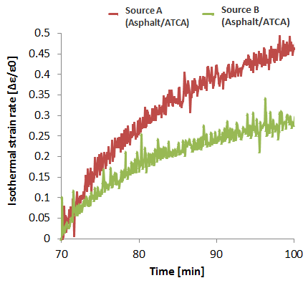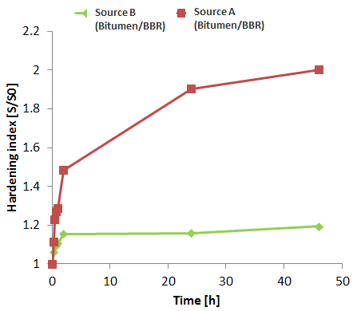
Figure 21. Comparison of physical hardening susceptibility of two asphalt binders of identical Superpave performance grades. The field section using mixture of source “A” cracked two times more than mixture of source “B”.

The importance of the observed behavior in this section is its implications for the validity of the current method for thermal stress calculations. Currently, the prevalent method for thermal stress calculation is to use a restrained beam geometry for which the rate of potential thermal strain is calculated using appropriate coefficients of thermal contraction; and coupling this input with the calculated change of the relaxation modulus, to ultimately estimate the resulting stress in the specimen. The relaxation modulus in this method is a function of both loading time and temperature, thus accounting for stress relaxation in the viscoelastic material. On the other hand, thermal strain is assumed as only a function of temperature, thus the time dependency of the strain, especially when approaching the glass transition temperature is ignored. This assumption leads to a deviation from the true thermal stress build up as the temperature approaches the glass transition region. Such discrepancies have been noted by previous research when comparing experimental and calculated thermal stress, but have usually been attributed solely to the unreliability of the relaxation modulus master curves or the coefficients of thermal contraction in this temperature range.

Micromechanical Simulation of Thermo-Volumetric Properties in Asphalt Mixtures (Objective 2)

Introduction

Finite element modeling was used to develop a semi-empirical model to better estimate the coefficients of thermal contraction/expansion (CTEs) of asphalt mixtures. Also, modeling was used to investigate how the thermo-volumetric properties (i.e., CTEs and T_{g}) of the mastic (i.e., asphalt binder+ filler) is changed by the addition of large aggregate particles.
Dilatometric testing is used to obtain the glass transition behavior of the mastic and digital images of mixture specimens are used to represent the internal aggregate structure of the asphalt mixture. The finite element model developed in ABAQUS considers the mixture as a two-phase heterogeneous material (e.g., asphalt mastic and large aggregate). The simulations were used to assess the effect of volumetric fraction and microstructural properties of asphalt mixture (e.g., aggregate to aggregate contact length and number of contact zones) on the glass transition of the mixture. The results indicate that the aggregate structure plays an important role in controlling the coefficient of expansion/contraction above the transition (i.e., α_{l}). However, the coefficient of expansion/ contraction below T_{g} (i.e., α_{g}) was less affected by internal aggregate structure. The FE simulations indicated that it is possible to estimate the transition behavior measured with the ATCA from mastic glass transition and specific aggregate structure characteristics.

Background

As discussed in the previous section, one of the most important pavement material properties considered for the estimation of thermal cracking susceptibility is the coefficient of thermal expansion/contraction (CTE). Limited research has been conducted to accurately determine this property for both asphalt binders and mixtures (22, 26-30, 31-34). However, a considerable portion of thermal cracking behavior can be explained by studying the change in thermal coefficients of contraction for asphalt binders below, within, and above their glass transition temperature (35, 36).
Thermo-volumetric properties of the mixture are dependent on the thermal contraction coefficients of its main constituents: aggregate and asphalt binder (or more appropriately, the binder-filler mastic). It is important to note that the linear contraction coefficient of an asphalt binder may be up to 10 times that of the asphalt mix (26). The CTE of the asphalt binder is significantly different than the CTE of the asphalt mixture due to the volumetric fraction of its constituents, the very low CTE of the aggregates, and the internal structure of the mix.
Recently, research has shown that the properties of the aggregate skeleton may affect various aspects of the asphalt mixture performance, although this effect has not been studied with regards to the thermo-volumetric properties (37, 38). Thus, the main objective of this portion of the study was to determine the relationship between the thermal-volumetric properties of asphalt mixtures and the properties of its components such as the mastic’s thermo-volumetric parameters, mastic-mixture stiffness ratio, and the internal aggregate structure (e.g., number of aggregate to aggregate contact zones and contact length) (39).

Thermal Expansion/Contraction Coefficient of Composites

Asphalt mixtures can be treated as two phase composite materials consisting of a mastic (binder plus filler) and aggregate phase. There are several micromechanical methods associated with calculating the mean properties of a composite. Depending on the spatial configuration and phase interface condition, two extreme cases can be considered as the upper (Figure 22) and lower (Figure 23) bounds of the composite properties. All non-ideal composites, such as asphalt mixtures, will fall somewhere in between these two extremes cases.
Figures 22 and 23 can be used to deduce the equations for the coefficient of thermal expansion/contraction for the two ideal configurations (i.e., parallel and series) of a two-phase composite material. Figures 22 and 23 represent the composite material for the arithmetic and harmonic model, respectively.

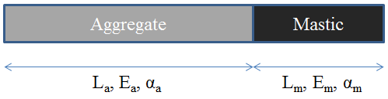
Figure 22. Composite under temperature shrinkage in x-direction (Case 1)

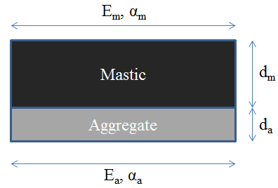
Figure 23. Composite under temperature shrinkage in x-direction (Case 2)

In Figures 22-23, the parameters L, d, E, and α are length, width, elastic modulus, and thermal coefficient of expansion, respectively. The effective thermal coefficient of expansion (CTE) of the composite material in these two extreme situations can be calculated using equilibrium and kinematic equations as follow:

Case 1:
$${∆l}_{c}={∆l}_{a}+{∆l}_{m}→l_{c}α_{c}∆T=l_{a}α_{a}∆T+l_{m}α_{m}∆T→α_{c}=α_{a}\left(\frac{l_{a}}{l_{c}}\right)+α_{m}\left(\frac{l_{m}}{l_{c}}\right)$$ | [1]
It is defined that
$$Φ_{a}=\frac{l_{a}}{l_{c}}, Φ_{m}=\frac{l_{m}}{l_{c}}$$ | [2]
Thus, the equivalent coefficient of thermal expansion in this case can be calculated with:
$$α_{c}=α_{a}Φ_{a}+α_{m}Φ_{m}$$ | [3]
Case 2:
$${∆l}_{c}={∆l}_{a}={∆l}_{m}→lα_{c}∆T=lα_{a}∆T+\frac{Fl}{d_{a}.1 E_{a}}=lα_{m}∆T-\frac{Fl}{d_{m}.1 E_{m}}$$ | [4]
By simplifying the above equation, the equivalent thermal coefficient of expansion of the composite can be calculated as
$$α_{c}=\frac{d_{a}α_{a}E_{a}+d_{m}α_{m}E_{m}}{d_{a}E_{a}+d_{m}E_{m}}$$ | [5]
By defining the following parameters we can rewrite the expression for the equivalent coefficient of expansion as follows:
$$Φ_{a}=\frac{d_{a}}{d_{c}}, Φ_{m}=\frac{d_{m}}{d_{c}}$$ | [6]
Thus:
$$α_{c}=\frac{Φ_{a}α_{a}E_{a}+Φ_{m}α_{m}E_{m}}{Φ_{a}E_{a}+Φ_{m}E_{m}}$$ | [7]

It can be seen that in case 1, the mastic has the maximum contribution to the thermal contraction coefficient of the total mixture; on the other hand in case 2 its contribution is minimum. Therefore, it can be said that Equation [3] is an upper bound and equation [7] is the lower bound for the thermal expansion/contraction coefficient of a two-phase composite material. The two calculated bounds can be used to check the results from the FE thermal analysis of the asphalt mixtures and to develop semi-empirical models for the estimation of CTE of mixtures.

General Description of FEM Simulation

The Finite Element (FE) analysis software ABAQUS was used to model asphalt mixtures undergoing thermal contraction and glass transition. A 4-node bilinear plane stress quadrilateral and reduced integration element (i.e., CPS4R) was used in the simulations. Colored images of asphalt mixtures obtained using a flatbed scanner were converted to binary images using digital imaging processing techniques. The pixels in the binary image were mapped into CPS4R elements in the FE model using MATLAB.
The modulus of elasticity and Poisson’s ratio for the aggregates used in the model were assumed to be 40 GPa and 0.3, respectively. The Poisson’s ratio of the mastic is assumed to be constant with a value of 0.5. The imaging techniques and filters cannot accurately capture aggregate particles smaller than 1.18 mm, and therefore the mastic phase is considered to be a homogenous mixture of the fine aggregate particles dispersed in the binder phase.
The boundary conditions considered in the modeling are shown in Figure 24. The coefficient of expansion for the mastic was entered in 2°C increments of temperature starting from 0° and decreasing to -60°C. As the mastic reached the glass transition zone the coefficient of expansion/contraction was gradually decreased incrementally until settling at a lower constant “glassy” value. Thermo-volumetric properties for mastics used in the simulations were measured with the dilatometric system described earlier in this report. Adjustments were made for the effect of varying fine content in the mastics by assuming that an arithmetic model can be applied to the homogenously dispersed fine particles in the binder matrix. A typical constant temperature-independent coefficient of expansion was used for the aggregate phase.
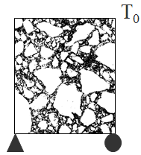
Figure 24. 2D asphalt mixture model showing the boundary conditions.

More than 50 simulations were conducted to investigate the effect of the microstructure on the glass transition of the mixture. These simulations consisted of a number of idealized models with circular aggregates using different configurations and volume fractions, as well as many FE simulations using binary images of actual asphalt mixtures with various gradations and volume fractions.

Importance of Aggregate Structure on Thermal Properties of the Mixture

As the first step in developing the micromechanical models for thermo-volumetric properties of asphalt mixtures, it was decided to perform an initial investigation using an idealized mixture consisting of uniform round aggregates. The idealized geometry was used to isolate the effect of aggregate shape on the simulations.
Three mixtures with circular aggregate particles and the same volumetric fraction (i.e., 10 percent) but different internal structures were considered as shown in Figure 25.

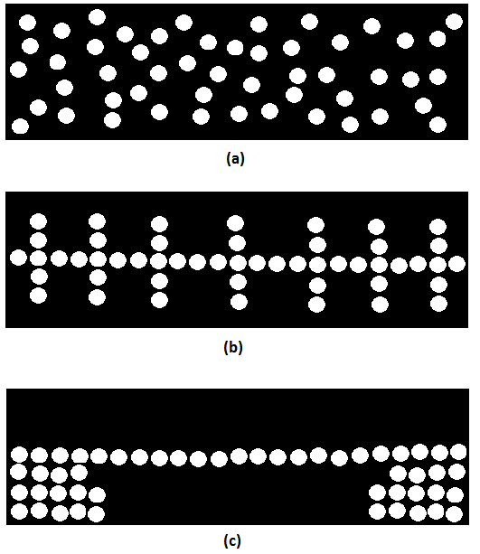
Figure 25. (a) Random structure (b) First structure (c) Second structure.

These artificial mixes were subjected to a reduction in temperature in ABAQUS using the boundary conditions in Figure 24. The results from these simulations are presented in Figure 26. As it can be seen, the thermal contraction coefficient (CTE) of the mixture decreased as the connectivity of the aggregates increased. This is thought to be due to the increase in aggregate connectivity interfering with the contraction of the mastic (i.e., continuous phase), causing a reduction in the overall thermal strain rate.

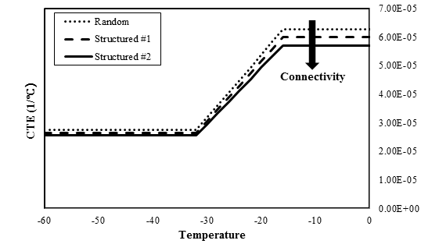
Increasing Connectivity
Figure 26. CTE versus temperature.

Finite Element Modeling of Asphalt Mixture Binary Images

The simple model discussed in the previous section highlighted how the internal aggregate structure can be an important factor in the determination of the thermo-volumetric properties of the mixture. Different parameters which provide a good characterization of the internal aggregate structure of the mixture have been discussed in detail in the literature (39). For this research, the number of aggregate to aggregate contact zones, and the overall length of the aggregate to aggregate contact were selected as the representative parameters for the effect of microstructure on thermo-volumetric properties of the asphalt mixture. These parameters were calculated using iPas, a 2-D image analysis software under development by the University of Wisconsin-Madison and Michigan State University.
Different mixtures with different aggregate structures as shown in Table 4, and over a range of gradations covering most of the allowable range of gradations for a 12.5 mm nominal maximum aggregate size (NMAS) were used (Figures 27 and 28). Mastic properties were calculated based on dilatometric tests run on the binders shown in Table 1 (Figure 29).

Table 4. Microstructural analysis of mixtures.

Mixture | No of Contact Zones | Volumetric Fraction of Large Aggregates (%)
Mix 1 | 886 | 58.8
Mix 2 | 831 | 60.2
Mix 3 | 914 | 60.3
Mix 4 | 770 | 59.5
Mix 5 | 975 | 59.7

Figure 27. Gradation of mixtures for FEM.

Figure 28 shows the binary images obtained from iPas for two of the analyzed mixtures having the highest and lowest number of aggregate contact zones, (i.e., connectivity).
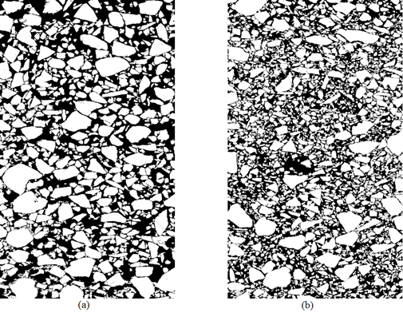
Figure 28. Binary representation of asphalt mixtures (a) lowest number of contact zones (b) highest number of contact zones.

It is observed that the number of contact zones for a fine gradation is higher than that of a coarse gradation. Three different asphalt mastics with highly different CTE values and temperature dependency were used. The variation of the thermal contraction coefficients of these mastics as function of temperature is shown in Figure 29.
The stiffness vs. temperature curve was generated by using the assumption that a viscoelastic material follows a sigmoidal trend, with the main change in modulus happening during the glass transition zone, after which the modulus levels off to a constant glassy value. Thus, having the glass transition behavior for each mastic from the dilatometric test, a sigmoidal curve was fitted to BBR creep stiffness measurements at three temperatures, -12, -18, and -24℃, allowing for a good coverage of the modulus transition zone. Figure 30 shows the resulting curves.
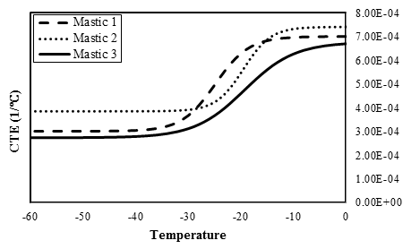
Figure 29. CTE of three different mastics.

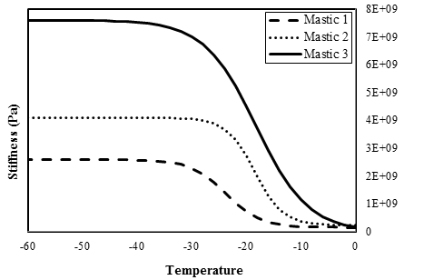
Figure 30. Stiffness of three different mastics

Using the CTE and modulus of mastics from Figures 29 and 30 as input, and knowing the volume fraction for the mastic and aggregate phases for each mixture, the ABAQUS model was used to estimate the thermal strain and to calculate the CTE for each mixture as temperature decreased.
Based on the number of aggregate to aggregate contact zones presented in Table 4, it can be concluded that increasing the number of contact zones generally will cause a reduction in the thermal contraction coefficient (CTE). Figures 31, 32, and 33 show the relation between contact points/zones and CTE below and above T_{g}. In these figures, α_{l} and α_{g} have been shown versus the number of contact zones for the three different mastics and five different mixtures considered. It is observed that there is a good correlation between the number of contact zones and α_{l}, and a fair correlation with α_{g}.

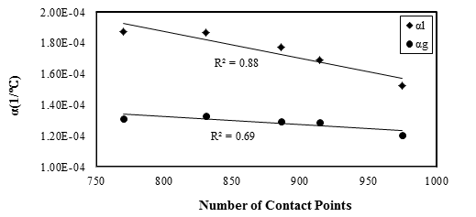
Figure 31. CTE vs. number of contact zones/points for mixtures with Mastic 1.
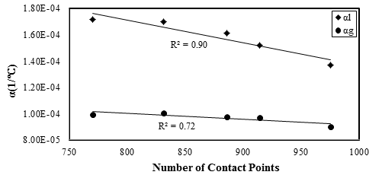
Figure 32. CTE vs. number of contact zones/points for mixtures with Mastic 2.

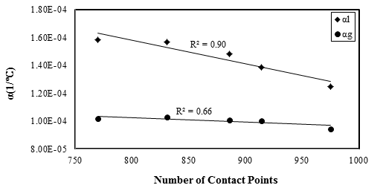
Figure 33. CTE vs. number of contact zones/points for mixtures with Mastic 3.

Based on the simulations performed, it was observed that a decrease in the number of aggregate contact zones, which may implies a less effective aggregate skeleton structure, and an increase in the elastic modulus of the mastic phase will result in an overall increase in the level of contribution of the mastic phase in the total thermal contraction coefficient of the composite mixture.

Models for Estimation of α_{l} and α_{g} of Asphalt Mixtures

It has been observed based on the FE simulations, that other than the thermo-volumetric properties of the mastic phase and the volume fractions of each phase, the total coefficient thermal expansion/contraction of the mixture is also dependent on the internal structure of the aggregate skeleton.
In this section based on the aforementioned results, and relatively large number of additional FE simulations, a model is proposed for the approximation of the asphalt mixture α_{l} and α_{g}. The general structure of the model is based on the Hirsch model, which is commonly used for estimation of modulus of asphalt mixes. The proposed model assumes that the mixture CTE is a weighted average of the upper and lower theoretical bounds of the CTE. The theoretical bounds are calculated based on the volume fractions and moduli of each phase. An empirical weighting factor is used to show the contribution of each of the bounds to the total CTE as temperature changes. This empirical factor is dependent on the number of aggregate to aggregate contact zones in the mixture aggregate skeleton and on the mastic to aggregate stiffness ratio, which in turn is a function of temperature. The general form of the model is shown in Equation [8] and Equation [13] for the thermal contraction/expansion coefficient of the mixture above and below T_{g}, respectively.
$$α_{mix}^{L}=α_{up}^{L}F+α_{low}^{L}\left(1-F\right)$$ | [8]
where F is a function of internal aggregate structure, mastic stiffness, and α_{l} of the mastic.
$$F=\left(0.7-0.31β\right)*{E_{l}}^{100∝_{l}}$$ | [9]
where
$$β=\frac{Number of Contact Zones of the Mixture}{770}$$ | [10]
where, β is a function that adjust the number of contact zones based on aggregate volume fraction and E_{l} is the stiffness of the mastic before glass transition.
$$α_{low}^{L}=\frac{Φ_{a}α_{a}E_{a}+Φ_{m}α_{m}E_{m}}{Φ_{a}E_{a}+Φ_{m}E_{m}}$$ | [11]
Φ_{a} and Φ_{m} are the volumetric fraction of the aggregate and mastic, respectively.
$$α_{up}^{L}=α_{a}Φ_{a}+α_{m}Φ_{m}$$ | [12]

$$α_{mix}^{G}=α_{up}^{G}F+α_{low}^{LG}\left(1-F\right)$$ | [13]
$$F=\left(0.98-0.29β\right)*{E_{g}}^{20∝_{g}}$$ | [14]
where, E_{g} and α_{g} are the stiffness and CTE of the mastic below glass transition, respectively.
Fifteen different mixtures were used to obtain the constants of the proposed semi-empirical model. Figures 34 and 35 showed the α_{l} and α_{g} calculated using the optimized model constants versus the results obtained from the simulation in ABAQUS.

Figure 34. α_{l} from FEM vs. prediction using proposed model.
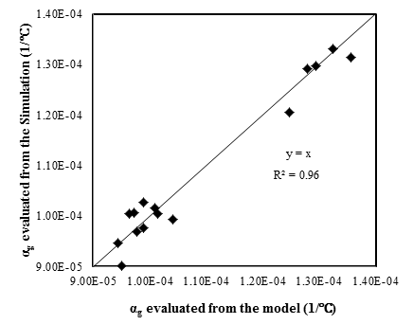
Figure 35. α_{g} from FEM vs. prediction using proposed model.

To validate the proposed semi-empirical model, nine different mixtures with different aggregate structures and mastic properties were used. Note that these mixtures were not used in the calibration of the constants of the models. The calculated α_{l} and α_{g} for these nine different mixtures from the proposed model have been shown versus the results of simulations by ABAQUS (Figures 36 and 37).
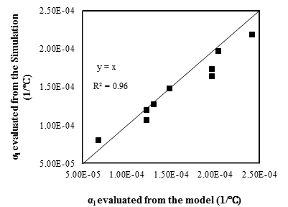
Figure 36. Comparison of α_{l} from FE simulations and using proposed model.
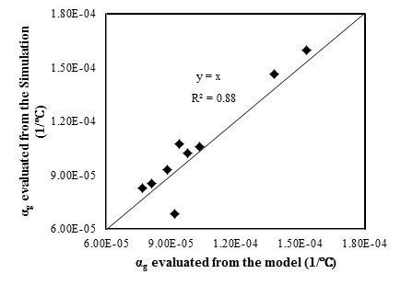
Figure 37. Comparison of α_{g} from FE simulations and using proposed model.

Based on the results observed in Figures 36 and 37, it can be seen that the model performs relatively well for the estimation of the CTE of the mixtures in both the liquid and glassy phase. It must be noted that this model can only serve as an approximation of the mixture thermo-volumetric properties. The true value of such a model is its ability to take into account the mixture aggregate skeleton microstructure properties, the glass transition, and the stiffness ratios of the phases, for the estimation of the total CTE, rather than simply relying on the volume fractions of each phase, as it is commonly done in most applications such as the MEPDG.

Sensitivity Analysis of Thermo-Volumetric Parameters Through Modeling (Objective 3)

Sensitivity analysis of thermo-volumetric properties was performed for eight parameters during cooling and heating. The width of glass transition region during cooling and heating was also considered as a potentially important parameter, thus it was added to the original 6 parameters considered in the work plan (T_{g}, α_{l} and α_{g} in cooling and heating).
The sensitivity analysis was performed using a thermal stress calculation framework recently developed at the University of Wisconsin-Madison (40). A theoretical approach for the calculation of thermal stress build-up in mixtures subjected to varying cooling and isothermal conditions was derived. The approach combines relaxation modulus master curves, the WLF equation for time-temperature superposition of thermo-rheological simple material, Boltzmann’s superposition principle, and a sub-model describing the isothermal contraction of asphalt mixture as a continuous function of conditioning time and temperature.
The model uses a nonlinear thermo-volumetric curve with different T_{g}, α_{l} and α_{g} in cooling and heating. The model also includes the effect of time dependent strain on the thermal stress during cooling, isothermal conditioning, and heating. The model inputs are described in the following sections.

Model Input and Assumptions

Many methods exist to determine the relaxation modulus of asphalt material. Relaxation modulus master curves acquired from different methods may be used as required input for the thermal stress prediction model.
Thermo-Volumetric Behavior and Glass Transition of Asphalt Mixtures
Thermal stress calculation are based on the potential thermal strain of the mixture due to temperature differential. Thermal strain is measured directly for asphalt mixture beams using the ATCA device. The resulting strain may be plotted as a function of temperature and fitted using the formulation proposed by (5). The relationship is shown in equation [15].

$ϵ_{th}=\frac{∆l}{l_{0}}=C+α_{g}\left(T-T_{g}\right)+\ln\left\{{\left[1+e^{\frac{T-T_{g}}{R}}\right]}^{R(α_{l}-α_{g})}\right\}$ [15]

where:

- $\frac{∆l}{l_{0}}$ is the relative change of length, or thermal strain,
- C is an intercept with no physical meaning,
- α_{l} and α_{g} are the liquid and glassy coefficients of thermal contraction/expansion, and
- R is a parameter representing the curvature between the two linear asymptotes
The formulation fits two linear portions to the curves above an below the non-linear “glass transiton” region, the slopes of which are defined as the liquid and glassy coefficients of thermal contraction/expansion (α_{l} and α_{g}). The temperature at the intersection of the two linear sections is defined as the glass transition temeprature (T_{g}). The “R” parameter represents the “strength” of the transiton, which is a measure of the difference of slopes before and after the transition as well as the length and curvature of the transition region. Equation [15] was used to predict thermal strain at any given temperature.
Physical Hardening in Asphalt Binders and Mixtures

A prediction model for the rate of physical hardening at different temperatures and conditioning times based on a creep viscoelastic model was used to account for the physical hardening strain in the thermal stress buildup. This model is described in great detail in (24) and presented in Task 2.
The model is based on concepts of rheological response of viscoelastic materials, postulating that the creep behavior at the molecular level is similar to the volume relaxation behavior observed in physical hardening. Thus, it is hypothesized that a modified creep expression, the Kelvin-voigt model, can be adjusted to explain physical hardening behavior. In such a model, strain or relative change in deflection (i.e., ${∆l}/{l_{0}}$), is replaced by relative change in volume, ${∆V}/{V_{0}}$, which according to the free volume concept is taken to be directly proportional to relative change in stiffness, or hardening rate (${∆S}/{S_{0})}$. The change in stiffness (∆S) is the difference in stiffness after conditioning time t_{c} and the initial stiffness, S₀.
The “creep” behavior at isothermal conditions was considered to be induced by the excess of internal energy due to the deviation of the material from thermo-dynamic equilibrium within the glass transition region. Experimental data from the authors shows that the rate of physical hardening (${∆S}/{S_{0})}$ peaks at the glass transition temperature, hereby denoted as T_{g}, and decreases toward zero as the temperature approaches the beginning and the end of the glass transition region. This is also supported by experimental data reported by Planche et al. (7). Thus a “stress” parameter based on the glass transition temperature, the relative position of the conditioning temperature from the glass transition temperature, and the length of the glass transition region was envisioned for the model. The loading time is the length of time the material is in not at thermo-dynamic equilibrium, or in other words, the conditioning time (t_{c}).
By implementing these changes into the Kelvin-Voigt creep model, Equation [16] is derived, and it is shown to fit the observed physical hardening behavior of a number of asphalt binders very well. A three-dimensional representation of the physical hardening as a function of conditioning time and temperature, is shown in Figure 38.

$ϵ_{PH}=\frac{e^{\frac{-{9(T-T_{0})}^{2}}{{\left(2x\right)}^{2}}}}{G}\left(1-e^{-t_{c}\frac{G}{η}}\right)∝\frac{∆V}{V_{0}}∝\frac{∆S}{S_{0}}$ [16]

where:
- $\frac{∆S}{S_{0}}$ is the hardening rate,
- T₀ is the peak temperature for hardening rate, assumed to be the Tg (°C),
- T is the conditioning temperature (°C),
- t_{c} is the conditioning time (hrs),
- 2x is the length of the temperature range of the glass transition region (°C),
- G and η are model constants, derived by fitting the model.

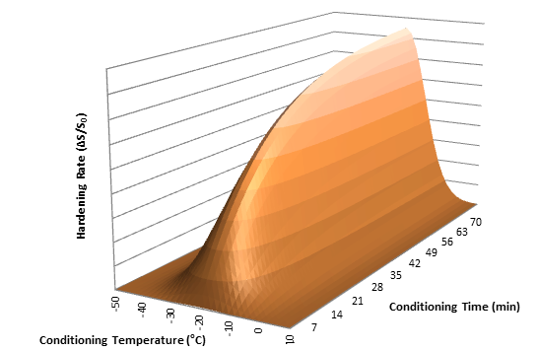

Figure 38. 3-D representation of the physical hardening model for a glass transition temperature of -20°C.

The model parameters, G and η, are shown to be unique material parameters that remain constant at all conditioning times and temperatures. Thus, by fitting the model to data from a single conditioning temperature and having the Tg, one may predict the binder physical hardening at any other temperature or conditioning time.
Equation [16] is developed and verified using asphalt binder stiffness measurements with the BBR. Assuming that isothermal shrinkage is proportional to hardening, it is expected that the trend of physical hardening strain buildup in asphalt mixtures be similar to that of binders, but of a much smaller magnitude due to the relatively small volume of binder in the entire asphalt mixture. The trend of isothermal strain in an asphalt mixture measured with the ATCA is shown in Figure 39, in which Equation [16] was successfully fitted to the curve (Figure 39a). Since the measurements can only show the total response, the exact nature of the transformation between binder and mixture hardening is still under investigation, however initial tests measuring isothermal shrinkage and stiffness of asphalt mixture beams using the ATCA and BBR respectively, support the aforementioned assumptions.

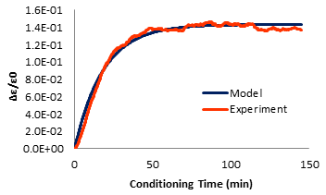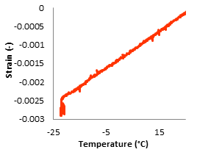
- (b)

Figure 39. (a) Isothermal strain rate in asphalt mixture beam plotted against conditioning time, and (b) strain in the same asphalt mixture beam plotted against speciment temperature.

Prediction of Thermal Stress Buildup and Relaxation
Thermal stress in a restrained beam of visco-elastic material is calculated using the following convolution integral (2, 9, and 40):
[17]

where,
- σ(t) is stress as a function of time,
- E is the relaxation modulus,
- ε is thermal strain,
- and ξ is reduced time.
The true nature of this integral is better understood if its broken down to a finite number of increments. The input thermal strain can be divided into small step increments for which the relaxation response can be easily computed and added in time to obtain the total thermal stress, according to Boltzmann’s superposition principle. This concept is depicted in Figure 40.

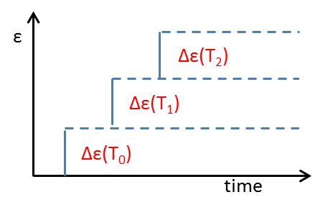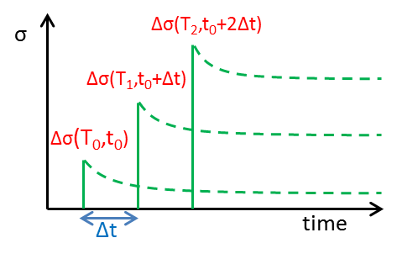
- (b)
Figure 40. Concept of incremental stress buildup and relaxation in viscoelastic material.

Following this logic, if at any point the temperature is held constant, stress in subsequent steps will only be the sum of the relaxing stresses in previous steps, thus will continue to decrease over time, since no additonal stress can build up once temperature is held constant, the total stress will begin to decrease immediately due to relaxation. This expected behavior, however, is not observed in the ATCA experiments due to physical hardening and continued shrinkage at constant temperature. In the proposed model, the addition of a time-dependent strain to the temperature-dependent strain is shown to be able to describe stress buildup trends very similar to observations. This time-dependent strain term is applied to the aforementioned procedure by multiplying this term by the relaxed modulus at the corresponding loading time. The initially high rate of isothermal strain will result in a gradual isothermal stress buildup.
The rate of buildup will gradually decrease as the modulus further relaxes, ultimately resulting in a gradual stress relaxation. Figure 41 shows the effect of using a time-dependant strain term in the thermal stress build-up and relaxation.

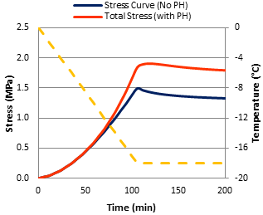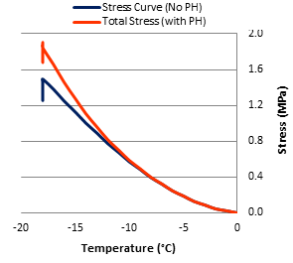
- (b)
Figure 41. Thermal stress calculation with and without using time-dependent strain and accounting for physical hardening (PH) as a function of time (a), and temperature (b).

It can be seen in Figure 41 that the addition of the time dependent strain causes the stress buildup to deviate from the common calculation method as the temperature approaches the glass transition temperature. Furthermore, the stress does not immediately relax once temperature is held constant, but initially builds up and peaks isothermally, before gradually relaxing. Considering the time-dependent physical hardening improved the prediction of stress build up with time significantly.
In summary, the model for the calculation of thermal stress buildup in mixtures was derived using relaxation modulus master curves, the WLF equation for time-temperature superposition of thermo-rheological simple material, Boltzmann’s superposition principle, and a model describing the isothermal contraction of asphalt mixtures as a continuous function of conditioning time and temperature. The key idea behind this model is that the input thermal strain can be divided into small increments for which the relaxation response can be easily computed and added in time to obtain the total thermal stress.
Thermal stress buildup and relaxation tests were performed on selected asphalt mixtures to verify the accuracy of the proposed calculation scheme, and to show the influence of binder physical hardening on mixtures stress history. The tests were done at 0.1 and 1 °C/min cooling rates and held isothermally for periods ranging from 1 to 10 hours, during which the stress and strain in the beams were continuously monitored. Figure 42 show experimental results of beams cooled to the temperature of -20°C, at which they were kept isothermally.

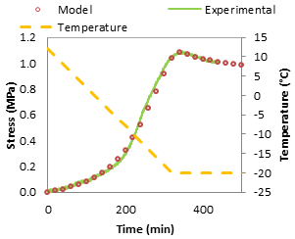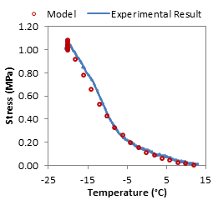
(a) (b)
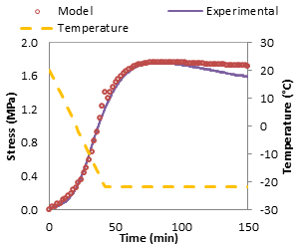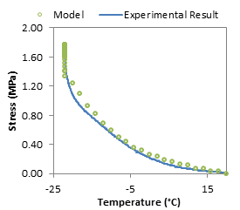
(c) (d)
Figure 42. Calculated and measured thermal stress buildup plotted against time and temperature at cooling rates of 0.1°C/min (a, b) and 1°C/min (c, d).

In Figures 42(a) and 42(b) at the cooling rate of 0.1°C/min no sudden isothermal stress buildup is observed. On the other hand, when the rate was increased to 1°C/min (Figures 42(c) and 42(d)), it can be seen that a significant amount of stress buildup occurs during isothermal conditions due to delayed time-dependent strain. This behavior is reflected in the analytical calculation. It is seen that a very good agreement between experimental and calculated results exists.

Sensitivity Analysis

A sensitivity analysis of thermal stress to eight thermo-volumetric parameters during cooling and heating was performed. The width of glass transition region during cooling and heating was also considered as a potentially important parameter, thus a parameter describing the transition width (R) was added to the six parameters originally considered (T_{g}, α_{l} and α_{g} in cooling and heating). These parameters were defined earlier, following Equation [15].
Parameter values for a typical mixture were used as a baseline. The parameters were then systematically varied by ±20% to capture the sensitivity of the parameters on thermal stress buildup in the mixture. The 20% variation was selected as the maximum percentage of change allowable to keep all parameters in a realistic and practical range. Tables 5 and 6 show the analysis matrix and the values used in this study.

Table 5. Analysis matrix used for the sensitivity analysis

 |  | Run 1 | Run 2 | Run 3 | Run 4 | Run 5 | Run 6 | Run 7 | Run 8 | Run 9 | Run 10 | Run 11 | Run 12 | Run 13 | Run 14 | Run 15 | Run 16 | Run 17
Cooling | T_{g} | 1 | 1.2 | 0.8 | 1 | 1 | 1 | 1 | 1 | 1 | 1 | 1 | 1 | 1 | 1 | 1 | 1 | 1
Cooling | R | 1 | 1 | 1 | 1.2 | 0.8 | 1 | 1 | 1 | 1 | 1 | 1 | 1 | 1 | 1 | 1 | 1 | 1
Cooling | α_{l} | 1 | 1 | 1 | 1 | 1 | 1.2 | 0.8 | 1 | 1 | 1 | 1 | 1 | 1 | 1 | 1 | 1 | 1
Cooling | α_{g} | 1 | 1 | 1 | 1 | 1 | 1 | 1 | 1.2 | 0.8 | 1 | 1 | 1 | 1 | 1 | 1 | 1 | 1
Heating | T_{g} | 1 | 1 | 1 | 1 | 1 | 1 | 1 | 1 | 1 | 1.2 | 0.8 | 1 | 1 | 1 | 1 | 1 | 1
Heating | R | 1 | 1 | 1 | 1 | 1 | 1 | 1 | 1 | 1 | 1 | 1 | 1.2 | 0.8 | 1 | 1 | 1 | 1
Heating | α_{l} | 1 | 1 | 1 | 1 | 1 | 1 | 1 | 1 | 1 | 1 | 1 | 1 | 1 | 1.2 | 0.8 | 1 | 1
Heating | α_{g} | 1 | 1 | 1 | 1 | 1 | 1 | 1 | 1 | 1 | 1 | 1 | 1 | 1 | 1 | 1 | 1.2 | 0.8

Table 6. Parameter values used for the sensitivity analysis

 |  | Run 1 | Run 2 | Run 3 | Run 4 | Run 5 | Run 6 | Run 7 | Run 8 | Run 9 | Run 10 | Run 11 | Run 12 | Run 13 | Run 14 | Run 15 | Run 16 | Run 17
Cooling | T_{g} | -17 | -20 | -13 | -17 | -17 | -17 | -17 | -17 | -17 | -17 | -17 | -17 | -17 | -17 | -17 | -17 | -17
Cooling | R | 6 | 6 | 6 | 7 | 5 | 6 | 6 | 6 | 6 | 6 | 6 | 6 | 6 | 6 | 6 | 6 | 6
Cooling | α_{l} | 5E-5 | 5E-5 | 5E-5 | 5E-5 | 5E-5 | 6E-5 | 4E-5 | 5E-5 | 5E-5 | 5E-5 | 5E-5 | 5E-5 | 5E-5 | 5E-5 | 5E-5 | 5E-5 | 5E-5
Cooling | α_{g} | 1E-5 | 1E-5 | 1E-5 | 1E-5 | 1E-5 | 1E-5 | 1E-5 | 1.3E-5 | 9E-6 | 1E-5 | 1E-5 | 1E-5 | 1E-5 | 1E-5 | 1E-5 | 1E-5 | 1E-5
Heating | T_{g} | -17 | -17 | -17 | -17 | -17 | -17 | -17 | -17 | -17 | -20 | -13 | -17 | -17 | -17 | -17 | -17 | -17
Heating | R | 6 | 6 | 6 | 6 | 6 | 6 | 6 | 6 | 6 | 6 | 6 | 7 | 5 | 6 | 6 | 6 | 6
Heating | α_{l} | 5E-5 | 5E-5 | 5E-5 | 5E-5 | 5E-5 | 5E-5 | 5E-5 | 5E-5 | 5E-5 | 5E-5 | 5.E-5 | 5.E-5 | 5.E-5 | 6E-5 | 4E-5 | 5.E-5 | 5.E-5
Heating | α_{g} | 1E-5 | 1E-5 | 1E-5 | 1E-5 | 1E-5 | 1E-5 | 1E-5 | 1E-5 | 1E-5 | 1E-5 | 1E-5 | 1E-5 | 1E-5 | 1E-5 | 1E-5 | 1.3E-5 | 9E-6
Figures 43(a-d) show the results of thermal stress calculations for a mixture cooled at 1°C/min from 10 to -22°C and then held isothermally for 180 minutes before being heated back up to 10°C at the same rate. The stress calculations were made both with and without taking time-dependent strain into account (i.e., solid and dotted lines respectively).

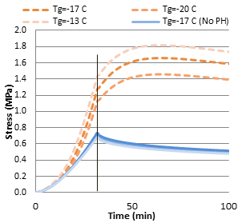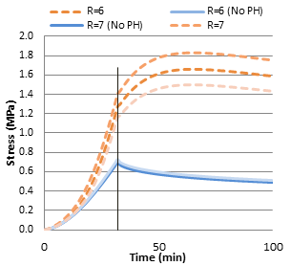
(a) (b)
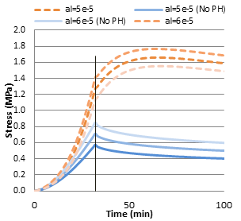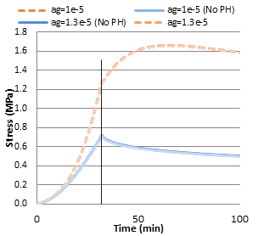
(c) (d)
Figure 43. Sensitivity analysis of calculated mixture stress buildup with and without accounting for physical hardening, by changing (a) T_{g}, (b) R, (c) α_{l}, and (d) α_{g}.

A qualitative analysis of Figure 43 shows that changing α_{l} has the most effect on the thermal stress buildup during cooling, when not accounting for physical hardening, while changing the glass transition temperature and the related parameters (α_{l} and R) did not show significant effects. On the other hand, the stress sensitivity to T_{g} and R increased significantly when accounting for the physical hardening. These variations are shown in Figure 44 by plotting the thermal stress buildup for every condition, normalized to the initial unchanged state of the parameters.
A noteworthy trend in Figure 44 can be seen when comparing the T_{g}+ and T_{g}- conditions to the base condition. If no time-dependent strain (physical hardening) is considered in the stress calculations, a higher T_{g} would simply lead to the CTE value reducing from α_{l} to α_{g} at higher temperatures, thus less subsequent stress buildup will be calculated for any given temperature below the T_{g}. As mentioned earlier, for the calculation of physical hardening it is assumed that the rate of time dependent strain increases as the temperature approaches the T_{g}, from both sides. Thus, if physical hardening is considered in the stress calculation, increasing the T_{g} would also mean that time dependent strain accumulate at a higher rate at higher temperatures, potentially resulting in a higher stress buildup in the sample, as seen in Figure 44.

Figure 44. Variation of thermal stress at -20°C, by changing thermal parameters by ±20% (X± shown in the chart indicates that parameter X has been changed by ±20%)

The glassy coefficient of expansion/contraction (α_{g}) did not significantly affect thermal stress calculations. Subsequent tests at -30, -40, and -45°C did not show any significant effect from changing α_{g.} This observation does not indicate the unimportance of considering α_{g}. This fact is highlighted in Figures 45(a, b), in which the thermal stress is calculated in three methods: a. using full strain-temperature curve considering glass transition, b. using a constant CTE equal to α_{l}, and c. using a constant CTE equal to the average of α_{l} and α_{g} for all temperatures. It can be seen that the simplifying assumptions made for the CTE lead to more than 25% difference in the total accumulated thermal stress at -30°C. On the other hand, the thermal stress insensitivity to changes in α_{g} observed in Figure 43(d) would indicate that using a typical value for α_{g} may be sufficient for thermal stress calculation, and measurement of an exact α_{g} may not be necessary.
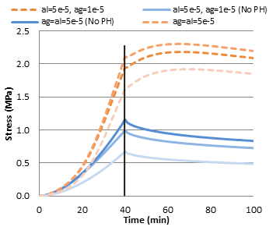
(a) (b)
Figure 45. Comparison of effect of different assumptions for CTE on (a) thermal stress curves, and (b) stress at -30°C normalized to stress at when both α_{l} and α_{g} are considered.

Using the model, the CTEs and T_{g} in the heating phase were also varied by ±20% and compared in Figure 46. It can be seen that the variation of the α_{l}, followed by the variation of T_{g}, had the highest effect on the rate of thermal stress reduction as the sample is heated back up to the initial temperature, while little sensitivity was observed to the R and α_{g} parameters. As indicated by the overall small level of change for thermal stress for all parameters during heating, the importance of experimentally measuring actual parameter values for this range seems to be minimal, indicating the possibility of using typical average values for this range.

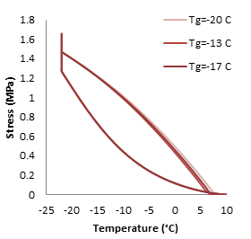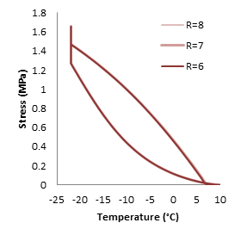
(a) (b)
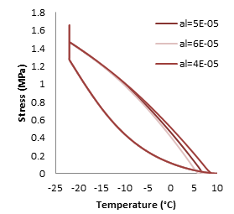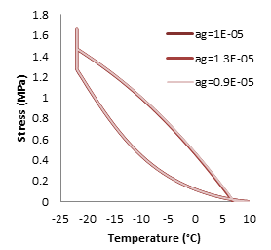
(c) (d)
Figure 46. Sensitivity analysis of calculated mixture stress reduction during heating with and without accounting for physical hardening, by changing (a) T_{g}, (b) R, (c) α_{l}, and (d) α_{g}.

Summary of Findings and Conclusions

Conclusions
The primary objectives of Task 5 were to: (1) expand the database developed in Phase I for thermo-volumetric properties of asphalt binders and mixtures to a wider range of modified asphalts and types of mixtures, (2) develop a micromechanical numerical model that can be used to estimate coefficients of thermal contraction/expansion of mixtures from variables commonly measured for binder grading and for mixture design, and (3) conduct thermal cracking sensitivity analysis to determine which of the glass transition parameters are statistically important for cracking, which ones need to be measured, and the effect of using estimated values rather than measured values. To address these objectives a comprehensive experimental and modeling investigation on the contraction and expansion of asphalt mixtures due to thermal cycles was completed. The experimental effort used the recently developed Asphalt Thermal Cracking Analyzer (ATCA) to investigate thermal stress buildup during cooling and the subsequent reduction during heating of MnROAD mixes. The thermal cracking sensitivity analysis of the glass transition parameters was conducted based on a calculation model experimentally validated to account for temperature and time-dependent strain (i.e., physical hardening) effects. Based on the analysis of results the following notable conclusions are derived:

- The liquid phase CTE (α_{l}) and the glass transition temperature (T_{g}) showed the most influence on the rate and trend of thermal stress buildup; the later becoming more prominent when accounting for the time dependency of strains in the glass transition region. Generally, an asphalt mixture with lower liquid CTE and T_{g} is expected to accumulate less thermal stress during a cooling cycle, and thus has the potential to be less susceptible to thermal cracking.
- Almost all published thermal cracking models, including those used in the Mechanistic Empirical Pavement Design Guide (MEPDG), use a default value for CTE or a formula derived empirically based on testing a relatively small set of mixtures. The only justification for this over-simplification is the lack of a proper experimental device to measure CTE of asphalt mixes as a function of temperature. In this Task, results indicate that using the assumption of a constant value for CTE estimated from the MEPDG model can lead to significant error (up to 25%) in calculation of thermal stress and strain in asphalt mix exposed to a cooling cycle between 10 and -30°C.
- The limited sensitivity of thermal stress to changes in magnitude of α_{g} indicates the possibility of using a typical value for α_{g} in place of experimental measurements. Therefore, thermal cracking modeling can include a simplified glass transition model.
- Overall, it is concluded that accurate calculation of thermal stress during cooling is not possible without reliable measures of the α_{l}, T_{g}, and the transition rate near the T_{g}. A database of these parameters for typical mixtures used in Minnesota is available to designers and DOT personal for proper estimation of thermal cracking. It is recommended that these values be used in place of the estimated values in MEPDG.
- Thermal expansion coefficient of the asphalt mixture is strongly dependent on the elastic modulus of its constituents and the variation of the mastic-aggregate stiffness ratio as temperature varies.
- In this study it was shown that the CTE has a notable dependency on the internal aggregate structure. It is observed that there is a good correlation between number of contacts zones and α_{l} of the mixture and a model has been proposed to evaluate this term based on micromechanical properties of the mixture. Also it has been shown that for temperatures below T_{g} the effect of the microstructure on the thermal expansion/contraction coefficient is not significant. Generally, asphalt mixtures with high connectivity (i.e., high number of contact zones) have lower liquid CTE and consequently their thermal stress and deformation potential is lower.
- A semi-empirical model based on the Hirsch model has been proposed to estimate CTE of asphalt mixtures below and above T_{g}. The model takes into account the aggregate skeleton microstructure, the glass transition, and the stiffness ratios of the phases, for the estimation of the total CTE, rather than simply relying on the volume fractions of each phase.

Recommendations and Potential Applications for DOTs
Most of the thermal cracking models/tools (e.g., MEPDG) available to transportation agencies and contractors consider Relaxation Modulus/Creep Compliance and Fracture Properties (i.e., KIC and Gf) as the most important properties driven thermal cracking performance and consistently assume simple linear CTE for asphalt materials while ignoring glass transition change. However, CTE of asphalt materials are non-linear function of temperature and its impact on low temperature performance can be as important as the aforementioned properties. These assumptions are believed to cause serious errors in estimating thermal stresses. The findings from this Task can be used to:
- Modify thermal stress estimation model in ILLI-TC by using more realistic values for CTE above glass transition and inclusion of Tg.
- Select proper CTE values either from typical experimental results obtained in this Task with the Asphalt Thermal Cracking Analyzer (ATCA) or from the micromechanical model proposed (i.e., CTE of mix is function of aggregate skeleton microstructure, the glass transition, and the stiffness ratios of the phases). Use these values in MEPDG or current version of ILLI-TC for better prediction of thermal cracking.
- Conduct testing of a wider range of mixtures for thermo-volumetric properties using the recently developed ATCA to enhance the CTE and Tg database.
References

1. Jung, D.H., Vinson, T.S., “SHRP-A-400: Low-Temperature Cracking: Test Selection.” Strategic Highway Research Program, National Research Council. Washington D.C., 1994.
2. Bouldin, M., Dongre‚, R., Rowe, G., Sharrock, M.J., Anderson, D. “Predicting Thermal Cracking of Pavements from Binder Properties-Theoretical Basis and Field Validation.” Journal of the Association of Asphalt Pavement Technologists, Vol. 69, 2000, pp. 455.
3. Bahia, H.U., and Anderson, D.A., "The Development of the Bending Beam Rheometer: Basics and Critical Evaluation of the Rheometer." Edited by J.C. Hardin. Physical Properties of Asphalt Cement Binders: ASTM STP 1241, American Society for Testing Materials, 1995.
4. Monismith, C.L, Secor, G.A. and Secor, K.E., “Temperature Induced Stresses and Deformations in Asphalt Concrete.” Journal of the Association of Asphalt Pavement Technologists, Vol. 34, 1965, pp. 245-285.
5. Bahia H.U., Low-Temperature Isothermal Physical Hardening of Asphalt Cements. Ph.D. Thesis.Pennsylvania State University, 1991.
6. Anderson, D., Christensen, D., Bahia, H.U., Dongre, R., Sharma, M., Antle, C., and Button J. “Binder Characterization and Evaluation Vol. 3: Physical Characterization. SHRPA-369”, Strategic Highway Research Program, National Research Council, Washington, D.C., 1994.
7. Planche, J.P., Claudy, P.M., Létoffé, J.M., Martin, D., “Using Thermal Analysis Methods to Better Understand Asphalt Rheology,” ThermochimicaActa, Vol. 324, 1998, pp. 223-227.
8. Anderson, D.A., and Marasteanu, M.O., “Physical Hardening of Asphalt Binders Relative to Their Glass Transition Temperatures”, In Transportation Research Record: Journal of the Transportation Research Board, No. 1661, Transportation Research Board of the National Academies, Washington, D.C., 1999, pp. 27-34.
9. Bahia, H., Zeng, M., Nam, K., “Consideration of Strain at Failure and Strength in Prediction of Pavement Thermal Cracking.” Journal of the Association of Asphalt Pavement Technologists, Vol. 69, 2000, pp. 497-540.
10. Kriz, P., Stastna, J. and Zanzotto, L., “Temperature Dependence and Thermo-reversibility of Physical Hardening of Asphalt Binders,” submitted to 4th Eurasphalt & Eurobitume Congress, Copenhagen, Denmark, 2008.
11. Bahia, H.U., and Velasquez, R., “Understanding the Mechanism of Low Temperature Physical Hardening of Asphalt Binders.” Proceedings of the 55th Annual Meeting of the Canadian Technical Asphalt Association, 2010.
12. Struik, LCE.,Physical Hardening in Amorphous Polymers and Other Materials, Elsevier, 1978.
13. Ferry, J.D., Viscoelastic Properties of Polymers, 3rd Edition, Wiley, New York, NY, 1980.
14. Hesp, SAM and Subramani, S. “Another Look at the Bending Beam Rheometer for Specification Grading of Asphalt Cements”, Proceedings of 6th MAIREPAV Conference, Torino, Italy, 2009.
15. Romero, P., Youtcheff, J., Stuart, K., “Low-Temperature Physical Hardening of Hot-Mix Asphalt”, In Transportation Research Record: Journal of the Transportation Research Board, No. 1661, Transportation Research Board of the National Academies, Washington, D.C., 1999, pp. 22-26.
16. Evans, M. and Hesp, S.A.M., “Physical Hardening Effects on Stress Relaxation in Asphalt Cements and Implications for Pavement performance,” Presented at the 90th Annual Meeting of the Transportation Research Board, Washington D.C., 2011.
17. Shenoy, A., “Stress Relaxation can Perturb and Prevent Physical Hardening in a Constrained Binder at Low Temperatures,” Road Materials and Pavement Design, Vol.3, Issue 1, 2002, pp. 87-94.
18. Cannone-Falchetto, A., Marasteanu, M.O., Di Benedetto, H.V., “Analogical Based Approach to Forward and Inverse Problems for Asphalt Materials Characterization at Low Temperatures,” Preprints of the Association of Asphalt Pavement Technologists, 2011.
19. Cannone-Falchetto, A., Mugurel, T., Ki Hoon, M., Marasteanu, M.O., Dongre, R.N.,“Physical Hardening: from Binders to Mixtures,” Presented at the 90th Annual Meeting of the Transportation Research Board, Washington D.C., 2011.
20. Marasteanu, M., Zofka, A., Turos, M., Li, X., Velasquez, R., Li, X., Buttler, W., Paulino, G., Braham, A., Dave, E., Ojo, J., Bahia, H., Williams, C., Bausano, J., Gallistel, A., McGraw, J., “Investigation of Low Temperature Cracking in Asphalt: Pavements National pooled Fund Study 776,” Minnesota Department of Transportation, MN/RC 2007-43 (2007).
21. Bahia, H.U., Hanson, D.H., Zeng, M., Zhai, H., Khatri, M.A. & Anderson, R.M., “Characterization of Modified Asphalt Binders in Superpave Mix Design.” NCHRP Report 459. Washington DC: National Academy Press (2001).
22. Bahia, H.U., and Anderson, D.A., “Glass Transition Behavior and Physical Hardening of Asphalt Binders,” Journal of the Association of Asphalt Pavement Technologists, Vol. 62, 1993, pp. 93-129.
23. Nam, K., and Bahia, H.U., "Effect of Binder and Mixture Variables on Glass Transition Behavior of Asphalt Mixtures," Journal of the Association of Asphalt Paving Technologists, Vol. 73, pp. 89, 2004.
24. Clopotel, C., Velasquez, R., Bahia, H.U., “Measuring Physico-Chemical Interaction in Mastics Using Glass Transition,” Accepted for publication in the Journal of the Association of Asphalt Pavement Technologists, 2012.
25. Tabatabaee, H.A., Velasquez R., Bahia, H.U., “Predicting Low Temperature Physical Hardening in Asphalt Binders.” Submitted for publication in the Journal of Construction and Building Materials, Elsevier, 2011.
- Hass, R.G.G., and Phang, W.A., “Relationships between mix characteristics and low temperature pavement cracking”, paper presented to AAPT, 1998.
- Domaschuk, L., Skasgard, P.S., and Christianson, R.H., “Cracking of asphalt pavement due to thermal contraction”, Proceedings of the Golden Jubilee Convention, Canadian good roads association, October, Montreal, Que., pp. 395-407, 1964.
- Gaw, W. J., Burgess, R. A., and Yoong, F. D., “Road performance after five years and laboratory predictions of low temperature performance”, proceeding of the Canadian technical asphalt association, Vol. 19, 1974.
- Janoo, V., Bayer, J., and Walsh, M.,“Thermal stress measurements in asphalt concrete”, CRREL Report 93-10. July 1993.
- Stoffels, S. M. and Kwanda, F. D., “Determination of the Coefficient of thermal contraction of asphalt concrete using the resistance strain gage technique”, Proceeding of the association of asphalt paving technologists, Vol. 65, pp. 73-98, 1996.
- Wada, Y., and Hirose, H., “Glass transition phenomena and rheological properties of petroleum asphalt”, Journal of the Physical Society of Japan, Vol. 15, No.10 ,p. 1885, 1960.
- Schimidt, R.J. and Sntucci, L.E., “A practical method for determining the glass transition temperature of asphalt and calculation of their low temperature viscosities”, Proceeding of the Association of asphalt paving technologists, Vol. 35, p. 61, 1966.
- Jongepier, R. and Kuilman, B., “The dynamic shear modulus of bitumens as a function of frequency and temperature”, Rheological Acta, Band 7, Heft 1, p.102, 1970.
- Nam, K., “Effect of asphalt modification on low-temperature cracking”, M.S. dissertation, University of Wisconsin-Madison, 2001.
- Bahia, H.U., Zeng, M., and Nam, K., “Consideration of strain at failure and strength in prediction of pavement thermal cracking”, Proceedings of the association of asphalt paving technologists, Vol. 69, pp. 445-498, 2000.
- Nam, K., “Effect of thermo-volumetric properties of modified asphalt mixtures on low-temperature cracking”, Ph.D. dissertation, University of Wisconsin-Madison, 2005.
- Abu Al-Rub, R. K., You T., Masad, E. A., and Little, D. N., “Mesomechanical modeling of the thermo-viscoelastic, thermo-viscoplastic, and thermo-viscodamage response of asphalt concrete”, 2011.
- Sadd, M.H. and Dai, Q., “Simulation of asphalt materials using Finite Element Micromechanical model with damage mechanics”, 2010.
- Roohi, N., Tashman, L., and Bahia, H. U., “Internal structure characterization of asphalt mixtures for rutting performance using imaging analysis”, Accepted for publication in the Journal of the Association of Asphalt Pavement Technologists, 2012.
- Tabatabaee, H.A., Velasquez, R., and Bahia, H.U., “Modeling Thermal Stress in Asphalt Mixtures Undergoing Glass Transition and Physical Hardening,” Submitted to 91st Annual Meeting of Transportation Research Board, Washington. D.C., 2012.
- Marasteanu, M. "Role of Bending Beam Rheometer Parameters in Thermal Stress Calculations." Transportation Research Record: Journal of the Transportation Research Board (TRB, National Research Council) 1875, pp.9-13, 2004.

