Safety Service Patrol Pooled Fund Study
DRAFT June 2026
6/17/2026

Unmanned Aerial System (UAS) Usage in Safety Service Patrol Programs

Background

Safety Service Patrol Programs
Safety service patrol (SSP) programs are important components of many States’ Traffic Incident Management (TIM) strategy, as they improve safety and support reliable operations in their designated service areas, primarily by removing stranded motorists and their vehicles from the roadway. At least forty states have SSPs and in some cases, their roles go significantly beyond assisting stranded motorists.
Today’s SSPs are often first on the scene of an incident and may provide critical services, such as: emergency traffic management around an incident site; emergency medical assistance; debris removal and spill clean-up, sometimes including hazardous materials; communication coordination between other responders and the traffic management center (TMC); and more. Roadway incidents cause delay and interrupt traffic flow, which can lead to secondary crashes. SSP programs that include traffic management and incident clearance mitigate or even prevent congestion through early and effective response services, reducing the likelihood of secondary crashes. SSP programs are a proven solution to maintain safe and effective traffic operations along corridors, improving reliability by minimizing each incident’s impact on the roadway.

The SSP Pooled Fund Study
This document was produced as part of the Federal Highway Administration (FHWA) Transportation Pooled Fund Study: Safety Service Patrol Standardization and Management Practices (TPFS5(489)). The Pooled Fund Study (PFS) researches areas of interest to its members and produces reports and whitepapers documenting the results. This whitepaper explores the use of Unmanned Aerial Systems (UAS), colloquially known as drones, by SSP programs.

Unmanned Aerial Systems (UAS) in Safety Service Patrol Programs

What are UAS?
A UAS is a system of components and elements that enable safe and efficient unmanned flight. FHWA defines UAS as multi-use aircraft remotely controlled by a licensed operator. UAS (and its core components) are sometimes referred to as Unmanned Aerial Vehicles (UAV), Remotely Piloted Aircraft Systems (RPAS), and drones. A UAS typically consists of:
- An Unmanned Aircraft (UA), i.e., the remotely piloted flying vehicle, often propelled by a series of rotors and outfitted with sensors such as lidar, GPS, and cameras;
- Support Equipment to operate the UA and enable its functions. This often includes a control interface (i.e., a remote controller), navigation support systems, monitors for video feeds, data links, communications equipment, and power supply units; and
- An Operator, often a licensed human pilot assisted by algorithms that support flight control functions.
UAS have recently been used by DOTs to support transportation projects and efforts – including bridge inspections, land surveying, and traffic monitoring.
Some SSPs have been exploring the use of UAS for traffic monitoring, incident response, emergency responder support, and safety monitoring for special events. These devices are often used to transmit a video feed, providing real-time monitoring and information to SSP operators and the Traffic Management Center (TMC). Over the past few years, an increasing number of SSP programs explored the potential uses and benefits of UAS.

Tethered vs. Battery Powered UAs
UAs can be tethered or battery powered. Both can have utility within an SSP program.
Tethered UAs are frequently installed on an SSP asset, such as a fleet vehicle or trailer, that provides the UA power via a wired connection. Tethered UAs cannot be used independently of the vehicle or trailer that supplies them power. Unlike battery powered UAs, tethered UAs are not restricted by battery capacity and can be deployed for longer durations.
Battery powered UAs have limited flight time due to their battery capacity. They also require time to recharge between deployments – meaning one unit cannot be deployed at back-to-back incidents. Since they aren’t attached to any objects on the ground, they have an extended flight range compared to their tethered counterparts. Unlike tethered UAs, battery powered units can be transferred and shared between SSP vehicles.
Some SSP programs report using tethered UAs – such as FotoKite – to monitor traffic, providing real-time video to the Traffic Management Center (TMC). Because of their limited flight time, battery-powered UAs have not been used for traffic monitoring.

SSP Programs are Piloting UAs
The SSP programs that have piloted or are currently piloting tethered UAs include: North Carolina, Michigan, Indiana, Tennessee, Georgia, Alabama, and Utah. Tethered UAs may be stored on SSP traffic trailers – such as in Michigan’s SSP program, or on specialized trucks – such as in North Carolina’s SSP program. Michigan, Indiana, North Carolina, Alabama, and Tennessee’s safety service patrols all use tethered UAs to support operations. Alabama’s program plans to expand usage of both tethered and untethered UAs, and Tennessee has integrated tethered UAs into their SSP program, adding one to each SSP zone.
Figure 1 below depicts a UA tethered to a North Carolina Incident Management Assistance Patrol (IMAP) vehicle.
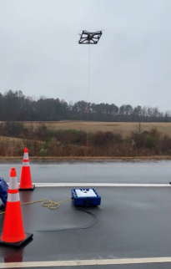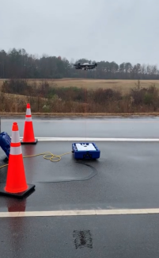Figure 2 shows two photographs taken at an IMAP UA demonstration. The first photograph (left) shows an IMAP operator using a tablet interface to pilot the UA and monitor video feeds. The second photograph (right) shows how the tethered UA connects to the IMAP vehicle.
Figure 1: North Carolina IMAP demonstrates their tethered UA being deployed and taking flight. (Photo credit: Berthaume, December 2022).

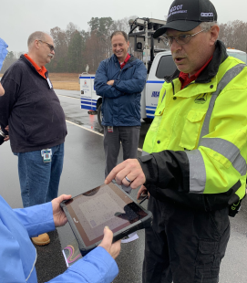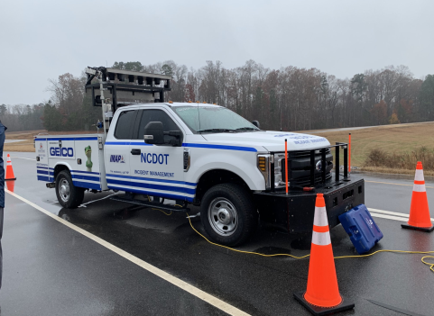Uses of UAS by SSP Programs
Figure 2: North Carolina IMAP demonstration of their vehicle-powered tethered UA, and explaining how to use the tablet interface to pilot the UA and monitor video feeds. (Photo credit: Berthaume, December 2022).
SSPs report using UAs to directly assist in their daily operations by:
- Monitoring traffic conditions at incident sites;
- Quickly and effectively surveying and documenting the scene of a crash; and
- Inspecting incident areas for other environmental or situational hazards, keeping those dangers under observation.
SSPs that have integrated UAs into their fleet may be asked to use them to support other agencies and tasks. These secondary uses include:
- Supporting safety and security at special events;
- Replacing boots-on-the-ground in dangerous situations to scan for hazards (such as unexploded ordinance or avalanche potential); and
- Locating missing persons.
These primary and secondary uses are explained in further detail below.

[Primary Use] Traffic monitoring at an incident site
SSP Programs can use UAS to monitor traffic conditions for incidents in areas where traditional pole-mounted pan/tilt/zoom (PTZ) cameras are limited or unavailable. This includes rural areas outside the TMC’s camera network, and segments with limited or no camera deployments near the incident.
- Michigan’s SSP uses UAs at large incidents on arterial streets to monitor traffic and get “eyes on the road or area.”
- Tennessee DOT uses UAs for incident and traffic management.
- Washington State DOT also uses UAs for incident management.
Figure 3 shows an aerial image of a traffic incident, captured by a UA. The image shows how UAs can provide a clear view of both the incident and traffic conditions, allowing TMCs to monitor oncoming vehicles and response activity at the incident.
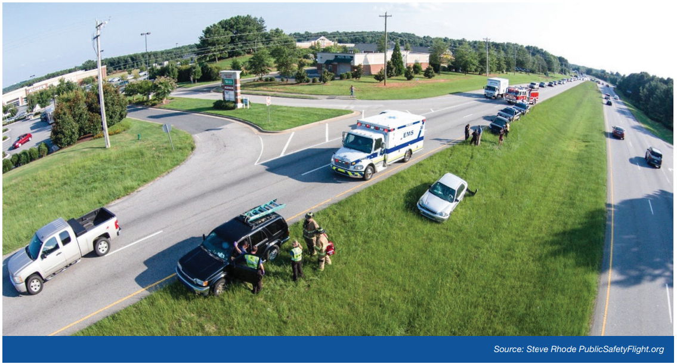
Figure 3: Aerial footage of a traffic incident captured by a UA. Image taken from the FHWA Every Day Counts (EDC) 6 Factsheet on TIM and Unmanned Aircraft, availble online: https://ops.fhwa.dot.gov/tim/docs/EDC-6_Factsheet_TIM_UnmannedAircraft_v2_508.pdf

UAs can fill critical gaps in TMC camera networks, but when tethered to a vehicle, the UA is only available when the vehicle is available. Because of this, some SSP Programs restrict deployment of their UA-equipped trucks so they’re available for incidents in camera-poor regions. For instance, North Carolina limits the operation of their tethered UA to incidents where few or no pole-mounted traffic cameras are in the area, or when an additional camera is justified or significantly useful.

[Primary Use] Surveying and documenting the scene of a crash
Serious crashes often result in multi-lane or full-road closures. To reopen travel lanes, crashed vehicles and debris need to be cleared quickly. Some crash scenes need documentation for investigative purposes before vehicles or debris can be moved. UAS can be quickly deployed to effectively survey and document crash scenes. UA cameras can provide aerial photographs, and UAs equipped with lidar can map and measure an area, allowing full crash scene reconstruction. This enables a full and thorough investigation, while expediting roadway clearance to restore traffic flow.
Both tethered and battery-powered UAs can be used to document crash scenes, but battery-powered UAs offer additional utility and flexibility. Battery-powered UAs are not bound to a specific SSP asset, so they can be shared between operators and vehicles and deployed as needed. Battery-powered UAs have limited flight time due to battery capacity, however, surveying and photographing a crash scene takes 10-15 minutes, which is within the operational range for most battery-powered UAs. Since they aren’t anchored to a truck or trailer, these units can move around the crash scene and take photos from multiple angles, fully capturing the crash scene.

- Washington State uses UAs to assess and document crash scenes, particularly when fatalities occur. Washinton also takes advantage of their UA’s 3D mapping capabilities to map and measure distances, object locations, elevations, etc. for crash scene documentation.
- Georgia Highway Emergency Response Operators (HERO) has a virtual reality software that can use UA-collected footage and data to reconstruct crash sites in 3D.

[Primary Use] Monitoring other hazards and incidents
Traffic isn’t the only hazard that UAs can monitor.
UAs have been used to scan incident scenes during SSP response, looking for hazards and monitoring environmental dangers besides the flow of traffic. This includes soil and slope stability during mudslides, water flows during flooding, and general monitoring during hazmat incidents.
- Utah’s SSP program used UAS in avalanche and mudslide situations.
- Indiana and North Carolina found UAS to be useful during flooding events.
- Michigan used UAs for monitoring planned special events.
When used in this manner, UAs improve safety for SSP operators on-site, and allows them to focus more on incident response tasks.

[Secondary Use] Supporting Special Events
If an SSP program has a UA, they might be asked to use it to support other agencies during special events. UAs have been used to supplement security camera networks to cover “blind spots” during sporting events, such as marathons and similar events. They have also been used to monitor large crowds during gatherings. An SSP UA can be leveraged to provide additional support and surveillance at special events, especially when SSP operators are already onsite providing traffic management support.

[Secondary Use] Scanning for hazards at emergencies other than freeway incidents
SSP operators are often called out to hazardous scenarios that require road closures. Some of these scenarios involve situations that present additional physical or environmental hazards. In these cases, SSP UAs have been used to scan a large area quickly, without placing first responders into a hazardous situation.
Utah reports using their UA to examine snow drifts for the potential for an avalanche. Using the UA allowed responders to assess the danger in a region without placing responders in harm’s way.
Tennessee reports using their UA to find people and debris during a munitions plant explosion in 2025. The explosion scattered live ordinance and potentially explosive materials across a vast area. SSP arrived on scene to close roadways in the area, while other first responders were called in to search for casualties and survivors. The SSP used their UA to support the search, scanning the region for survivors and explosive materials. Using the UA allowed agencies to conduct a search without putting first responders in danger. It also enabled a more efficient search in an emergency where time was of the essence.

[Secondary Use] Locating missing persons
UAs equipped with thermal imaging can help law enforcement and first responders locate missing persons. Because a body’s thermal image “stands out” against most backgrounds, and because UAs provide aerial coverage, these devices can scan a large area quickly and effectively. Thermal-camera-equipped UAs are especially helpful in situations with limited visibility, such as at night, or in a wooded or grassy area where vegetation obscures line-of-sight.
One SSP (MDOT) reports using their thermal camera to find an unconscious person that was ejected from a car and into a grassy field during a nighttime crash. The thermal camera helped find the individual quickly, which allowed for faster medical assistance.
Louisianna used their SSP thermal cameras to help locate escaped convicts. Thermal cameras identified heat signatures that helped law enforcement track and locate the convicts.
Another SSP program used their thermal-camera-equipped UA to help locate a child reported lost in the woods. The SSP assisted law enforcement, using their UA and thermal camera to scan broad regions quickly – eliminating some areas from the search.

UAS Operational Requirements
To effectively integrate UAS into SSP programs, and to optimize the impacts of UAS on daily SSP operations, a variety of requirements need to be met, and considerations need to be taken into account:
- Training and licensure. Operating a UA in public spaces often requires specific training and licensure – specifically, FAA Part 107.
Some SSPs have licensure requirements for their UA pilots. For example:
  - Utah’s DOT requires licensure for UAS pilot operations.
  - Georgia’s SSP program mandates all SSP personnel that pilot a UA be either: (1) a licensed UA pilot (i.e., FAA Part 107), or (2) under direct supervision of a licensed and GDOT approved UA pilot. These licensed pilots and supervisors must be approved by GDOT.
Not every State requires FAA Part 107 licensure. For example:
  - Michigan’s SSP does not currently require a license to operate its UAS.
In addition to licensing, pilots need ongoing training to remain up-to-date on the protocols, processes, rules, regulations, and best practices for UA usage.
- Tethered vs. untethered UAs. Tethered and untethered UAs range in price, capabilities, and features. Determining which units best support SSP program objectives, deciding how many units to acquire, and funding the costs (including capital, operational, and maintenance) is required before a program decides to integrate UAs into their daily operations.
- [for tethered UAs] Installation. If a program purchases a tethered UA, then the unit needs to be installed on an SSP asset – usually a vehicle or trailer – to use as a power source.
- [for untethered UAs] Daily charging / ensuring batteries are fully charged. Battery-powered UAs need a charging station, and charging needs to be routinely performed. Care needs to be taken to ensure batteries remain charged, even if a unit hasn’t been used recently, as fully-charged UA batteries can discharge slowly over time. It’s important that batteries always remain fully charged so the UA is available when needed.
- Transmission of UA video to the TMC. Many UAs transmit their video over the internet. TMCs need access to video feeds to use UAs for traffic monitoring. Due to security concerns, many TMCs operate using a closed system architecture, limiting internet access and making it difficult to integrate new video feeds. For all SSP programs that intend to use UAs to monitor traffic, a solution is needed to transmit UA video to the TMC and onto the video wall.
  - TMCs that don’t have internet access on their video wall. For TMCs where video walls are fully air-gapped from the internet, a solution is required to bridge that gap. SSP programs often implement unique work-arounds to address this. For instance, one TMC reported having one computer connected to the internet and network, but not the TMC video wall. They streamed UA video to the internet-capable computer, then used a meeting platform (such as MS Teams) to screenshare to other computers in the TMC network. Although these work-arounds are fine for program piloting and testing, more robust and secure solutions will be required to enable long-term use of UAs.
  - UAs that don’t use a consistent URL to transmit video. Fotokite UAs are tethered units that transmit images (thermal and standard video) from the UA to a ground station using a secure wired connection (i.e., the tether cable). This data is processed at the ground station, then broadcast to a local Wi-Fi network and through 4G/LTE/5G simultaneously. Using the Fotokite Live app, SSP operators near the ground station can view video by connecting their tablet or monitor to the ground station’s short-range Wi-Fi network. Remote users, however, must use the internet to access video streams, using a secure internet link to view video transmitted over the 4G/LTE/5G network.

Some UAs transmit their video using a static URL, meaning end users can access the video feed by logging into the same URL every time the UA is used. Some UAs transmit their video to a randomly generated URL, meaning end users need to navigate to a new URL to view video feeds each time the UA is used. URLs can be shared via QR code to help streamline this process.

For TMCs, additional difficulties arise for UAS that generate a new URL to stream video every time the UA is deployed. Some UAs, such as FotoKite, generate a new unique URL every time the UA is deployed – meaning the URL for the video feed changes each time the UA is used. Because the URL changes, a permanent solution often cannot be easily coded to transmit video feeds to the TMC. This could be especially problematic for TMCs that share video feeds with other responders, such as law enforcement, since the new URL needs to be shared each time.
- Standard Operating Procedures (SOP) and protocol for when and where to use the UAs. If an SSP has one UA, and there are two simultaneous incidents that would benefit from using the UA, which incident uses the UA? SSPs need to establish rules and methodologies to determine which incidents get priority. If the UA is tethered to an SSP vehicle, should that vehicle be used regularly or should it be reserved for incidents in rural areas with limited traffic camera coverage? These (and other) considerations need to be addressed in an SOP. SOPs will vary from State-to-State, as will the content covered in each State’s UA SOP – for example:
  - Georgia DOT’s SOP includes guidance for UA usage near controlled airspace. It reiterates some requirements laid out in FAA Part 107 (such as, that SSP UAs must yield right of way to other aircraft), and documents the protocols and requirements for SSPs (such as, when operating a UA near an airport SSP operators must obtain a waiver or airspace authorization granted by FAA). Additionally, Georgia’s SOP includes guidance on UA deployment conditions, establishing minimum weather and visibility for operations.
  - Florida DOT developed a UAS website and brochure that lays out UA usage rules, as well as the roles and responsibilities for pilots, law enforcement, airports, and other UA users and/or other individuals that interface with UAs. ,
- Identify and coordinate with other state divisions, departments, or groups regarding UA usage. UA usage in a state may be regulated or monitored by other departments or agencies within a state. UA usage should be planned and coordinated with these agencies. For instance:
  - Tennessee uses its aeronautics division to determine their SSP UAS requirements for their tethered UAS.
  - Georgia’s SSP program uses the Federal Aviation Administration rules and regulations to ensure their UAS usage complies with federal law.

Benefits and Limitations of UAs in SSP Programs
As a result of UAS pilot programs, SSPs better understand the potential benefits and limitations of UAS. SSP program managers also better understand how to use UAS technologies to maximize their impact and efficacy.

Benefits of UAS
Based on feedback from SSP programs, the UAS pilots demonstrated multiple benefits. These include:
- Tethered UAS are useful for monitoring traffic incidents and traffic flow conditions on roadways with limited cameras.
- UAS are useful for quickly and thoroughly surveying and documenting crash scenes.
- UAS have been useful in supporting and monitoring other incidents, emergencies, and special events. Examples include:
  - Locating people when thermal camera is equipped,
  - Monitoring other hazards that could endanger SSP operators onsite, such as mudslides or rising flood waters,
  - Monitoring special events, such as marathons, providing additional security cameras where needed.
These benefits are further explained below.

Tethered UAs are useful for monitoring traffic when roadside cameras are limited
UAS have proven useful for roadway segments and regions with few or no pole-mounted cameras. UAS video feeds can be transmitted to TMCs, giving TMC operators the ability to monitor traffic flow during incident response.
Battery-powered UAs are not as useful for monitoring traffic. The flight time of most battery-powered UAs is often less than 30 minutes, meaning the UA cannot be deployed for longer-term incidents. Additionally, battery-powered UAs need to be recharged between incidents/deployments, which can take an hour.
States like Michigan, Tennessee, and Georgia, have improved SSP operator safety by using UAs to monitor traffic flow near incident sites. This was shown to be especially useful for long-term and large-scale incidents such as bridge collapses, and particularly in areas where pole-mounted camera coverage was incomplete.

UAS have been useful in supporting and monitoring other incidents, special events, and emergency scenarios.
UAS can be used to monitor other potential hazards that may be present onsite. Drones have been used to monitor flooding incidents. Indiana’s SSP found drones were extremely valuable during a flooding incident to ensure water would not overtop a bridge. Subsequently Indiana’s DOT received increased funding for 7 more drones. North Carolina used Fotokite drones for a flooding incident in 2024; their experiences justified an increase in UA funding for drones.
Some states SSPs use UAs to enhance safety and security for special events. Michigan recently used their SSP drones to monitor a marathon route, providing security footage for areas that did not have existing camera coverage. UAs have also been used to monitor vehicle queuing at or near stadiums before or during games and concerts.
The thermal cameras on UAs have shown to be particularly helpful, assisting other agencies such as law enforcement and successfully locating people and objects in areas (such as tall grass) or times (such as night) with limited visibility. Multiple programs report using UA thermal cameras to help locate missing people; for instance, Michigan’s safety service patrol collaborates with police who request support from SSP’s UA, using the thermal camera technology to locate missing people. Michigan SSP also deployed their UA to locate a person who had been ejected from a vehicle.
UAs can also be used to scan a dangerous location, helping locate victims and hazards without putting operators and first responders at risk. For instance, Tennessee recently had a major explosion at a munitions factory that scattered unexploded ordinance across a wide area. Law enforcement and first responders needed to search the area for wounded victims, however, entering the area would place them in danger. Their SSP used the UAs to scan the region, helping to locate unexploded ordinance and helping to quickly find any wounded persons onsite.

UAs are useful for surveying crashes.
SSPs reported that UAs are useful for surveying crash sites. Notably, the Washington State Patrol reduced their investigative time at crashes by 70% by using the UAS (drone) equipment.

Limitations of UAS in an SSP Environment

Integrating UAS into legacy systems
There are some technological issues associated with UAS, particularly regarding integration of a drone’s video feed into the closed-loop CCTV systems typically used by TMCs. For example, Fotokite systems generate a new URL every time the UA is used. This can be beneficial for some SSP programs, like Michigan DOT, because it limits video access to select individuals. However, these UAs require different solutions for transmitting video data which create an additional layer of video storage and management activity for SSPs.
Integrating UAs into regional ITS plans could assist with identifying and overcoming these technological issues. Washington’s SSP program uses tethered UAs as a larger part of intelligent management systems; outcomes and findings from that effort are as yet unknown.

Strategic deployment and a Standard Operating Procedure (SOP)
UAS management and deployment requires careful and strategic thought. It is sometimes difficult to determine where and when to use UAS. An SOP for where and how to use UAs could help bridge this gap; programs considering UAS could develop an SOP that addresses known concerns. These concerns include:
Which incidents to use the UAs. If a UA is deployed at an incident and/or if a vehicle with a tethered UA is on patrol, then that UA will not be available for other incidents. An SOP could help determine what incidents the UA should be deployed at, as well as other considerations to ensure UAs are available when needed. The same point can be made about the availability of licensed UA pilots.
Programs in North Carolina and Indiana identified challenges with placing the UA in the right place at the right time.
Roles and responsibilities with UA operations. Adding a UA to an incident adds a new task onsite. Roles and responsibilities should be defined in the SOP. Indiana’s SSP program explains there are difficulties in determining who focuses on traffic control and operates UA during SSP operations.
Where to deploy the UA with respect to the incident. The location and angle the UA is deployed should be described in the SOP. For example, most SSP vehicles approach an incident from behind, however, an SSP vehicle equipped with a UA might need to park downstream from the incident, so the UA camera can monitor both the incident and traffic approaching the incident.
Considerations should be made for conditions that limit visibility, such as solar glare or inclement weather. It can be difficult to operate a UA in windy conditions. It can also be difficult to see video feeds in windy or rainy conditions, or sunrise/sunset conditions where the UA is facing the sun. An SOP should describe how to handle inclement weather and how to accommodate conditions where visibility might be reduced.

Availability of licensed UA pilots (FAA Part 107)
Licensure requirements for SSP UA usage also may be a challenge for SSPs. States must consider whether to require specific licenses for operators and potential implication of this license, including costs. Some states utilize and require licensures while others may not similarly require this for UA operations. Utah’s DOT requires licensure for UA pilot operations; however, states like Michigan do not require this licensure.
Ultimately, the issues in UA usage lie in determining proper means, and incongruent licensure requirements for UA operations in SSPs.

Conclusions
UAS can add meaningful value to an SSP program. For programs considering UAS, managers should consider the value added, the potential use cases, and weigh the known limitations and considerations required to deploy UAs.

From the FAA: “An unmanned aircraft system is an unmanned aircraft and the equipment necessary for the safe and efficient operation of that aircraft.” https://www.faa.gov/faq/what-unmanned-aircraft-system-uas
Unmanned Aerial Systems (UAS). FHWA. https://www.fhwa.dot.gov/uas/
FHWA UAS Library on the EDC-5 webpage. https://www.fhwa.dot.gov/uas/library.cfm
From FHWA Office of Operations’ Every Day Counts (EDC) website. Unmanned Aircraft Systems for Traffic Incident Management. Factsheet. https://ops.fhwa.dot.gov/tim/docs/EDC-6_Factsheet_TIM_UnmannedAircraft_v2_508.pdf
Article on Talbot County, Maryland website: Emergency Services Deploys Drone During Hazmat Incident. July 25, 2024. https://talbotcountymd.gov/press-releases/emergency-services-deploys-drone-during-hazmat-incident
See https://www.fhwa.dot.gov/innovation/everydaycounts/edcnews/20240808.cfm for examples using a QR code.
FDOT website: Unmanned Aircraft Systems (UAS). https://www.fdot.gov/aviation/uas.shtm
Unmanned Aircraft Systems (UAS): A Brief Guide of Current Regulations and Guidelines. Published by FDOT. https://fdotwww.blob.core.windows.net/sitefinity/docs/default-source/aviation/uas-brochure-2021-final.pdf?sfvrsn=23bcd85b_6

