Quarterly Progress Report (QPR)

Applications of Enterprise GIS in Transportation – Part 2
Progress Report for Quarter 3 [October 1st, 2025 – December 31st, 2025]
WSP Program Manager: Jag Mallela (jag.mallela@wsp.com)
WSP Technical Lead: Abhishek Bhargava (abhishek.bhargava@wsp.com)
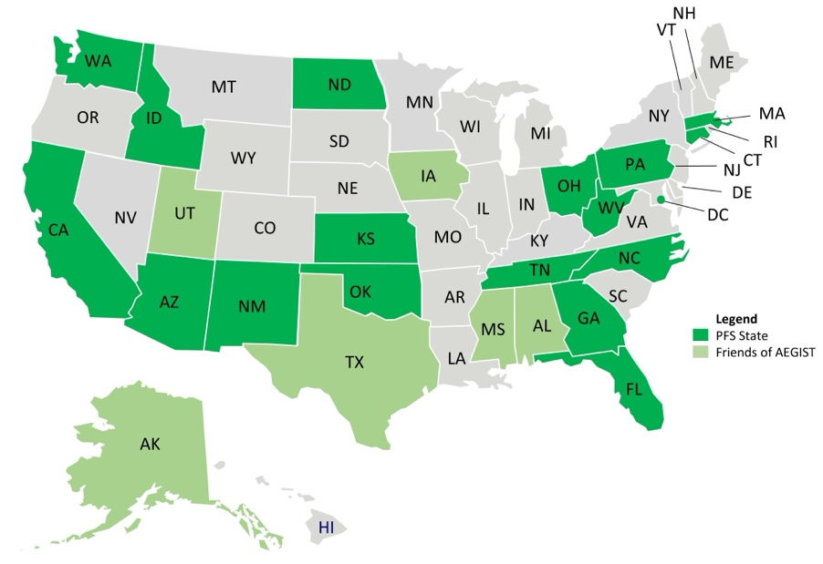
Background
The Pooled Fund Study (PFS) on Applications of Enterprise GIS in Transportation (AEGIST) was initiated by FHWA in 2018. During 2019-2024 (AEGIST Part 1), a guidebook was developed for transportation agencies in the United States, with the primary objective of documenting guidance on how spatial and linear referenced data should be managed by States. Also, Technical Services were provided to 15 State DOTs. The technical services activities included:
- Geoprocessing tools development
- Web applications development
- Geodatabase management
- Data Governance
- Intersection data model development for MIRE
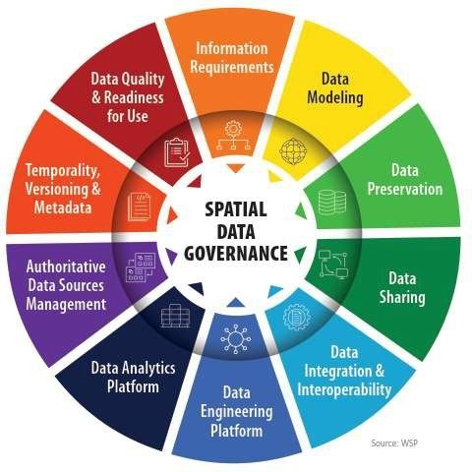
- Lidar and/or Imagery data management and processing (using AI) for asset data extraction
- AI Knowledge Platforms (chatbot) deployment for GIS/LRS Training and Ad-hoc Data querying
- Event data processing and integration with ALRS
- Local roads data integration with DOT LRS
- Design-Construction Digital As-builts data integration
AEGIST Part 2: Project Objectives
During October 2024 – October 2027, AEGIST Part 2 will be executed.
- Develop structured spatial data management systems and processes. This involves establishing governance systems, business rules, applications, and tools for modeling transportation data, especially linear referencing system (LRS) data. Facilitate importing, exporting, and conflating road network data across DOT LRS and Federal, State, and Local data systems.
- Utilize, develop and deploy Artificial Intelligence (AI) tools, systems and techniques to support technical services to AEGIST pooled fund states related to geospatial data management and government.
- Establish guidelines for managing and governing data in spatial and linear referencing systems at transportation agencies, including but not limited to routes, intersections, interchanges, roundabouts, road segments, roadway characteristics, infrastructure assets, model inventory of roadway elements (MIRE), HPMS data items and ARNOLD road network.
- Update the AEGIST Guidebook that was prepared during 2019-2024 by continuing to document best practices across agencies in managing spatial data using enterprise data systems, including but not limited to Asset Management Systems, Traffic and Safety Systems, Project Planning and Programming Systems, Design and Construction Systems, and GIS and Linear Referencing Systems (LRS).
- Conduct conference presentations, webinars, workshops and meetings of the pooled fund states and provide technical services to the States participating in the pooled fund to develop national standards in data modeling and management; enhance existing enterprise GIS systems at these agencies.

Work Accomplished This Reporting Period: October 1st – December 30th 2025

Task 1: Project Management
Task Objective: Perform project management activities, which include conducting monthly status meetings, developing quarterly status reports, creating a project work plan, managing project resources, schedule, deliverables, and communication with all stakeholders.
Activities:
- Developed and delivered weekly and monthly progress reports along with invoices for September, October, and November 2025.
- Technical Summaries: Prepared formal summaries detailing the technical services work completed for California, Idaho, and Massachusetts.
- Future Planning: Developed the 2026 technical services work plans for West Virginia, Oklahoma, and DCDOT.

Task 2: Technical Services
Task Objective: Provide technical services to PFS States by completing various agency-specific and cross-agency activities identified in the work plan.
Activities:
California (CaRS)
- Infrastructure and Web Service Development: Architected the ArcGIS Data Hub for road network data sharing among Caltrans, CalOES, and counties, which included establishing access roles, designing a specialized stakeholder web page, and developing a catalog of web feature services.
- Data Conflation and Technical Analysis: Automated the analysis of road data conflation results between Caltrans All Roads and NG911 data to identify missing roads by functional class and established geospatial feature classes to publish the final results.
- Dataset Integration and Metadata: Identified and documented specific Caltrans HPMS and ALRS datasets for inclusion in the hub, while developing metadata and documentation for all geospatial services scheduled for publication.
- Stakeholder Outreach and Engagement: Facilitated monthly CaRS working group meetings featuring live demonstrations of new feature services and provided counties with data integration packages and instructions for using change proposal data to update local datasets.
- Collaboration and Follow-up Actions: Coordinated with stakeholders to secure road data for Shasta and San Benito counties and established ALRS and HPMS web services for ingestion into the 1Integrate tool.

Idaho
- Model Delivery and Compliance: Presented a statewide intersection data model derived from ALRS routes that meets MIRE specifications, delivering the model along with the MIRE data dictionary and AEGIST Guidebook to specialized units for testing.
- Workflow and Stakeholder Collaboration: Established a collaborative business workflow where the GIS unit manages geometry while the Traffic/Safety unit handles MIRE attributes, supported by formal tool reviews and stakeholder meetings to finalize future project steps.
- Technical Enhancements: Improved the modeling tools by updating geoprocessing logic for interchange polyline features to include mainline and ramp segments and enhancing bridge polyline development to account for grade-separated intersections.
- Testing and Review: Performed unit testing of intersection model data using ITD ALRS data, documenting issues for future sprints and publishing results on SharePoint for team review.
- API Development: Continued building web APIs for intersection modeling designed to assist states in creating features within the standardized data model.

Massachusetts
- Reviewed intersection data provided by the MassDOT traffic and safety team for ingestion into the Intersection data model.
- Customized the Intersection data schema to align with MassDOT’s specific traffic and safety data.
- Developed a backlog of features, identifying MIRE data items that require automated rules to be configured for calculating values and updating the geodatabase.

West Virginia
- Updated the process for labeling imagery extracted from the image server to prepare training data for AI model development.
- Researched approaches for generating coordinate vertices using the training AI model.
- AI Training Preparation: Updated the process for labeling imagery extracted from the image server to create training data for AI model development.
- Vertex Generation Research: Conducted research into various AI model approaches for the automated generation of coordinate vertices.

Task 3: Marketing and Communication
Task Objective: Webinars and Workshops will be held, and Articles will be presented in conferences and other industry forums to communicate information about the activities of the project, especially the technical work products developed as part of the project.
Activities:
- Workshop Collateral and Documentation: Compiled necessary materials for the AEGIST GIS-T Workshop, including the abstract, presenter list, and contributor biographies.
- Presentation and Demonstration Development: Created the presentation deck and a technical demonstration environment to showcase intersection models developed for Idaho and Massachusetts.
- Strategic Narrative and Standards Integration: Refined a story-driven narrative explaining the AEGIST vision and pooled-fund model, specifically focusing on how combining ISO, OGC, GMNS, and bSI standards for route and intersection modeling improves decision-making.
- Use Case Modeling: Developed content outlining three levels of use cases—planning, intelligent routable network, and multimodal/lane-level—to demonstrate how standardized road network modeling benefits diverse business units.
- Coordination and External Outreach: Facilitated discussions with presenters to establish roles for upcoming sessions and developed a specialized slide-deck for a TRB presentation regarding Network Analysis modeling using AEGIST data models.

