Quarterly Progress Report (QPR)

Applications of Enterprise GIS in Transportation – Part 2
Progress Report for Quarter 3 [July 1st, 2025 – September 30th, 2025]
WSP Program Manager: Jag Mallela (jag.mallela@wsp.com)
WSP Technical Lead: Abhishek Bhargava (abhishek.bhargava@wsp.com)
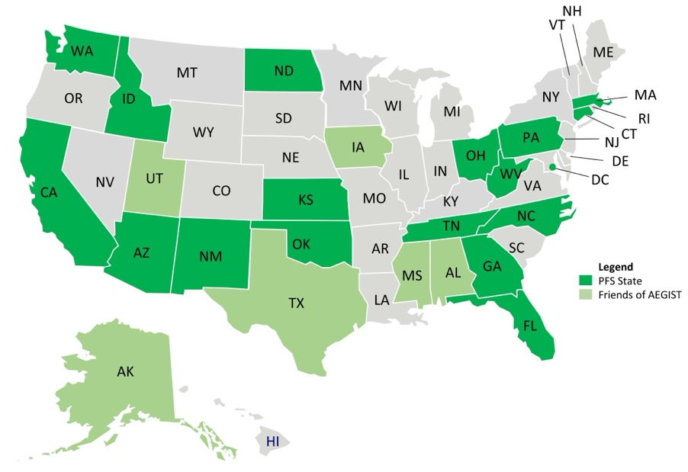
Background
The Pooled Fund Study (PFS) on Applications of Enterprise GIS in Transportation (AEGIST) was initiated by FHWA in 2018. During 2019-2024 (AEGIST Part 1), a guidebook was developed for transportation agencies in the United States, with the primary objective of documenting guidance on how spatial and linear referenced data should be managed by States. Also, Technical Services were provided to 15 State DOTs. The technical services activities included:
- Geoprocessing tools development
- Web applications development
- Geodatabase management
- Data Governance
- Intersection data model development for MIRE
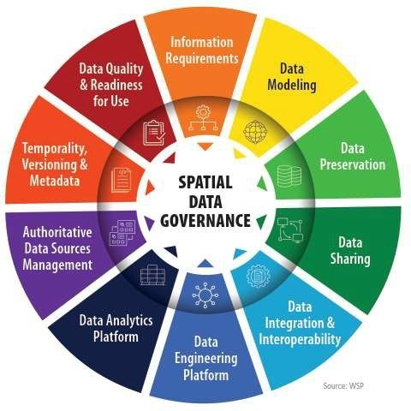
- Lidar and/or Imagery data management and processing (using AI) for asset data extraction
- AI Knowledge Platforms (chatbot) deployment for GIS/LRS Training and Ad-hoc Data querying
- Event data processing and integration with ALRS
- Local roads data integration with DOT LRS
- Design-Construction Digital As-builts data integration
AEGIST Part 2: Project Objectives
During October 2024 – October 2027, AEGIST Part 2 will be executed.
- Develop structured spatial data management systems and processes. This involves establishing governance systems, business rules, applications, and tools for modeling transportation data, especially linear referencing system (LRS) data. Facilitate importing, exporting, and conflating road network data across DOT LRS and Federal, State, and Local data systems.
- Utilize, develop and deploy Artificial Intelligence (AI) tools, systems and techniques to support technical services to AEGIST pooled fund states related to geospatial data management and government.
- Establish guidelines for managing and governing data in spatial and linear referencing systems at transportation agencies, including but not limited to routes, intersections, interchanges, roundabouts, road segments, roadway characteristics, infrastructure assets, model inventory of roadway elements (MIRE), HPMS data items and ARNOLD road network.
- Update the AEGIST Guidebook that was prepared during 2019-2024 by continuing to document best practices across agencies in managing spatial data using enterprise data systems, including but not limited to Asset Management Systems, Traffic and Safety Systems, Project Planning and Programming Systems, Design and Construction Systems, and GIS and Linear Referencing Systems (LRS).
- Conduct conference presentations, webinars, workshops and meetings of the pooled fund states and provide technical services to the States participating in the pooled fund to develop national standards in data modeling and management; enhance existing enterprise GIS systems at these agencies.

Work Accomplished This Reporting Period: July 1st – September 30th 2025

Task 1: Project Management
Task Objective: Perform project management activities, which include conducting monthly status meetings, developing quarterly status reports, creating a project work plan, managing project resources, schedule, deliverables, and communication with all stakeholders.
Activities: Developed and delivered weekly progress reports and monthly reports for June, July, and August 2025. Prepared invoices for June and July 2025. Created a task backlog and action plan based on previous months' progress.

Task 2: Technical Services
Task Objective: Provide technical services associated to PFS States by completing various agency-specific and cross-agency activities identified in the work plan.
Activities:
- Caltrans
  - Prepared and conducted the monthly CaRS Working Group meeting, developing a slide deck and poll to discuss schedule, agenda, objectives, and additional topics.
  - Updated all CaRS artifacts created since 2021 and consolidated them for presentation. Prepared an automated script for processing county data files for input into the 1Integrate environment.
  - Executed 1Integrate jobs for county data conflation with Caltrans ALRS data, specifically for San Luis Obispo county, generating and reviewing change proposals. Investigated change proposal results from San Luis Obispo to assess alignment, configuration updates, and correct identification of geometric differences per AEGIST rules.
  - Coordinated with Caltrans and 1Spatial regarding 1Integrate configuration and data conflation issues. Developed an annual conference schedule for the CaRS working group. Prepared a list of activities for the upcoming sprint, including data processing, analysis of change proposals, and integration efforts. Held the monthly CaRS task force meeting to discuss road data quality assessment rules. Identified next steps for continued collaboration and data sharing. Coordinated with CalOES on deliverables, including structure and communication.
  - Planned the execution of conflation processes for remaining counties during the week of August 25th. Provided CalOES with updates on county conversations, stakeholder artifacts, and ongoing efforts.
  - Updated 1Integrate configuration to conflate NG911 and Caltrans data, with a plan for five counties. Ran data conflation for four counties, reviewing results and discussing issues. Met with Caltrans to assess confluence results and identify necessary refinements.
  - Analyzed conflation results for accuracy, categorizing by roadway class, and refined the proposal outputs. Investigated geoprocessing tools for RouteID and Functional Class to improve results for Caltrans and CaRS counties.
  - Conducted the monthly CaRS Task Force, presenting on data conflation and change proposals. Held meetings with the CaRS Core Group to review progress, data quality rules, and next activities. Updated the CaRS Technical Data Architecture and Data Hub Report. Coordinated an upcoming meeting with 1Spatial on data conflation. Planned future monthly meetings focused on data modeling and QA/QC. Discussed the CaRS task force plan for the next six months, including volunteer county involvement.
- District of Columbia DOT
  - Developed and continued to enhance a batch data processing tool designed to accept point data as input and locate it as an event on the road network in the LRS.
  - Ensured the enhanced tool correctly locates the processed data on the LRS.
  - Created test data for the geoprocessing tool and established test scenarios and scripts for its unit testing.
  - Executed test scripts and iterated through the development to fix issues related to accurately locating points on the road network.
  - Compared the results of the batch geoprocessing tool with a single-point input tool to identify differences in processing results.
  - Prepared for a meeting with DC DOT to present the developed tools and unit testing results.
- Idaho DOT
  - Held a monthly technical services meeting on data quality, governance, intersection modeling, and FLMA roads. Scheduled a deep-dive on AEGIST Intersection approach and shared feature classes.
  - Processed roads, intersections, and lidar data, loading into ArcGIS. Integrated intersection geoprocessing into Idaho's environment for script execution.
  - Set up development environments for federal and FLMA roads conflation. Updated project backlog with geoprocessing tools for Idaho data. Developed a work plan, scope, budget, and presentation.
  - Discussed intersection data modeling with ITD units, establishing next steps with automated tools. Coordinated multiple discussions with ITD on intersection modeling needs and technical approaches.
  - Created a baseline environment using ITD road data for intersection modeling. Developed a tool to validate route geometry. Set up conflation environments for scenarios.
  - Prepared an intersection model by converting the bridges layer into a linear format and extracting data from the ITD GIS services. Loaded Idaho LRS data for intersections.
  - Developed a schema update tool for extra data fields and ensured compliance with MIRE standards. Customized intersection data model for Idaho LRS and feature classes. Coordinated with ITD for future discussion.
- Massachusetts DOT
  - Updated the intersection model geoprocessing tool to add functionality for classifying nodes and points, and to utilize these classifications to generate road elements and interchange features differently.
  - Re-executed the intersection geoprocessing tool to generate nodes and points according to MIRE 2.1 specifications and AEGIST Guidebook definitions, flagging specific node/point types. Enhanced logic for generating road elements, utilizing points in addition to nodes to create additional elements at interchanges. Enhanced logic to create the interchange polyline feature class using nodes, points, and road elements.
  - Executed the updated intersection model for multiple states to test that the updates will work without errors. Unit tested results generated from the intersection geoprocessing tool to validate results and performed enhanced test scripts with more checks on generated intersection data. Started testing of nodes, points, road elements, and interchange feature classes.
  - Updated the intersection data model automation tool so it can be used with various route configurations and route data files to generate intersection data. Updated the intersection modeling tool to include the functional class of a road in its logic for developing intersections.
  - Held meetings with MassDOT's traffic and GIS units to present the intersection model and the features automatically generated from LRS routes, structures, and functional class data. Reviewed and enhanced automated intersection data modeling rules, establishing the need to include features like medians and AADT.
  - Identified that MIRE table attributes, such as the number of intersection legs, can be populated automatically using geospatial data.
  - Developed tools to configure MIRE data attributes as a relationship table within the intersection data model.
  - Automatically populated the MIRE attributes relationship table using information from features generated by the Intersection modeling tool and reviewed the data for alignment.
  - Held discussions with MassDOT Traffic and Safety about preparing the MIRE Data model using the AEGIST Intersection data model and integrating their data for MIRE data management.
  - Addressed an issue with flagging approach and departure segments due to differing digitization methods and brainstormed solutions. Demonstrated data issues relating to bridge locations impacting the intersection model.
- Oklahoma DOT
  - Developed a geoprocessing tool for creating intersection features using the Oklahoma Routes data.
  - Enhanced the geoprocessing tools for extracting sidewalks and bike lanes data for Oklahoma using Open Street Maps and Overture Maps.
- West Virginia DOT
  - Developed geodata warehouse architecture and a data integration vision and approach.
  - Updated the backlog of technical services activities necessary for enhancing and updating the WVDOT geodata warehouse.
  - Held data warehouse architecture development work sessions with West Virginia DOT.
  - Reviewed WVDOT's enterprise Geodatabase and Geo-datawarehouse data pipelines from various sources including Assetwise, Fugro, Deighton, and Esri Roads and Highways.
  - Presented data warehouse architecture options and data management strategies for managing and governing the data warehouse.
  - Developed a plan and updated the sprint backlog for work to be done in August and September.
  - Coordinated with WVDOT to set up a meeting to discuss the scope of the Datawarehouse Development and Architecture Task.
  - Continued to develop geoprocessing tools to extract turn segments/lanes data from open sources for use in AI Model training dataset labeling.
  - Prepared a demonstration of the AEGIST Intersection Model for WVDOT to share information on how their intersection data model would be created.
  - Developed a technical services work plan for geodatabase data management, which outlines how AEGIST will architect the data schema and pipelines for integrating data from business systems into the enterprise geodata warehouse.

Task 3: Marketing and Communication
Task Objective: Webinars and Workshops will be held, and Articles will be presented in conferences and other industry forums to communicate information about the activities of the project, especially the technical work products developed as part of the project.
Activities:
- Developed an article on AEGIST Intersection Data Model development and highlighted how MIRE and AEGIST establish intersection data modeling guidelines
- Developed an article on AEGIST guidelines on levels of development in Road Network Data Model for various modeling dimensions, components and elements.
- Developed an article on Applications of Artificial Intelligence techniques in Road Network Data development.
- Attended TRF Conference and presented an AI-model created for predicting traffic on roads where traffic data is not collected annually.
- Coordinated with FHWA to discuss what the AI model does, how it can be used, and how it helps with predicting traffic based on road characteristics like functional class, facility type, temporal trends in traffic, and road location.
- Completed development of an article on the use of AI for predicting traffic on road segments with missing data and how it supports Traffic Data Collection programs.
- Developed and submitted an abstract for the GIS-T workshop on Intersection Modeling, which will cover data generation, maintenance, and governance.
- Coordinated with presenters and facilitators from Idaho, Massachusetts, and the FHWA to confirm their availability for the workshop.

