TRANSPORTATION POOLED FUND PROGRAM
QUARTERLY PROGRESS REPORT

Lead Agency (FHWA or State DOT): North Carolina DOT

INSTRUCTIONS:
Lead Agency contacts should complete a quarterly progress report for each calendar quarter during which the projects are active. Please provide a project schedule status of the research activities tied to each task that is defined in the proposal; a percentage completion of each task; a concise discussion (2 or 3 sentences) of the current status, including accomplishments and problems encountered, if any. List all tasks, even if no work was done during this period.

Transportation Pooled Fund Program Project #  TPF-5(493) |  | Transportation Pooled Fund Program - Report Period:  □ Quarter 1 (January 1 – March 31)  □ Quarter 2 (April 1 – June 30)  □ Quarter 3 (July 1 – September 30)  XQuarter 4 (October 1 – December 31)
TPF Study Number and Title:
TPF-5(493) – Investigation of Dual Grade/Hybrid Steel Plate Girders Utilizing Stainless Steels

Lead Agency Contact:  Jason Provines | Lead Agency Phone Number:  (434) 293-1917 |  | Lead Agency E-Mail:  Jason.provines@vdot.virginia.gov
Lead Agency Project ID: | Other Project ID (i.e., contract #): |  | Project Start Date:  2/13/24
Original Project Start Date:  2/13/24 | Original Project End Date:  11/13/26 |  | If Extension has been requested, updated project End Date:  N/A

Project schedule status:
X On schedule □ On revised schedule □ Ahead of schedule □ Behind schedule

Overall Project Statistics:
Total Project Budget | Total Funds Expended  This Quarter | Percentage of Work  Completed to Date
$400,000 | $83,676.81 | 50%

Project Description:

Corrosion is a major concern for steel bridges, and if not properly designed for or mitigated, can lead to costly maintenance or service failures. One such option for making steel bridges more corrosion resistant is by using a dual grade girder, in which ASTM A709 Grade 50CR (50CR) plate is welded or bolted to conventional steel bridge girder components. In this case, the 50CR could be placed in a more corrosive environment, such as under a deck joint, and the conventional steel bridge material would be placed in other areas to allow for cost savings. However, there are still several unknowns related to welded and bolted dual grade connections.

This project will address those unknowns through experimental testing and analysis. Dual grade welds will be fabricated with different welding parameters, and PQR tests will be conducted to evaluate the welds for their structural performance. NDE research will be conducted to determine the suitability of eddy current to be used for weld inspection and to refine UT techniques to account for the high attenuation of austenitic weld metals and the different ultrasonic velocity and high anisotropic ratio of 50CR. Corrosion research will be conducted to assess the galvanic, stress, pitting, and crevice corrosion performance of dual grade connections. Results from that corrosion research will then be used to determine appropriate bolt types to be used in bolted dual grade connections. Additionally, torqued tension testing of stainless steel bolts will be conducted to determine tabulated values for installation pretension and installation criteria (such as rotation requirements for turn-of-nut installation).

After the experimental testing and analysis are complete, a final report will be developed. It will include recommendations for additions or revisions to be made in the AASHTO LRFD Bridge Design Specifications, AASHTO Bridge Construction Specifications, and AASHTO/AWS D1.5 that will allow welded and bolted dual grade connections to be designed, fabricated, and constructed successfully.

Progress this Quarter (includes meetings, work plan status, contract status, significant progress, etc.):

Task 1 – Literature Review

No work was done on this task. 100% completed.

Task 2 – Connection Testing & Verifying Design/Fabrication Details

Task 2A – Welded Dual Grade Connections

All test specimens were cut by VTRC and were shipped out to their respective testing agencies.

VTRC has completed all the side bend and fillet weld break testing. Analysis is underway of the test results. A methodology has been successfully developed for the stress corrosion cracking tests. The test method involves a self-reacting loading protocol for the specimens. During loading, stresses in the samples will be measured using digital image correlation (DIC) to obtain accurate stress data. Three stress corrosion cracking samples are included for each welding parameter combination. These samples will be loaded to “low” (~5 ksi), “medium” (~10 ksi), and “high” (~15 ksi) stress values before testing. These stress values were selected to conservatively mimic potential sustained stresses in steel bridge connections. After being stressed, these samples will be placed in a corrosion chamber and will be subject to 90 corrosion cycles using the SAE D2334 protocol.

Utah State has completed polishing the macroetch test specimens to a 1000-grit finish. Standard laboratory equipment and experimental procedures for the macroetch specimens are currently being validated, and macroetch testing should be completed soon. Their Universal Testing Machine (UTM) has been updated and calibrated and is now prepared for reduced-section tensile testing. In parallel, the team will begin polishing and etching specimens for DIC to conduct reduced-section tensile tests. The DIC system is expected to arrive in January. Preparations for accelerated corrosion testing are ongoing. The research team is awaiting installation of the accelerated corrosion chamber, after which accelerated corrosion experiments will begin.

Missouri University has conducted ultrasonic testing (UT) on machined dissimilar metal weld specimens (G1–G5) containing 5/64-in. side-drilled holes (SDHs) to simulate internal defects. Each specimen includes four SDHs: one located at each fusion boundary between the weld metal and the adjacent base material, and one additional SDH in each base metal positioned approximately 2 in. from the fusion boundary. The base-metal SDHs serve as reference reflectors for evaluating wave propagation characteristics and signal attenuation relative to defects located at or beyond the weld region. Initial UT was performed using a 2.25 MHz angle-beam transducer to assess the ability of shear waves to detect SDHs located at the fusion boundaries and after propagation through the weld. While the base-material SDHs were consistently and accurately detected, strong background reflections originating from the weld region were observed and significantly affected the detectability of SDHs at the fusion boundaries. Ongoing work focuses on evaluating longitudinal-wave inspections at multiple frequencies and refraction angles to identify optimal inspection parameters for improved defect detection in the weld region.
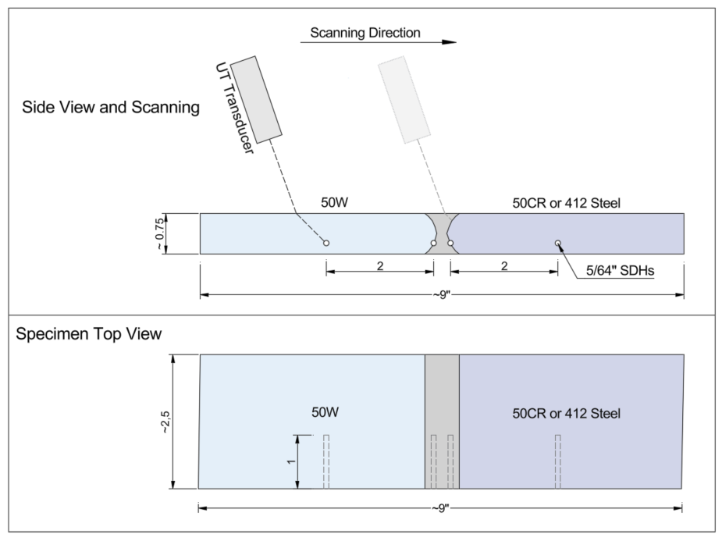
Figure 1: Typical machined dissimilar metal weld specimen with four 5/64-in. side-drilled holes used for ultrasonic testing.

Task is 60% completed.

Task 2B – Bolted Dual Grade Connections

No work was done on this task in this period.

Task is 60% completed.

Task 3 – Final Report & Guidelines

No work was done on this task in this report period. 0% completed.

Virginia Transportation Research Council (VTRC)/University of Virginia (UVA) Dissimilar Metal Welding Research Project

VTRC and UVA have completed their project on evaluating dissimilar metal welds made between 50CR/412 and 50W/A36. The report was submitted to VTRC in October 2025. It has since been submitted to the VTRC publishing team for revisions. The report will be shared with the TPF TAC once it has been approved by VTRC.

The weldability evaluation showed that DMWs made between 50CR/412 steel and A36/50W steel are susceptible to solidification cracking and cold cracking. Both types of cracking can be eliminated using lower heat input and a single-V with backgouge weld joint. Crack-free DMWs were found to meet the mechanical property requirements of the AASHTO/AWS D1.5 Bridge Welding Code.

DMWs experienced uniform, pitting, galvanic, and intergranular corrosion. Galvanic corrosion was present in the heat affected zones (HAZs) on both sides of the stainless steel weld interface. The A36/50W steel HAZs experienced accelerated uniform corrosion as compared to A36/50W steel base metal. The 50CR steel experienced accelerated pitting and intergranular corrosion as compared to 50CR steel base metal.

The nondestructive evaluation results showed challenges with radiographic testing, ultrasonic testing (UT), and phased array ultrasonic testing (PAUT) of the DMWs. Some radiographic testing conducted at the fabricator displayed artifacts that could mask potential defects in the welds. DMWs also exhibited ultrasonic anisotropic behavior and ultrasonic wave refraction, causing typical ultrasonic and phased array ultrasonic testing procedures to mislocate or completely miss defects in DMWs.

Based on the results, the Virginia Transportation Research Council recommends that VDOT not pursue using 50CR/412 steel in dissimilar metal welds due to remaining challenges with their corrosion performance and nondestructive evaluation. The Virginia Transportation Research Council also recommends that VDOT continue to exercise caution with specifying 50CR steel due to recent poor quality and long lead times. Both recommendations allow VDOT to proactively manage risk on future projects and help to ensure structural integrity and on time and on budget project delivery.

Anticipated work next quarter:

Task 1 – Literature Review

This task has been completed. No additional work planned.

Task 2 – Connection Testing & Verifying Design/Fabrication Details

Task 2A – Welded Dual Grade Connections

VTRC will complete the analysis on the results of the side bend and fillet weld break tests. VTRC will begin the stress corrosion cracking testing.

Utah State will complete the macroetch testing and will begin conducting the reduced section tension testing using the DIC to measure behavior. Installation of the corrosion chamber will be completed, and the corrosion testing of the welded and bolted samples will commence.

Missouri University will continue to conduct UT on remaining groove weld samples. Analysis will continue to evaluate longitudinal-wave inspections at multiple frequencies and refraction angles to identify optimal inspection parameters for improved defect detection in the weld region.

Task 2B – Bolted Dual Grade Connections

The research team will order materials and begin assembling bolted specimens for accelerated corrosion testing.

Task 3 – Final Report & Guidelines

No work is planned on this task in the next report period.

VTRC/UVA Dissimilar Metal Welding Research Project

No additional work. This project has officially completed.

Significant Results:

Due to the early stages of this project, no significant results have been found yet.

VTRC/UVA Dissimilar Metal Welding Research Project

- Dissimilar metal welds made between 50CR/412 steel and 50W/A36 steel can meet the mechanical property requirements of the AASTHO/AWS D1.5 Bridge Welding Code. This requires using different welding parameters than those typically used for other steel bridge welds.
- Dissimilar metal welds made with 50CR/412 steel and A36/50W steel experience a significant reduction in corrosion resistance compared to non-dissimilar 50CR steel welds and the base metals in these welds. The heat affected zones of the weld and the base metals experience multiple forms of detrimental corrosion including uniform, pitting, galvanic, and intergranular corrosion. The corrosion resistance of the heat affected zones in these dissimilar metal welds is as follows, from greatest corrosion resistance to least: 50CR steel/309L weld metal >> 50W steel/309L weld metal > A36 steel/309L weld metal.
- Significant challenges remain with the nondestructive evaluation of dissimilar metal welds made with 50CR/412 steel and A36/50W steel. Radiographic testing using parameters typically used for other bridge welds has the potential to mask potential defects in these dissimilar metal welds. Due to the ultrasonic anisotropy of dissimilar metal welds, defects in the welds can be missed or mislocated using traditional ultrasonic testing calibration processes. Further, ultrasonic wave refraction can lead to missing or mislocating defects in these welds when inspecting them using traditional ultrasonic testing or phased array ultrasonic testing.
- 412 steel is a potential alternative to 50CR steel. 412 steel has a similar chemistry to 50CR steel, which gives it a similar corrosion resistance, has similar mechanical properties to 50CR steel, and is regularly produced by a domestic steel supplier. However, it does not meet the current heat treatment requirements for Grade 50CR steel as specified in ASTM A709.

Circumstance affecting project or budget. (Please describe any challenges encountered or anticipated that
might affect the completion of the project within the time, scope and fiscal constraints set forth in the
agreement, along with recommended solutions to those problems).

None.

Potential Implementation:

The primary research product will be the final report as developed in Task 3. Recommended changes to the AASHTO LRFD BDS/BCS and AWS D1.5 will be included in appendices within the report and will be based on the combined results from this research and the VTRC/UVA research dual grade welding research. Recommended changes will be written in a similar format to the specifications for which they are intended (i.e., recommendations for AASHTO specifications will follow a two-column specification/commentary format, and recommendations for D1.5 will follow a two-chapter specification/commentary format.). Using a similar format to existing specifications will allow these revisions to be more easily balloted and adopted.

The research team will present at conferences, meetings, and the AASHTO/NSBA Collaboration as well as develop journal publications to disseminate research findings to the steel bridge community. The research team will also present recommendations to the AASHTO Steel and Metals committee for review/adoption into the AASHTO LRFD BDS/BCS and to the Joint AASHTO/AWS Bridge Welding Subcommittee for review/adoption into AWS D1.5.

