Continuous Bituminous Pavement Stripping
Assessment through Non-Destructive Testing

Task #2 - Processing and Preliminary Evaluation of 3DGPR Data

Task 2 Report

October 7, 2025

All data collected as described under Task 1 has been processed and reviewed by the project team. The initial review has included qualitative analysis of the data using Examiner, ARRB Hawkeye (for TSD data) and other available tools. A second phase evaluation has used detailed data analysis with currently available analytic tools (e.g. Examiner and Expore3DGPR), and correlation with supporting data (deflections, surface distress, core data). TSD and FWD data has been analyzed for more detailed measures of the pavement condition, such as SCI-12, as described below.

- Analysis of Data Collected at MnROAD Stripping Test Site

The data sets described in Task 1 were analyzed to investigate the correlation with the known defects built into the test section. The PSPA test provides data to carry out a spectral analysis of surface waves (SASW) evaluation of the change in modulus with depth. Figure 1 shows the test equipment and the type of results obtained for intact and damaged pavement. The PSPA also provides an impact-echo test which provides a “thickness resonance” related to the intact depth of the pavement. The GPR data responds to inhomogeneities within the pavement structure A sample b-scan of the GPR data in Figure 2 shows how the defect features in the test section appear in the GPR data. Note that the GPR signal appears to be more sensitive to the coarse defect material (red color) than the fine treated material (green). This is likely due to the presence of larger voids within the coarse material

Figure 3 shows the results of this initial analysis. Based on this analysis, the following conclusions were reached.

- The PSPA SASW modulus at 7-inch depth dropped anywhere from 30 to 70 percent within each of the defect areas
- The FWD SCI-300 value jumped from a background value of 20 µm to values ranging from 40 to 400 µm within the defect areas. Interestingly, the bigger jumps were in areas with the treated material.
- The impact-echo thickness resonance dropped anywhere from 25 to 75% within the defect areas. Note that the effectiveness of Impact Echo decreases with increasing temperature. The temperature at the time of the testing was 65 degrees F.
- The GPR activity analysis using a threshold of 90% above the mean matched many but missed some of the defect areas, especially the deeper ones in the middle of the section (cells 2418 and 2417).

One conclusion from these tests is that the FWD and PSPA would be useful as for local confirmation testing prior to coring.

- Analysis of the data provided by the states

The data provided by the states for the 10 selected sites was analyzed as follows:

- All 3DGPR data was processed in Examiner
- TSD data was analyzed to provide graphical output of SCI-12.
- Core data was evaluated and rated based on the level of observed damage.
- All core data was geolocated within the GPR and TSD data.
- Processed 3DGPR data was analyzed for stripping potential using an existing activity analysis algorithm.

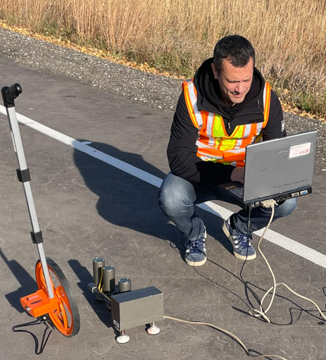
Intact

Stripped

Figure1 – PSPA Testing and Result

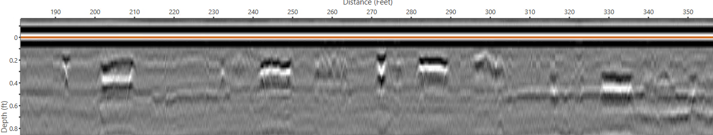

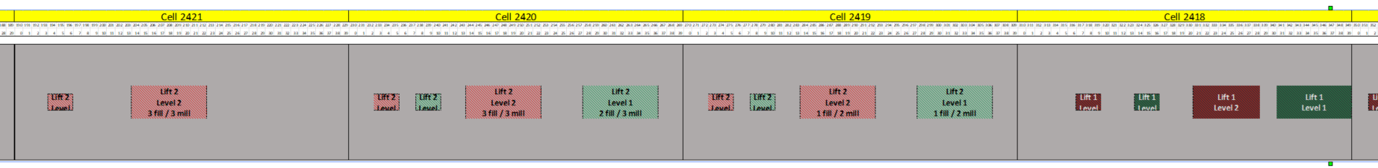

Figure 2 - GPR Data (above) Showing Embedded Defects (below)

Figure 4 shows examples of the results of the GPR processing and Figure 5 shows results of the FWD SCI-12 processing. The above processing was carried out at all available core test locations. Figure 6 shows the results of a GPR reflection activity analysis on a section of US-93 in Nevada along with the location of core NV4

IE Thickness Resonance

PSPA modulus At 7” depth

Test Section Plan View

FWD (SCI_300)

,

3DGPR Activity Analysis

Figure 1 – Analysis of Data Collected at the MnROAD Stripping Test Site

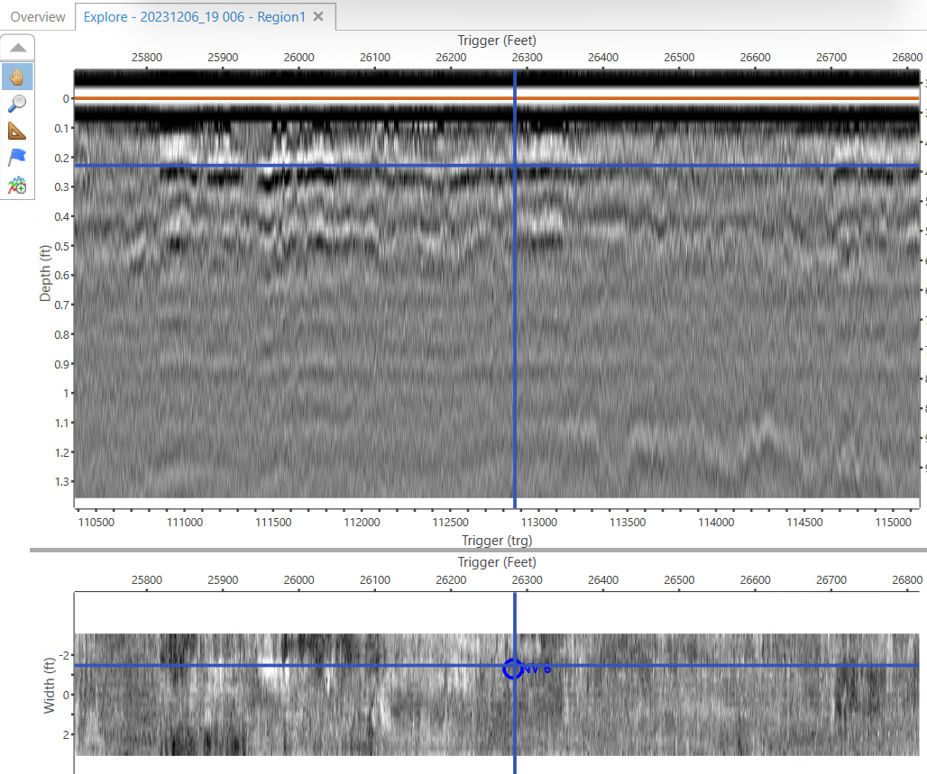
Figure 4 – Processed 3DGPR data from US-93 in Nevada showing location of core NV6

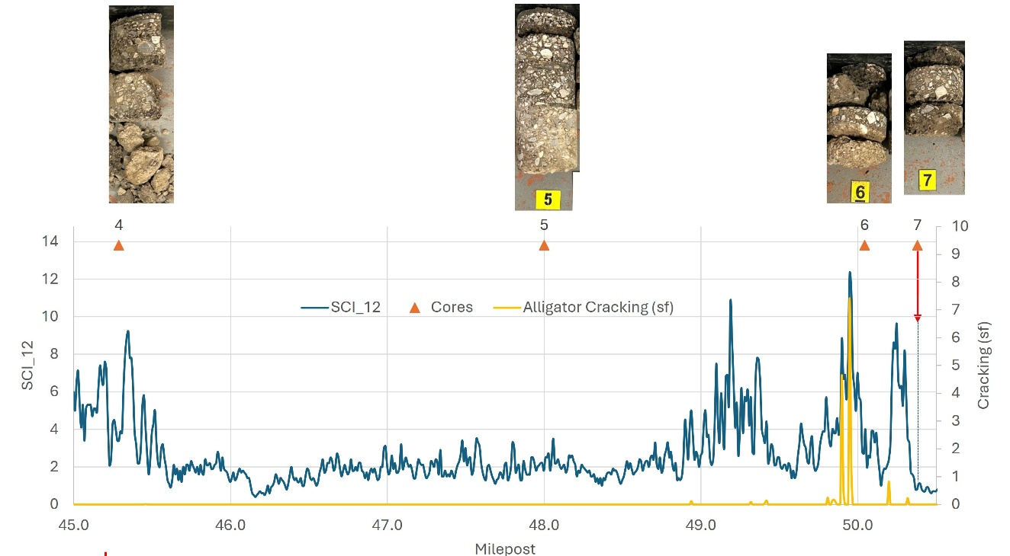

Figure 5 – Processed US-93 TSD Data showing core locations and core photos

. Figure 6 - GPR reflection activity analysis on a section of US-93 in Nevada along with the location of core NV4

- Setup of a Data Inventory

The data described above, for 10 road sections and 160 core locations has been organized into an easily accessible database referred to as the Inventory. A version of the Inventory has been provided to NRRA project manager on July 31, 2025. Screenshots of segments of the Inventory database are provided in Figures 7 and 8.

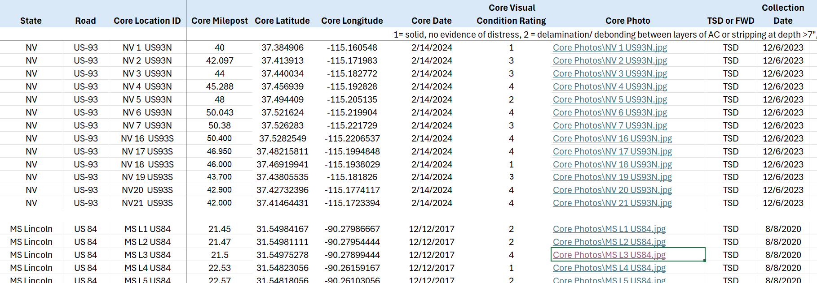

Figure 7 – Sample of Data from the Inventory Database Part 1

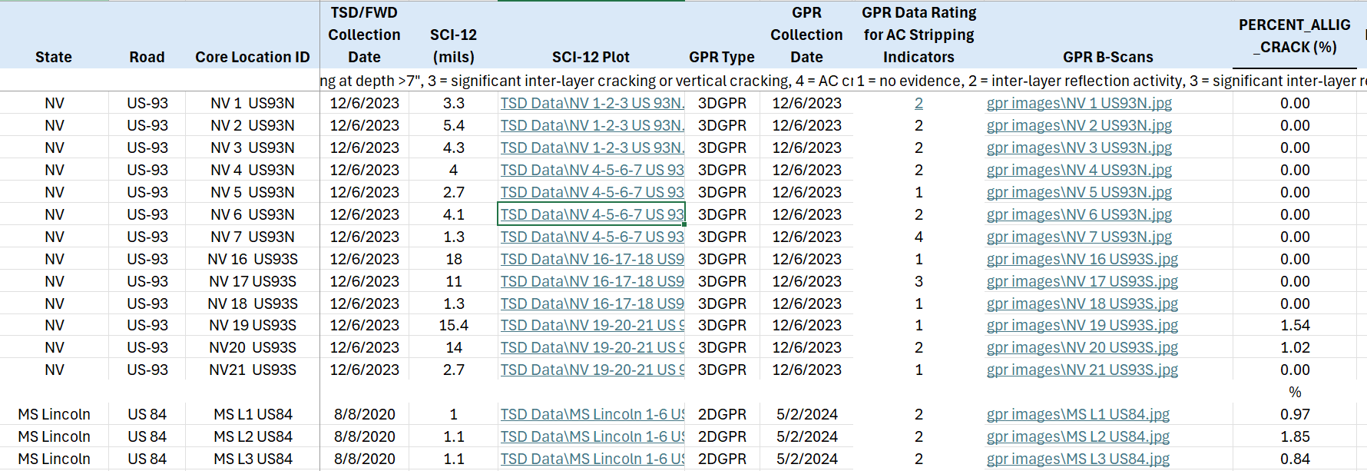

Figure 8 – Sample of Data from the Inventory Database Part 2

