Quarterly Progress Report (QPR)

Applications of Enterprise GIS in Transportation – Part 2
Progress Report for Quarter 2 [January 1, 2025 – March 5th, 2025]
WSP Program Manager: Jag Mallela (jag.mallela@wsp.com)
WSP Technical Lead: Abhishek Bhargava (abhishek.bhargava@wsp.com)
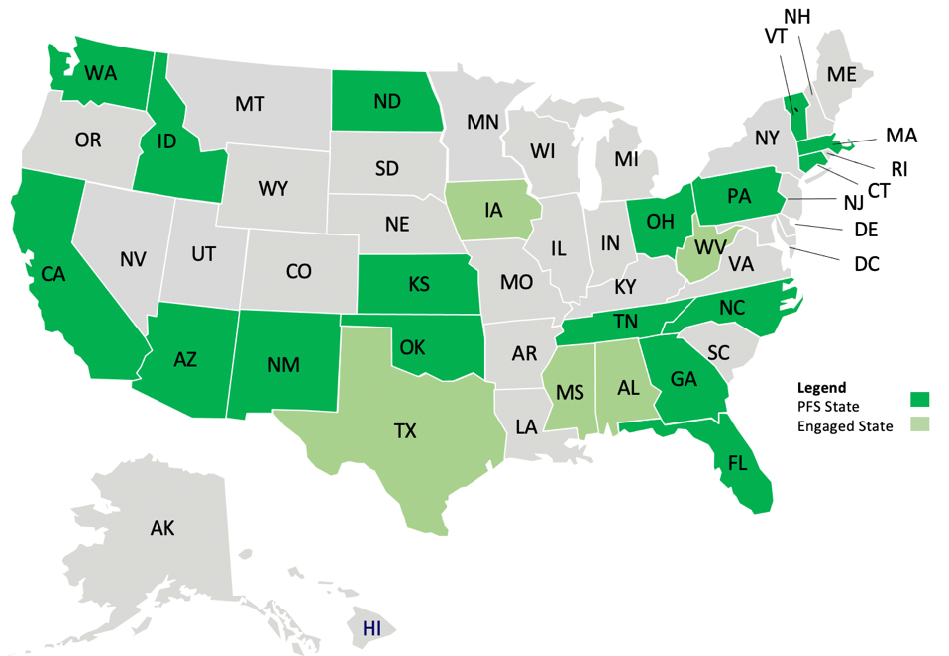
Background
The Pooled Fund Study (PFS) on Applications of Enterprise GIS in Transportation (AEGIST) was initiated by FHWA in 2018. During Phase 1 of this study a guidebook was developed for transportation agencies in the United States, with the primary objective of documenting guidance on how spatial and linear referenced data should be managed by States. Phase 2 of this PFS was initiated in October 2019. This phase will span over 5 years (October 2019 – March 2025), during which the objectives outlined below would be accomplished.
AEGIST Part 1: Project Objectives
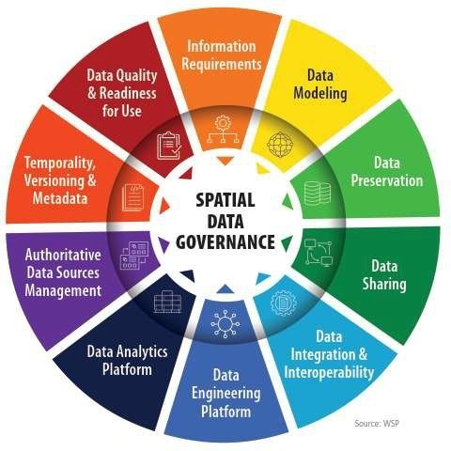
- Establish a standard for managing and governing data in spatial and linear referencing systems at transportation agencies, including but not limited to routes, intersections, interchanges, roundabouts, road segments, roadway characteristics, infrastructure assets, model inventory of roadway elements (MIRE), HPMS data items and ARNOLD road network.
- Develop guidance for States for modeling spatial transportation data, especially linear referencing system (LRS) data. Importing, exporting & conflating road network and roadway characteristics data across DOT LRS and Federal, State and Local data systems.
- Conduct a series of webinars, workshops, peer exchange meetings and provide consulting services to the States participating in the pooled fund to develop national standards in data modeling and management; enhance existing enterprise GIS systems at these agencies.
- Update the AEGIST Guidebook that was prepared in Phase 1 by documenting best practices, patterns and similarities across agencies in managing spatial data using enterprise data systems, including but not limited to Asset Management Systems, Traffic and Safety Systems, Project Planning and Programming Systems, Design and Construction Systems, and GIS and Linear Referencing Systems (LRS).
- Collaborate with States to enhance and develop spatial data management systems, processes, platforms to establish a structured and systematic approach for management of spatial data. This would involve establishing spatial data governance systems, business rules, applications, tools and platforms for:
  - Spatial Data Modeling
  - Spatial Data Integration and Engineering
  - Spatial Data Analytics

AEGIST Part 2: Project Objectives
During October 2024 – October 2027, AEGIST Part 2 will be executed.
- Develop structured spatial data management systems and processes. This involves establishing governance systems, business rules, applications, and tools for modeling transportation data, especially linear referencing system (LRS) data. Facilitate importing, exporting, and conflating road network data across DOT LRS and Federal, State, and Local data systems.
- Utilize, develop and deploy Artificial Intelligence (AI) tools, systems and techniques to support technical services to AEGIST pooled fund states related to geospatial data management and government.
- Establish guidelines for managing and governing data in spatial and linear referencing systems at transportation agencies, including but not limited to routes, intersections, interchanges, roundabouts, road segments, roadway characteristics, infrastructure assets, model inventory of roadway elements (MIRE), HPMS data items and ARNOLD road network.
- Update the AEGIST Guidebook that was prepared during 2019-2024 by continuing to document best practices across agencies in managing spatial data using enterprise data systems, including but not limited to Asset Management Systems, Traffic and Safety Systems, Project Planning and Programming Systems, Design and Construction Systems, and GIS and Linear Referencing Systems (LRS).
- Conduct conference presentations, webinars, workshops and meetings of the pooled fund states and provide technical services to the States participating in the pooled fund to develop national standards in data modeling and management; enhance existing enterprise GIS systems at these agencies.
AEGIST Part 2 Completion Status and Summary
Project Time Frame: October 1, 2024 to October 30, 2027
Total Time, months: 36
Time Expended, months: 4
Percent Calendar Time Expended: 11%
Percent Complete for Tasks & Sub-Tasks:

Work Accomplished This Reporting Period: January – March 2025

AEGIST Part 1

Task 1: Project Management
Task Objective: Perform project management activities, which include conducting monthly status meetings, developing quarterly status reports, creating project work plan, managing project resources, schedule, deliverables and communication with all stakeholders.
Activities:
- Prepared and delivered AEGIST Quarterly Report #21 and #22 for the periods Oct – Dec 2024 & Jan-Mar 2025.
- Technical services tasks managed for following PFS States: Arizona, Kansas, North Dakota, New Mexico, and Tennessee. Details provided in the section below on Task 2.

Task 2: Technical Services
Task Objective: Provide technical services associated to PFS States by completing various agency-specific and cross-agency activities identified in the work plan.
Activities:
- Kansas
  - Provided guidance on integrating the AEGIST intersection model with intersection data generated using the Rizing Intersection Manager and Esri ArcGIS Pro Intersection Tool.
  - Reiterated recommendations for utilizing Traffic events data for estimating Intersection Approach AADT (Annual Average Daily Traffic).
  - Scheduled a meeting to discuss how the AEGIST intersection data model and tools could be leveraged.
  - Reviewed the use of the ‘traffic sequence id’ in the Kansas ALRS geodatabase to assess how this information could be used to create and update the intersection data model.
  - Presented the intersection data model to Kansas DOT and discussed how the model could be integrated with the Kansas ALRS, Lidar, and existing Intersection Management data.

- New Mexico
  - Coordinated with New Mexico DOT to deliver the Intersection data that was generated from NMDOT routes.
  - Held discussions on how the delivered intersection data could be used by NMDOT to help them prepare for MIRE compliance.
  - Discussed the next steps and upcoming products and tools planned for 2025 related to intersection modeling.
  - Coordinated with New Mexico to present the developed intersection data model.
Note: The previous quarterly reports (QPR-20 and QPR-21) reported that work was completed 100% for New Mexico. The work reported above was done for New Mexico because the intersection model was enhanced for Kansas, and the enhancements were migrated to Florida, Massachusetts and New Mexico that received the intersection data model in the past.

- Massachusetts [Task 2.MA.]
  - Updates to the intersection data model using latest MassDOT Roads data published as web service.
  - Regenerated intersection data based on intersection modeling tool updates and delivered model.
Note: The previous quarterly reports (QPR-20 and QPR-21) reported that work was completed 100% for Massachusetts. The work reported above was done for Massachusetts because the intersection model was enhanced for Kansas, and the enhancements were migrated to Florida, Massachusetts, and New Mexico, which received the intersection data model in the past.

- Arizona
  - Technical services included discussions on the Route ID Architecture guidelines for Collector Distributor Roads and Flex Lanes.
  - Scheduled and held a call with the Arizona DOT team to review comments on the Route ID Architecture Report deliverable. Delivered updated report.

- North Dakota
  - Updated the report on Road Data extraction from Lidar to address previously identified issues, and generated results from the AI Model.
  - Documented additional information about how North Dakota DOT could use the AI model for extracting road data from Lidar.
  - Completed developing and delivering the deliverables on extracting road data from LiDAR data using AI.

- Tennessee
  - Held a meeting with the Design Group lead at TDOT to present the AEGIST deliverables and explain how the department could leverage them.
  - Re-shared the AEGIST deliverables with TDOT's Planning and IT groups to ensure they also understood how these could be utilized.
  - Developed detailed instructions on the use of deliverables by different business administration groups to facilitate the deployment of BIM-GIS integration at the enterprise level.
  - Deployed the design models on the iTwin platform to demonstrate how the platform could be used for facilitating data exchanges between designers and GIS personnel.
  - Developed documentation outlining the steps for TDOT to execute in 2025 to leverage the AEGIST deliverables and connect their Bentley infrastructure cloud with their ArcGIS infrastructure cloud.
Note: The previous quarterly reports (QPR-20 and QPR-21) reported that work was completed 100% for Tennessee. The guidebook was presented at the AEGIST meeting of the States in September 2025, and the evolution of best practices for BIM-GIS integration was discussed. The need to update the BIM-GIS integration deliverables that were delivered to Tennessee DOT was identified, to ensure that the TDOT deliverables are in sync with the Guidebook. Furthermore, the need to communicate with all Stakeholders at TDOT was identified to ensure that the AEGIST deliverables can be used effectively by TDOT in the coming years. Therefore, the above “knowledge transfer and deliverable maintenance support” activities were conducted to ensure that TDOT can leverage the AEGIST deliverables and all stakeholders are aware of how to use the deliverables.

AEGIST Part 2
Task 1: Project Management
Task Objective: Perform project management activities, which include conducting monthly status meetings, developing quarterly status reports, creating a project work plan, managing project resources, schedule, deliverables, and communication with all stakeholders.
Activities:
- Coordination began with DCDOT, WVDOT, Oklahoma DOT, and Idaho Transportation Department (ITD) to scope AEGIST Part 2 Technical Services.
- A roster of potential technical services was developed and shared with the AEGIST Part 2 States as a starting point for scope planning.
- The quarterly report for 2024 Q4 was developed.
- An article for EDC on Road Data Collaboration was created.
- An AEGIST Project Update was presented at the TRB AED Committee Meeting.

Task 2: Technical Services
Task Objective: Provide technical services associated to PFS States by completing various agency-specific and cross-agency activities identified in the work plan.
Activities:
- California
  - Continued development of the CaRS program deliverables, focusing on finalizing updates to the Memorandum of Understanding (MOU) to reflect revised roles and a regional responsibility model, and completing the Technical Data Architecture and Conflation report. Editorial styling of the MOU was aligned with AEGIST styling. Discussions were held with the CaRS Core Group and Task Force on ongoing activities and backlog.
  - Significant effort was dedicated to preparing and delivering the CaRS presentation at the CalGIS conference to communicate program goals and engage stakeholders, involving multiple planning calls, slide development, county coordination (including showcasing their roads data management processes), and using a Mentimeter poll for feedback.
  - Technical challenges related to data conflation using the 1Integrate tool were addressed through ongoing discussions, work sessions, testing configuration fixes in development and production environments, and investigating execution errors with 1Spatial and Caltrans.
  - Additional activities included exploring potential collaboration opportunities between CaRS and Overture with Merced and Fresno counties, migrating data comparison results from counties to the CaRS Roads Data Sharing Architecture document, pursuing county roads data integration using 1Integrate with Caltrans All Roads data, and documenting program workflows and agency responsibilities. A backlog of technical services tasks was prepared for 2025.

- West Virginia
  - Continued development of the intersection modeling tool, which was developed as part of AEGIST Part 1, to add MIRE data element tables and features. Approaches were investigated to generate an “Intersection ID” using routes and linear structures data.
  - Started developing a plugin for the ArcGIS platform to enable the execution of the AEGIST Intersection model tool using a more user-friendly tool, enhancing the integrated geoprocessing tool. The tool is specifically designed to add these MIRE elements into the intersection and intersection leg feature classes.
  - Technical services work planning meetings were held with WVDOT to discuss the scope for intersection modeling, imagery data extraction using AI, and geodatabase/data warehouse management and governance. A meeting summary and action items were developed.
  - Work progressed on asset data extraction using AI from imagery and/or terrestrial photography, including development of labeled imagery dataset for AI model training, geoprocessing and geo-transformation of imagery tiles, investigation of imagery labeling tools and techniques, research into approaches for labeling satellite imagery, coordination with Vermont University for labeled datasets, and analysis of the WV GIS Mosaic Map service resolution for AI model development feasibility.
  - Examples for an enterprise geo data warehouse architecture were developed for presentation to WVDOT.
- Oklahoma DOT
  - Technical services tasks were established, including Intersection modeling, Bike Lane/Routes Data Modeling, and Sidewalks Modeling. Planning calls were held to discuss AEGIST Technical Services opportunities for ODOT.
  - Investigation of datasets and models for training and finetuning of AI models for extraction of sidewalks data commenced. A geoprocessing tool was developed for extracting sidewalks data from OpenStreetMap and Google APIs to automate AI model development.
  - For all three tasks (Intersection, Bike Lane/Routes, Sidewalks), the approach for developing geoprocessing tools and/or automating modeling using data sources like imagery, open street maps, and street view data was investigated.
  - Work started on extracting MIRE elements data from the MIRE 2.1 guidebook for intersection data model development and mapping MIRE and HPMS data items to prepare the MIRE dataset using HPMS data. Potential services opportunities for MIRE Compliant intersection modeling were identified.
- DCDOT
  - Identified technical services work activities: develop batch geoprocessing tool to locate points on a route, Production Geodatabase architecture and deployment, and Develop Data Quality Assessment Tool.
  - Reviewed the approach and solutions for the development of the batch geoprocessing tool for locating points on the route.
  - Prepared the agenda for a technical discussion on Tasks 1-3 for further development of scope and discussion on the development environment and approach.
  - Defined potential technical services opportunities for DCDOT, including intersection data development, LRS Data Preparation/Geospatial Data Engineering, Geo-database Management Services, Data Governance, AI Knowledge Platform, Integration with External Systems, LiDAR/Imagery/Videos for LRS Data Extraction, Customized Geoprocessing tools using SQL, Python, and/or AI techniques, Topological/Routable Network development, and Data Redundancies/Data Quality Assessment Tools.
- Idaho
  - Technical services work plan development meetings were coordinated and held with ITD to discuss AEGIST Technical Services for 2025-2027.
  - AEGIST Intersection features and AEGIST Levels were shared with the ITD team. Potential technical services tasks to provide automated checks to intersections across the state network were discussed.
  - Defined technical services opportunities for ITD to be: Intersection approach modeling, LRS data quality review and automation, Federal Roads data conflation, NG911 Roads data conflation, Address Modeling, Digital project delivery and building information modeling.
  - Monthly calls were scheduled to continue refining the scope, schedule, and activities for AEGIST Technical Services with the ITD team. The AEGIST Technical Services project folder was shared with the ITD team. A presentation on BIM-GIS Integration was developed for Idaho to demonstrate it as a potential technical service activity.
- Massachusetts
  - Investigation began into the development of an ArcGIS Pro plugin for intersection model development, specifically for executing the intersection geoprocessing tool developed during 2022-2024.
  - Coordination and discussions were held with MassDOT regarding the Intersection model delivered the previous year and next steps.
  - A roster of potential technical services activities for discussion with Massachusetts was built. Follow-up meetings were scheduled to continue AEGIST technical services as part of Part 2.
  - Investigation also included published ArcGIS geoprocessing web-services for intersection data model development. A prototype deep learning model was developed for extracting road data from lidar and imagery for identifying missing local roads. The MassDOT Intersection model was updated to remove nodes at flyovers.
  - A list of MIRE data columns from the MIRE report was compiled into a data dictionary to automate the addition of MIRE fields into the Intersection data model.
Task 3: Marketing and Communication
Task Objective: Webinars and Workshops will be held, and Articles will be presented in conferences and other industry forums to communicate information about the activities of the project, especially the technical work products developed as part of the project.
Activities:
- GIS-T Workshop: Extensive work was done on the GIS-T workshop material, including the AEGIST Guidebook, Minimum Content Guidelines (MCG), AI, presentation slides, handouts/worksheets, and website content/webpage tool. The AEGIST Road Network Data Planner web tool was deployed for demonstration and exercises. Coordination occurred with speakers/presenters on facilitation plan, presentation script, roles, responsibilities, discussion topics. Travel instructions for invitational travelers were prepared and FHWA approval sought. The workshop was conducted on April 7th, and materials were delivered to participants via email and website. Meetings were held with AEGIST States (West Virginia, North Carolina, New Mexico, Washington) to discuss technical services work following the workshop.
- Other Presentations/Conferences: Development started on an AI model for predicting AADT data based on historical traffic data and location information for presentation at the TRF conference in July. An abstract was prepared and submitted for the 2025 AMPO Annual conference on Geospatial Data Generation Using Artificial Intelligence for Model Inventory of Road Elements (MIRE), focusing on automatic generation of roads and intersection data. An abstract was prepared for the Traffic Safety Forum on Using Generative AI for creating traffic data for rural, low-volume roads. A list of conference presentations to be made in 2025 was developed, identifying conferences for abstract submission.
- Created an article on Road Data Collaboration to lay out how local agencies (counties, cities, municipalities) can work with State departments of transportation (DOT) to build the road network dataset by conflating and unifying their roads datasets.
Task 4: Annual Meeting of the Pooled Fund States
Task Objective: Conduct the annual meeting of the AEGIST pooled fund states
- Task 4.5: AEGIST Meeting of the Pooled Fund States, Meeting 5, Idaho
- Planning for the 2025 Annual Meeting of the AEGIST States, scheduled for September 9-11, 2025.
- Coordination occurred with the host agency, ITD, to review venue reservations and other logistics, including scheduling a meeting to discuss logistics and reserving the venue. Next steps associated with planning and obtaining conference approval with FHWA were discussed.
- Communication material was developed and updated for outreach to the AEGIST States, including a Save the Date flyer, Meeting Information flyer, Call for Presentation flyer introducing themes and topics, and draft emails to request attendees and presentation submissions. Coordination with FHWA was requested for review of flyers, registration page, and email.
- The AEGIST website was updated to post information about the meeting objectives and a call for presentations registration page. The registration and abstract submission page was developed.
- A production plan was prepared outlining activities and key milestones leading up to the meeting, coordinating with stakeholders (organizers, presenters, attendees).
- Enhancements were added to the Road Network Model Planner tool for discussion and evaluation at the Meeting of the States. The AI Model Planner tool information was connected to the AI LLM Model to create a fine-tuned model for generating guidelines on road network modeling based on user queries. Continued development of the AEGIST Road Network Planning Tool progressed so that states can use it to feed data to the AI Agent and help specify road modeling rules and specifications.
- Compiled the list of MIRE (Model Inventory of Roadway Elements) elements from the MIRE report for addition to the intersection data model that was created using the routes geoprocessing tool.

