Progress Report – 3/31/2022

Title: Assessment and Repair of Prestressed Bridge Girders Subjected to Over-height Truck Impacts Pooled Fund Project

Project Number: TR202011

Principal Investigator (PI): Mohamed ElGawady PhD (PI)
Co-PI(s): William Schonberg PhD, PE (Co-PI)

Award date: | 1/1/2021
Scheduled completion date: | 12/31/2023 | % of project completed to date: | 35%
Total budget: | $755,000 | % of budget expended to date: | 38%
Draft report due: | 9/30/2023 | Final report due: | 12/1/2023

Provide a short description of the work currently underway.
Use additional notes section if you need to provide more information.
While not part of the tasks, it is essential to establish a good team to carry out the research tasks. Interviewing more than 30 potential students were carried out and four graduate students were selected and the hiring process started.

Task 2. Experimental testing of bridge girders subjected to lateral impacts: There is a delay in receiving the small size setup and the wheels for the full-scale cart. The small size test setup will be shipped on April 15th. However, all required pieces for the full-scale test set up arrived to Rolla (Figs. 1-2). The installation of the test setup for the large-scale testing is moving forward. HSS were used as cross ties for the impact rail. The cross ties were drilled and installed in the laboratory strong floor. Steel H-beams and rails were also drilled and fixed on top of the cross ties. Four vertical stubs were fabricated using W-shaped cross sections. Plates were fixed atop of the columns having inclined angles to accommodate the H-shaped beams and the rails. The plates were also drilled to fix the rail. Currently, the cured segment of the rail is being manufactured. The cart is being manufactured awaiting the arrival of the wheels. The instrumentation for the testing will be finalized as well.

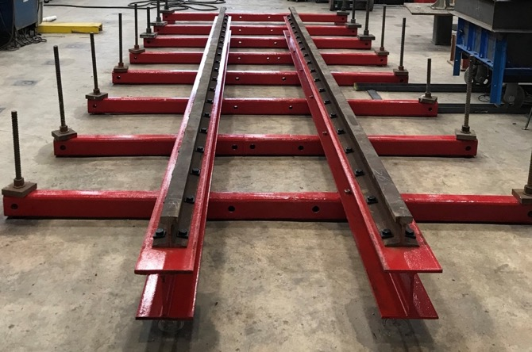
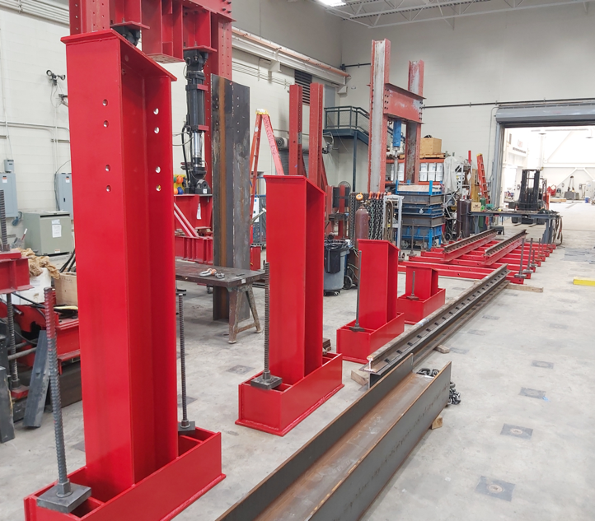

Task 3. Determine the residual flexural and shear strengths of the damaged bridge girders
The current investigation primary goal is to address the gap in literature on prestressed girders subjected to impact loads in terms of residual bending capacity for damaged beams. Furthermore, the tested girders after impact will be repaired and will be vertically loaded statically to determine the girder residual capacity and identify the failure modes. The flexural capacity was computed using the ACI 318-19 method. The shape of the test setup and beam flexural capacity calculations are show at the end of this report.
Task 5: Develop finite element models for the beams. Three finite element (FE) models have been developed and validated using previous experimental studies. The main goal is to prepare a calibrated FE model that is capable of capturing the prestressed girder response under both static and impact loading conditions. The model should be able to predict the prestressed girder mode of failures such as flexural, shear, and flexural-shear modes. The first model was validated using the experimental study by Gangi et al. (2018) for a 44 ft long AASHTO girder type III failed mainly in flexural mode of failure. The second model was validated using the experimental study by Chehab et. al. 2018 by testing AASHTO type II girder that failed due to shear. The previous two models were tested under static loading. The third model was validated against the impact loading experimental test by the University of Tennessee – Knoxville by Mitchell et al. (2015) of AASHTO type I girder. All figures are show at the end of this report. Modeling of a full bridge is also continued as shown at the end of this report.
Task 7: Deliverable. A first draft for the literature review chapter I the final report is attached to this report. The write up of the experimental work and finite element chapters are in progress.

Provide a short description of the noteworthy activities/accomplishments during this reporting period.
Use additional notes section if you need to provide more information.

Task 1: Literature review. This task was 100% completed.

Task 2. Experimental testing of bridge girders subjected to lateral impacts: Several delays occurred due to the current supply chain issues. However, manufacturing the test setup is moving forward as shown at the end of this report.
To prepare for testing, an experimental database of 140 reinforced concrete beams collected by Zhao et al 2019, was used to predict the peak impact force (PIF) . The database contains RC beams with clear span ranges from 1500 mm to 6000 mm with a mean span value of 2400 mm. Polynomial regression was used to plot the kinetic energy as a function of the PIF as shown at the end of this report. The figure was used to qualitatively determine the PIF for the full-scale and small size prestressed girders. A maximum predicted peak impact force of 1250 KN (281 Kips) is estimated for the test specimens.
Data measurements and acquisition for the impact testing were designed. Two load cells will be used to record the girder positive (push) reactions due to the impact load at both ends and another two load cells for the negative (pull) reaction due to the girder rebound.

Up to eleven wire strain potentiometers will be installed along the length of each beam spaced at 4 ft to measure the out-of-plane deformation of the girders. In addition, five strain potentiometers will be used to measure the vertical displacements.

Up to fourteen accelerometers of up to 2000 g with a 0-150 HZ frequency range will be installed on each beam along the girder span to obtain the acceleration profile of the girder due to impact load as shown in the figure at the end of this report. The accelerometers are mounted to the top flange of each girder and closely spaced at every 4 ft. The acceleration profiles will be used for the validation of the finite element models. The inertial forces distribution of reinforced concrete beams is often assumed to be linear.

Several strain gages will be used to measure the longitudinal strains in the girder's different components. Concrete vibrating strain gages will be used at one-third and mid-span at the upper and lower flanges to measure the extreme concrete fiber strain. Strain gages to monitor the strain distribution in the steel ties will be also used at different locations along the girder span.
A high-speed video camera, with 2000 frames per second will be used to record the impact incident. Also, to accurately acquire the impact cart speed, a radar gun will be used for this purpose.

Impactor head design
During this period, the research team designed also the impactor head. An accurate prediction of the impact demand is one of the most important parameters in this investigation. The impactor head was designed to have a flat head along the front part of the impactor cart to make a more realistic model of a semitrailer head with a uniformly distributed load rather than a concentrated load. A 5-axle semitrailer has a width of about 98” (Report, 2015). The impactor head in this experimental work will be approximately 72 inches representing about 70-75% of the actual semitrailer cargo.
The cart is composed of an impact front beam HP10X42 supported by two side beams W12X53 connected to two standard train wheel axels as shown in the figure at the end of this report. A bracing member HP10X42 is used at its mid-span to decrease the unbraced length and prevent the impact beam global buckling. Another cross beam HP10X42 connects the two side support beams which will be used for the cart releasing mechanism from the elevated track. This system was chosen to accommodate the wheels and axels while providing the highest structural resistance to the impact that can be achieved. The dimensions of the cart are 62 inches by 72 inches. A C-channel impactor head (C10 X 30) will be bolted to the front part of the impact cart. The cart was designed to withstand a lateral load of 600 kips distributed uniformly along the length of the impact beam. This value corresponds to AASHTO’s vehicular collision force for the design of bridge piers against vehicular impact [1]. This value is chosen as an upper-bound conservative value since its basis stem from the collision of a tractor-trailer with a rigid column at 55 mph [2]. The cart will be loaded with concrete blocks producing a gravity load of 11.5 kips.

Identify issues or problems that need to be addressed.
Use additional notes section if you need to provide more information.
We finally received the rails and other parts of the test setup except the wheels for the cart. All precast plants are too busy to cast the beams. However, we should start receiving the girders in two months. Another ongoing issue is to bring in the last graduate student as he is international student and has issues with his visa.

Provides dates for when the next progress report or presentation due:
6/30/2022

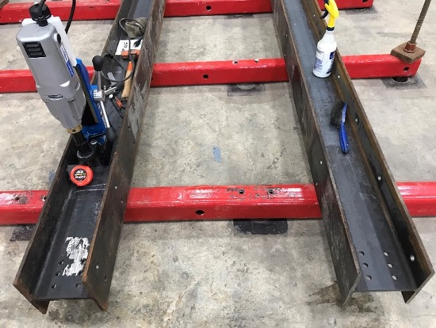
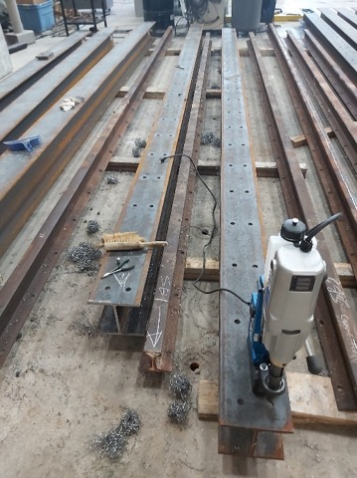
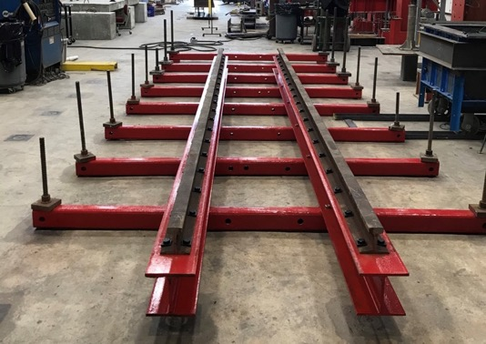
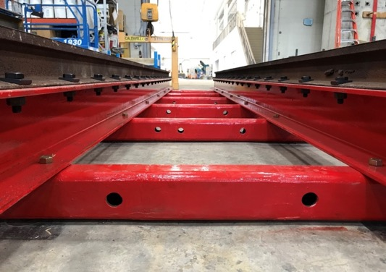
Fig. 1: Track lower segment

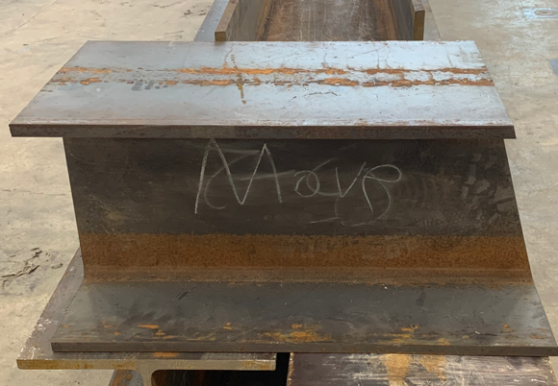
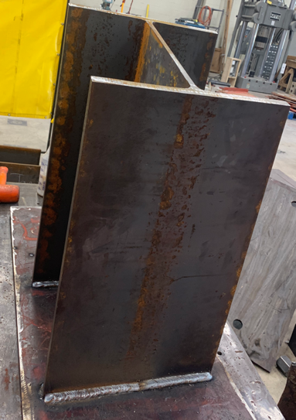
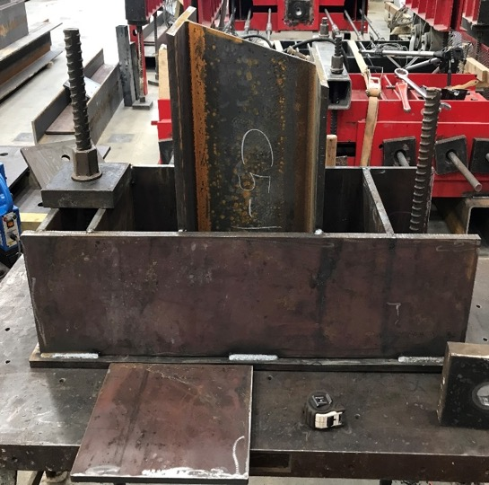
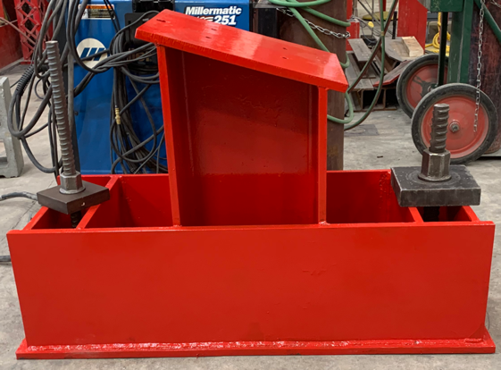
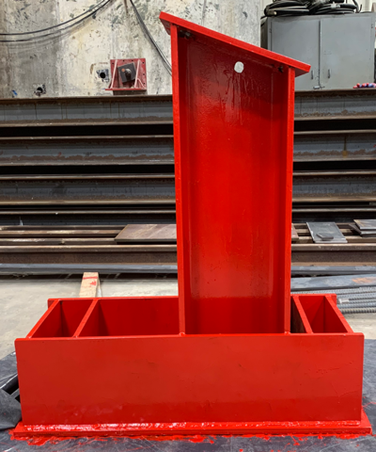
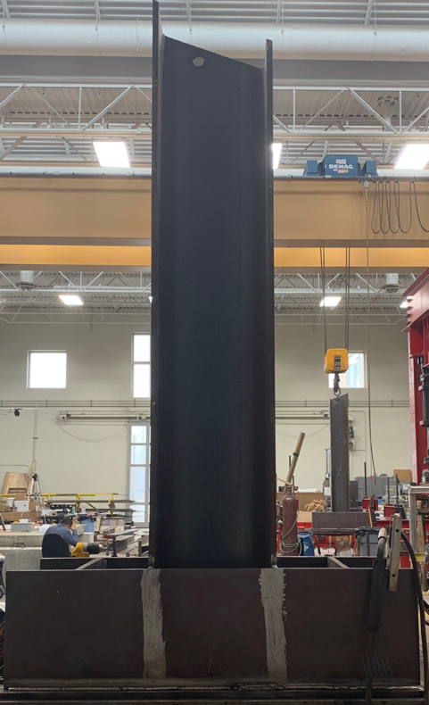
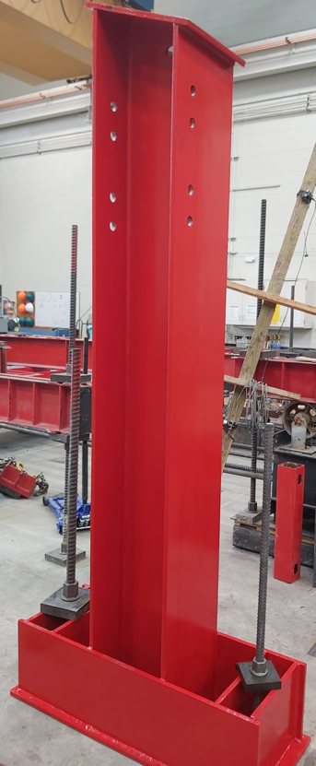
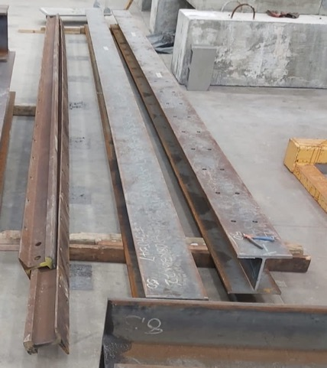
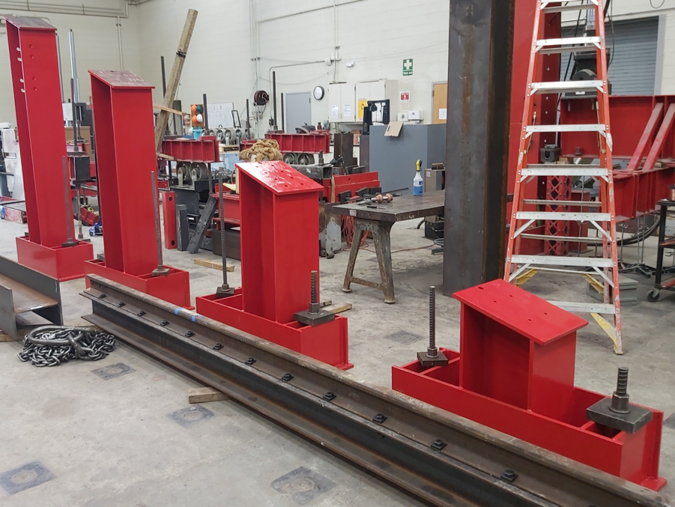
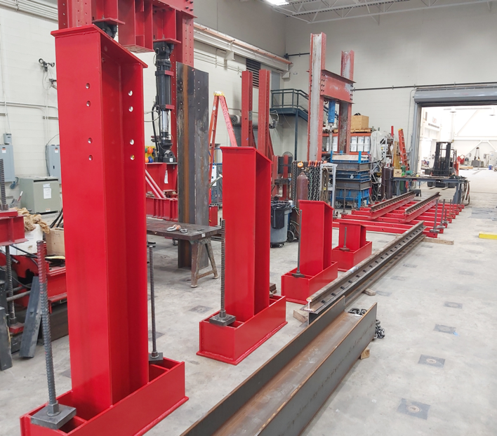
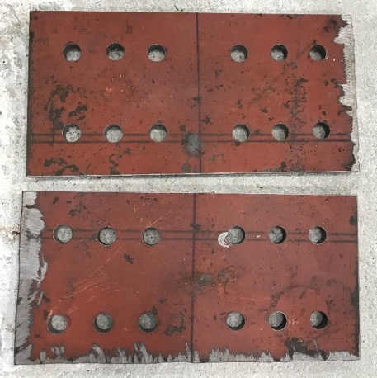
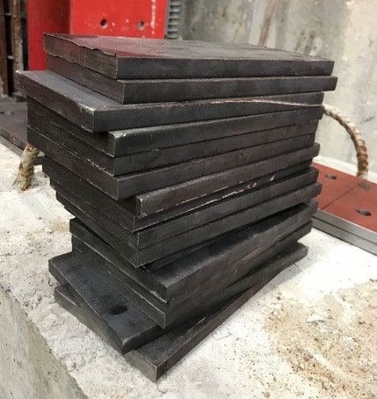
Fig. 2: Inclined segment of the track with the assembled stub columns

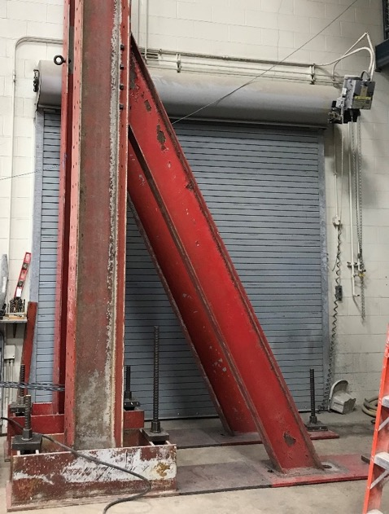
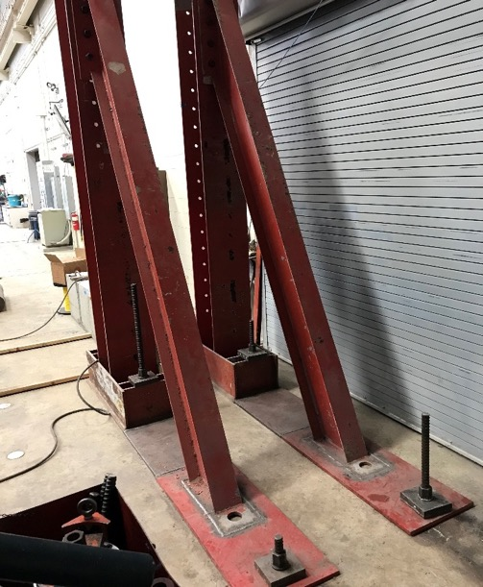
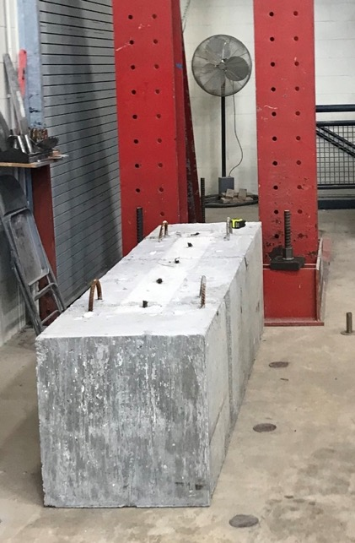
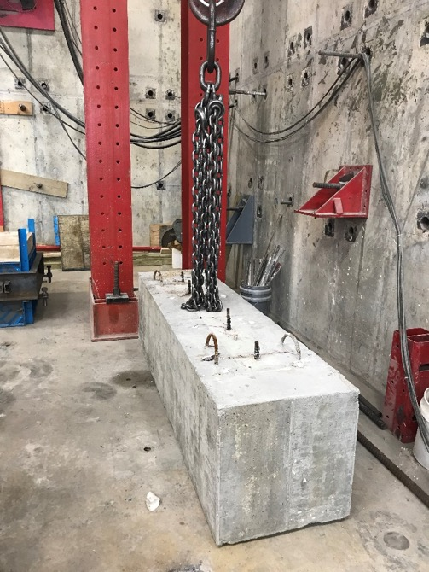
Fig. 3: Back stops and concrete supports of the investigated girders

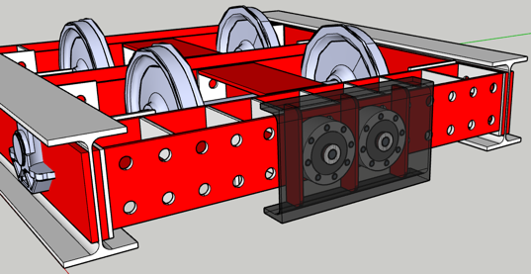
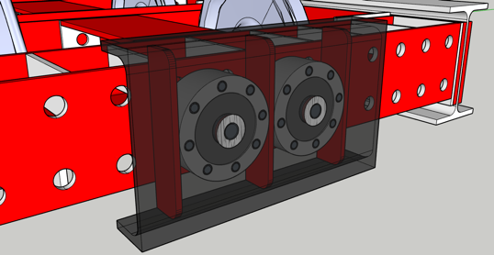

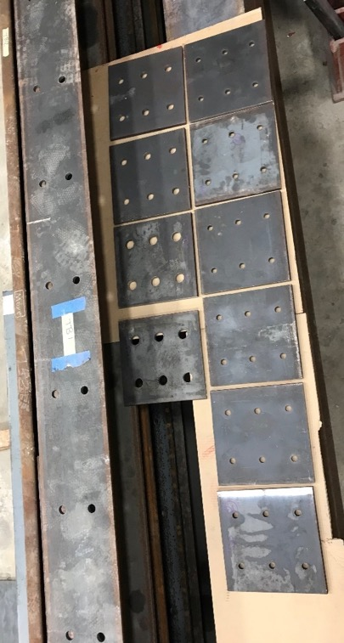
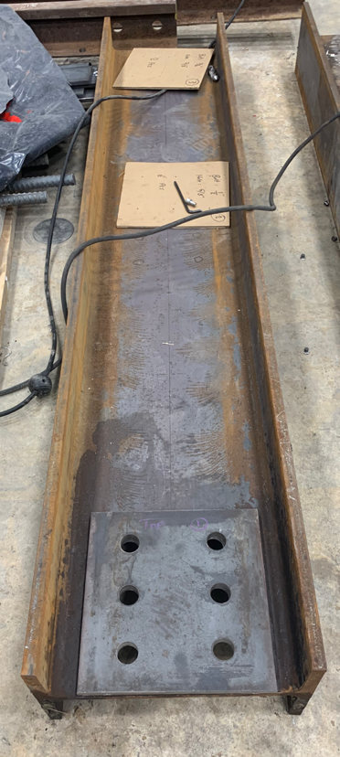
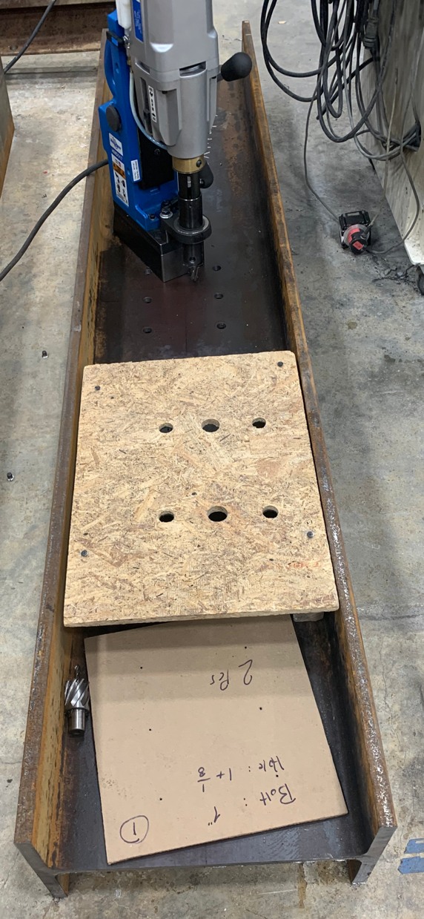
Fig. 4: Manufacturing the impact cart

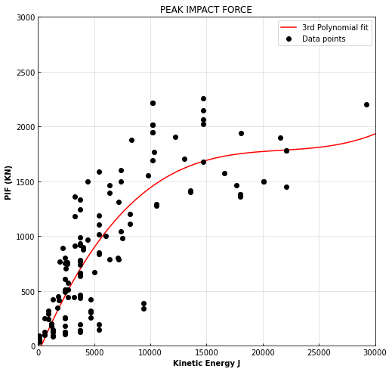
(a)
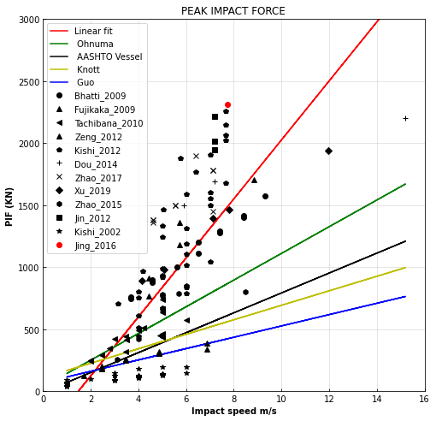
(b)

Fig. 5. PIF prediction (a) Kinetic energy, (b) Impact speed

Table 1. Predicted peak impact force
The test | Maximum impact speed (m/s) | Maximum impact mass (Kg) | Maximum kinetic energy (Joul) | Predicted PIF based on impact speed (KN) | Predicted PIF based on impact kinetic energy (KN) | Mean PIF (KN) | Max. PIF (KN)
Small size precast beams | 5. 50 | 300 | 4704 | 1000 | 750 | 875 | 1000
Large size precast girders | 6.70 | 5000 | 112225 | 1250 | 940 | 1095 | 1250

Table 2. Summary of the proposed load cells
Location | Predicted force (kips) | Load cell capacity | Qty | Measurement
Girder vertical support | - | 450 | 2 | Vertical reaction due to uplifting restraint
Girder mid-span | 281 | 450 | 1 | Impact force
Girder support Backside reaction | 140 | 450 | 2 | Positive support reaction
Girder front side | 140 | 450 | 2 | Negative support reaction

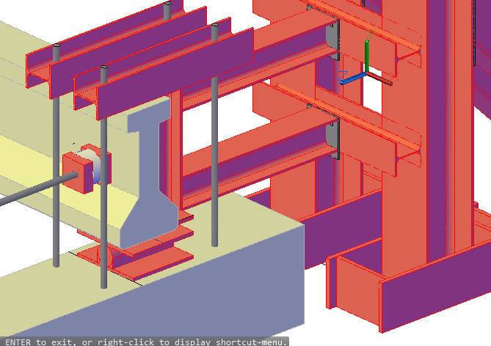 | 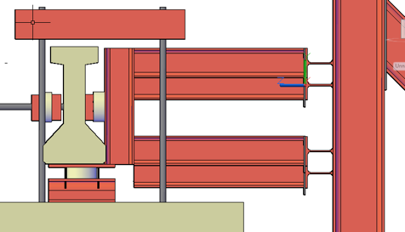
Figure 6. Load cell locations

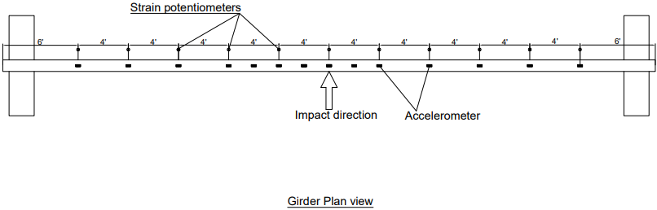
Figure 7. String potentiometers and accelerometers profile
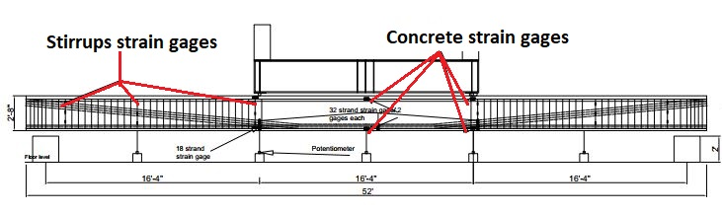
Figure 8. Strain gage locations
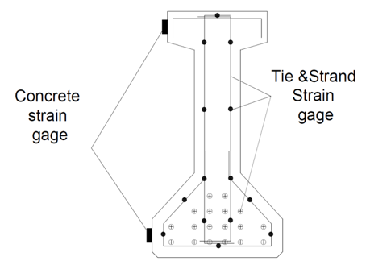
Figure 8. Strain gages locations

Table 3. Summary of the planned measurements
Item | Qty/girder
Load cells (450 kips) | 8
Wire Potentiometer | 11
Accelerometer | 14
Steel tie strain gage | 84
Strand strain gage | 96
Concrete strain gage | 6
High-speed video camera | 1
Radar gun | 1

Design of the flexural test setup

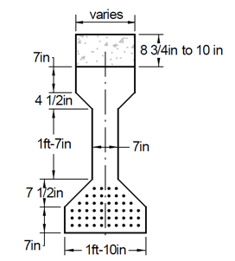
The flexural capacity of each beam was determined per ACI 318-11 simplified method as follows:
Number of strands = 50
A_{ps}/strands = 0.08 in² ( for strand diameter of 0.375 inch )
A_{ps} (total) = 50 * 0.08 = 4 in²
Distance form top compression fiber to strands centroid (dp)
Assume a deck thickness = 8.75 in
d_{p} = 53.75- 6.5= 47.25 in
Top flange width (b_{f}) = 16 in
Prestressing strands ratio, = $ρ=\frac{Aps}{b*dp}= \frac{4 in2}{16 in*47.25 in}=0.0053=0.53 \%$
F_{py} = 0.9 * 250 = 225 Ksi, F_{py} / F_{pu} = 225/250 = 0.9 , ɣ_{p} = 0.28
Rectangular stress block factor 𝛽₁
F’c = 6.65 Ksi
𝛽₁ = 0.85 – 0.05(f’c – 4 ksi) ≥ 0.65 for f’c ≥ 4 Ksi
= 0.85- 0.05(6.65-4) = 0.718
Strand stress at ultimate for bonded tendons ( No non- prestressed reinforcement was used)
$Fps=Fpu \left[1-\frac{ɣp}{β}\left[ρ\frac{Fpu}{F'c}\right]\right]$ , 𝛽₁ = 0.718 ACI 318-19 (20.3.2.3.1)
$Fps=250 \left[1-\frac{0.28}{0.718}\left[0.0053\frac{250}{6.65}\right]\right]=230.6 ksi$
From equilibrium in section forces
C = T
0.85 F’c b_{c} a = A_{ps} f_{ps}
Compression block depth (a) = $\frac{4 in2* 230.6 ksi}{0.85 * 6.65 ksi*16}=10.2 in$ < (h_{flange} = 20.25) in flange
Depth of neutral axis C :
$$C= \frac{ a}{β}=\frac{ 10.2}{0.718}=14.2 in$$
$$M_{n}=A_{ps }f_{ps}\left(d_{p}-\frac{a}{2} \right)$$
$M_{n}=4 x 230.6 ksi\left(47.25 in-\frac{10.2 in}{2} \right)=$38,879 Kips.in = 3239 Kips.ft

Check prestressing strand strain
$Ɛ_{cp}=0.003\left(\frac{d_{p}-c}{c}\right)=0.003\left(\frac{47.25-14.2}{14.2}\right)=0.00698$ > $Ɛ_{ty}+0.003$
ACI 318-19 ( 21.2.2.2)
All prestressed RFT : $Ɛ_{ty}=0.002$ (steel yield strain)
$$Ɛ_{TC}=0.002+0.003=0.005$$
Flexural failure and section is Tension-controlled
Cracking moment
M_{cr} = $M_{cr}= S_{b}\left(f_{r}^{'}+\frac{P_{pf}}{A}+\frac{P_{pf}e_{p}}{s_{b}}\right)$
Modulus of rupture $f_{r}=7.5\sqrt{f_{c }^{'}}=7.5\sqrt{6650 psi}=611.6 psi$
H= 53.75in
d_{p} = 53.75 -6.5 = 47.25 in
A_{g} = bh = 615.5 in²
Centroid location from top fiber (_{Yct})
$$Y_{ct}=\frac{8.75*16*\frac{8.75}{2}+7*16*12.5+2\left(0.5*4.5*4.5*\left(\frac{4.5}{3}+7+8.75\right)\right)+19*7*26.75+2\left(0.5*7.5*7.5*\left(\frac{7.5}{3}+7+36.25\right)+7*22*50.25\right) }{615.5}=26.37 in$$
Gross moment of inertia (I_{g} )
$$Ig=\left(16*\frac{{8.75}^{3}}{12}+12*8.75*{\left(4.375-26.37\right)}^{2}\right)+\left(16*\frac{7^{3}}{12}+16*7*{\left(12.5-26.37\right)}^{2}\right)+2\left(4.5*\frac{{4.5}^{3}}{36}+0.5*4.5*4.5*{\left(17.25-26.37\right)}^{2}\right)+\left(7*\frac{{19}^{3}}{12}+7*19*{\left(26.75-26.37\right)}^{2}\right)+2\left(7.5*\frac{{7.5}^{3}}{36}+0.5*7.5*7.5{\left(45.75-26.37\right)}^{2}\right)+\left(22*\frac{7^{3}}{12}+22*7*{\left(50.25-26.37\right)}^{2}\right)=51,690+22,003+1707+4020+21,302+88,448=137,531 in3$$

$$S_{b}=\frac{I_{g}}{y_{cb}}= \frac{137,531}{27.38}=5023 in3$$
e = 26.3-6.5 = 19.8 in
Prestressing losses by AASHTO LRFD
$${Δf}_{pT}= {Δf}_{pES }+{Δf}_{pSR}+{Δf}_{pCR}+{Δf}_{pR2}$$

Initial stress in tendons immediately prior to transfer
f_{p +} 𝞓f_{pES} = 0.75f_{pu} (S5.9.5.3)
= 0.75 * 250 = 187.5 Ksi

Elastic shortening losses (SC 5.9.5.2.3a-1)
$${Δf}_{pES }=\frac{A_{ps}f_{ps}\left(I_{g}+e_{c}^{2}A_{g}\right)-e_{c}M_{g}A_{g}}{A_{ps}\left(I_{g}+e_{c}^{2}A_{g}\right)+\frac{A_{g}I_{g}E_{c}}{E_{p}}}$$
$$E_{C}=57000\sqrt{f_{c}^{'}}=57000\sqrt{6650}=4648209 Psi=4648 Ksi$$
M_{g} = Girder midspan moment due to member self-weight
Girder self weight = 615.5 in2 * (44 ft * 12 ft/in) * 150 Ib/ft3 *(1/12^3) = 28210 Ibs = 28.2 Kips
= 28.2 / 44*12 = 0.053 Kips/in
Mg = 0.053 * (44*12)^2 / 8 = 1861 Kips. in

$${Δf}_{pES }=\frac{4 in2*0.75*250 ksi\left(137531+{19.8}^{2}*615.5\right)-19.8* 1861*615.5}{4\left(137531+{19.8}^{2}*615.5\right)+\frac{615.5* 137531* 4648 Ksi}{28500 Ksi}}=\frac{261443894}{15320755}=17.06 Ksi$$
Prestressing stress at transfer
f_{pt} = stress immediately prior to transfer - 𝞓f_{pES}
= 187.5 – 17.06 =170.48 Ksi

Prestreeing force at transfer
Pt = N_{strands} A_{ps} f_{pt} = 50 * 0.08 * 170.48 = 681.92 Kips
Initial prestress loss = 1-170.48/184.5 = 7.59 %

Shrinkage losses (S5.9.5.4.2)
𝞓f_{pSR =} (117-1.03H) (MPa)
Where H is the average annual ambient relative humidity % = 70%
𝞓f_{pSR =} (117-1.03*70) = 44.9 (MPa) = 6.51 Ksi

Creep losses (S5.9.4.3-1)
𝞓f_{pCR =} 12 f_{cgp} - 7.0 𝞓f_{cdp} Mpa≥ 0
Where f_{cgp} is the concrete stress at the c.g of the prestressing strands at transfer. 𝞓f_{cdp} is a change in concrete stress at c.g of prestressing strands due to permanent loads. It depends on the effect of the weight of the deck, diaphragm, haunch and parapet. For simplicity will be assumed as 20% of f_{cgp}
$$f_{cgp }=\frac{\frac{A_{ps}f_{ps}}{A_{g}}\left(1+\frac{e_{c}^{2}A_{g}}{I_{g}}\right)-\frac{e_{c}M_{g}}{I_{g}}}{{1+\frac{A_{ps}}{A}}_{g}(\frac{E_{c}}{E_{p}})(1+\frac{e_{c}^{2}A_{g}}{I_{g}})}$$

$f_{cgp }=\frac{\frac{4*0.75*250}{615.5}\left(1+\frac{{19.8}^{2}*615.5}{137531}\right)-\frac{19.8*1861}{137531}}{1+\frac{4}{615.5}(\frac{4648}{28500})(1+\frac{{19.8}^{2}*615.5}{137531})}= \frac{3.088}{1.002}=3.08 Ksi$
𝞓f_{pCR =} 12*3.08 *6.89 Ksi/MPa - 7.0 *0.2*3.08 *6.89 Ksi/MPa = 224.9 Mpa = 32.6 Ksi ≥ 0

Relaxation losses (S5.9.5.4.4c) for stress-releievd strans
𝞓f_{pR2} = 138 – 0.4 𝞓f_{pES} – 0.2 (𝞓f_{pSR} + 𝞓f_{pCR} ) (MPa)
= 138 - 0.4 * 17.06*6.89 – 0.2*( 44.9 +224.9) = 37 Mpa = 5.37 Ksi

Total loss after transfer
𝞓f_{pT} = 𝞓f_{pES} + 𝞓f_{pSR} + 𝞓f_{pCR} + 𝞓f_{pR2}
= 17.06 + 6.51 + 32.6 + 5.37 = 61.54 Ksi

Actual effective prestress after all losses
Max f_{pe} = 0.8 f_{py} = 0.8 * 0.9 *250 =180 Ksi
f_{pe} = 0.75 f_{pu} - 𝞓f_{pT} = 0.75*250 – 61.54 = 125.9 Ksi < Max f_{pe} (180 Ksi) Ok
> 0.5f_{py} (112.5 Ksi) Ok
Effective force in prestressing P_{pf} = A_{p} f_{pe} = 4 * 125.9 = 503.6Kips
Bottom fiber stress ( f_{cb} )
$$fcb=-\frac{P_{pf}}{A}-\frac{P_{pf}e_{p}}{s_{b}}+\frac{M_{cr}}{S_{b}}$$
$M_{cr}= S_{b}\left(f_{r}^{'}+\frac{P_{pf}}{A}+\frac{P_{pf}e_{p}}{s_{b}}\right)$ = $5023\left(0.611+\frac{503.6}{615.5}+\frac{503.6*19.8}{5023}\right)=17150 Kip in=1429 Kip. ft$

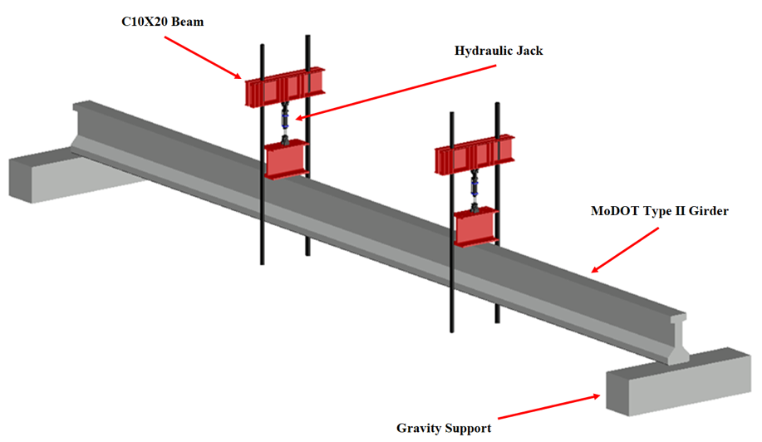

Figure 9. A 3D model for flexural test setup

Maximum Internal Forces:

M_{ult} = 4.5 kip.in Maximum Bending Moment
V_{ult} = 0.5 kip Maximum Shear Force

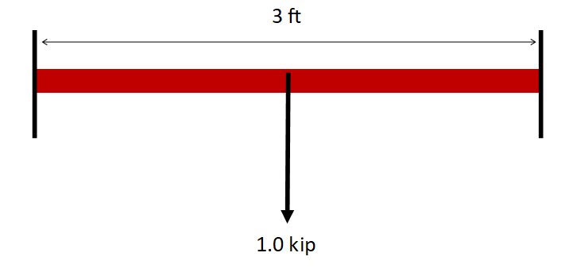
Section considered based on the available dimensions
Choice of Section: C10X20

Required data
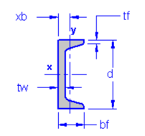
t_{w} = 0.375 in
_{w} = 12 in
b_{f} = 3 in
t_{f} = 0.375 in
r_{y} = 3.67
Z_{x} = 19.4
E = 29000 ksi
F_{y} = 50 ksi

Design For Flexure:

For flanges:
B_{flange}/2t_{flange}= 3/2*0.375 = 4
From Table 4.1a, case 10 (i.e flanges of channels)

0.38*sqrt(E/F_{y}) = 0.38*sqrt(29000/50) = 9.15

2.99 < 9.15

Flange is non-compact

For web:

h_{web}/t_{web} = 12/0.375 = 32
From Table 4.1b, case 15 (i.e webs of doubly symmetric channels)

h_{web}/t_{web} = 32 < 3.76*sqrt(E/F_{y}) = 90.55

The web is non-compact
Section is non-compact

Chapter F, Section F2 Applies

The nominal flexural strength, Mn, shall be the lower value obtained according to the limit states of lateral-torsional buckling and yielding.

Design Limit State of Lateral Torsional Buckling:

L_{b} = 36 in.(req) <L_{p} = 1.76*r_{y}*E*F_{y} = 155.55 in. AISC -F2-5

The design limit state of LTB does not apply

Yielding:
M_{n} ==F_{y} Z_{x} = 50*(19.4) = 970 kip.in AISC -F2-1
Φ = 0.90 (LRFD)
Φ M_{n} = 873 kip.in
Given section is adequate and efficient

Design For Shear:

From Section G2
V_{n} = 0.6F_{y} A_{w}C_{v} = 135 AISC -G2-1

Since h_{web}/t_{web} = 32 < 1.1*sqrt(Kv*E/Fy) = 61.2 AISC-G2-3
C_{v} = 1.0
Kv=5.34 (since web is without stiffeners)
Φ V_{n} = 0.9*135=121.5 > 0.5

The given section satisfies the required moment and shear stress; thus, a section is adequate.

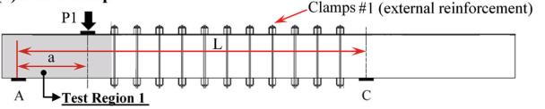 |  | 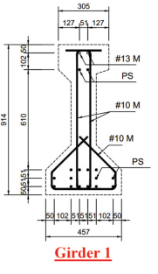
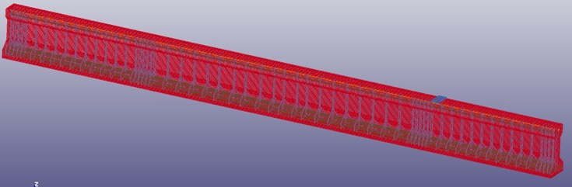
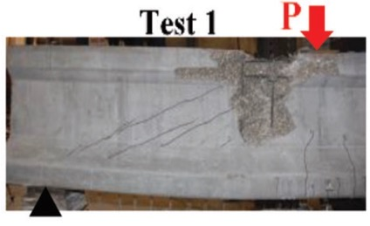 | 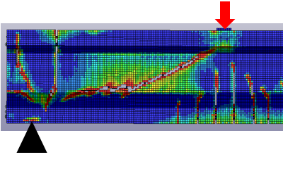

Figure 10. The Experimental testing by Chehab et. al. 2018 and the FE results

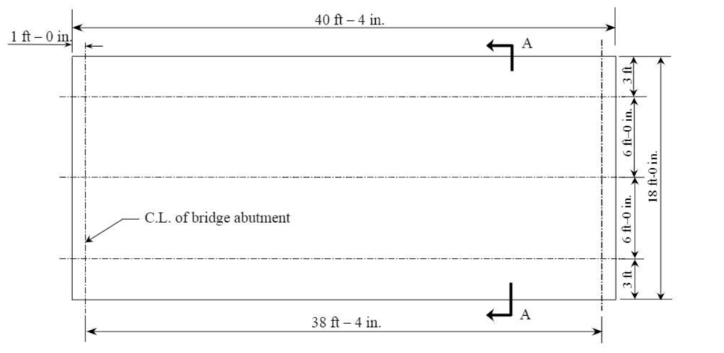
a) Bridge layout
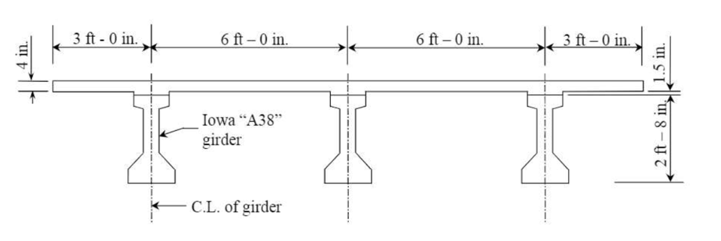
b) Cross-section details
Figure 11. Bridge details; a) layout, b) cross-section

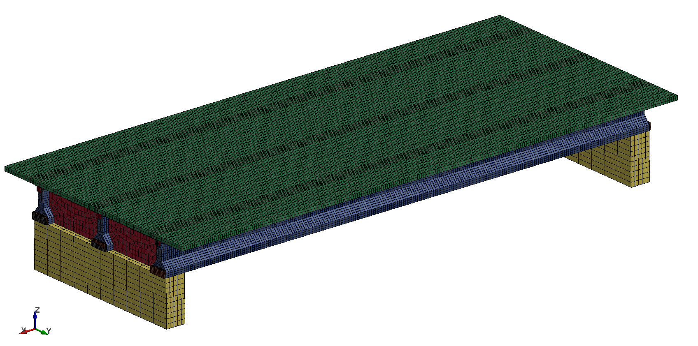
Reinforced Concrete Deck:
Concrete SOLID ELMS + MAT_CSCM
RFT BEAM ELMS + MAT_PLASTIC_KINEMATIC
Coupling shared nodes or CLIS
Prestressed Girders:
Concrete SOLID ELMS + MAT CSCM
Strands BEAM ELMS + MAT_PLASTIC_KINEMATIC
Apply prestressing force using Temperature
Figure 12: Full-scale finite element bridge model

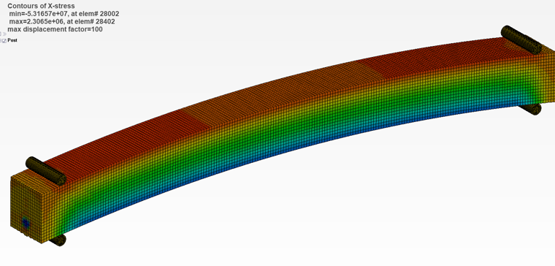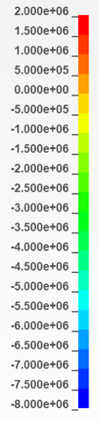
- Proposed prestressing method
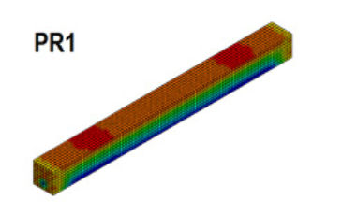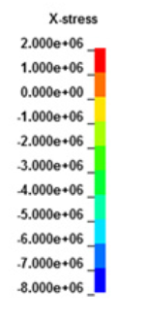
- Husain’s (2019) model
Figure 13: Validation of the prestressing force method;
a) the proposed method, b) Husain’s (2019) model

- Compressive stresses at midspan

- Tensile stresses at midspan
Figure 14: Mesh Sensitivity analysis
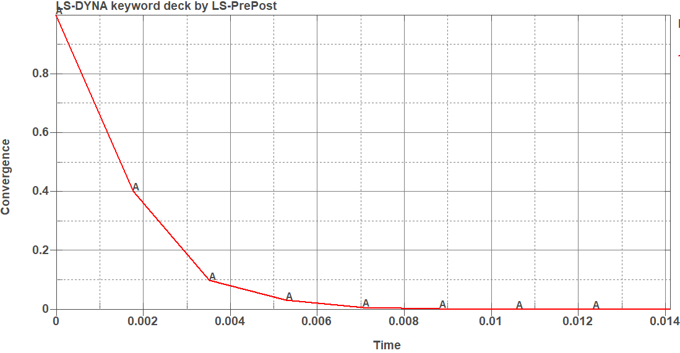
- Convergence
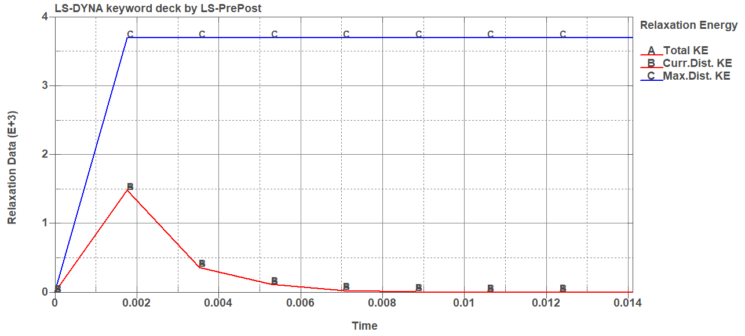
- Distortion vs total energy
Figure 15: Dynamic Relaxation results

- Load-Deflection results at the midspan of the exterior girder

- Load-Deflection results at the midspan of the interior girder
Figure 16: FE model validation
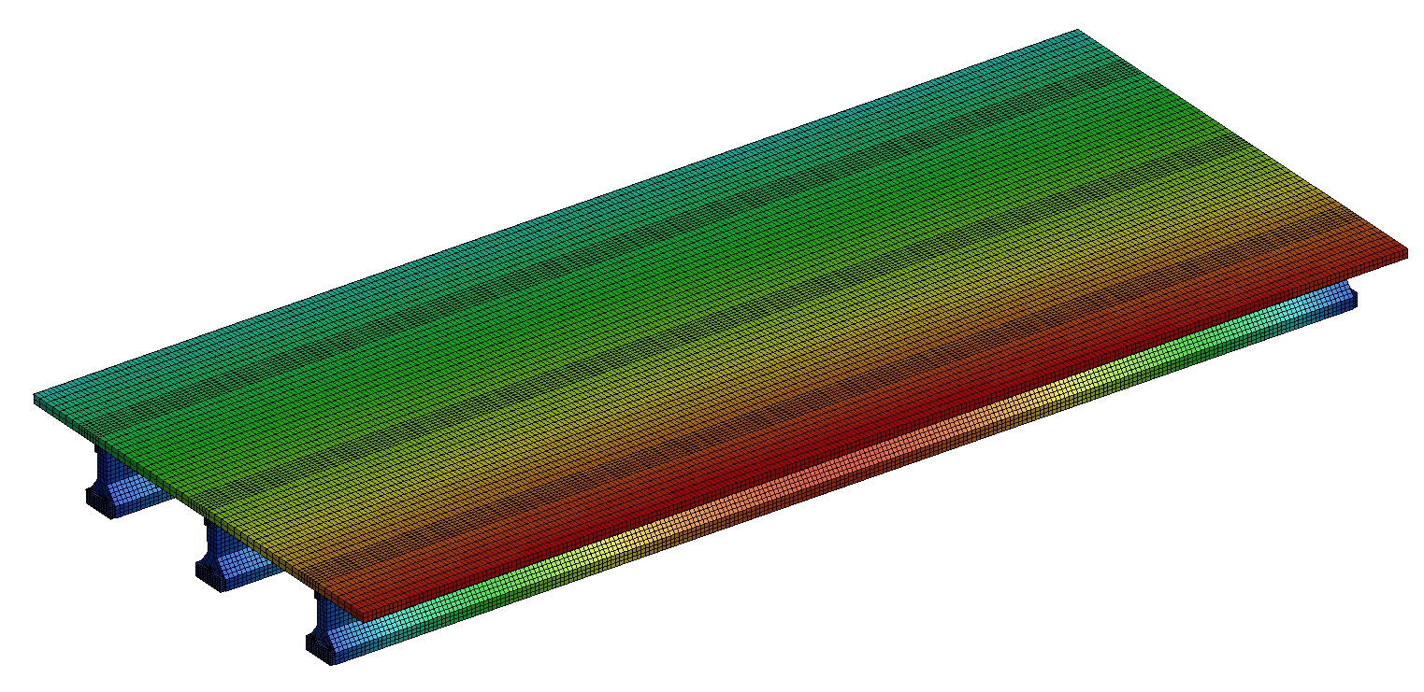

Figure 17: Deflection of the bridge subjected to a vertical load at the exterior mid-span girder

