Fund Transfer Requests Procedures
State Apportioned Transfers Initiated in FMIS
FHWA Division Offices and the HCF’s Budget Execution Team

Table of Contents
II. Purpose 2
III. Roles, Responsibilities, and Frequency 3
IV. Desktop Procedure: State Apportioned Transfers Initiated in FMIS 3
VI. Desktop Procedure: Return of Apportioned Funds Previously Transferred to a FHWAan FHWA Program Office, FTA, or other Federal Agency 6
VII. Appendix A: Process Map 8
VIII. Appendix B: Acronyms 9
IX. Appendix C: FMIS Transfer Types 10
X. Appendix D: Transfer Statuses & Default Pending Lists 15
XI. Appendix E: Guidance on State Submission of Transfer Requests 17
XII. Appendix F: First-In, First-Out (FIFO) Fiscal Year Calculation 26

- Purpose
The Federal Highway Administration (FHWA) Financial Policy & Procedure titled “Fiscal Management Information Systems (FMIS) Transfers” requires that FHWA Division Offices and the Office of the Chief Financial Officer’s (HCF’s) Budget Execution Team perform the tasks outlined in this document when a State submits an apportioned funds transfer request in FMIS.

Title 23, United States Code (23 U.S.C.) provides the States with the authority to transfer certain apportioned/formula funding between programs within the State, between States, to FHWA Program Offices, and to other Federal agencies. These requests are reviewed and approved by the FHWA Division Offices and processed by the HCF’s Budget Execution Team. This desktop procedure defines the FHWA Division Offices’ and the HCF’s Budget Execution Team’s roles and responsibilities. It outlines the steps each should take in their review/approval or processing of the State-submitted requests. In addition, the appendices provide detailed information related to the recent (in fiscal year (FY) 2023) automation of this process within FMIS to inform and guide all users.

- Roles, Responsibilities, and Frequency
FHWA Division Offices – FHWA Division Offices are responsible for monitoring their “pending transfers” list in FMIS to identify new or revised transfer requests at least weekly; reviewing all transfer requests to ensure compliance with applicable laws, regulations, and guidance; and either approving or rejecting all transfer requests within a week of receiving.

Office of the Chief Financial Officer (HCF) Budget Execution Team (HCFB-12) – The HCF Budget Execution Team is responsible for monitoring their “pending transfers” list in FMIS every other business day and processing or rejecting those pending transfers. They also create new transfer requests in limited circumstances involving the return of funds previously transferred to another Federal Agency (e.g., return of funds the Federal Transit Administration (FTA) to FHWA) or FHWA Program Offices.

HCF Financial Systems Team (HCFB-20) – The HCF’s Financial Systems Team is responsible for resolving any FMIS system related issues that arise in completing an automated transfer and for approving/reviewing any transfer access rights.

- Desktop Procedure: State Apportioned Transfers Initiated in FMIS

Initiate Transfer Request
  - Division Office Monitoring of its Pending Transfers List in FMIS:
    - The (Insert FHWA Division Office Staff member by title responsible) checks the “pending transfers” list in FMIS to identify new or revised transfer requests (Specify frequency and must be at least weekly) and promptly initiates the approval review process.

Verify Transfer Request is Accurate

  - Division Office validation that the transfer recipient (Agency, Division, State, and/or an FHWA Program Office) has the authority to request a transfer:
    - The (Insert FHWA Division Office Staff member by title responsible) reviews that the requestor is the direct recipient or has approval from the direct recipient of the funding through apportionment tables and/or legal Notices providing the funding.
  - Division Office Review to confirm that type of transfer is allowable:
    - The (Insert FHWA Division Office Staff member by title responsible) reviews the submitted transfer request requirements associated with the funding in Title 23 or the applicable Authorization Act to confirm there is statutory authority allowing the action to take place (See Appendix 3, table 1 in Policy and Procedure Volume 4 Chapter 1).
    - The (Insert FHWA Division Office Staff member by title responsible) must also verify if there are program-level restrictions or additional guidance provided by an Authorization Act regarding the funds to be transferred. As appropriate, the (Insert FHWA Division Office Staff member by title responsible) must coordinate their review with other Division Office subject matter experts prior to approval.
  - Division Office confirms Funding Source uses an appropriate FMIS transfer type, and that request documentation is correct.
    - The (Insert FHWA Division Office Staff member by title responsible) validates that the FMIS transfer type for the request is appropriate. (See Appendix 3, “FMIS Transfers Overview and Types,” table 1 in Policy and Procedure Volume 4 Chapter 1, for additional information on types of FMIS transfers and when they should be used.)
    - The (Insert FHWA Division Office Staff member by title responsible) validates that the transfer request documentation aligns with the type of FMIS transfer request and is accurate. (See Appendix 3, table 1 in Policy and Procedure Volume 4 Chapter 1, which details the documentation associated with FMIS transfer types.)
    - The (Insert FHWA Division Office Staff member by title responsible) validates that the transfer request in FMIS is using valid To and From program codes, the appropriate amount is represented in alignment with documentation and the Transportation Pooled Fund Study (TPF) number and description are entered (as necessary).
  - Division Office verify apportionment balance and Obligation Limitation is available.
    - The (Insert FHWA Division Office Staff member by title responsible) verifies the availability of the apportionment and obligation limitation in the FMIS fund control module. This includes validating the FY is available and transfer is not exceeding limits. (See Appendix F of this desktop procedure for additional information on validating FY and see Appendix 3, table 1 in Policy and Procedure Volume 4 Chapter 1 details the limits established in law.)
  - Division Office confirms receiving entity is prepared to administer and obligate the funding.
    - The (Insert FHWA Division Office Staff member by title responsible) confirms that the receiving entity is prepared to obligate the funding within the current fiscal year or period of availability of the funding. This is confirmed by information provided in the attached supporting documentation or a communication from the entity.

Execute on Transfer Request:

  - The (Insert FHWA Division Office Staff member by title responsible) in the Division Office “approve” or “reject” the transfer as part of the monitoring of the “pending transfers” list in FMIS. If approved the request is routed to HCFB for processing (i.e., Transfer Status will show as “Pending HCFB Processing”). If rejected, a reason for rejection must be provided, either chosen from the supplied list of reasons or by selecting “Other” and providing a reason. The Transfer Status changes to “Rejected by Division” and is sent to the State’s “pending transfers” list. A rejected request must be re-submitted by the State.
  - The (Insert HCFB-12 Staff member by title responsible) in HCFB-12 is responsible for actively monitoring their “pending transfers” list in FMIS every other business day.
  - Review of Pending Transfers in FMIS by the Budget Execution Team
    - The (Insert HCFB-12 Staff member by title responsible) in HCFB-12 review the requests for the “Specific Requirements for HCF Processing” as outlined in Appendix C.
    - The (Insert HCFB-12 Staff member by title responsible) in HCFB-12 will ensure the request is prior to the yearend deadline that is established in the calendar distributed by HCF and that, since the time of Division Office approval, other obligation activity has not adversely impacted the available balances for the transfer by reviewing the fund control module within FMIS.
  - HCFB-12 Processing: The (Insert HCFB-12 Staff member by title responsible) in HCFB-12 will “process” or “reject” the transfer in the FMIS review panel. If approved the request will process (i.e., Transfer Status will show as “Processed”). If rejected, a reason for rejection must be provided, either chosen from the supplied list of reasons or by selecting “Other” and providing a reason. The Transfer Status will change to “Rejected by HCFB” and is sent to the State’s “pending transfers” list. A rejected request must be re-submitted by the State, through the Division Office.
  - Processing of Certain FMIS Processed Transfers in Delphi: The (Insert HCFB-12 Staff member by title responsible) in HCFB-12 separately processes State-initiated apportioned transfer types impacting both FMIS and Delphi (i.e., State to FHWA Program Office – Pooled Fund, State to FHWA Program Office (excluding Pooled Funds), certain Other Allowable Transfers, and To Other Federal Government Entity), utilizing the steps outlined below:
    - The (Insert HCFB-12 Staff member by title responsible) in HCFB-12 must first run the appropriate Business Objects report “Federal Highway Inter-Agency Transfer of Funds Report” identifying the transfers processed in FMIS since the last processing in Delphi and with the necessary information to accurately complete the appropriate transfer (e.g., to/from Delphi funds values). Run the report(s) to show only the activity since the report was last run and processed in Delphi (e.g., if the report is run every other Friday, the report is run from two Fridays ago to the prior day (i.e., Thursday)). This is done biweekly.
    - The (Insert HCFB-12 Staff member by title responsible) in HCFB-12 must then forward the advice of funds to the Budget Director for signature to support the to/from transfer of funding in Delphi. The request must also include the Business Objects report run in the prior step.
    - After Budget Director approval, the (Insert HCFB-12 Staff member by title responsible) in HCFB-12 must then process in Delphi via transfer to FHWA Program Office, Parent/Child Allocation Account, or Non-expenditure transfer, as appropriate.

- Desktop Procedure: Return of Apportioned Funds Previously Transferred to an FHWA Program Office, FTA, or other Federal Agency
- Budget Execution receives request to return apportioned funds previously transferred to an FHWA Program Office, FTA, or other Federal Agency.
  - The (Insert HCFB-12 Staff member by title responsible) receives a request via email or via a Notice of Authority Transfer (NAT) that an FHWA Program Office, FTA, or other Federal Agency would like to return unused apportioned funding previously transferred to them by a State.
- Budget Execution reviews the original request and supporting documentation received and verifies the return is appropriate:
- The (Insert HCFB-12 Staff member by title responsible) locates the original transfer request based on the provided information. The original transfer request is used to identify the appropriate program codes and the upper limit of the available return.
- Budget Execution creates a “Returns from FHWA Program Office, FTA, and Other Federal Agencies” Type of Transfer and Processes:
- The (Insert HCFB-12 Staff member by title responsible) creates a “Returns from FHWA Program Office, FTA, and Other Federal Agencies” transfer in FMIS utilizing the information from the return request and the original transfer form.
- The (Insert HCFB-12 Staff member by title responsible) checks the “Limitation Transfer” checkbox to also return obligation limitation if (1) annual obligation limitation was originally transferred and the return is occurring in the same fiscal year as the original transfer, (2) if special obligation limitation was originally transferred, and (3) if the return is from FTA.
- The (Insert HCFB-12 Staff member by title responsible) also uploads the return request and original request as supporting documentation and provides all relevant information in the “Additional Information” field.
- Budget Execution process the return
- The (Insert HCFB-12 Staff member by title responsible) processes the “Returns from FHWA Program Office, FTA, and Other Federal Agencies.”

Revision Guide
Included below are details regarding the document version to account for Desktop Procedure updates and edits. Note, the most recent version of this document supersedes previous versions.
Include details of update requirements (e.g., frequency of updates for this Desktop Procedure).
Version | Date | Description of Revision or Update | Author(s)

- Appendix A: Process Map
TO BE PROVIDED

- Appendix B: Acronyms
FHWA – Federal Highway Administration
FIFO – First-In, First-Out
FMIS – Fiscal Management Information System
FTA – Federal Transit Administration
FY – Fiscal Year
GF – General Fund
HCFB – FHWA Office of Budget and Finance
HCFB-12 – HCF Budget Execution Team
HCFB-51 – HCF Financial Systems Team
NAT – Notice of Authority Transfer
NCHRP – National Cooperative Highway Research Program
HCF – Office of the Chief Financial Officer
PC – Program Code
TPF – Transportation Pooled Fund
U.S.C. – United States Code
- Appendix C: FMIS Transfer Types
The below is a list of the different apportioned transfer types available in the FMIS transfers module, explains their purpose/when they should be used, system validations in place, and any requirements for processing. Note: A Division Office may have additional requirements to support its review and approval of these transfers, which should be outlined for its State.

    - Between Programs – Fund to Fund (23 U.S.C. 126)
  - Purpose – The purpose of this type of transfer is to request the transfer of funds among apportioned programs eligible under 23 U.S.C. 126 within a State. Note: This type of transfer only transfers contract authority, not obligation limitation.
  - Required Fields & System Validations
    - From and To Program Codes must be different and are limited to the program codes eligible for this type of transfer as identified in the Supplementary Tables (e.g., Table 23, Page 2 of the FY 2023 Supplementary Tables).
    - The requested transfer amount must be less than or equal to the least of the Apportionment Balance, Unobligated Balance, or Transferability Limit. The Transferability Limit is based on the 50 percent amount identified in the Supplementary Tables and is automatically reduced as transfers are processed.
  - Specific Requirements for HCF Processing: None.
    - Within Program – Expired GF Upward Adjustment
  - Purpose – The purpose of this type of transfer is to request the transfer of funds within the same program from a cancelled FMIS program to an active FMIS program code available for upward adjustments. This transfer type is only applicable for General Fund programs as outlined in the annual “INFORMATION: Procedures for Expired Highway Infrastructure Program Funds” guidelines.
- Note: At this time, the FMIS transfers module does not support transfers for allocated programs. Therefore, any request to transfer expired allocated GF balances for upward adjustments must be made via a paper 1575C Form.
  - Required Fields & System Validations
- From and To Program Codes must be different and are limited to the list of eligible codes, which is updated annually based on “INFORMATION: Procedures for Expired Highway Infrastructure Program Funds.”
- The requested transfer amount must be less than or equal to the least of the Apportionment Balance or Unobligated Balance.
  - Specific Requirements for HCF Processing
- In the “Enter Detail #, Pooled Fund Project Description, or any additional information” (henceforth, “additional information”) field, the State must supply the justification for the upward adjustment including specific FMIS project agreement number, and the following language “I hereby certify that this request for an upward adjustment is for costs incurred within the original scope and obligation and does not exceed the unobligated program code balance of the State’s HIP funds available. The increase in costs is not related to a contract claim or escalation clause.”
    - State to State – Pooled Fund Project
  - Purpose – The purpose of this type of transfer is to transfer apportioned funds in support of a pooled fund project from one State to another State that has accepted the lead on that pooled fund project.
  - Required Fields & System Validations
- From and To Program Codes are the same and the description fields will auto-populate. Urban programs codes are not allowed.
- The “Pooled Fund Project Number (TPF)” field must be complete.
- “Yes” must be checked to signify an agreement with the receiving entity to accept the funds being transferred and supporting documentation must be attached.
- The requested transfer amount must be less than or equal to the least of the Apportionment Balance, Unobligated Balance, or Limitation Balance.
  - Specific Requirements for HCF Processing
- The name of the TPF project in the “additional information” field.
- The acceptance letter from the receiving entity must be attached and include the TPF number and name. Note: Acceptance memos detailing the previous paper-based transfer request process can still be used and will be accepted.
    - State to State – Non-Pooled Funds
  - Purpose – The purpose of this type of transfer is to transfer apportioned funds from one State to another State that is not in support of a pooled fund project.
  - Required Fields & System Validations
- From and To Program Codes are the same and the description fields will auto-populate.
- Urban programs codes are allowed and the From and To urban areas may be different.
- “Yes” must be checked to signify an agreement with the receiving entity to accept the funds being transferred and supporting documentation must be attached.
- The requested transfer amount must be less than or equal to the least of the Apportionment Balance, Unobligated Balance, or Limitation Balance.
  - Specific Requirements for HCF Processing
- The acceptance letter from the receiving entity must be attached. The receiving entity identified in the acceptance letter must match with the selected “Transfer to State” identified.
    - State to FHWA Program Office – Pooled Fund
  - Purpose – The purpose of this type of transfer is to transfer apportioned funds in support of a pooled fund project from a State to an FHWA Program Office that has accepted the lead on that pooled fund project.
  - Required Fields & System Validations
- From and To Program Codes are the same and the description fields will auto-populate. Urban programs codes are not allowed.
- The “Pooled Fund Project Number (TPF)” field must be complete.
- “Yes” must be checked to signify an agreement with the receiving entity to accept the funds being transferred and supporting documentation must be attached.
- The requested transfer amount must be less than or equal to the least of the Apportionment Balance, Unobligated Balance, or Limitation Balance.
  - Specific Requirements for HCF Processing
- The name of the TPF project in the “additional information” field.
- The acceptance letter (or memo for NHCRP) from the receiving entity must be attached and include the TPF number and name. The receiving entity identified in the acceptance letter (or memo for NHCRP) must match with the selected “Transfer to Other” entity identified. Note: Acceptance memos detailing the previous paper-based transfer request process can still be used and will be accepted.
    - State to FHWA Program Office (excluding Pooled Funds)
  - Purpose – The purpose of this type of transfer is to transfer apportioned funds from a State to an FHWA Program Office and the funding being transferred will not support a pooled fund project.
  - Required Fields & System Validations
- From and To Program Codes are the same and the description fields will auto-populate.
- Urban programs codes are allowed and the From and To urban areas may be different.
- “Yes” must be checked to signify an agreement with the receiving entity to accept the funds being transferred and supporting documentation must be attached.
- The requested transfer amount must be less than or equal to the least of the Apportionment Balance, Unobligated Balance, or Limitation Balance.
  - Specific Requirements for HCF Processing
- The supporting documentation showing the receiving entity’s acceptance of the funds must be attached. The receiving entity identified in the supporting documentation must match with the selected “Transfer to Other” identified.
    - Other Allowable Transfers:
  - Purpose – The purpose of this type of transfer is for rare instances when a State is transferring funds among its apportioned programs, but the transfer does not fall under a more specific type of transfer (e.g., transferring excess CA from a program code subject to special limitation to a program code subject to formula limitation, transferring STBG Off-System Bridge funding to STBG Flex with an approved waiver, etc.). Note: This type of transfer only transfers contract authority, not obligation limitation.
  - Required Fields & System Validations
- From and To Program Codes may be the same or different and the corresponding descriptions will auto-populate.
- Urban programs codes are allowed and the From and To urban areas may be different.
- The radio button to signify an agreement with the receiving entity will default to “N/A” and the other options will be disabled.
- The “Additional Information” field must include a justification for the use of this type of transfer.
- The requested transfer amount must be less than or equal to the least of the Apportionment Balance or Unobligated Balance.
  - Specific Requirements for HCF Processing: None.
    - To Other Federal Government Entity
  - Purpose – The purpose of this type of transfer is to transfer apportioned funds from a State to another Federal Government Entity, including FTA, when that entity will be responsibility for the State-identified project.
  - Required Fields & System Validations
- From and To Program Codes are the same. While the “From” description will auto-populate, the “To” description will be open for manual entry. Urban programs codes are allowed.
- “Yes” must be checked to signify an agreement with the receiving entity to accept the funds being transferred and supporting documentation must be attached.
- “Additional Information” field must be completed. If applicable, please include the FTA-defined urban area code in this field.
- The requested transfer amount must be less than or equal to the least of the Apportionment Balance, Unobligated Balance, or Limitation Balance.
  - Specific Requirements for HCF Processing:
    - For transfer requests to FTA, each detail line item amount to be transferred must be a whole dollar amount.
    - Returns from FHWA program Office, FTA, and Other Federal Agencies: This type of transfer may only be created by the appropriate analysts in the HCF, States do not have access to create this type of transfer.
  - Purpose – The purpose of this transfer type is to return funds to a State that were previously transferred to an FHWA program office, FTA, or other Federal Agency. This typically occurs at project closeout when all the funds were not utilized.
  - Required Fields & System Validations
- The requesting Agency will display the FHWA Programs and Other Federal Agency options and the “Transfer to State” field will be enabled.
- From and To Program Codes are the same and the descriptions will auto-populate. Urban programs codes are allowed.
- The radio button to signify an agreement with the receiving entity will default to “N/A” and the other options will be disabled.
- The “additional information” field is required along with supporting documentation.
- If obligation limitation is to be returned with the contract authority, the “Transfer Limitation” box must be checked.
- The requested transfer amount must be less than or equal to the Apportionment Balance, which will reflect the total amount previously transferred to the requesting entity.
  - Specific Requirements for HCF Processing
- The email request from the requesting Agency must be uploaded as supporting documentation and the “additional information” field must include all relevant information.
Exceptions: At this time the automated process does not support State requests for transfers of allocated programs including demo IDs/earmarks. Any such requests (e.g., repurposed earmarks) must be submitted via a paper 1575C form to the FHWA Transfers Inbox.

- Appendix D: Transfer Statuses & Default Pending Lists
The below is a list of the transfer funds statuses in FMIS.

    - Recipient Signature Needed: This status reflects a transfer request that has been created/saved, but not yet signed by the State.

    - Division Signature Needed: This reflects a transfer request that has been signed by the State but not yet approved or rejected by the Division Office.

    - Pending HCFB Processing: This status reflects a transfer request that has been signed by the State, approved by the Division Office, but not yet processed or rejected by HCFB.

    - Rejected by Division: This reflects a transfer request that has been signed by the State but rejected by the Division Office, and the reason for rejection has not yet been acknowledged by the State.

    - Rejected by HCFB: This reflects a transfer request that has been signed by the State and approved by the Division Office but rejected by HCFB, and the reason for rejection has not yet been acknowledged by the State.

    - Recipient Signature Needed (Previously Rejected): This status reflects a transfer request that was previously rejected by either the Division Office or HCFB, and the reason for rejection has been acknowledged by the State.

    - Division Signature Needed (Previously Rejected): This status reflects a transfer request that was previously rejected by either the Division Office or HCFB, and the State has revised and re-signed.

    - Pending HCFB Processing (Previously Rejected): This status reflects a transfer request that was previously rejected by either the Division Office or HCFB, the State has revised and re-signed, and the Division Office has approved, but has not yet been processed by HCFB.

    - Processed: This status reflects a transfer request that has been signed by the State, approved by the Division, and processed by HCFB. The transfer is now reflected in FMIS.

State users’ pending transfer list defaults to show the requests in statuses that require State action (i.e., Recipient Signature Needed, Recipient Signature Needed (Previously Rejected), Rejected by Division, and Rejected by HCFB).

Division Office users’ pending transfer list defaults to show the requests in statuses that require Division Office action (i.e., Division Signature Needed and Division Signature Needed (Previously Rejected)).

HCF Budget Execution Team’s pending transfer list defaults to show the requests in statuses that require HCF action (i.e., Pending HCFB Processing and Pending HCFB Processing (Previously Rejected)).

- Appendix E: Guidance on State Submission of Transfer Requests

In general, States are responsible for identifying the appropriate type of transfer request, drafting the request in FMIS, reviewing the request in FMIS, and approving the request via electronic signature in FMIS. If a State-submitted request is rejected, the State is responsible for acknowledging the reason for rejecting and making any necessary adjustments prior to re-approving.

Detailed Process on the State Creation, State Approval, Division Office Review, Division Office Approval/Rejection, and HCF Processing/Rejection of Transfer Requests

  - State Creation of a Transfer Request

Step 1: State users must submit a request to their FMIS Division Office Sponsor for the appropriate Transfer Rights, which are routed to the HCFB Systems Team for approval. After approval, the State user may create and sign transfer requests, depending on their access rights.

Step 2: To create a new transfer request, select the “Add New Transfer” option under the Fund Control Module’s “Manage Transfers” List.

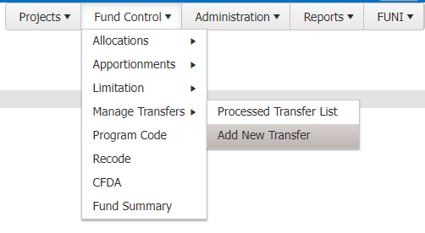

Step 3: (Required) On the “Add Funds Transfer” screen, select the appropriate transfer type from the “Transfer Type” dropdown. See Appendix D for information on the different types of transfers.

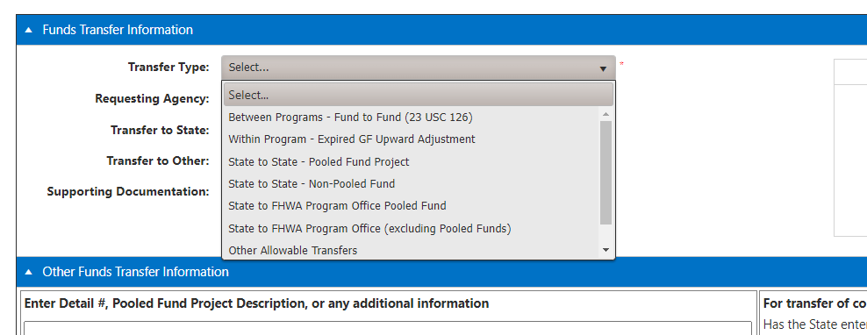

Step 4: (Optional/Required) Attached supporting documentation, if necessary. For certain types of transfers, supporting documentation must be provided or the State will not be able to sign the request. See Appendix C above for further information.

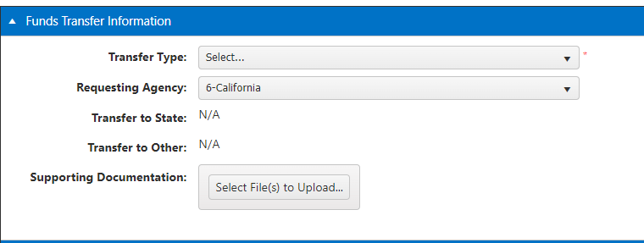

Step 5: (Optional) Insert information on the State’s Transfer Request Contact and the State’s Tracking Number. An FHWA Tracking Number will be assigned after the request is initially saved.

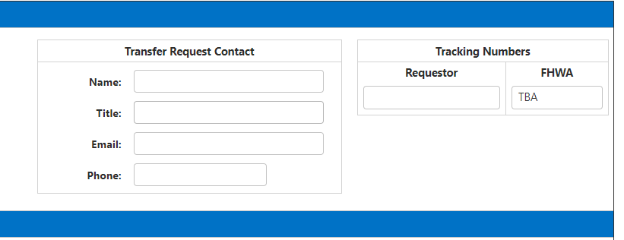

Step 6: (Optional/Required) Insert any relevant information in the “Enter Detail #, Pooled Fund Project Description, or any additional information” section. For certain types of transfers, this is a required field. See Appendix C above for further information. Note: This information may be added or edited after the initial save.

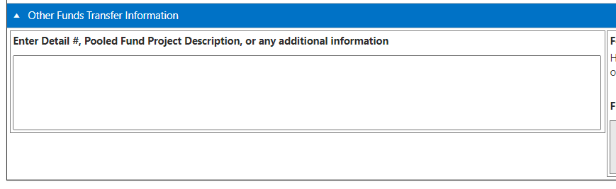

Step 7: (Required) Identify whether the State has entered into an agreement with the receiving Agency/entity by selecting “Yes”, “No”, or “N/A.” For certain types of transfer, this area will default to “N/A” and be unavailable for edits.

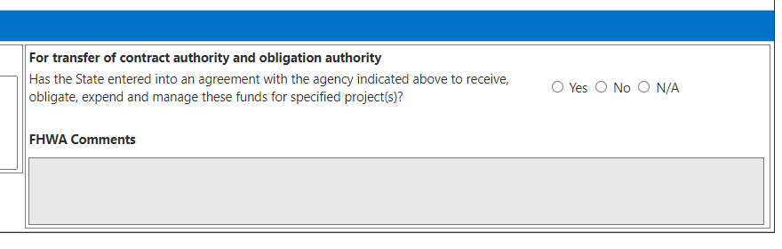

Step 8: (Required) Save the transfer request. Saving takes you from the “Add Funds Transfer” screen to the “Edit Funds Transfer” screen. In addition, this step creates the FHWA Tracking Number and puts the request in the “Recipient Signature Needed” status.

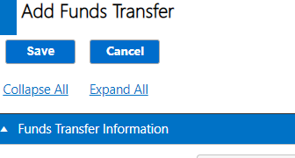

Step 9: Once on the “Edits Funds Transfer” screen, add detail lines by selecting “Add Funds Transfer Detail.”

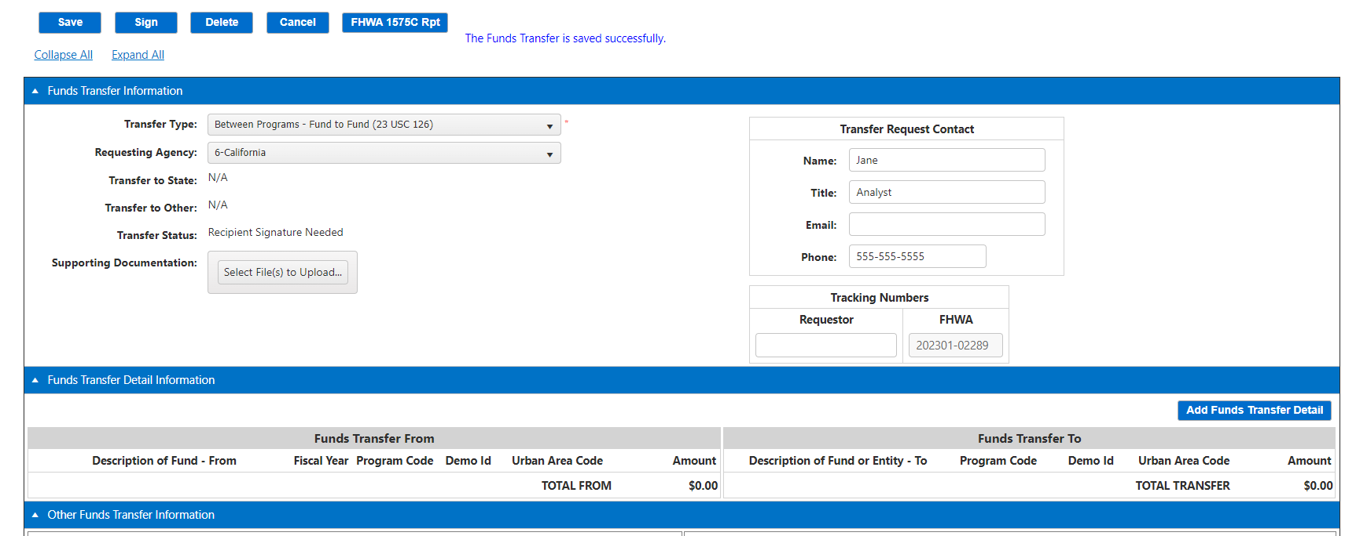

Step 10: On the “Add Fund Transfer Detail” screen, select the From “Program Code” and appropriate “Fiscal Year.” The “Description of Fund” will automatically populate based on the “Program Code” chosen and the “Fiscal Year” will be limited to the FYs associated with the Program Code. At this point, the amount of (1) pending transfers, (2) pending obligations, (3) Apport/Alloc Balance, (4) Unobligated Balance, and the (5) Transferability Limit, if applicable, will auto populate.

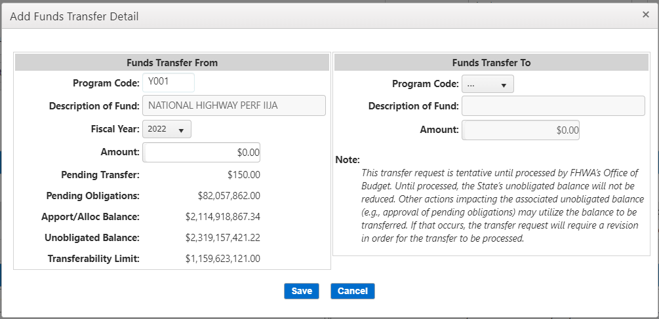

Step 11: Insert the “Amount” of the request on the “From” side, which will automatically populate the “Amount” on the “To” side.
- The amount on the “From” and “To” side for each detail line will be equivalent. If $200 is being transferred from PC WXYZ, with $100 going to PC ABCD and $100 going to PC KLMN, then two detail lines must be created with $100 being transferred from PC WXYZ in each detail line, and
- There cannot be multiple details lines with the same “To” and “From” PC/FY combination on the same transfer request.

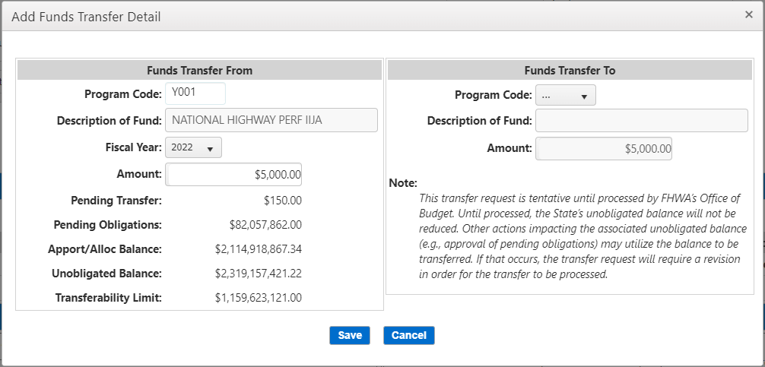

Step 12: If applicable, select the appropriate To “Program Code.” For certain transfer types, the To “Program Code” will automatically populate and for others, there will be a limited list of possibilities. Once selected, the To “Description of Fund” will automatically populate.

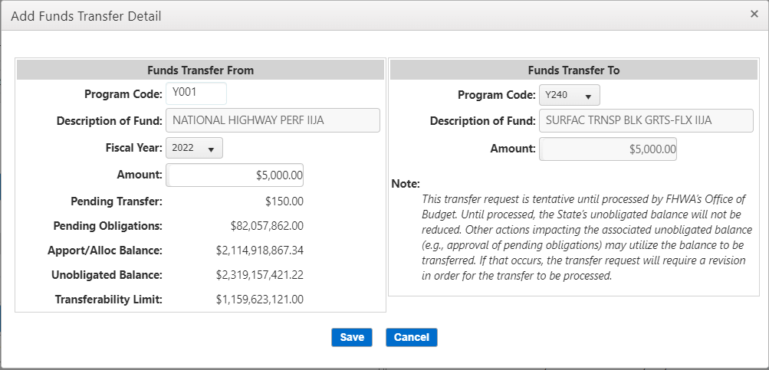

Step 13: Click Save. If the amount does not pass funds control checks against the “Apport/Alloc Balance”, “Unobligated Balance”, and “Transferability Limit”, if applicable, then the user will not be able to save and an error message will appear. If the amount passes funds control, then a message confirming addition will be displayed.
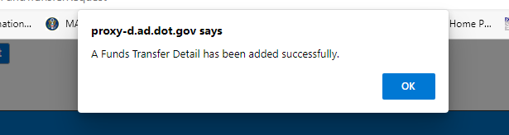

The detail line information is now shown under the “Funds Transfer Detail Information” section and can be edited or reviewed by clicking the detail line number. If an additional detail line is necessary, add it by clicking “Add Funds Transfer Detail” and following the above steps again. Up to 8-line items may be added to any one request.

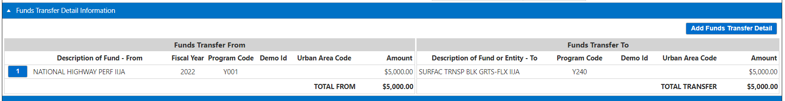

  - State Signature of a Transfer Request

Step 14: Once completed, a State user with “Transfer Signature Allowed” rights may sign the request by clicking “Sign.”

If all required fields/documentation are complete and all system validations pass, then the request will be signed. Once signed, the status will change to “Division Signature Needed” and will appear in Division Office users’ default pending transfers list.
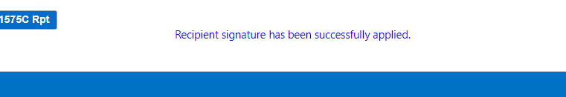

If any required fields/documentation is not complete and/or any system validation fails, the user will receive an error message and must address the issue prior to signature.

  - Division Office Review of a State-Signed Transfer Request

- Step 15: Once the request is signed by the State, the Division Office may review and approve it in their “Pending Transfer” tab. To open the request for review, click the view icon.

- 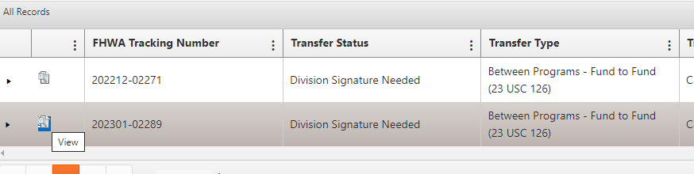

- Step 16: Review the information in the “Funds Transfer Information” for accuracy and click on the appropriate “Funds Transfer Detail Information” line item to review the details.

- 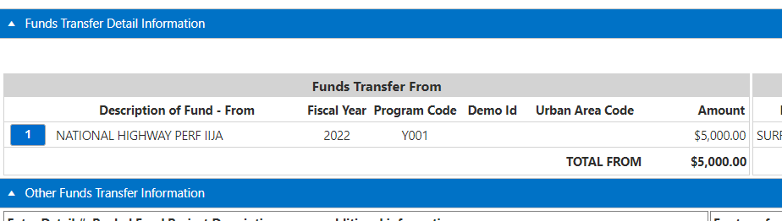

- 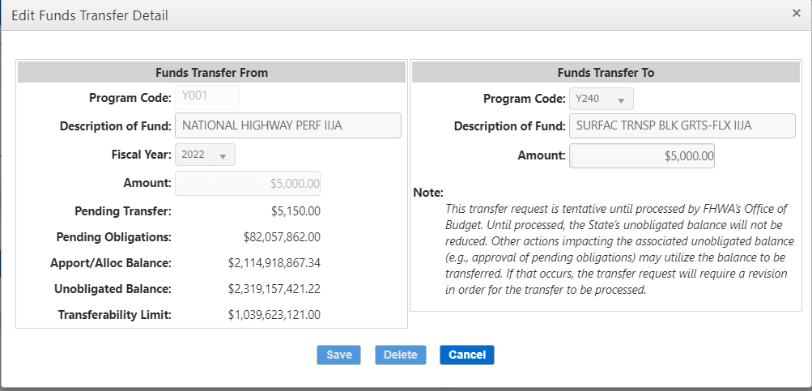

- Step 17: After review, the FHWA Division Office reviewer/approver inputs any comments into the “FHWA Comments” field, which is the only editable field for an FHWA Division Office reviewer/approver.

- 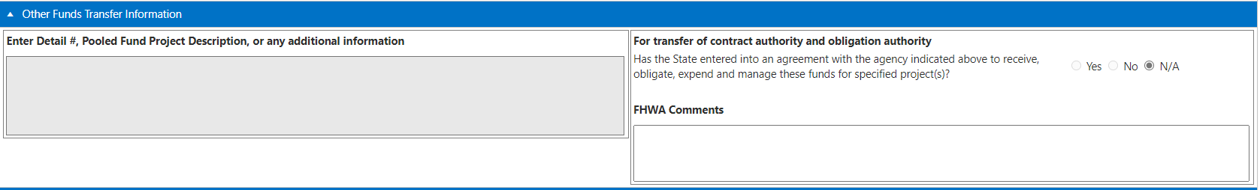

- Step 18: After review, the FHWA Division Office approver may either “reject” or “sign” the request.

- 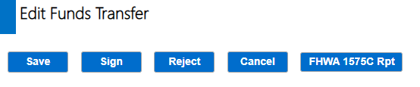

- If the Division Office approver rejects the request, the approver must input a reason for rejection either from the supplied list of reasons or by choosing “Other” with a written explanation. Once rejected, the status changes to “Rejected by Division Office” and is sent to the State’s pending transfers list. Note: A State must acknowledge the reason for rejection prior to revising and resubmitting.

- If the Division Office approver signs the request and all system validations pass, then the status changes to “Pending HCFB Processing” and is sent to the HCFB pending transfers list.

  - HCFB Processing of a State-Signed and Division-Approved Transfer Request

- Step 19: Once the request is signed by the State and approved by the Division, HCFB may review and process it from their “Pending Transfer” tab. To open the request for review, click the view icon, as shown above.

- Step 20: HCFB should follow a similar process as the Division Offices to review. However, HCFB is not able to make any updates/changes to the request.

- Step 21: After review, the HCFB processor may either “process” or “reject” the request.

- If the HCFB processor rejects the request, a reason for rejection must be provided. Once rejected, the status changes to “Rejected by HCFB” and is sent to the State’s pending transfers list. Note: A State must acknowledge the reason for rejection prior to revising and resubmitting.

- If the HCFB processor processes the request and all system validations pass, then the transfer will process, and its status will change to “Processed.” In addition, the transfer can now be viewed on the “Processed Transfers” tab.

Note: At any point after the initial save by the State, a PDF version of the 1575C report can be viewed and downloaded by clicking the “FHWA 1575C Rpt” button.

- Appendix F: First-In, First-Out (FIFO) Fiscal Year Calculation
In general, States are responsible for identifying the appropriate fiscal year of funds available based on the first-in, first-out methodology of attributing program code obligations to fiscal year of funds. Division Offices are responsible for reviewing and ensuring the appropriate fiscal year utilization.

Detailed Example of Identifying Fiscal Year of Funds Available in Accordance with First-In, First-Out (FIFO) Methodology

  - State Identification of Net Fiscal Year Apportionment Available for Given Program Code

Step 1: Once States have identified the appropriate program code for a given transfer request, the State must identify the net apportionments available for each FY under that program code. To do so, navigate to the “Apportionment List” screen in FMIS under the Fund Control Module àApportionments.

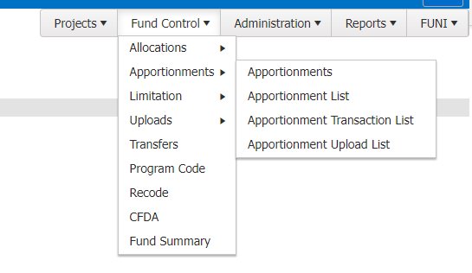

Step 2: Input recipient (i.e., State) and program code information. Click Search.

Step 3: Identify the net funds available for each FY tied to that program code.
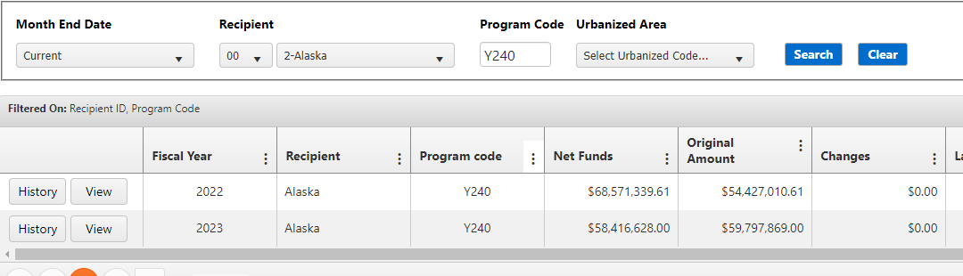

Step 4: Run the recipient’s current FMIS W10A report under Standard Reports.

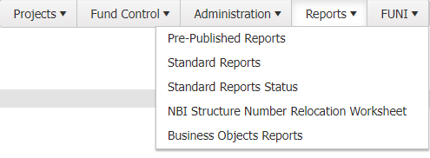

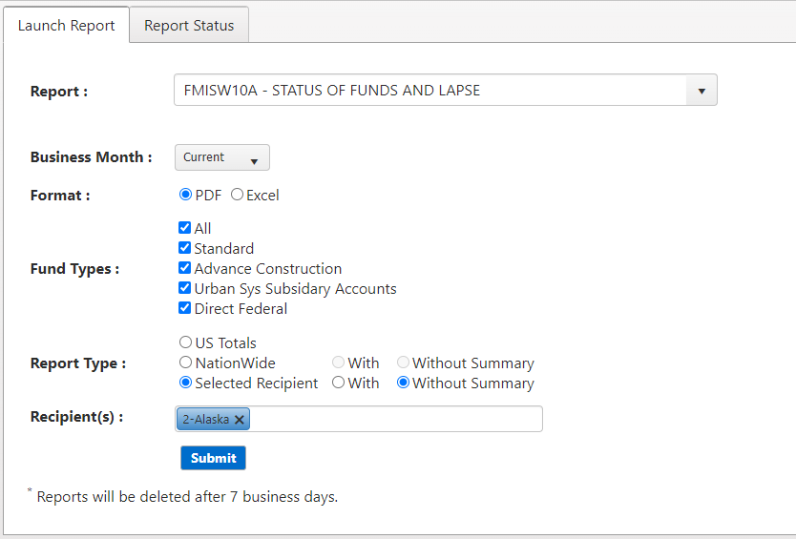

Step 5: Identify the unobligated balances for the impacted program code on the W10A.
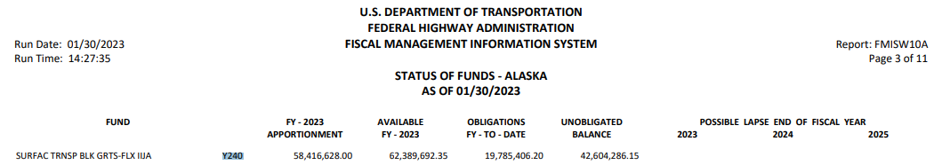

Step 6: Attribute the unobligated balances of funds to the most recent fiscal year(s) of net apportionment funds. Under FIFO we always assume that the oldest balances are obligated first. This means the unobligated (remaining) balances are the most recent balances available.

W10A Y240 Unobligated Balance = $42,604,286.15

Apportionment List:
FY 2023 Y240 Net Apportioned Funds = $58,416,628.00
FY 2022 Y240 Net Apportioned Funds = $68,571,339.61

Fiscal Year | Net Funds | Unobligated Balance
FY 2023 | $58,416,628.00 | $42,604,286.15
FY 2022 | $68,571,339.61 | $0
Total | $126,987,967.61 | $42,604,286.15

Because the unobligated balance is less than the most recent FY (FY 2023) net apportioned funds all of the unobligated balances in Y240 are attributable to FY 2023 and the transfer request must utilize FY 2023 as the appropriate FY. All FY 2022 are deemed obligated.

If the W10A Y240 Unobligated was $70,000,000.00. Then, the entire FY 2023 Y240 net apportioned funds in the amount of $58,416,628 are available for transfer along with $11,583,372 in FY 2022 funds. In other words, if the transfer request is less than $11,583,372, FY 2022 could be used as the FY of funds on the transfer request. If the transfer request is greater than $11,583,372, then the request would either need to be (1) a combination of FY 2022 and FY 2023 funds or (2) entirely FY 2023 funds.

Fiscal Year | Net Funds | Unobligated Balance
FY 2023 | $58,416,628 | $58,416,628
FY 2022 | $68,571,339.61 | $11,583,372
Total | $126,987,967.61 | $70,000,000.00

When multiple fiscal years are available for transfer based on the above calculation, it is at the State’s discretion as to which FY to utilize. However, if the more recent funding is transferred, there is a chance that lapsing calculations are impacted. If a transfer is being used as part of an overall approach to ensure funding does not lapse, the State will want to take this into consideration.

