Quarterly Progress Report (QPR)

Applications of Enterprise GIS in Transportation
Progress Report for Quarter 8 [August 1st 2021 – Sept 30th, 2021]
WSP Program Manager: Jag Mallela (jag.mallela@wsp.com)
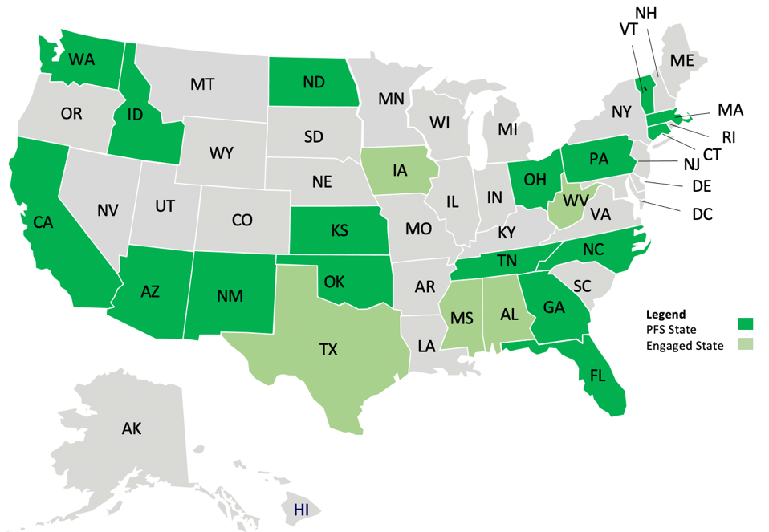
WSP Technical Lead: Abhishek Bhargava (abhishek.bhargava@wsp.com)
Background
The Pooled Fund Study (PFS) on Applications of Enterprise GIS in Transportation (AEGIST) was initiated by FHWA in 2018. During Phase 1 of this study a guidebook was developed for transportation agencies in the United States, with the primary objective of documenting guidance on how spatial and linear referenced data should be managed by States. Phase 2 of this PFS was initiated in October 2019. This phase will span over 5 years (October 2019 – September 2024), during which the objectives outlined below would be accomplished.
Objectives
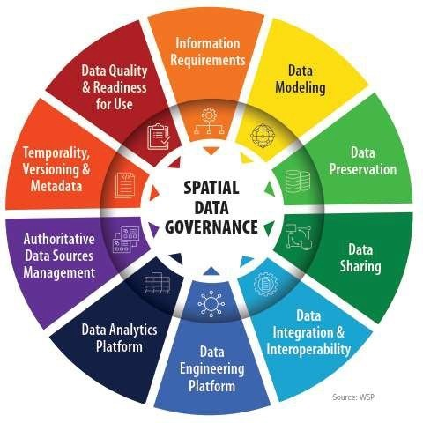
- Establish a standard for managing and governing data in spatial and linear referencing systems at transportation agencies, including but not limited to routes, intersections, interchanges, roundabouts, road segments, roadway characteristics, infrastructure assets, model inventory of roadway elements (MIRE), HPMS data items and ARNOLD road network.
- Develop guidance for States for modeling spatial transportation data, especially linear referencing system (LRS) data. Importing, exporting & conflating road network and roadway characteristics data across DOT LRS and Federal, State and Local data systems.
- Conduct a series of webinars, workshops, peer exchange meetings and provide consulting services to the States participating in the pooled fund to develop national standards in data modeling and management; enhance existing enterprise GIS systems at these agencies.
- Update the AEGIST Guidebook that was prepared in Phase 1, by documenting best practices, patterns and similarities across agencies in managing spatial data using enterprise data systems, including but not limited to Asset Management Systems, Traffic and Safety Systems, Project Planning and Programming Systems, Design and Construction Systems, and GIS and Linear Referencing Systems (LRS).
- Collaborate with States to enhance and develop spatial data management systems, processes, platforms to establish a structured and systematic approach for management of spatial data. This would involve establishing spatial data governance systems, business rules, applications, tools and platforms for:
  - Spatial Data Modeling
  - Spatial Data Integration and Engineering
  - Spatial Data Analytics
Completion Status and Summary
Time Frame: October 1, 2019 to September 30, 2024
Total Time, months: 60
Time Expended, months: 24
Percent Calendar Time Expended: 40%
Work Accomplished This Reporting Period: Aug – Sep, 2021

Task 1: Project Management
Task Objective: Perform project management activities, which include conducting monthly status meetings, developing quarterly status reports, creating project work plan, managing project resources, schedule, deliverables and communication with all stakeholders.
Activities:
- Prepared and delivered AEGIST Quarterly Report #7 along with invoice for the period (Aug – Sept, 2021). Both Base Period and Performance Period 1 activities with 11 PFS States were reported.
- Task management meetings held with following PFS States: Idaho, California, Tennessee, Pennsylvania, Ohio, North Carolina, Kansas, New Mexico, Florida.

Task 2: Technical Services
Task Objective: Provide technical services to PFS States by completing various agency-specific and cross-agency activities identified in the work plan.
Activities: Following technical services activities were carried out for each of the listed States in Base Period.
- Idaho:
  - Task 2.ID.2: Created following spatial data governance system artifacts:
    - Application Communication Diagram and Application Catalog
    - Updated Data Dictionary, Data Catalog (Portfolio)
    - Data governance dashboard showing all web applications, web maps and dashboards
- California
  - Task 2.CA.1: Created the envisioned roads data and application architecture diagram to show how data will be exchanged and what applications/systems will be used for integrating roads data from local agencies and Caltrans. Analyzed road centerline data from Merced County (NG911) and Caltrans R&Hs system to determine road centerline geometry differences.
- Pennsylvania
  - Task 2.PA.1: Updated AEGIST Technical services work plan document.
  - Task 2.PA.10: Roads Data Modeling – NG911, PennDOT RMS & National Road Network – Prepared slides for presentation to NG911 group.
  - Task 2.PA.11: LRS Systems Demonstration – Prepared slides for presentation of LRS Systems: Bentley AWLRS and Esri R&Hs to PennDOT
- Ohio
  - Task 2.OH.2: Continued development of strategic roadmap for GIS/LRS activities on
    - 2.OH.1.1: HPMS, MIRE and ARNOLD
    - 2.OH.1.8: LRS Data Architecture Management & Administration Workflows
    - 2.OH.1.4: Roadway Inventory: Bike lanes, Turn lanes, Conflation of Assets to LRS/GIS
    - 2.OH.1.6: BIM Design and Construction Data to Asset Management (As-Builts Handoff)
    - 2.OH.1.7: BTRS LRS Release: Identify Stakeholders, Needs and Assess Value/Gaps in Process & Architecture
    - 2.OH.1.10 Road Sections Creation & Road Characteristics Data Integration & Engineering for Analytics
- North Carolina
  - Task 2.NC.1: Intersection Modeling Pilot:
Roads Datasets acquired from NCDOT. These included: NG911, ALRS Routes and Events, County Roads data files, Traffic Signals data and Structures data. Development environment setup. Intersection modeling approach and steps documented for NC (as well as other States using similar datasets as NC, i.e., New Mexico, Florida, Kansas).
- New Mexico
  - Task 2.NM.1: Intersection Data Modeling Pilot:
Identified locations for intersection modeling pilot, reviewed NMDOT datasets (LRS Routes and events data) and created bookmarks for testing.
Leveraged approach used for North Carolina Intersection modeling (and in general AEGIST intersection modeling) to create intersection and junction creation tools and development environment.
- Florida
  - Task 2.FL.2: Intersection Data Modeling Pilot
Discussed technical approach for Intersection Data Modeling Pilot and reviewed Florida data for arcs, routes, nodes and topology rules.
Documented modeling steps, created bookmarks at locations that will be used for testing.
- Kansas
  - Task 2.KS.1: Intersection Data Modeling Pilot:
Identified locations for pilot.
Identified KS datasets that will be used for the intersection modeling pilot
- Lidar FGDB with MIRE elements,
- NG911 Road Centerline data,
- Intersection Manager road segments and intersections data
- ALRS Routes and events data
Leveraged approach used for North Carolina Intersection modeling (and in general AEGIST intersection modeling) to create intersection and junction creation tools and development environment.
and “Lidar Data integration and management in GIS/LRS”. Finalized scope of these tasks and documented in AEGIST Technical Services Document

Task 3: Marketing and Communication
Task Objective: Webinars and Workshops will be held, and Articles will be presented in conferences and other industry forums to communicate information about the activities of the project, especially the technical work products developed as part of the project.
Activities:
- Task 3.2.x – AEGIST Workshops & Presentations
  - Task 3.2.4: Prepared and delivered presentations for
    - FHWA’s National Road Network (NRN) Panel on AEGIST PFS State Activities in 11 States, during the Base Period and Performance Period 1. August 31st.

Task 5: HPMS Remodeling Support Services
Task Objective: HPMS 9.0 Remodeling Support services
Activities:
- Received and addressed comments from State DOTs on the Interim Report on Roads Data Modeling.

Work Planned for Next Reporting Period: Aug – Sep 2021

Task 1: Project Management
Task Objective: Perform project management activities, which include conducting monthly status meetings, developing quarterly status reports, creating project work plan, managing project resources, schedule, deliverables and communication with all stakeholders.
Activities:
- Prepare and Deliver AEGIST Quarterly Report #7 for the period (Aug –September 2021) for Base Period and Performance Period 1
- Prepare for PFS States Quarterly Meetings #7 on October 21st. Publish agenda, presenters and details at https://gisintransportation.com/. Tentative agenda/theme: Spatial Data Analytics.

Task 2: Technical Services
Task Objective: Provide technical services associated to PFS States by completing various agency-specific and cross-agency activities identified in the work plan.
Activities:
- Idaho:
  - Task 2.ID.2: Presentations to additional stakeholders at ITD and discussion on opening access to data governance artifacts to additional stakeholders at the DOT; Development of additional data governance dashboards and tools. Present spatial data governance system and artifacts at the Idaho’s Data Summit in October.
  - Task 2.ID.3: Demonstrate Roads Data Conflation process and tools being created for Idaho LRS and Federal Lands data conflation, to stakeholders such as Federal Lands Management Agency, FHWA and ITD. Discuss next steps.
- California
  - Task 2.CA.1: Development of flyer and presentation material for California Roads Sharing (CaRS) program. Meetings with stakeholders and presentation to GIS Council. Presentation to State GIO, Caltrans, CalOES on next steps and tools/data/applications architecture requirements.
- Connecticut
  - Task 2.CT.1: Update FME workspace for data quality assessment rules. Create output feature classes and imported into ArcGIS Online for development of Data Quality Analysis dashboards.
- Pennsylvania
  - Provide technical services related to:
    - Task 2.PA.1: AEGIST work planning
    - Task 2.PA.7: Speed Limit Data extraction from PDF and Excel files using Artificial Intelligence and Natural Language Processing techniques.
    - Task 2.PA.11: LRS Systems Demonstration in November to PennDOT stakeholders on Nov 10th.
    - Task 2.PA.10: Roads Data Modeling – NG911, PennDOT RMS & National Road Network Presentation to PEMA NG911 group on Dec 7th.
- Ohio
  - Task 2.OH.2: Continue development of strategic roadmap by identifying activities that need to be carried out corresponding to the following areas:
    - 2.OH.1.1: HPMS, MIRE and ARNOLD
    - 2.OH.1.8: LRS Data Architecture Management & Administration Workflows
    - 2.OH.1.4: Roadway Inventory: Bike lanes, Turn lanes, Conflation of Assets to LRS/GIS
    - 2.OH.1.6: BIM Design and Construction Data to Asset Management (As-Builts Handoff)
    - 2.OH.1.7: BTRS LRS Release: Identify Stakeholders, Needs and Assess Value/Gaps in Process & Architecture
    - 2.OH.1.10 Road Sections Creation & Road Characteristics Data Integration & Engineering for Analytics
- North Carolina
  - Task 2.NC.1: Perform following Intersection modeling activities
    - Create Nodes and Edges (Road Segments) from NCDOT LRS Routes data, NC NG911 data
    - Extract Ways and Nodes information from NC Open Street Maps and integrate with NC Nodes and Edges created from NCDOT LRS Routes and NG911 datasets. Identify Turn Lane and Median Crossover locations in Open Street Maps data, especially locations where these features are not represented in NC LRS.
    - Automatically create intersection and junction features from the nodes data engineered from NCDOT LRS, NG911 routes and Open Street Map Roads.
    - Develop web map for publishing intersection modeling data. Post on North Carolina ArcGIS Online.
    - Setup Intersection feature class with coded value domains to hold MIRE data. Integrate data from ‘Traffic Signals’ and Open Street Maps into
- New Mexico
  - Task 2.NM.1: Perform following Intersection modeling activities by modifying scripts/tools created for Intersection Modeling as part of the North Carolina pilot
    - Create Nodes and Edges (Road Segments) from NMDOT LRS Routes data
    - Extract Ways and Nodes information from NM Open Street Maps and integrate with NM Nodes and Edges created from LRS Routes
    - Automatically create intersection and junction features from the nodes data engineered from NM LRS and Open Street Map Roads.
    - Develop web map for publishing intersection modeling data. Post on ArcGIS Online.
- Florida
  - Task 2.FL.1: Dual Carriageway Modeling.
    - Identify routes and locations that would need to be setup as dual carriageways based on Open Street Maps data and HPMS dual carriageway modeling requirements
  - Task 2.FL.2: Intersection Modeling
    - Modify intersection and junction modeling scripts/tools prepared for NC and Kansas to create the geoprocessing tools/scripts for florida and create intersection and junctions data.
- Kansas
  - Task 2.KS.1: Perform following Intersection modeling activities
    - Integrate Mobile Lidar FGDB and Intersection Manager Intersection Data
    - Create Intersection Feature Class from Safety Unit’s Intersection Excel Spreadsheets
    - Create Nodes and Edges (Road Segments) from Kansas LRS Routes data, Kansas NG911 data
    - Extract Ways and Nodes information from NC Open Street Maps and integrate with NC Nodes and Edges created from NCDOT LRS Routes and NG911 datasets.
    - Automatically create intersection and junction features from the nodes data engineered from Kansas LRS and Open Street Map Roads.
    - Develop web map for publishing intersection modeling data. Post on Kansas ArcGIS Online.

Task 3: Marketing and Communication
Task Objective: Webinars and Workshops will be held, and Articles will be presented in conferences and other industry forums to communicate information about the activities of the project, especially the technical work products developed as part of the project.
Activities:
- Task 3.1.x – AEGIST Articles
  - Task 3.1.1 - Article 1: Based on technical services activities in North Carolina, Kansas, Florida and New Mexico, and, comments received from State DOTs on AEGIST Task 5 Interim Report on Roads Modeling, update the draft Article 1 on “Road Network Publication Data Model with Topology, Temporality, Routable Network Rules”. Reflect the multiple centerline and one centerline practices in various States.
  - Task 3.1.2 - Article 2: Update content for AEGIST Article 2 on “Enterprise GIS Application for Spatial Safety Performance Functions Calibration and HSM-based Safety Analysis”.
  - Task 3.1.3 - Article 3: Prepare AEGIST Article 3 on “Engineering, processing and integrating spatial Traffic and Safety Data using Cloud”. Add content on use cases such as: Optimal Location of Traffic Monitoring Sites based on Enterprise Needs, Snow Plow data processing and integration,.
  - Task 3.1.4 - Article 4: Update content for AEGIST Article 4 on “Enterprise GIS Application for Modeling and Conflating Federal Lands Management Agency, DOT LRS and Local Agency Roads data”
  - Task 3.1.5 - Article 5: Prepare content for AEGIST Article 5 on “LRS Administration Levels and Maturity Model”.
- Task 3.2.x – AEGIST Workshops & Presentations
  - Task 3.2.4: Prepare and deliver presentations; or submit presentation abstracts for
    - Deliver presentation on November 9th to Federal Land Management Agency on AEGIST activities in Idaho corresponding to conflation of Federal Lands and State DOT LRS Roads.
    - Prepare and submit presentation abstract to GIS-T 2022 on “AEGIST Activities in PFS States”, and, for the “AEGIST Workshop on Roads and Intersection Data Modeling”
    - Prepare for TRB 2022 presentation on: Highway Safety Analysis using MIRE Compliant Intersection and Road Segment Data Modeling, using the content developed for AEGIST Article 2 on “Enterprise GIS Application for Spatial Safety Performance Functions Calibration and HSM-based Safety Analysis”.
    - Prepare AEGIST One-Page Flyer that justifies investment in AEGIST
    - Prepare slides on for FHWA Safety on AEGIST activities related to MIRE and submit by Aug 30th.
    - Develop and Submit Abstract for NATMEC presentation in 2022.
Task 5: HPMS Remodeling Support Services
Task Objective: HPMS 9.0 Remodeling Support services
Activities: Coordinate with FHWA to determine next steps for review and updates to report. Align with Task 3.1.1.

Complete List of AEGIST Deliverables
Note: Deliverables on which work is complete (in green) and work is in progress (in light yellow).
Task | D# | Deliverable Name | Due Date | Status
Task 1 | 1.1.0 | Kick-off Meeting | 10/30/19 | Completed.
Task 1 | 1.2.0 | Work Plan Version 1: Cross-Agency Tasks, Deliverables & Schedule | 4/30/20 | Completed. Submitted to FHWA and PFS States.
Task 1 | 1.3.1 | Quarterly Progress Report - 1 (incl. 3 monthly reports and quarterly meetings) | 12/31/19 | Completed. Submitted to FHWA. Email sent to PFS States.
Task 1 | 1.3.2 | Quarterly Progress Report - 2 (incl. 3 monthly reports and quarterly meetings) | 3/31/20 | Completed. Submitted to FHWA.  Email sent to PFS States.
Task 1 | 1.3.3 | Quarterly Progress Report - 3 (incl. 3 monthly reports and quarterly meetings) | 6/30/20 | MPR for April, May, June published.  QPR-3 (April-June) published.
Task 1 | 1.3.4 | Quarterly Progress Report - 4 (incl. 3 monthly reports and quarterly meetings) | 9/30/20 | MPR for July and August prepared. QPR-4 Prepared.
Task 1 | 1.3.5 | Quarterly Progress Report - 5 (incl. quarterly meetings) | 12/31/20 | QPR-5 prepared. QTR Meeting (Dec 2020)
Task 1 | 1.3.6 | Progress Report 6: Jan-Apr 2021 (incl. quarterly meet) | 4/31/21 | QPR-6 prepared. QTR Meeting (Mar 2021)
Task 1 | 1.3.7 | Progress Report 7: May-July 2021 (incl. quarterly meet) | 8/30/21 | Completed and Submitted.
Task 1 | 1.3.8 | Progress Report 8: Aug-Sept 2021 (incl. quarterly meet) | 8/30/21 | Completed and Submitted.
Task 2 | 2.1 | TASK 2 Base Period Technical Services (incl. Work Plan v1.1 with State Tasks) - MONTH 8 - MAY 2020 | 5/30/20 | Work Plan v1.1 has Caltrans Tasks.  May 29th PFS States Presentation.
Task 2 | 2.2 | TASK 2 Base Period Technical Services (incl. Work Plan v1.2 with State Tasks) - MONTH 9 - JUN 2020 | 6/30/20 | Work Plan v1.2 has CA, GA, ID Tasks.  June 16th PFS States Presentation.
Task 2 | 2.3 | TASK 2 Base Period Technical Services (incl. Work Plan v1.3 with State Tasks) - MONTH 10 - JUL 2020 | 7/30/20 | Work Plan v1.3 with ID Task updates. Weekly work planning with Idaho.
Task 2 | 2.4 | TASK 2 Base Period Technical Services (incl. Work Plan v1.4 with State Tasks) - MONTH 11 - AUG 2020 | 8/30/20 | Work Plan v1.4. Tasks 2.1, 2.2, 2.ID.1
Task 2 | 2.5 | TASK 2 Base Period Technical Services (incl. Work Plan v1.5 with State Tasks) - MONTH 12 - SEP 2020 | 9/30/20 | Work Plan v1.5 with ID Task updates.  Tasks 2.1, 2.2, 2.ID.2 and 2.ID.3
Task 2 | 2.6 | TASK 2 Base Period Technical Services - MONTH 13 - OCT 2020 | 10/30/20 | Work plan activities at ID, TN, CA and Tasks 2.1 and 2.2.
Task 2 | 2.7 | TASK 2 Base Period Technical Services - MONTH 14 - NOV 2020 | 11/30/20 | Work plan activities at ID, TN, CA and Tasks 2.1 and 2.2.
Task 2 | 2.8 | TASK 2 Base Period Technical Services (incl. Work Plan v1.6 with State Tasks) - MONTH 15 - DEC 2020 | 12/30/20 | Work Plan v1.6 with updates for ID, CT, TN and CA. Continued Tasks 2.1 and 2.2
Task 2 | 2.9 | TASK 2 Base Period Technical Services - MONTH 16 - JAN 2021 | 1/20/21 | Technical Services to ID, TN, CA, PA, CT, OH and Cross-agency Tasks 2.1 & 2.2.
Task 2 | 2.10 | TASK 2 Base Period Technical Services - MONTH 17 - FEB 2021 | 2/28/21 | Technical Services to ID, TN, CA, PA, CT, OH and Cross-agency Tasks 2.1 & 2.2.
Task 2 | 2.11 | TASK 2 Base Period Technical Services - MONTH 18 - MAR 2021 | 3/20/21 | Technical Services to ID, TN, CA, PA, CT, OH and Cross-agency Tasks 2.1 & 2.2.
Task 2 | 2.12 | TASK 2 Base Period Technical Services - MONTH 19 - APR 2021 | 4/30/21 | Technical Services to ID, TN, CA, PA, CT, OH and Cross-agency Tasks 2.1 & 2.2.
Task 2 | 2.13 | TASK 2 Base Period Technical Services - MONTH 20 - MAY 2021 | 5/30/21 | Technical services to 11 States and for Cross-agency Tasks 2.1 & 2.2.
Task 2 | 2.14 | TASK 2 Base Period Technical Services - MONTH 21 - JUN 2021 | 6/30/21 | Technical services to 11 States and for Cross-agency Tasks 2.1 & 2.2.
Task 2 | 2.15 | TASK 2 Base Period Technical Services - MONTH 22 - JUL 2021 | 7/30/21 | Technical services to 11 States and for Cross-agency Tasks 2.1 & 2.2.
Task 2 | 2.16 | TASK 2 Base Period Technical Services - MONTH 23 - AUG 2021 | 8/30/21 | Technical Services to 8 States as listed in this report.
Task 2 | 2.17 | TASK 2 Base Period Technical Services - MONTH 24 - SEP 2021 | 9/30/21 | Technical Services to 8 States as listed in this report.
Task 2 | 2.18 | TASK 2 Base Period Technical Services - MONTH 25 - OCT 2021 | 10/30/21 | Started
Task 2 | 2.19 | TASK 2 Base Period Technical Services - MONTH 26 - NOV 2021 | 11/30/21 | Started
Task 2 | 2.20 | TASK 2 Base Period Technical Services - MONTH 27 - DEC 2021 | 12/30/21 | Started
Task 2 | 2.21 | TASK 2 Base Period Technical Services - MONTH 28 - JAN2022 | 1/30/22 | Not Started
Task 2 | 2.22 | TASK 2 Base Period Technical Services - MONTH 29 - FEB 2022 | 2/30/22 | Not Started
Task 2 | 2.23 | TASK 2 Base Period Technical Services - MONTH 30 - MAR 2022 | 3/30/22 | Not Started
Task 2 | 2.24 | TASK 2 Base Period Technical Services - MONTH 31 - APR 2022 | 4/30/22 | Not Started
Task 2 | 2.25 | TASK 2 Base Period Technical Services - MONTH 32 - MAY 2022 | 5/30/22 | Not Started
Task 3 | 3.1.1 | Article 1: Road Network Publication Data Model with Topology, Temporality, Routable Network Rule | 5/30/21 | In-Progress
Task 3 | 3.1.2 | Article 2: Enterprise GIS Application for Spatial Safety Performance Functions Calibration and HSM-based Safety Analysis | 5/30/22 | In-Progress
Task 3 | 3.1.3 | Article 3: Engineering, processing and integrating spatial Traffic and Safety Data using Cloud | 12/30/22 | In-Progress
Task 3 | 3.1.4 | Article 4: Enterprise GIS Application for Modeling and Conflating Federal Lands Management Agency, DOT LRS and Local Agency Roads data | 12/30/23 | In-Progress
Task 3 | 3.1.5 | Article 5: LRS Administration Levels and Maturity Mode | 9/30/24 | In-Progress
Task 3 | 3.2.1 | Workshop 1 - GIS-T 2021 | 4/30/21 | GIS-T Workshop 2021 Delivered
Task 3 | 3.2.2 | AEGIST Presentations (2020) | 12/30/20 | Following Presentations Delivered:  NY (Apr); TRF (Aug); KS (Jun); National Roads Symposium (Sep); Esri RHUG (Oct), AEGIST Modeling & Standards (Dec).
Task 3 | 3.2.3 | Workshop 3 – TRB 2022 | 1/30/21 | Planning Started
Task 3 | 3.2.4 | AEGIST Presentations (2021) | 12/30/21 | In-Progress  USDOT Presentation on April 2nd.  Presentations to new PFS States: WV, DC  Provided AEGIST Overview to Colorado. Presentation at NaTMEC on Jun 23rd. FHWA NRN Presentation on Aug 31st.  Presentation Slides for FHWA Safety Group on AEGIST-MIRE activities.  FLMA Presentation on Nov 9th.
Task 3 | 3.3.1 | Webinar 1: Data Governance | 2/11/21 | Webinar delivered on Feb 11th, 2021
Task 3 | 3.3.2 | Webinar 2: Spatial Data Integration & Engineering | 02/29/22 | Planning Started
Task 4 | 4.1.0 | Peer-Exchange 1 - 2019 | 12/30/19 | Completed.
Task 4 | 4.2.0 | Peer-Exchange 2 - 2020 | 12/30/20 | Aug 25th-26th Peer Exchange Conducted.
Task 4 | 4.3.0 | Peer-Exchange 3 – 2021 | TBD | Not Started. Likely to be moved to 2022.
Task 5 | 5.0 | HPMS 9.0 Remodeling Report/Article Database Design | 5/30/21 | Delivered report on Road Network Publication Data Model for FHWA and PFS States Review completed between July-Sept. Comments Addressed. Next Steps on publication to be determined.

