TRANSPORTATION POOLED FUND PROGRAM
QUARTERLY PROGRESS REPORT

Lead Agency: Utah Department of Transportation

INSTRUCTIONS:
Project Managers and/or research project investigators should complete a quarterly progress report for each calendar quarter during which the projects are active. Please provide a project schedule status of the research activities tied to each task that is defined in the proposal; a percentage completion of each task; a concise discussion (2 or 3 sentences) of the current status, including accomplishments and problems encountered, if any. List all tasks, even if no work was done during this period.

Transportation Pooled Fund Program Project #  TPF-5(272) |  | Transportation Pooled Fund Program - Report Period:  _ Quarter 1 (January 1 – March 31, 2015)  X Quarter 2 (April 1 – June 30, 2015)  _ Quarter 3 (July 1 – September 30, 2015)  _ Quarter 4 (October 1 – December 31, 2015)
Project Title:
Evaluation of Lateral Pile Resistance Near MSE Walls at a Dedicated Wall Site

Name of Project Manager(s):  Jason Richins | Phone Number:  801-360-4985 |  | E-Mail  jtrichins@utah.gov
Lead Agency Project ID:  Finet 42053, ePM PIN 11075  UDOT PIC No. UT11.404 | Other Project ID (i.e., contract #):  UDOT Contract No. 148434 |  | Project Start Date:  December 2, 2013
Original Project End Date:  September 30, 2016 | Current Project End Date:  September 30, 2016 |  | Number of Extensions:

Project schedule status:

X On schedule _ On revised schedule _ Ahead of schedule _ Behind schedule

Overall Project Statistics:
Total Project Budget | Total Cost to Date for Project | Percentage of Work  Completed to Date
$322,000.00 (current contract)  $322,000.00 (total committed) | $128,600.00 | 40%

Quarterly Project Statistics:
Total Project Expenses  and Percentage This Quarter | Total Amount of Funds  Expended This Quarter | Total Percentage of  Time Used to Date
$79,800, 25% | $79,800 | 57%

Project Description:

Pile foundations for bridges with integral abutments must resist lateral loads produced by earthquakes and thermal expansion or contraction. Increasingly, right-of-way constraints are also leading to vertical mechanically stabilized earth (MSE) walls at abutment faces. Currently, there is relatively little guidance for engineers in assessing the lateral resistance of piles located close to these MSE walls. As a result, some designers assume that the soil provides no resistance whatsoever which leads to larger pile diameters and increased foundation cost. Other designers locate the abutment piles six to eight pile diameters behind a wall face to minimize the interaction and use conventional design approaches. However, this approach increases the bridge span and the cost of the bridge structure. Still other designers position the pile close to the wall face and reduce the lateral pile resistance using engineering judgment. However, the appropriate reduction factor to use as a function of pile spacing is not well defined.

Recent testing conducted by Rollins et al (2013) and Pierson et al (2008) indicate that lateral resistance decreases substantially as pile spacing from the wall decreases; however, reinforcing can reduce this effect. Rollins et al also found that p-multipliers defined as a function normalized spacing and reinforcement length seemed to provide reasonable agreement with measured pile response. Furthermore, Rollins et al found that the tensile force in the reinforcements owing to the lateral load on the pile could be estimated for design purposes using a correlation with pile load, spacing behind the wall, and distance transverse from the pile load.

Although the tests to date provide a framework for understanding the mechanisms involved and likely design approaches, the available data is too limited to make firm design recommendations. To improve our understanding of pile-MSE wall interaction, this project will involve construction of a test embankment approximately 80 ft long and 20 ft tall where it will be possible to conduct a number of lateral pile load tests on different pile types behind an MSE wall with both strip and grid type steel reinforcements. Additional contributions to the project will consist of in-kind donations from various contractors and material suppliers.

Objectives for this study include:

1. Measure reduced lateral pile resistance vs. displacement curves for circular, square, and H piles behind an MSE wall with steel strips and grid reinforcement.
2. Measure the increase and distribution of tensile force in the MSE reinforcement induced by lateral pile loading.
3. Measure effect of special pile head geometry (e.g. corrugated pipe sleeves, double plastic sheeting) on lateral pile resistance.
4. Develop design rules (e.g. p-multipliers) to account for reduced pile resistance as a function of spacing and reinforcement.
5. Develop equation to predict reinforcement force induced by pile loading.
6. Develop design equations to account for pile shape and pile head geometry.

Tasks for this study include:

1. Instrument test piles and reinforcements.
2. Drive test piles and construct MSE wall to height of 15 ft.
3. Perform lateral load tests on piles with 15 ft high MSE wall.
4. Reduce data and develop report on the testing for the 15 ft high wall.
5. Determine p-multipliers and reinforcement force equations for 15 ft high wall test results.
6. Perform lateral load tests on piles with 20 ft high MSE wall.
7. Reduce data and develop report on the testing for the 20 ft high wall. (Not funded in original contract.)
8. Determine p-multipliers and reinforcement force equations for 20 ft high wall test results. (Not funded in original contract.)
9. Develop design recommendations to account for pile sleeves and plastic sheeting effects. (Not funded in original contract.)
10. Prepare final report with recommendations based on all tests. (Not funded in original contract.)
11. Hold Technical Advisory Committee (TAC) meetings.
12. Present results of the study at AASHTO, TRB, and ASCE meetings. (Not funded in original contract.)

Dr. Kyle Rollins of BYU is the Principal Investigator for this research project. The technical advisory committee (TAC) includes representatives from UT, FL, IA, KS, MA, MN, MT, NY, OR, TX, and WI DOTs.

Progress this Quarter (includes meetings, work plan status, contract status, significant progress, etc.):

Task 1 – 100% complete.
Task 2 – 100% complete.
Task 3 – 100% Complete
Task 4 – 100% Complete
Task 5 – 100% Complete
Task 6 – 100% Complete.
Task 7 – Funding is available. Amendment to the contract was completed and signed.
Task 8 – Funding is available. Amendment to the contract was completed and signed.
Task 9 – Funding is available. Amendment to the contract was completed and signed.
Task 10 – Funding is available. Amendment to the contract was completed and signed.
Task 11 – 10% complete. Follow-up teleconferences were held with suppliers of the MSE wall panels and reinforcements and UDOT staff. Plans are underway for a teleconference with the TAC
Task 12 – Funding is available.
Contract – A contract modification was completed to provide funding for all the work tasks.

Anticipated work next quarter:

Task 1 – Completed.
Task 2 – Completed.
Task 3 – Completed.
Task 4 – Completed
Task 5 – Completed.
Task 6 – Completed.
Task 7 – Data reduction will continue for the 20-ft pile testing.
Task 8 – p-multipliers will be back-calculated based on the results of the test.
Task 9 – Work will begin.
Task 10 – Work will begin.
Task 11 – Plan a date for a TAC meeting to review test results.
Task 12 – None planned.

Significant Results:

Piles within CMP Sleeves

Piles are sometimes driven within a Corrugated Metal Pipe (CMP) to reduce downdrag loads on the pile, to shield the pile from lateral deformations, or to allow approach fills to be constructed prior to pile driver availability. After the piles have been driven inside the CMP sleeve, the annular space between the pile and CMP is typically backfilled with sand or pea gravel without any particular effort at compaction. The lateral resistance of these piles is indeterminate, but designers sometimes assume that there is no resistance between the pile and the surrounding fill within the zone shielded by the CMP. As far as we can determine, no testing has been performed to investigate this issue. To provide some guidance regarding the actual lateral resistance of these piles, lateral load tests were performed on a single 12.75 inch OD steel pipe pile (3/8 inch wall thickness) surrounded by compacted sand, and two identical 12.75 OD pipe piles driven within a 2 ft diameter CMP with the same compacted sand around the outside of the CMP. The annular space within one CMP was backfilled with concrete sand while the space around the other CMP was backfilled with pea gravel. No effort was made to compact this backfill and it was simply poured into the pile from the top of the 20 ft high CMP pipe after the fill around the CMP had reached this level.

Figure 1 shows the pile head lateral load versus deflection curves for the three test piles. Load and deflection were measured at a height of one foot above the ground surface. Initially, the piles within the CMP sleeves developed lateral resistance that was very similar to the non-sleeved pile up to a lateral deflection of about 0.75 inch. At higher deflection levels, the sleeved piles developed greater lateral resistance than the non-sleeved pile for a given deflection. At the largest comparable deflections (2.25 in) the sleeved piles developed resistance that was 20% to 30% higher than the comparable non-sleeved pile. Although the resistance provided by the sleeved pile with the pea gravel backfill was higher than that for the pile with the sand backfill, the difference was typically small, less than 8%. The increase in lateral resistance for the sleeved piles relative to the non-sleeve pile is dramatically different than design assumptions which consider that there will be little if any lateral soil resistance within the CMP sleeve.

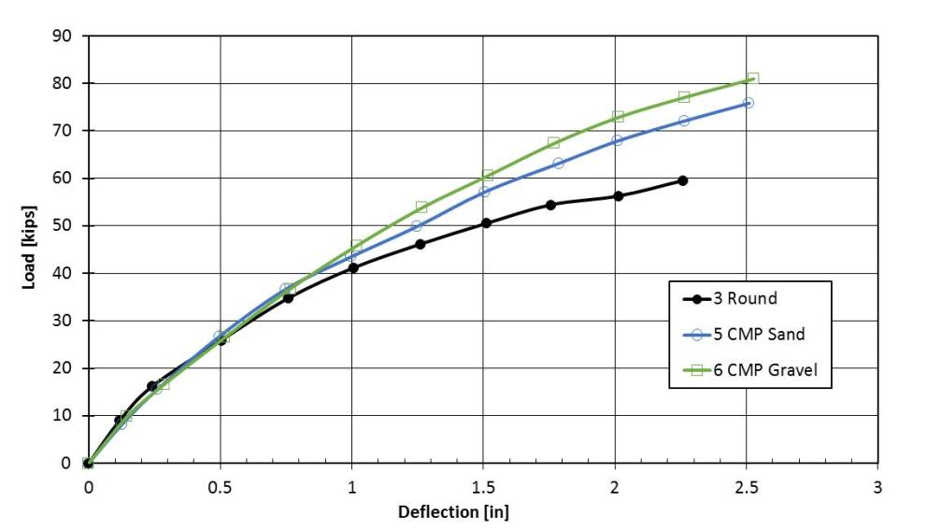

Figure 1. Pile head lateral load versus deflection curves from lateral load tests on a 12.75 in OD pipe pile surrounded by sand along with identical piles driven within a 2 ft diameter Corrugated Metal Pipe (CMP) with the annular space backfilled with sand and pea gravel, respectively.

Figure 2 provides photos which help explain the observed behavior of the piles within the CMP sleeves. As the pile was initially loaded, the pile displaced into the backfill within the annular space surrounding the pile and a small gap developed behind the pile. However, with relatively small deflections the fill within the annual space “locked-up”, to a large degree, and began deflecting into the surrounding CMP. At this point, the CMP began moving laterally and engaging the lateral resistance of the compacted sand backfill of the approach fill. As the CMP moved laterally, large shear cracks began radiating outward from the CMP while small cracks developed within the backfill in the annular space. Therefore, the increased lateral resistance observed at larger displacements likely occurs because the pile and the CMP begin to act as a composite pile with an outside diameter of 24 inches instead of a 12.75 inch pile without significant lateral soil resistance.

Figure 3 shows a photograph of the shear cracks at the end of the test of the pile within the CMP with the pea gravel backfill. The shear cracks are spray-painted in red while the sand backfill is painted white to improve contrast for the Digital Image Correlation cameras photographing the backfill. The shear pattern clearly indicates that the 12.75 inch pipe pile is effectively acting as a composite pile with a 24 inch diameter as it deflects into the surrounding compacted sand backfill surrounding the CMP. However, a smaller set of shear cracks is also visible in the pea gravel as the 12.75 inch pile deflected into the backfill within the annular space.

Piles Wrapped with Plastic Sheeting

Occasionally abutment piles are wrapped with a plastic sheeting prior to construction of an approach fill to reduce the potential for downdrag on the pile as compressible soils below the fill settle. Although this approach has been effective in reducing negative skin friction, unintended negative consequences could develop with respect to lateral resistance. For example, lateral load tests performed on piles wrapped in plastic sheeting at the Pioneer Crossing Overpass in Utah experienced a significantly reduction in lateral resistance that appeared to be a result of the sheeting rather than compaction of the surrounding backfill. Because lateral resistance between soil and structural elements is strongly affected by the interface friction, a reduction in lateral pile resistance would be expected when friction reducing measures are applied to the soil-pile interface. Unfortunately, little information is available to quantify the reduction.

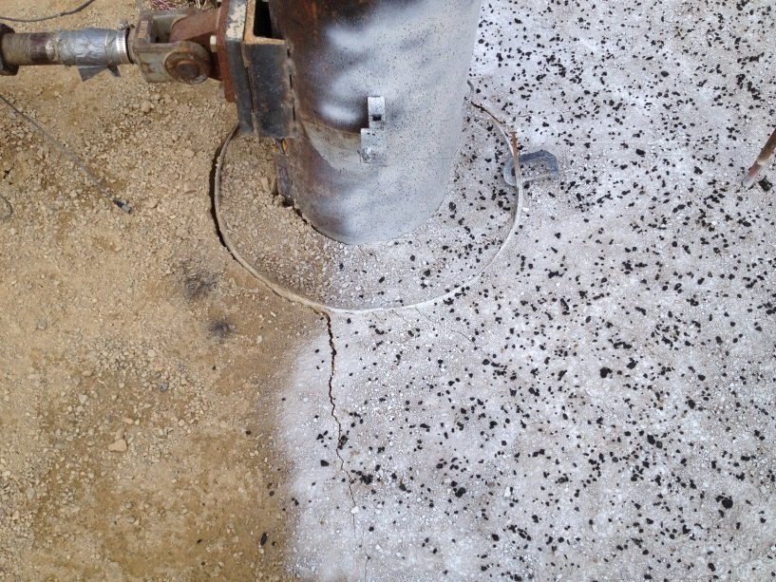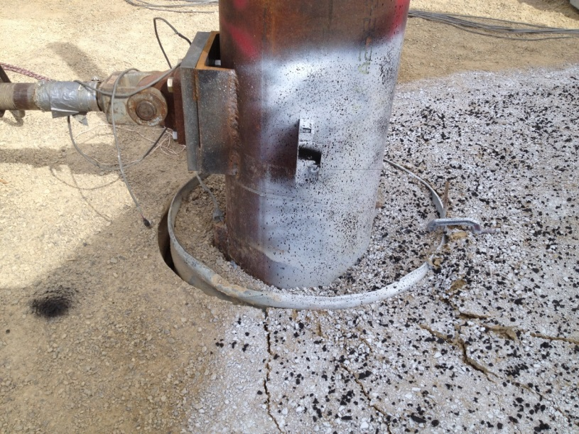
(b)
(a)

Figure 2. Photo of lateral load test on CMP pile showing the development of a gap behind the pile as it displaces into the annular backfill and a gap behind the CMP pile as it displaces into the sand backfill around the CMP, (a) at small deflections and (b) at large deflection.

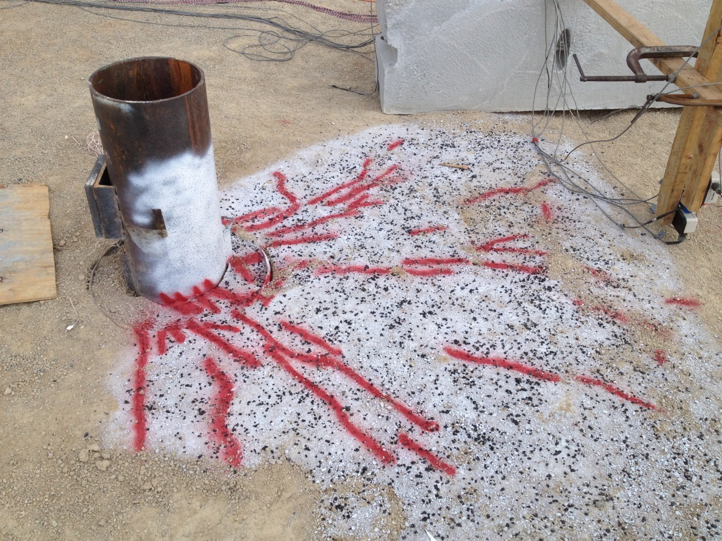

Figure 3. Photo of shear cracks (painted in red) that developed around the pile and the CMP sleeve at the completion of lateral loading. The crack pattern indicates that the 12.75 inch pipe pile and the CMP sleeve are effectively acting as a composite pile with a 24 inch diameter that deflects into the surrounding backfill.

To investigate the effect of plastic sheeting on the lateral resistance of abutment piles, lateral load tests were performed on two identical 12.75 inch OD steel pipe piles (3/8” wall thickness). One pile was tested without any treatment on the pile surface while two layers of plastic sheeting were wrapped around the second pile prior to compacting backfill around the piles. The compaction process around both test piles was comparable based on field observations and density tests.
A plot showing the pile head load versus deflection curves for the two test piles is provided in Figure 4. In both cases the piles were loaded at a height of 12 inches above the top of the surrounding fill.

Figure 4 provide a plot showing pile head lateral load versus deflection curves for the two test piles. Typically, the lateral resistance of the pile wrapped with plastic sheeting is 15% to 25% lower than that of the conventional pile. Because the pile properties are the same in both cases and only the soil resistance is reduced, p-multipliers which might be used to account for the reduction in lateral resistance would be likely need to be between 0.6 and 0.70 which represents a significant reduction. As far as we are aware this set of companion tests is the only test available in the literature that investigates the effect of plastic sheeting lateral pile resistance. These results highlight the need to consider negative consequences on other aspects of design when we try to mitigate hazard from another source.

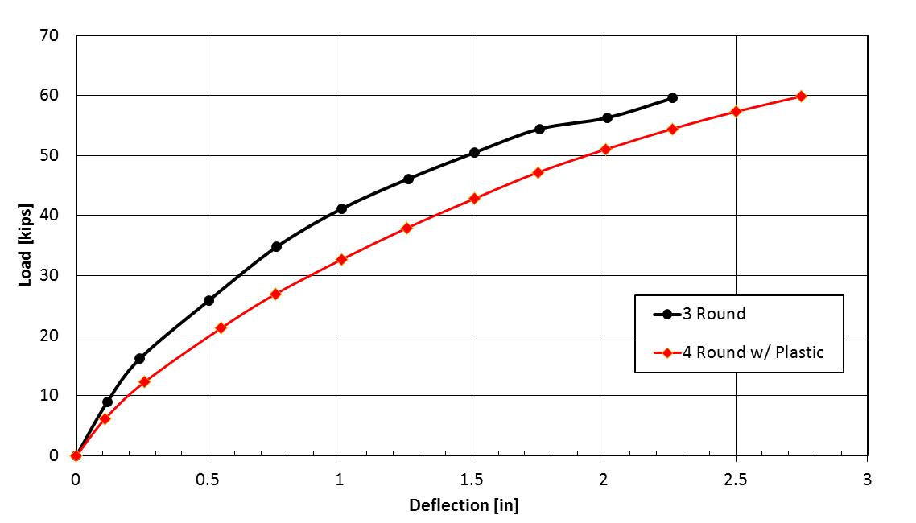

Figure 4. Pile head lateral load versus deflection curves from lateral load tests on a 12.75 in OD pipe pile surrounded by sand along with identical pile wrapped with plastic sheeting prior to sand compaction.

During the next quarter we will be investigating approaches for predicting lateral resistance for piles with CMP sleeves and piles wrapped in plastic sheeting. Analyses will most likely be performed using the LPILE computer model with p-multipliers for the plastic sheeting and composite pile sections to represent the pile-CMP sleeve interaction.

Circumstance affecting project or budget. (Please describe any challenges encountered or anticipated that
might affect the completion of the project within the time, scope and fiscal constraints set forth in the
agreement, along with recommended solutions to those problems).

None to report.

Potential Implementation:

