develop countermeasure strategies for protecting bridge girders against overheight VEHICLES impact
According to the Federal Highway Administration (FHWA), over 600,000 bridges are registered in the National Bridge Inventory (NBI). By a wide margin, most bridges that collapse do so during floods. The second leading cause of bridge failure or collapse is collision damage when a vehicle or a vessel hits a bridge. A recent survey of DOTs across the country has shown that the impact damage to bridges because of over-height trucks is a nationwide problem. A frequently used protection measure against over-height vehicles is the installation of laser protection systems to provide a warning to such vehicles approaching low clearance bridge/tunnel. However, the risk of serious damages to critical bridges/tunnels remains if truck drivers do not follow warning signs. Based on these facts, FHWA recently developed an energy-dissipative system prototype using a combination of a steel box beam with aluminum honeycombs for the protection of bridge girders from overheight impacts. Effectiveness of this device has been investigated recently by large-scale testing on steel beams in collaboration with researchers at Hunan University, where overheight impact was realized by a drop hammer. Figure 1 below shows the setup of the drop-hammer testing with the steel beam in the laboratory at Hunan University. The span length of the beam was 2 m and it had a box section of 6”x6”x5/16”. The yield strength of the steel was 50 ksi. The weight of the hammer was 970 kg. For the boundary condition, the steel beam was firmly clamped at one end and free to move longitudinally at the other end. In Figure 1, the bottom of the clamping devices was simply supported. Honeycomb blocks were attached to the top of the steel beam using epoxy. The crushing strength of the honeycomb was around 1 ksi.
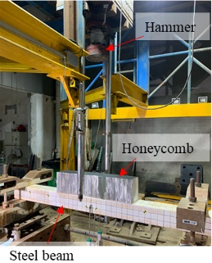
Figure 1. Drop-hammer test setup.
Although several cases of tests were conducted, effectiveness of honeycomb is illustrated through the most severe test case of impact by the drop hammer at a speed of 20 mph on a honeycomb block with dimension of 400 mm x 150 mm was attached to the beam.
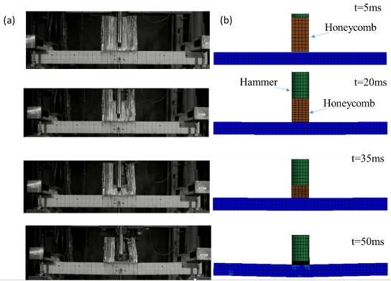
Figure 2: Drop hammer impact on the steel beam with honeycomb: (a) Test, (b) Simulation.

Figure 2 shows the comparison of the impact process during test and simulation in LS-DYNA. Figure 3 shows the comparison of impact force and peak vertical displacement of the beam during test and simulation, which shows quite good correlation between the two. Tests were also carried out to investigate the performance of the beam without and with honeycombs. Figure 4 shows the peak strain in the middle of the bottom flange of the beam without and with honeycombs. It is observed from Figure 4(a) that the peak deformation of the steel beam has been reduced significantly because of honeycombs. Further, honeycombs were effective in reducing the peak strain from approximately 4500µ to 3300µ and permanent deformation from 2100µ to 1000µ, i.e., approximately 27% decrease in peak strain and 52% decrease in the permanent strain.

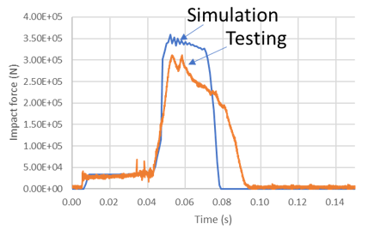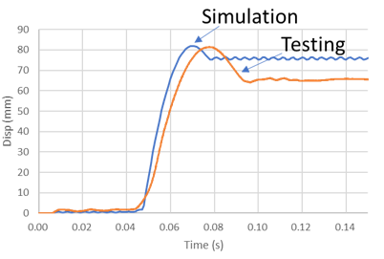
Figure 3. Impact force and Deformation time history of the beam under the 20mph drop-hammer impact.
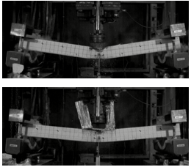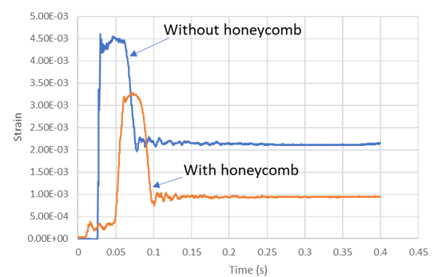
Figure 4. Comparison between steel beam without and with honeycomb for 20 mph hammer impact: (a) Steel beam without and with honeycombs, (b) strain time history comparison of steel beam without and with honeycombs.
These results the show significant potential of using honeycombs to develop an innovative over-height protection device that can protect over-height girders by absorbing impact energy through honeycombs. The tests results presented above would scale approximately to an impact by a 15,000 lb pointed object with 70-mph impact speed on a bridge girder. It should be note that the results presented above are preliminary in the sense that only one available configuration of the honeycomb was used and size of honeycomb could not be optimized because of lack of testing data on honeycombs. There is an urgent need to further develop this protection system, which could be replaceable after an impact, through detailed simulations and full-scale field testing.
This innovative protection device will be effective in preventing damages to concrete and steel beams, while sustaining moderate to severe damage to itself, depending on the intensity of the impact. This pooled fund work focuses on the detailed investigation of honeycombs in combination with other materials, development of the protection system for field deployment, full scale testing and evaluation of its effectiveness against over-height truck impacts. This system could be installed on low-clearance bridges or bridges susceptible to impact by over-height trucks to prevent significant damage to the main bridge system. These objectives will be achieved through the following tasks.
Task 1: Developing an overheight impact program for outdoor testing: Testing of the device will require several full-scale tests. Damaging a trailer during each test may be cost prohibitive and test results itself may be influenced by the material properties and rigidity of the trailer. Hence, focus of this task will be to develop a trailer with over-height impact portion that can be damaged during a test and will be replaceable for carrying out another test. This will not only reduce the cost of the test but will also make the impact force reproduceable between different tests.
Task 2: Theoretical development of full-scale overheight protective system: As shown through the large-scale testing with honeycombs that the proposed concept of using honeycombs has significant promise in protecting girders. However, further significant theoretical research, that will include finite element modeling of honeycombs, detailed modeling of honeycombs in combination with girders, use of honeycombs in combination of other materials, such as FRP or other composites is needed. There is significant work on the design of vehicle fenders that focuses on absorption of impact energy. This work will also be reviewed and investigated for adoption during the research on the protection system. Research will also focus on investigating the protection system extensively through simulations on different impact scenarios: Concrete girders, steel girders, small area impact and large area impact.
Task 3: Design of a method for installing the proposed protective system effectively: The proposed system should be effective during impact but should not cause debris that can lead to supplementary accidents. Hence, this task will focus on the design that will include supporting systems, connections, the protective system and means for easy replacement of damaged components.
Task 4: Design of Setup for Large-scale prototype testing: Before carrying out actual full-scale test, significant effects will be needed in designing a test bridge with girders to be impacted or a system supporting girder to be impacted that can represent the behavior of an actual bridge. The entire test process will need to be simulated in LS-DYNA to design test parameters, such as impact speed, impact area and connection of the protective device to the girder. These tests will need to be simulated for impact without and with protection system.
Task 5: Large-scale prototype testing for demonstration of effectiveness of the proposed protective system: The full-scale tests will be carried out on both steel and concrete girders without and with the impact protective system to evaluate the effectiveness of the proposed impact protection device. Simulations will be carried out to compare test results with those from simulation.
Task 6. Parametric Studies on the Impact Performance of the Protection Devices Installed on the Prestressed / Steel Girders:
Validated model in Task 5 will be used to conduct parametric studies on the protective systems for both prestressed concrete and steel girders that suffered overheight impacts. A wide range of truck parameters will be considered, including three impact velocities, 40, 55, and 70 mph, and three truck weights, 40,000, 60,000, and 80,000 lbs. The impact performance of the protection system, such as the impact force, deformation of the girder, and damage mode, will be evaluated.
Task 7: Development of a design method for proportioning the protective system to achieve a specific performance: For DOT engineers to use this device on a bridge, a design method based on energy principles will be developed. We will also investigate the possibility of using Machine Learning (ML) techniques to develop a predictive model. The simulation and testing results will be used to train a reliable ML model to predict the structural behaviors under a given truck impact event (hazard). In this model, the strength of the girder, truck speed, and weight could serve as the inputs and the output will be the deformations or damage levels of the impacted girder. The design framework can be made performance-based so that DOT engineers can design the girder for a desired structural behavior through the developed input-output model without complex modeling or heavy simulations.
Task 8: Development of design examples and templates for different scenarios: Several examples of installation of the device will be worked out and will be included in the final report. DOTs and consulting engineers may be able to use many of these design examples directly.
Task 9: Final Report: A final report will include outcomes of the tasks carried out in this project.
Comments:
The Federal Highway Administration (FHWA) is seeking a minimum of seven (7) partner states to commit funds in the amount of $70,000 per year for 3 years. The total funding amount per partner is $210,000. FHWA will be the lead agency.
Subjects: Bridges, Other Structures, and Hydraulics and Hydrology; Maintenance

