Research Problem Statement

Research Problem Title:
Pavement Markings in Merge Areas

Statement of Problem
The 2009 MUTCD indicates that for entrance ramps with a parallel acceleration lane, a normal width dotted white line shall be installed from the theoretical gore to a point at least one-half the distance from the theoretical gore to the downstream end of the acceleration taper (Federal Highway Administration, 2009). It also provides the option that the dotted white line may extend to the downstream end of the taper. Drawing A of Figure 3B-9 indicates the minimum distance to extend the dotted white line (at least half the length of the full-width acceleration lane plus taper) and also depicts the optional extension of the dotted white line beyond the minimum point. For a tapered deceleration lane, the MUTCD includes the option to install a normal width dotted white line extension from the downstream end of the of the channelizing line adjacent to the through lane to the downstream end of the acceleration taper, as depicted in Drawings B and C of Figure 3B-9, shown in Figure 1.
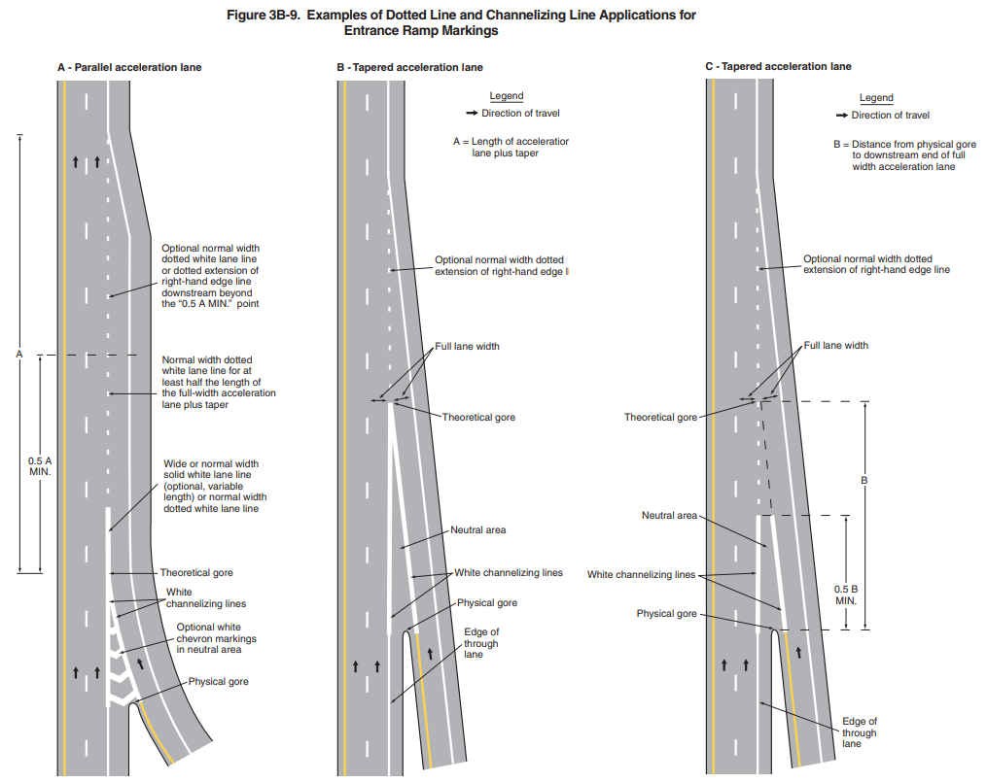
There is variation between States pertaining to the extension of the dotted white line, which could extend to the minimum distance at least half the length of the full-width acceleration lane plus taper, or extend to a distance past the minimum, and/or up to the end of the taper. Examples of these variations are depicted in Figure 2. As depicted in Figure 1, there is also variation in the length of the solid white line that extends past the physical gore.
Figure 1. 2009 MUTCD Figure 3B-9.

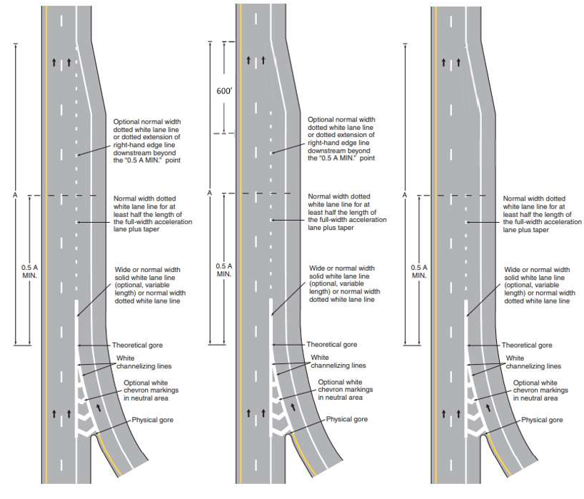
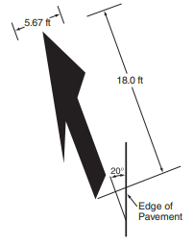
Figure 2. Example dotted line markings at parallel entrance ramps. Graphics provided by Mike O’Donnell (NHDOT)
Similarly, there is variation in practices involving lane-reduction transition markings. Section 3B.09 of the 2009 MUTCD provides guidance that lane line markings should be discontinued one-quarter of the distance between the Lane Ends sign (see section 2C.42) and the point where the transition taper begins (Federal Highway Administration, 2009). Nonetheless, some States or jurisdictions may extend lane lines through the merge, as opposed to ending them before the lane begins to taper. Regarding lane-reduction arrows, section 3B.30 paragraph 34 of the MUTCD indicates that they should be used where a lane-reduction transition occurs on a roadway with a speed limit of 45 mph or greater, or on roadways with a speed limit of less than 45 mph (except for acceleration lanes) if determined to be appropriate based on engineering judgement. However, section 3B.20 paragraph 35 of the MUTCD includes the option for lane-reduction arrows to be used on long acceleration lanes based on engineering judgement. Examples of varying approaches to lane-reduction markings are shown in Figure 4.
Figure 3. Lane-reduction arrow as depicted in Figure 3B-24 of the 2009 MUTCD.
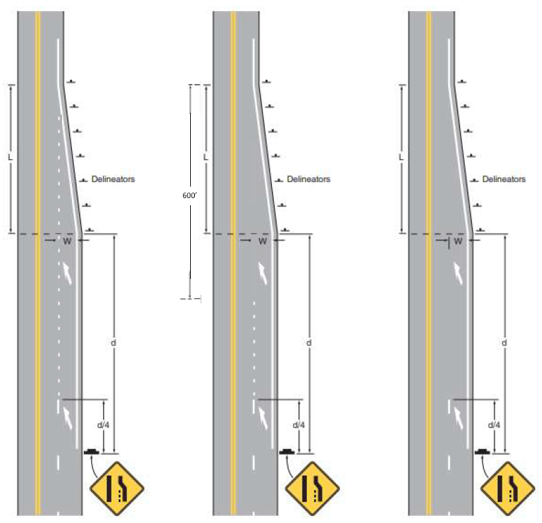
Figure 4. Example lane-reduction pavement markings. Graphics provided by Mike O’Donnell (NHDOT).
While dotted line markings in merge areas and lane-reduction pavement markings have received attention as of late due to their potential to provide guidance for autonomous vehicles, the variation in application of these markings also has potential implications for roadway safety and operations. For example, a recent study on signs promoting a late merge found that the presence of merge arrows with lane lines that extended through the merge was the most significant factor in increasing driver utilization of the right lane in a lane reduction where the right lane ends (Federal Highway Administration, 2023a). Depending on the application, lane-reduction pavement markings may be interpreted to suggest that one lane (the continuing lane) has priority over the other lane (the ending lane) and lead to inconsistent interpretations, increased speed differential between lanes, abrupt lane changes, and other undesirable merging behaviors.
The objectives of this research are as follows.
- Determine how dotted white line markings influence driver behavior at parallel entrance ramps, tapered entrance ramps, and in lane reduction situations, including testing the extension of the dotted white line all the way to the taper end.
- Determine how merge arrows (e.g., presence, number, placement, size) influence driver behavior at lane reductions.
- Determine if motorists understand the differences between line widths and patterns.

Summary of Existing Literature

The Minnesota Department of Transportation evaluated pavement markings (Tiger Tails, Sharks Teeth, Lane Arrows) to determine their influence on the timing of drivers merging when approaching a work zone (Briese, 2003). The study found that lane arrows performed the best in terms of promoting an early merge, particularly when the size of the arrows were increased from 12 feet to 19 feet.
A field study evaluated the effectiveness of static signs promoting a late merge at a lane reduction (Federal Highway Administration, 2023a). The research focused on right-lane drops on arterials and the research team used right lane utilization as the primary measure of sign effectiveness, as the goal of a late merge is to use both (or all) lanes up to the merge point. The research team used statistical models to estimate right lane utilization by location, data collection period (before sign installation, soon after installation period, and several months after installation), volume, and roadway characteristics (shoulder width at merge, presence of driveways or businesses on the right side of the road, presence of merge arrow pavement markings, etc.) and found that the most significant factor regarding right lane utilization was the presence of merge arrows. The research team reported that right lane utilization was significantly lower at the sites that include merge arrow pavement markings.

There is other evidence that lane reduction markings influence driver perception as well. A 2016 study sponsored by the Traffic Control Devices Pooled Fund Study examined driver comprehension of six different lane reduction marking approaches presented on five different roadways, resulting in 30 different scenarios that were viewed by participants (Federal Highway Administration, 2023b). The lane marking combinations varied by type of line and extension including 1) broken line that ended prior to the taper, 2) dotted line that ended prior to the taper, and 3) a broken line that is changed to a dotted lane line and continued to the start of the taper. Each of these scenarios were also presented with and without a solid white line adjacent to the broken/dotted line. Participants viewed the scenarios and were asked several questions pertaining to comprehension. The authors provided several overarching conclusions including:
- The addition of a solid white line may result in:
  - Earlier lane changes
  - An understanding that drivers in an adjacent lane should not move into a lane that is about to terminate
  - An understanding of drivers in the adjacent lane that they should expect merging
- Dotted lines (as compared to broken lines) resulted in greater understanding that a lane is about to end.
- Subjective/perceived effectiveness of the addition of the solid white line in indicating a lane reduction.
- Subjective/perceived effectiveness of dotted lines (over broken lines).
- Termination of the markings likely acts as a cue to change lanes.
The authors recommended that the MUTCD allow the usage of the dotted line in place of the broken line, but recommended further study using driving simulation or real-world testing.

Potential Research Approach
The general approach to the research has been identified as a field study in which varying pavement markings in merge areas are evaluated based on driver behavior.
Previous research suggests that lane reduction marking approaches influence driver perception, however the authors recommended further study using a driving simulator or real-world testing (Federal Highway Administration, 2023b). The behaviors to be evaluated relative to pavement markings in merge areas can be influenced by other factors such as driver states (e.g., distracted, in a hurry, etc.), traffic, vehicle speeds, etc., the complexities of which cannot be naturally recreated in a driving simulator. As such, a field study that captures natural driving behavior would be the most effective approach to capture actual behavior changes and potential safety benefits in response to the pavement markings being tested.

Task 1 – Kick-off Meeting and Project Management
Researchers would attend a kickoff meeting with FHWA and the TCD PFS panel. The research team will work with the TCD PFS and other stakeholders to ensure a common understanding of the research objective and research questions.

Task 2 – Literature and State of the Practice Review
The research team will review and synthesize literature regarding research that has been performed on pavement markings in merge areas. Additionally, current practices will be gathered from the TCD PFS members, at a minimum, and summarized.

Task 3 – Research Plan Development
The research team will work with the TOCOR, TCD PFS, MUTCD team, and other stakeholders to select the specific pavement marking patterns that will be evaluated and refine the characteristics of candidate locations that will be considered. This would involve considering varying applications of pavement markings including merge arrows (presence/absence, number, placement, size) and dotted lines (length/extension and width). It would also involve considering the type of merge scenario(s) to be evaluated (e.g., parallel entrance ramps, tapered entrance ramps, lane reduction) and other relevant roadway characteristics. The dependent variables (e.g., merge location, lane utilization, travel time, etc.) and methodology will be described in the research plan. The research team will also consider a comparison of vehicle speeds between the entrance ramp and the right lane, or another appropriate method, to determine how merges are occurring.

Based on inputs from the kickoff meeting and stakeholder coordination, as well as findings of the literature review, the research team will develop and submit a research plan specifying the pavement markings and methodology that will be used for conducting the study.

Task 4 – Optional Laboratory Recognition Testing (if needed)
If the Literature and State of the Practice Review and feedback from the TCD PFS do not sufficiently focus the scope of the research, then the research team may propose to conduct preliminary recognition testing to further narrow the variables to be tested in the field. The objective of the optional laboratory testing would be to determine the variables and/or levels of variables that are most likely to be noticeable in the field by motorists, thus narrowing the focus of the field study to increase the likelihood of gathering useful information. The research team would refine the research plan for the field study based on the findings of the laboratory testing, if conducted.

Task 5 – Field Site Selection and Preparation
Once the research plan is finalized, the research team will identify appropriate field locations (or sites) that meet the criteria identified in the research plan and enable the collection of sufficient data to address the research questions.
Task 6 – Data Collection & Analysis
The research team will collect and analyze data based on the approved, final research plan. This will involve the collection of driving behavior in response to the various pavement marking patterns to be tested.
Task 7 – Final Report and Presentation
The research team will develop a final report that describes the research approach and results and provides a discussion of the findings. The team will present their findings to the TCD PFS members.
Chance of Successful Evaluation
High
There is a relatively high likelihood that a field study can determine the effects of pavement markings in merge areas on merging behavior. However, some of the biggest challenges with evaluating merging behavior are 1) the level of effort required to accurately reduce video data to capture and code the driver behaviors of interest and 2) controlling and/or accounting for (e.g., via statistical models) traffic and roadway characteristics that may influence merging behaviors to accurately identify the effects of the pavement markings.
References

Federal Highway Administration. Manual on Uniform Traffic Control Devices (MUTCD). U.S. Department of Transportation, Washington, D.C., 2009.
Briese, M. (2003). Evaluation of Innovative Pavement Markings with Applications in Work Zones. Minnesota Department of Transportation. Office of Traffic, Security, and Operations.
Federal Highway Administration, Evaluation of Lane Reduction and Late Merge Signing (Washington, DC: 2023) https://doi.org/10.21949.1521375
Federal Highway Administration, Lane Line Markings in Advance of Lane-Reduction Transitions (Washington, DC: 2023) https://doi.org/10.21949/1521952

