Click here to enter Program or Project Title
Progress Report – Click here to enter a date.

Title: Assessment and Repair of Prestressed Bridge Girders Subjected to Over-height Truck Impacts Pooled Fund Project

Project Number: TR202011

Principal Investigator (PI): Mohamed ElGawady PhD (PI)
Co-PI(s): William Schonberg PhD, PE (Co-PI)

Award date: | 1/1/2021
Scheduled completion date: | 12/31/2023 | % of project completed to date: | 65%
Total budget: | $805,000 | % of budget expended to date: | 67%
Draft report due: | 9/30/2023 | Final report due: | 12/1/2023

Provide a short description of the work currently underway.
Use additional notes section if you need to provide more information.

Task 2. Experimental testing of bridge girders subjected to lateral impacts:
- Four girders were cast. Fine tune the test setup is in process. Things like how to release the weight is finalized.
- Analyze the first set of experimental data.

Task 4: Residual Capacity:
- Analytical tools that consider the biaxial demand on the girders are being developed.

Task 5: Repair Evaluation:
- Determine the different repair options and discuss with the DOTs and FHWA.

Provide a short description of the noteworthy activities/accomplishments during this reporting period.
Use additional notes section if you need to provide more information.

Task 2. Experimental testing of bridge girders subjected to lateral impacts:
Four full-scale girders were cast. Before casting the girders, several strain gauges were attached to the stirrups and the prestressing strands. Proper surface preparation as rust removal, grinding, and sanding was completed before applying the adhesive to attach the strain gages. Water protection was provided using Vinyl mastic tape as well (Figs.).
To ensure that the strain gauges will be installed correctly on the strands and the data acquisition system will be able to read the strains, initial testing for strain gauges was performed at the laboratory under both static and impact testing. For static testing, a standard uniaxial tension test was conducted on the 0.5-inch low-relaxation strand. The test was carried out upto 22 kips, below the yield stress. The measured strains were in a very good agreement with those measured using a 6 in. long extensometer.
For the impact testing, a 10 ft long steel beam HP 10x53 was fixed horizontally on a 20,000 lbs concrete footing. Strain gauges were attached to the web and flange of the steel beam. Data-acquisition system (DAQ) was used to record all the testing data. A sampling rate of 50 KHz was used to record the high frequencies. The cart empty weighs 2200 Ibs and was loaded with a 3 x 7-foot reinforced concrete slab 6” inches thick. The cart impacted the steel beam at mid-span. Fig. 6 shows the strain profile of the flange and web at mid-span. The test was successful to prove that the DAQ and strain gauges can capture the high frequencies and the very short time of 10 milliseconds. The tensile strength of the beam is 60 Ksi. The maximum strain response was almost 0.0021 and thereby, still in the elastic range.
To accurately measure the impact force time history at each test. Load cells need to be mounted on the front of the impact cart. Finite element simulations were conducted to test the maximum impact force that could be achieved with the highest speed of the simulator and impact mass. The estimated impact force from the simulation was 4400 KN (1000 kips) as shown in Fig. 7. An assembly of three load cells each is 450 kips capacity, two steel plates of 1.5 inches and 3-inch thickness, and 1.5-inch diameter steel shafts were used to fabricate a bumper that was mounted on the cart front. The bumper configuration layout is shown in Fig. 8.
Task 5: Develop finite element models for the beams.
The finite element models were refined and starting to look at the different repair options. Examples of the work done is shown below.

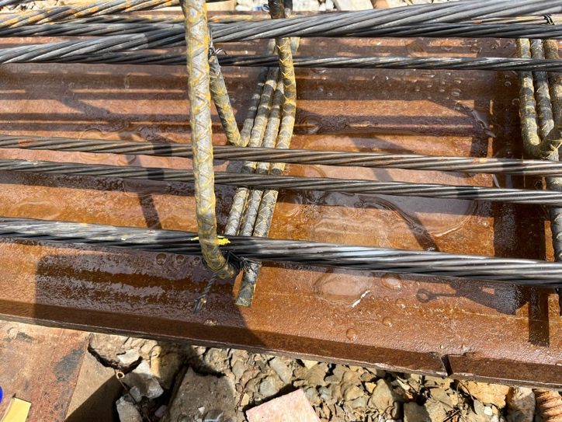
Figure 1. Strand surface preparation
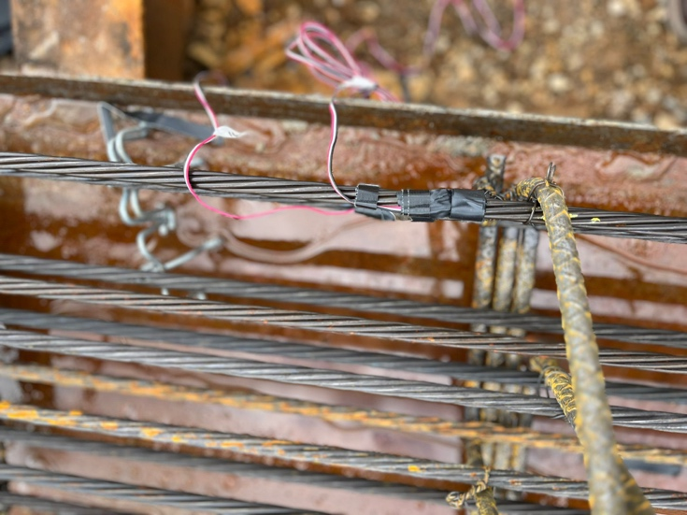

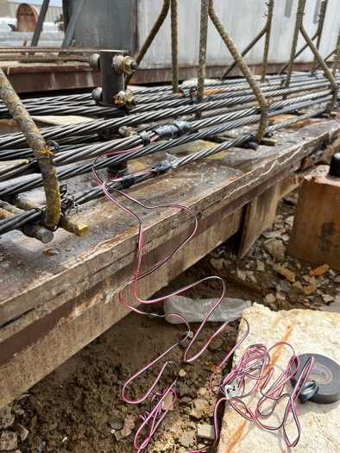
Figure 2. Attaching strain gauges to strands

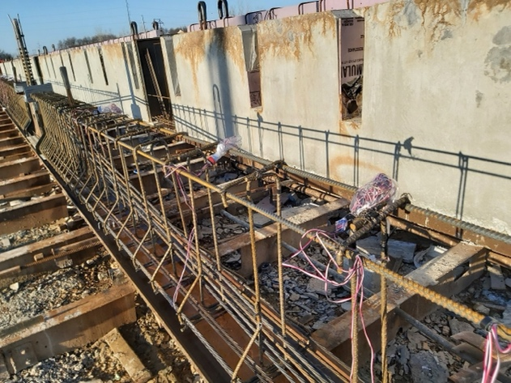
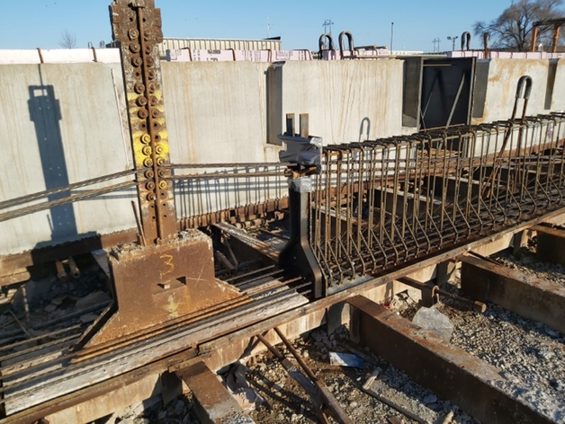
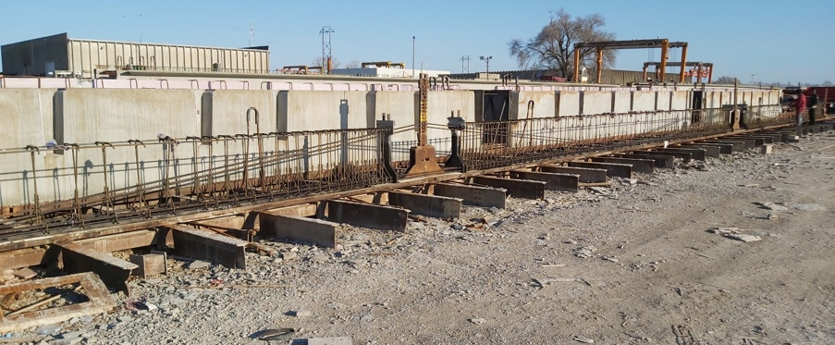
Figure 3. Strands and reinforcement of the beams
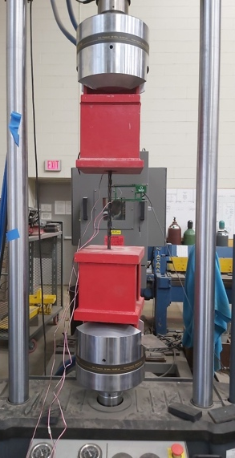
Figure 4. Uniaxial tension of 0.5”-inch strand
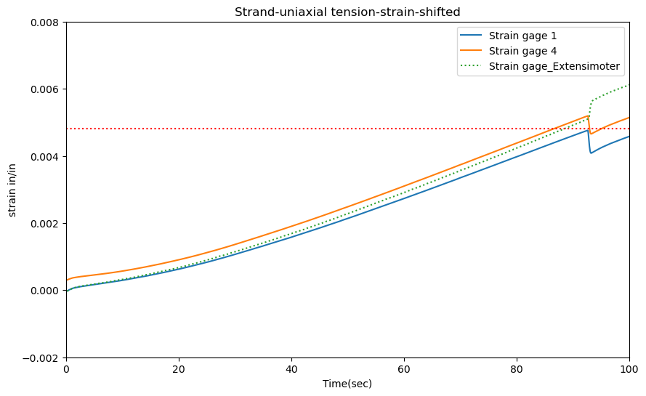
Figure 5. Strain profile from strain gauges and extensometer
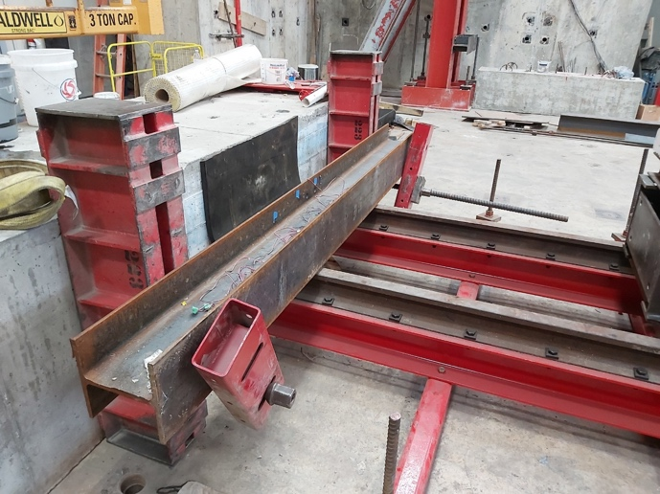
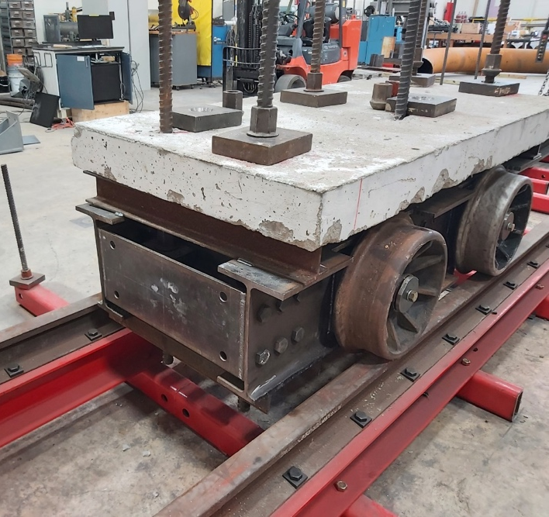
Figure 6. Initial impact testing

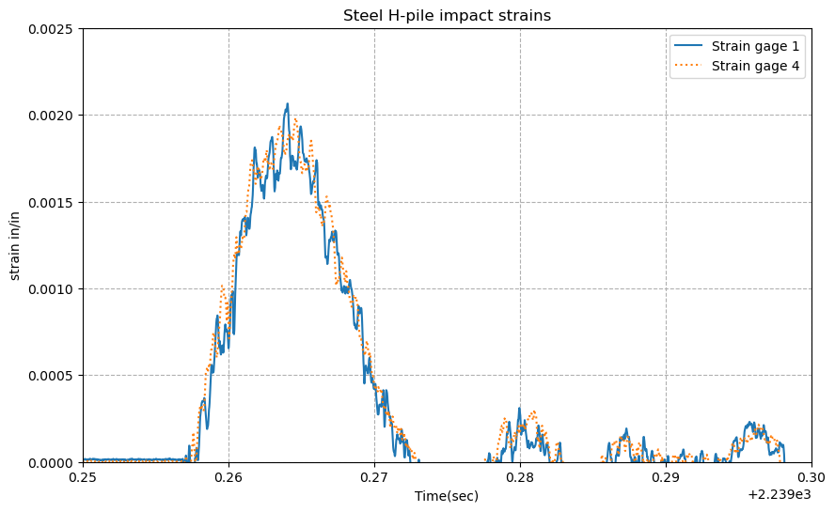
Figure 7. Strain profile of the steel beam flange and web at mid-span
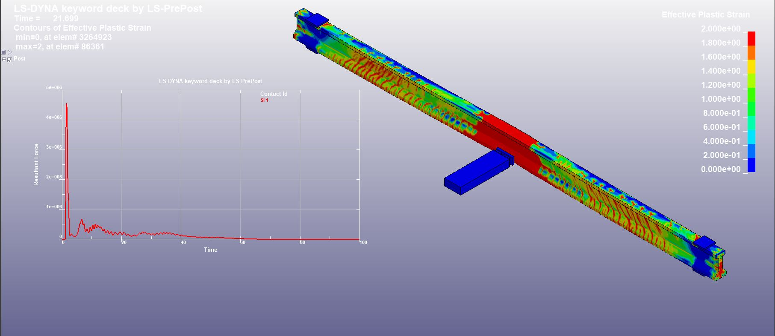
Figure 8. FE simulation results

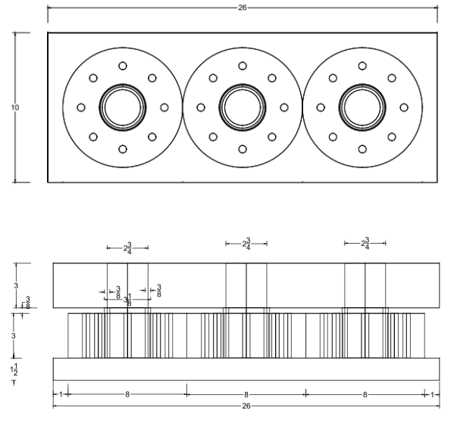
Figure 9. The layout of the bumper configuration
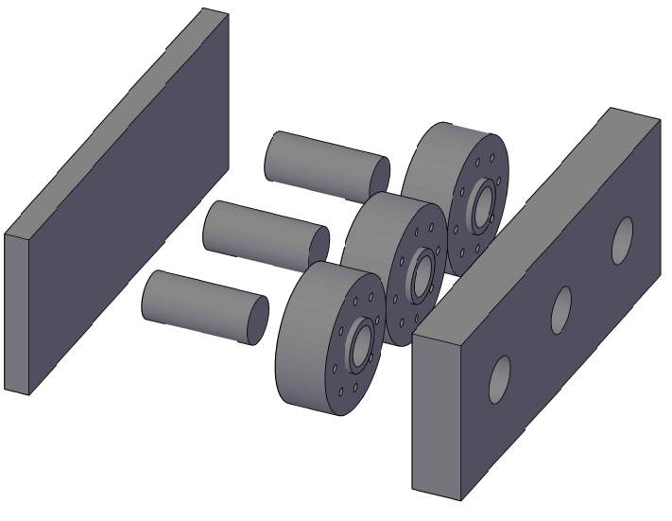
Figure 10. The load cells assembly from conceptual drawing to fabrication

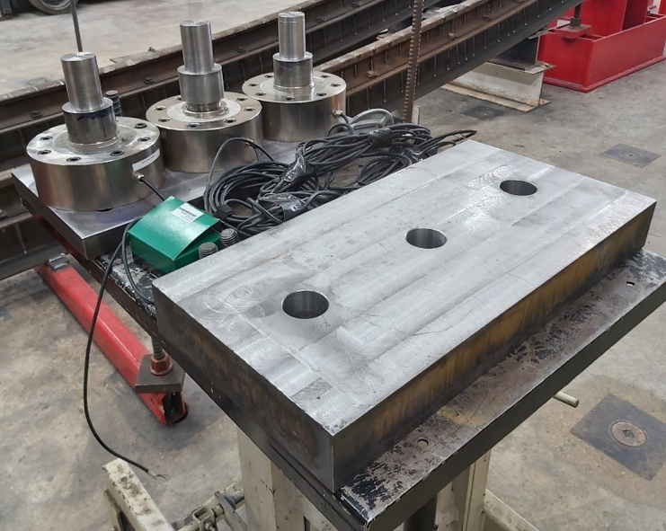
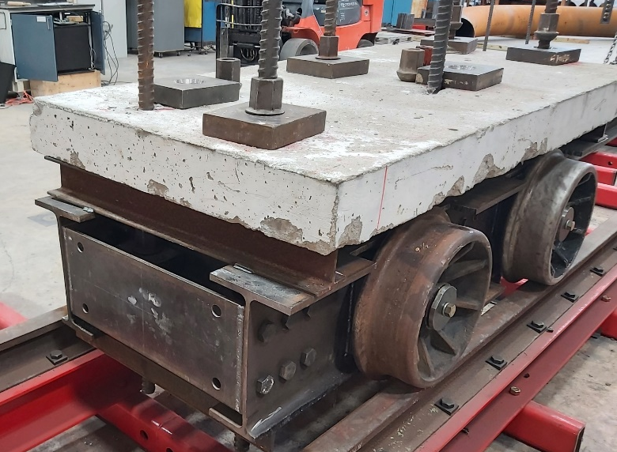
Figure 11. The cart bumper assembly and its location on the cart

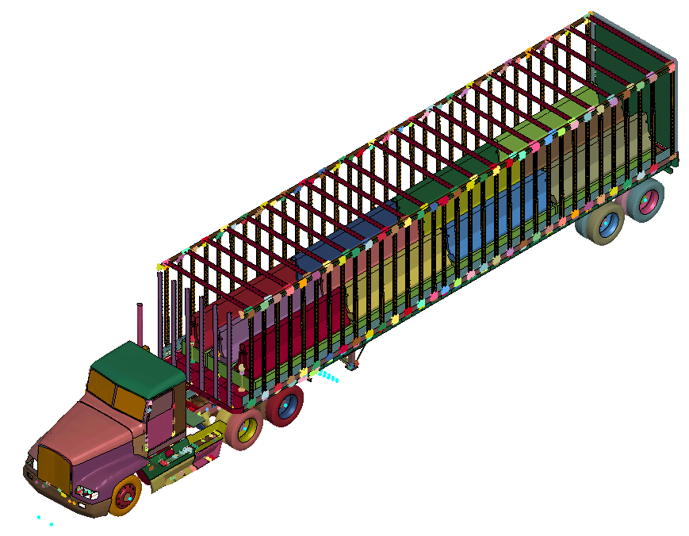 | 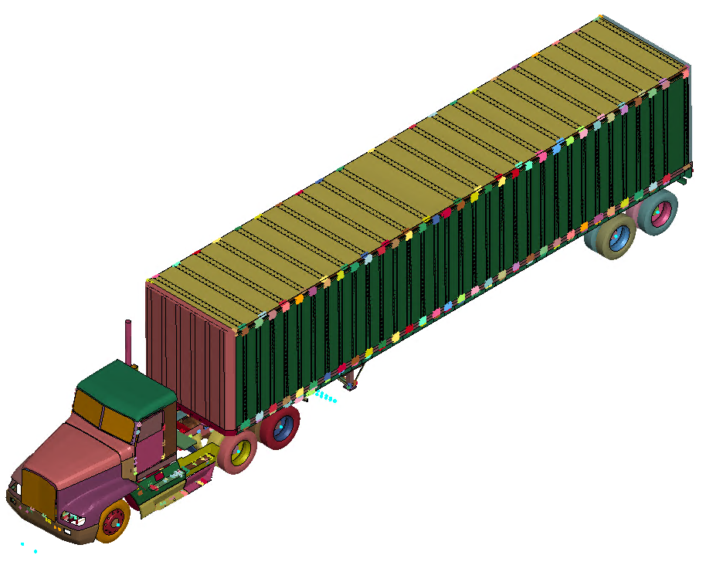
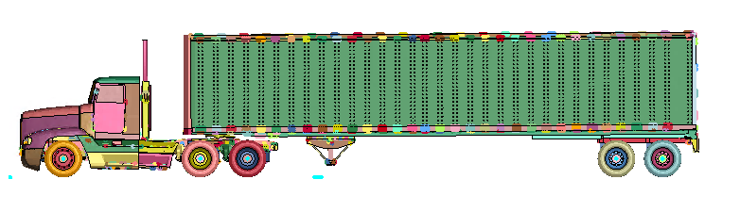
Figure 12. (a) Full finite element model for Texas Transportation Institute Test 7069-13

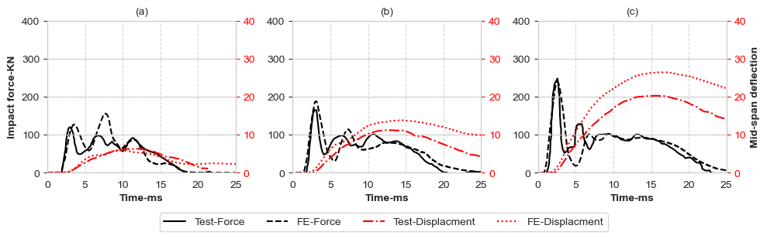
Figure 13. Model calibration: Experimental and FE impact force and mid-span deflection time histories with different drop heights

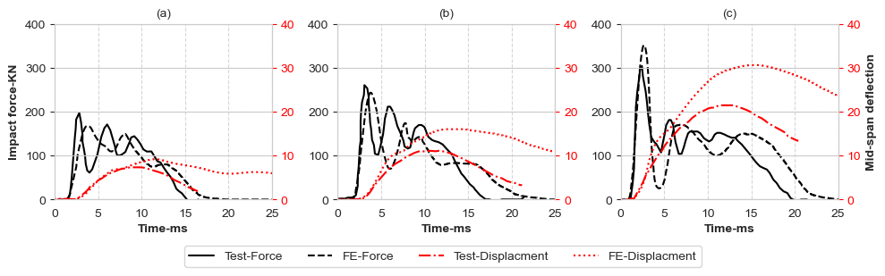
Figure 14. Model Calibration: Experimental and FE impact force and mid-span deflection time histories with different drop heights for another set of beams
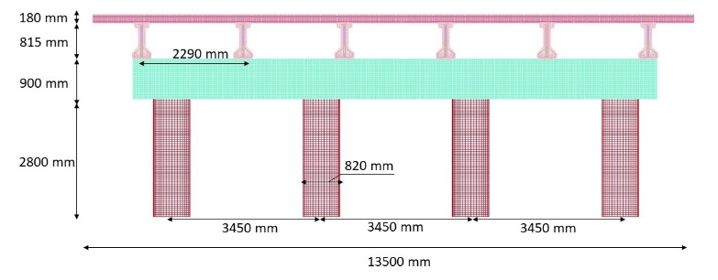
(a)
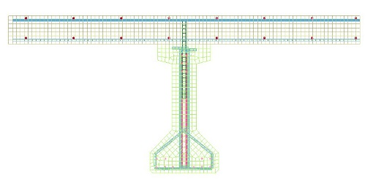
(b)
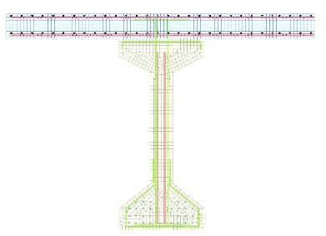 | 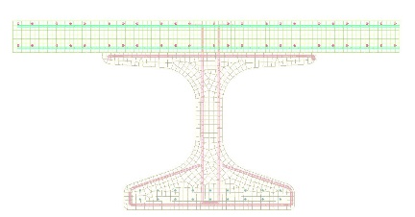
(c) | (d)
Figure 15. Performance of full bridge vs individual girders under impact loads
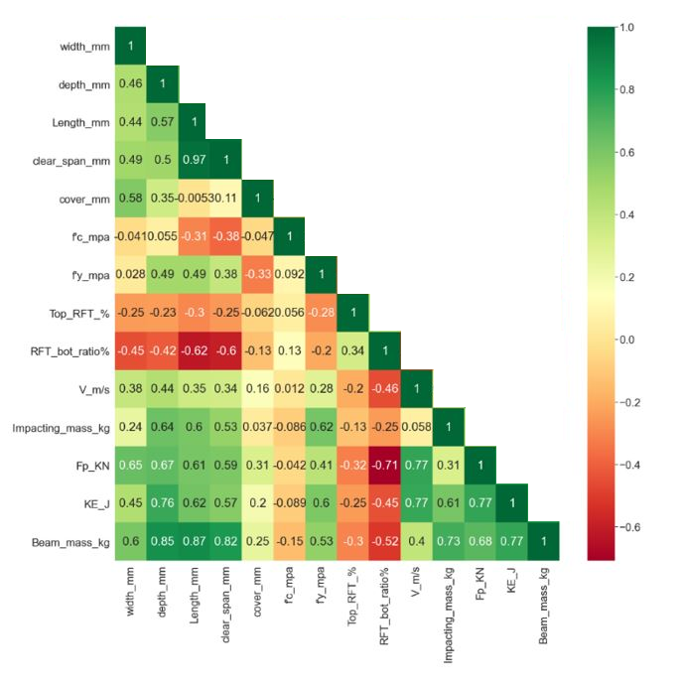 | 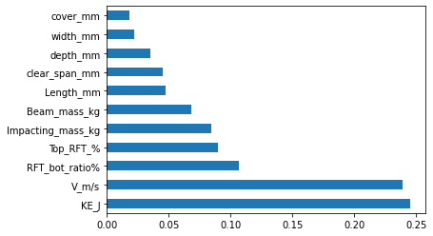
(a) | (b)
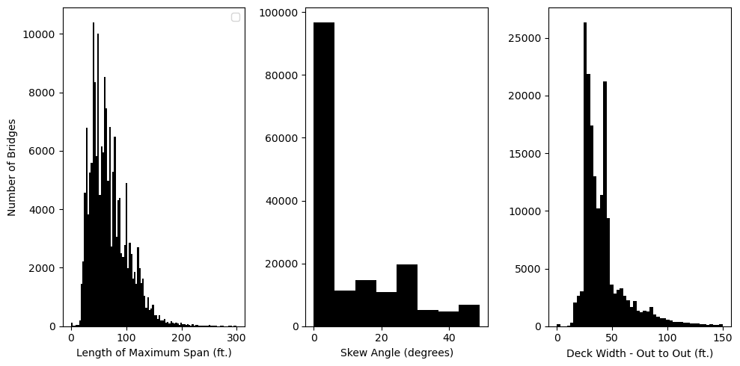
(c)
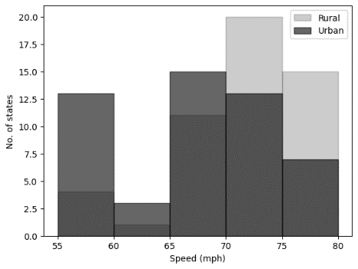
(d)
Figure 16. (a) Correlation map for different parameters, (b) Importance map, (c) Number of bridges with the span, skew angle, and deck width, and (d) Speed limits
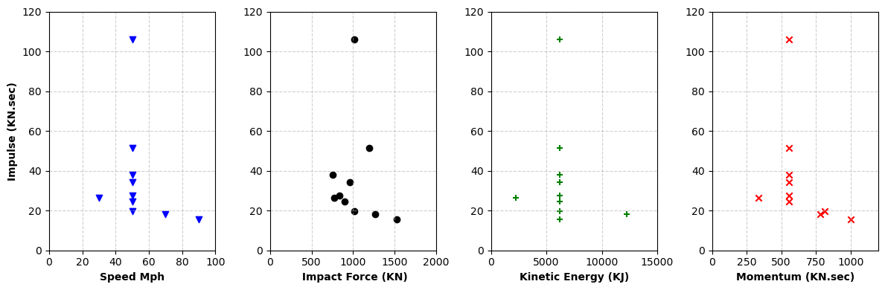
(c)
Figure 17. (a) Peak impact force and speed, (b) Impulse energy of M2-L50-S50 model, and (c) Impulse energy with different matrices
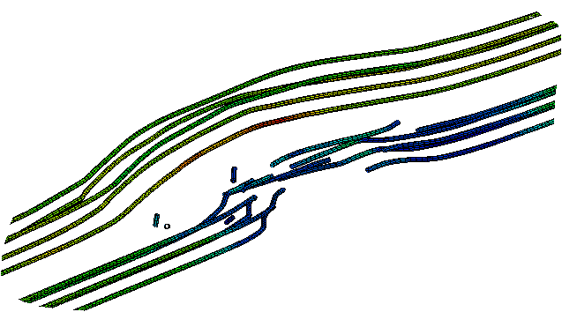

Figure 18: Strands cutting due to high-speed impact.

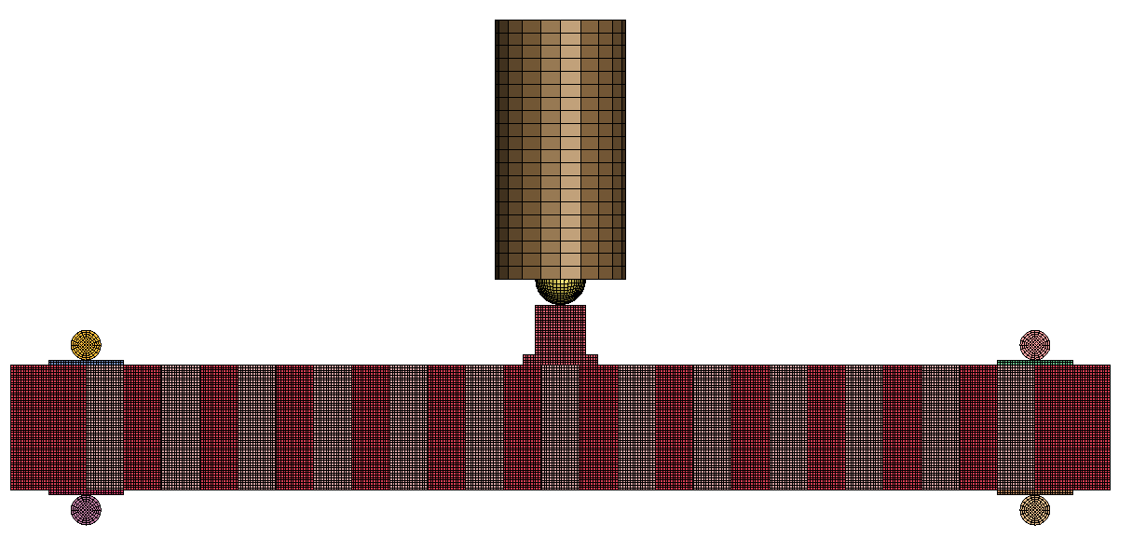
Load Cell
Rigid Impactor
FRP U-wraps
(a)
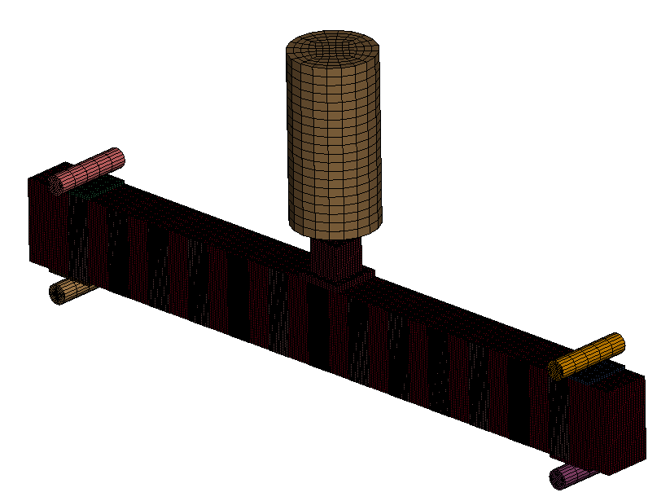
(b)

Figure 1: FE model
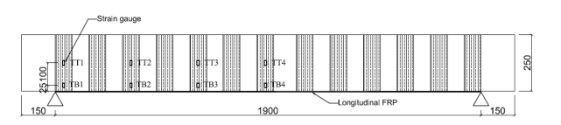
Figure 19: Calibrations for models of FRP-repaired beams under falling weight impact
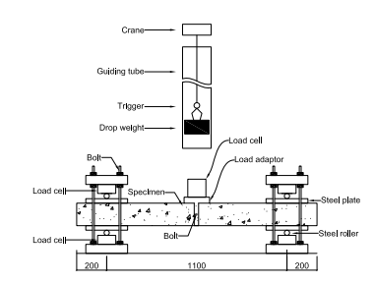
Figure 20: Impact test setup [6]

