Click here to enter Program or Project Title
Progress Report – Click here to enter a date.

Title: Assessment and Repair of Prestressed Bridge Girders Subjected to Over-height Truck Impacts Pooled Fund Project

Project Number: TR202011

Principal Investigator (PI): Mohamed ElGawady PhD (PI)
Co-PI(s): William Schonberg PhD, PE (Co-PI)

Award date: | 1/1/2021
Scheduled completion date: | 12/31/2023 | % of project completed to date: | 25%
Total budget: | $755,000 | % of budget expended to date: | 29%
Draft report due: | 9/30/2023 | Final report due: | 12/1/2023

Provide a short description of the work currently underway.
Use additional notes section if you need to provide more information.
While not part of the tasks, it is essential to establish a good team to carry out the research tasks. Interviewing more than 30 potential students were carried out and four graduate students were selected and the hiring process started.

Task 1: Literature review. The literature review was extended to include finite element analysis for prestressed girders and prestressed bridges. A draft of the literature review is attached to this report.

Task 2. Experimental testing of bridge girders subjected to lateral impacts: Two impact test setups were designed. One is dedicated to small-size beams and the second one is for the large-size beams. The small-size beams test setup will be in campus in two weeks. The vertical steel members (columns) and rails for the large-size setup arrived to Rolla. The cart, and wheels will arrive to campus this week. We still waiting for the steel beams to place the rail on. We are also working with a precast producer to prepare the in the prestressed concrete beams.

Task 5: Develop finite element models for the beams. Validation of the FE model for prestressed girders available in the literature is developed as presented at the end of this report. A FE model for a full bridge has been developed as well as show at the end of this report.

Task 7: Deliverable. A first draft for the literature review chapter I the final report is attached to this report. The write up of the experimental work and finite element chapters are in progress.

Provide a short description of the noteworthy activities/accomplishments during this reporting period.
Use additional notes section if you need to provide more information.

Task 1: Literature review. This task was 90% completed. A draft report is included at the end of this report.

Task 2. Experimental testing of bridge girders subjected to lateral impacts: The test setup should be ready for testing the first beam by the time of the next quarter report.

Task 5: Develop finite element models for the beams. The FE is being developed. A summary of the progress in this task is presented at the end of this report.

Identify issues or problems that need to be addressed.
Use additional notes section if you need to provide more information.
Delivering the rail and other parts of the test setup were very slow due to the current supply-chai issue. However, it should be delivered this week to Rolla. We are also waiting for few elements of the test setup that need to be cleared at LA port. Another issue was to bring in the last graduate student as he is international student and has issues with his visa. However, domestic MS ad undergraduate students will be hired.

Provides dates for when the next progress report or presentation due:
3/30/2022

Task 5: Develop finite element models for prestressed beams.

The implemented geometrical and material properties of the PCG were based on the experimental study conducted by the Virginia Department of Transportation and the University of Virginia by Gangi et al. (2018).
AASHTO beam Type III modeled in this report were 44 ft long, and each had 50 prestressed strands, which included two straight strands in the top flange, 40 straight strands in the bottom flange, and eight harped strands. The harping points were located at 24 ft from each end of the beam. Cross sections of the beam between the harping points and near the end of the beam. A cross section of a beam with deck concrete is shown in Figure 1.
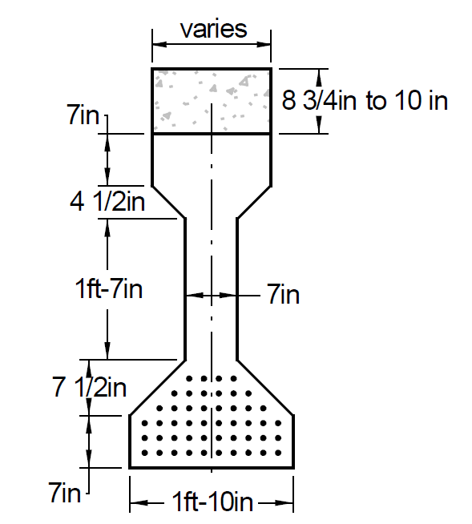
Figure 1. Cross Section of the AASHTO beam Type III (Gangi et al. 2018)

Shear reinforcement consisted of two No. 5 single leg stirrups, with variable spacing along each girder as shown in Figure 2. Figure 2 also shows the center of gravity of the harped prestressing strands. Each prestressing strand had a nominal diameter of 0.375 in, with a cross-sectional area of 0.080 in². Seven-wire stress-relieved strand with a minimum ultimate tensile strength of 250 ksi was used in the beams.

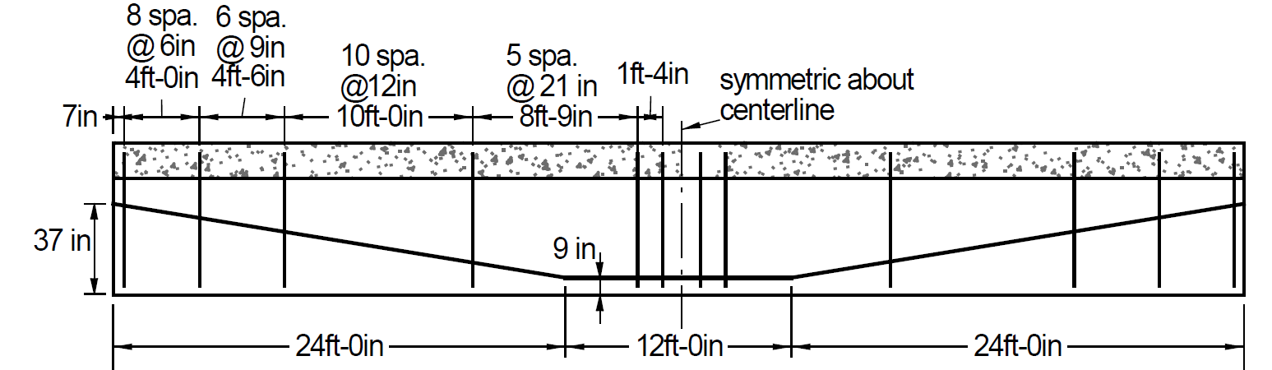
Figure 2. Cross Section with Stirrup and Harped Strand Pattern layout (Gangi et al. 2018)

Beam A was tested as the undamaged control test to provide a baseline for comparison with subsequent tests. Beam A was approximately 44 ft in length, and it was the longer segment of a beam that had broken into two pieces. The bottom flange of the beam was spalled at the broken end for about 7 ft. To ensure that the control test would represent an undamaged beam, the section of beam from the undamaged end to 37 ft from that end was considered to be undamaged (Figure 3).
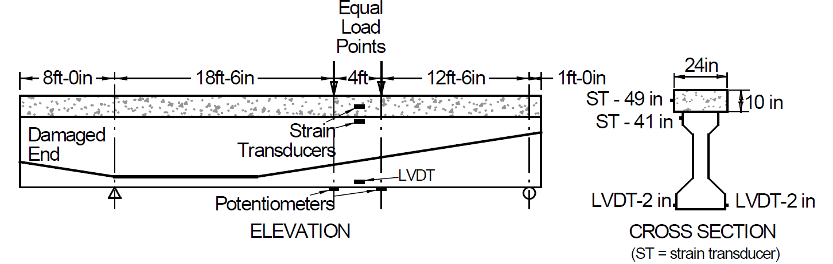
Figure 3. Cross Section with Stirrup, Harped Strand Pattern, and Loading Arrangement layout (Gangi et al. 2018)
The composite deck was cut during demolition of the bridge, but some existing deck still remained intact and attached to the girder. The existing deck on Beam A was roughly cut, with approximate dimensions 10-in deep and 24-in wide. Despite some damage to the concrete deck, it was assumed to act as fully composite. A schematic showing the loading arrangement and the location of instrumentation is presented in Figure 3.

Model Geometry
The FE models were created using LS-DYNA software. The FE model was previously developed to simulate the pre-damaged girder AASHTO type III tested experimentally by Gangi et al. (2018) under static loads (Fig. 4) which is the main task in this project progress report.
A sensitivity analysis was conducted to determine the different element sizes and types to provide the best predictions for strength and deformation. Each FE model had approximately 43,431 elements and 49,148 nodes. Fig. 4 shows the final finite element model with the different parts of the simulated test. The 8-node solid element with three degrees-of-freedom per node by default uses one-point integration plus viscous hourglass control.

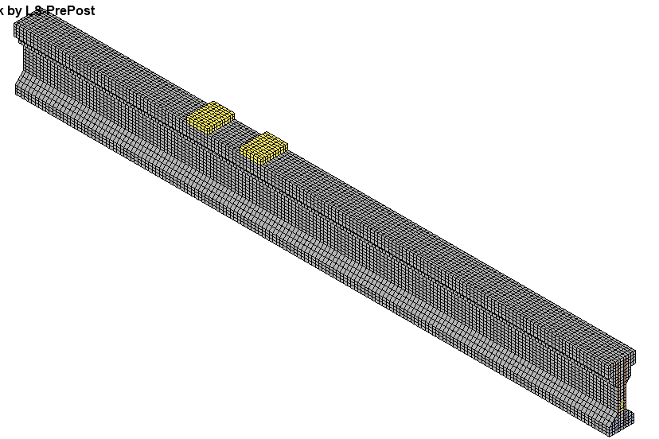
Loading points
(a)
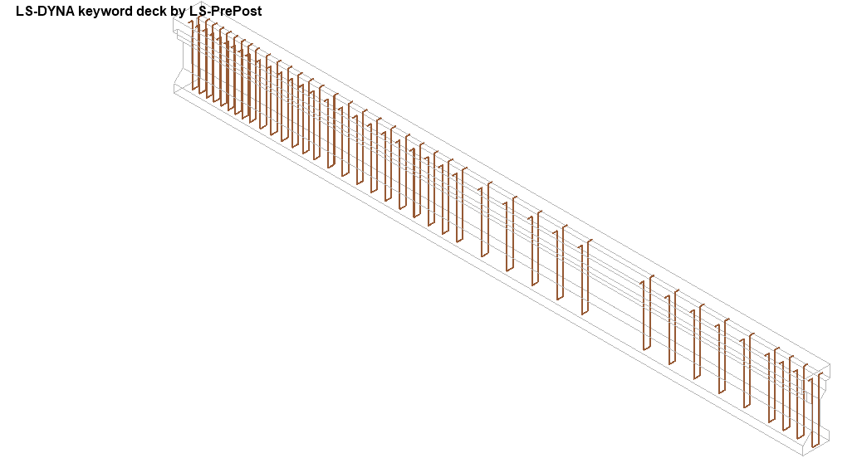
(b)
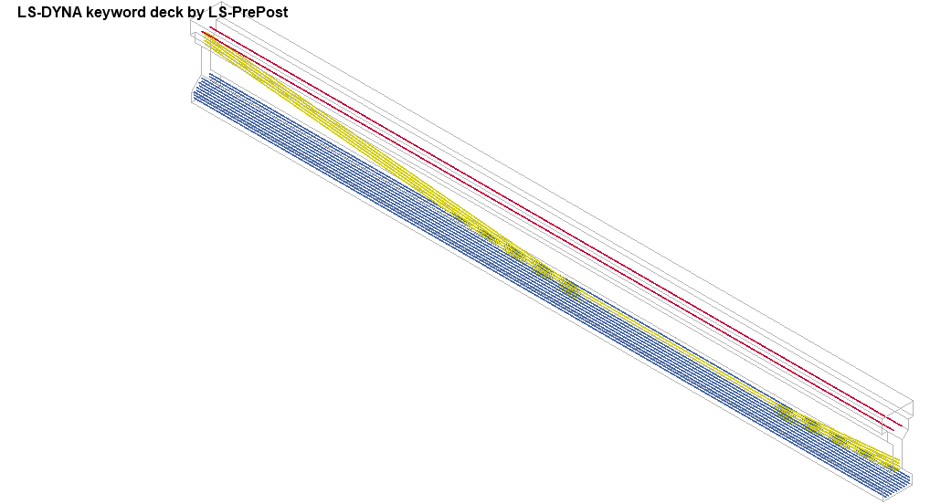
Lower strands
Upper strands
Harped prestressing strands
(c)
Figure 4. 3D view of the simulated FE model of the AASHTO beam Type-III under static loads (a) 3D view, (b) stirrups, and (c) strands

Material Models

Concrete
The concrete encasement was modeled using constant-stress solid elements, which uses single-point integration and reduces the computational time over the entire integration element with reasonable accuracy.
Release III of Karagozian and Case (K&C) was used to model the concrete material. The model was developed based on the theory of plasticity and had three shear failure surfaces (1) yield, (2) maximum, and (3) residual shear (Malvar et al. 1997). Several investigators used this material model to predict concrete structures’ performance under lateral cyclic loads (Abdulazeez et al., 2019; Abdelkarim et al., 2017; Youssf et al. 2014). An automatic option was used during this research to generate all the model parameters, i.e., given the uniaxial unconfined compressive strength $f_{c }^{'}$, the model can create all the constants required for the finite element analysis.
The Continuous Surface Cap Model (CSCM) became incorporated into LS-DYNA as MAT_CSCM_CONCRETE (159) was also used to model the girder concrete in this report. Because the failure surfaces were continuous, smooth transitions from one failure more to the next could be achieved. This allowed excellent smoothness of results even with coarser meshes and allowed the modeling of line elements representing embedded steel reinforcement. The continuous function combines an exponential cap function subtracted from a linear (Mohr-Coulomb) function. The linear, exponential surface is described by four parameters: tensile strength, compressive strength, shear strength or cohesion, and an exponential coefficient for the cap’s shape.
However, most numerical codes offer a great range of parameters that can be tuned to the specific application of simulation. The user often chooses only the necessary parameters for the desired complexity of material response Fossum et al. (2014). Thus, material efficiency and accuracy are continuously optimized during the simulation process.
It is worth mentioning that to simulate the pre-damaged region in the tested PCG during the experiential test, two approaches have been implemented in the developed models. The first approach was assigning a lower concrete material strength property f’_{c} by 65-85% than the undamaged regions. The second approach was by provoking small cracks in the predicted damaged area.

Steel Rebars
Material model 003-plastic_kinematic was used to model the headed studs in LS-DYNA. The steel rebars are modeled using truss-rebar elements with the default element formulation (ELFORM=1), i.e., Hughes-Liu beams- with 2x2 Gauss quadrature. The rebars are embedded into the concrete encasement using constrained-Lagrange-in-solids (CLIS) input by assuming a full bond. The required inputs are the part IDs of the rebars (as the slave) coupled to the concrete (as the master).

Tendons coupling in the concrete matrix
Tendons (strands) or rebars are typically modeled as tubular beam elements with the default element formulation (ELFORM=1), i.e., Hughes-Liu beams- with 2x2 Gauss quadrature. The explicit modeling technique requires discretizing rebars as one-dimensional elements (such as trusses or beams) and concrete as solid ones.
CONSTRAINED_LAGRANGE_IN_SOLID (CLIS), the CLIS with constrained acceleration and velocity (CTYPE=2), is commonly used and proved to give satisfactory results. However, the major drawback of CLIS is the mass interpolation concept. CLIS CTYPE=2 algorithm distributes the master node's velocities only to the beam end nodes neglecting the coupling points (Chen, 2017). As a result, an improved constraining keyword was introduced in 2014, mainly targeting rebar constraint coupling, i.e., CBIS (Chen, 2017).
CONSTRAINED_BEAM_IN_SOLID (CBIS) CBIS is developed particularly to couple beams to solids. As reported by Chen (2017), CBIS has addressed CLIS CTYPE=2 flaws correlated with mass interpolation. Additionally, another notable feature of CBIS is the coupling direction (CDIR) feature which distinguishes between modeling pre- and post-tensioned concrete members. Since pre-tensioning does not require ducts in the system, perfect bonding (coupling in all directions) can be assumed.

Prestressing via DR stress initialization (DR Method)
Dynamic relaxation is a phase of the pseudo solution before time zero. The solver employs the dynamic equation of motion to reach a state in which internal forces equal external forces disregarding the inertial forces. It can be used to apply prestressing as well as generally different types of preloading. DR works well for small displacements induced by preloading but unsuitable for large strains due to convergence difficulties. The major drawback of using DR to achieve prestressing is to guess the running time to obtain a quasi-static condition. Thus, a few trials were conducted to reach the optimum running time for the model first. On the other hand, users can judge how close the solution is to the quasi-static state by comparing the kinetic energy’s convergence tolerance. To apply prestressing with this approach, modeling only the tendons/prestressing bars without concrete was carried out at the first stage to obtain the prestress in the beam elements under specified preloading. The initial stresses of the tendons were added using the keyword card.

Boundary Conditions and Loading
Boundary conditions were modeled to represent the test setup described in the experimental test. The loads ( displacements) are incrementally applied as specified by the associated “time” curve.
Automatic Surface-to-surface contact elements were used to simulate the interface between the PCG and the loading plates (Fig. 5). In this approach, the master and slave surfaces are generated internally within LS-DYNA from the parts ID’s given for each surface. The coefficient of friction for all the contact elements was taken as 0.6. The hourglass stiffness-based control type and coefficient used during this study were 5 and 0.03, respectively.

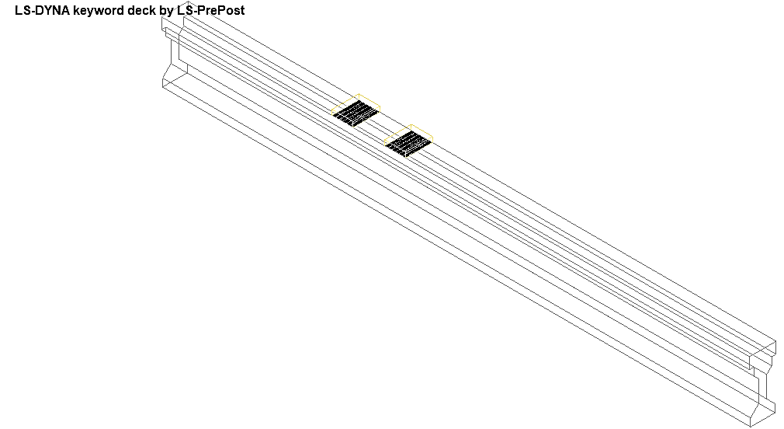
Automatic Surface-to-surface contact
Figure 5. The FE simulated boundary conditions and contact surfaces

FE Model Results
The FE results reveal a successful simulation of PCG and show good agreement with the experimental test results regarding the moment-deflection, overall behavior, and observations (Fig. 6 and 7). The FE model captured the stress concentration in the localized damaged regions due to applied loads (Fig. 6 a and b) that abserved in the experimental works conducted by Gangi et al. (2018) under static loads. Cracking patterns between and around the load points were consistent with impending flexural failure.

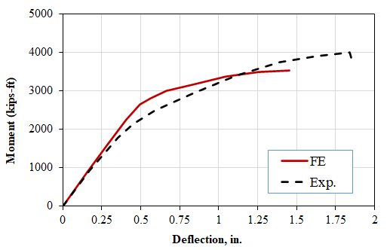
Figure 6. Moment Deflection Behavior comparison between FE and experimental results (Gangi et al. 2018)

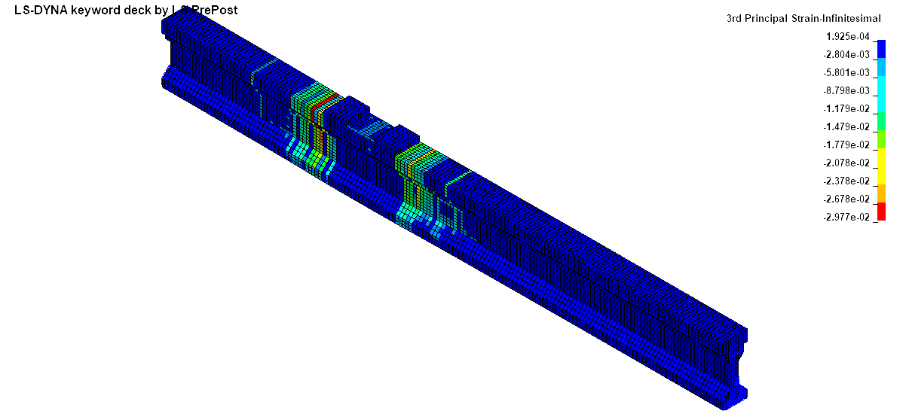
(a)
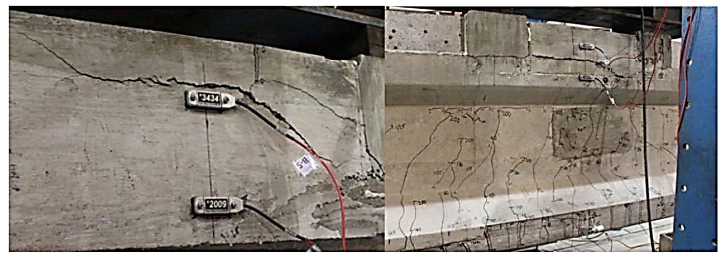
(b)
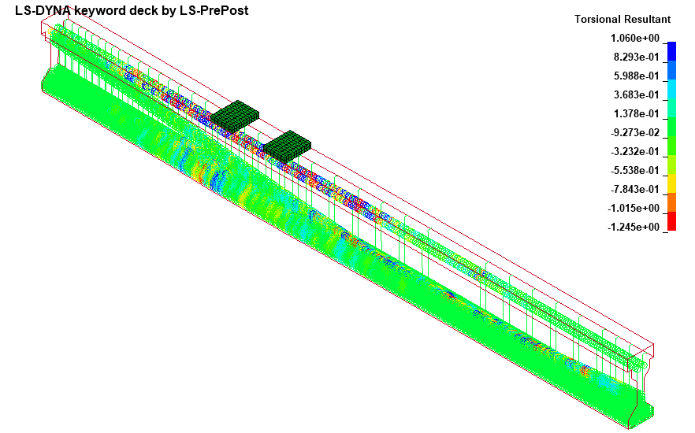
(c)
Figure 7. FE model results (a) failure mode (b) experimental work observations, (c) PCG reinforcement and strands

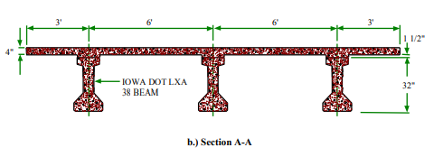
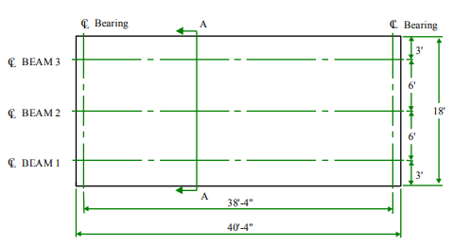
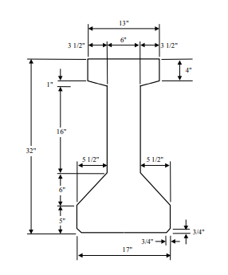
- Plan view
- SECTION (A-A)
- Girder cross section

Figure 8: IOWA DOT Bridge details that is used for full-bridge ivestigation

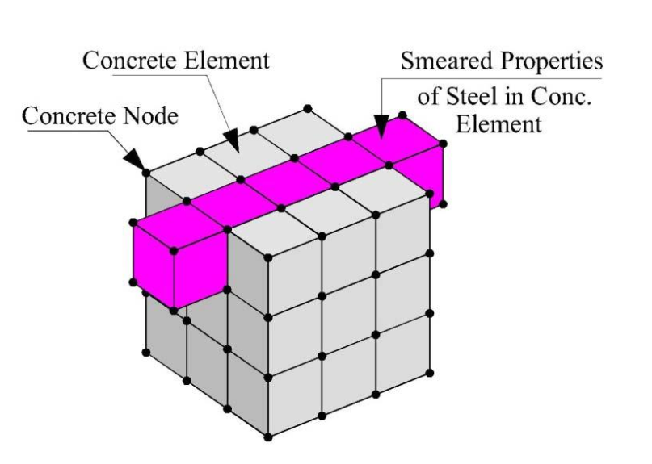
Figure 9: Smeared model for reinforced concrete

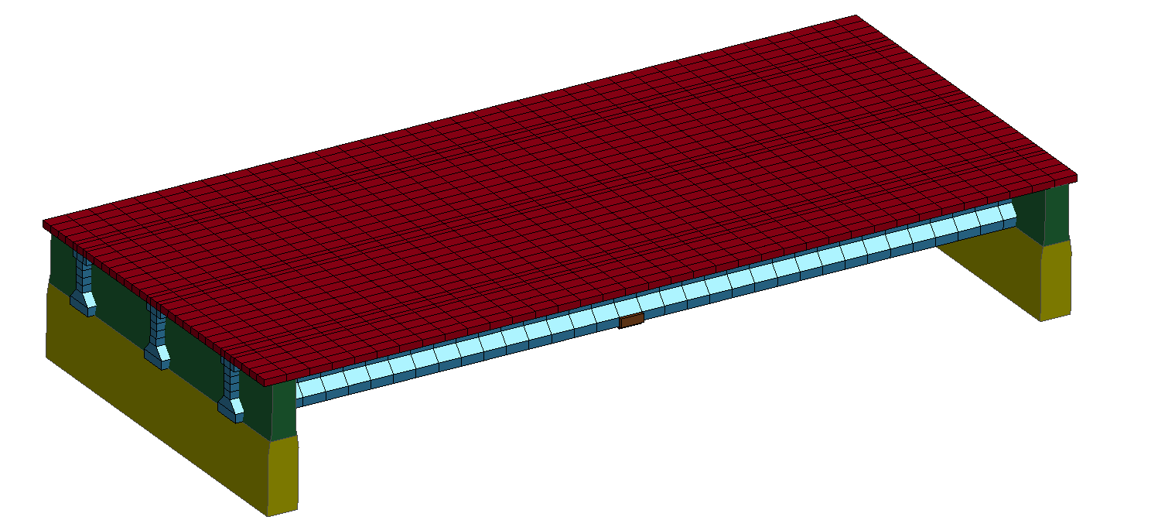
Concrete Deck (SOLID)
PC Girders
(SOLID)
End Diaphragms (SHELL)
Abutment
(SHELL)
Figure 1: IOWA DOT report

Figure 3: LS-DYNA Bridge model

Figure 10: Load-VL-deflection comparison at midspan point (more refinement of the model is still going on)

References

- Gangi, Michael, Mark Jones, Justin Liesen, Jiaxing Zhou, Vanessa Pino, Thomas E. Cousins, Carin L. Roberts-Wollmann, Ioannis Koutromanos, Antonio Nanni, and KPFF Consulting Engineers. Evaluation of repair techniques for impact-damaged prestressed beams. No. FHWA/VTRC 18-R8. Virginia Transportation Research Council, 2018.
- Fossum, Arlo F., Rebecca M. Brannon, Arlo F. Fossum, and Rebecca M. Brannon. “The Sandia geomodel: theory and user’s guide.” (2004).
- Malvar, L. Javier, John E. Crawford, James W. Wesevich, and Don Simons. “A plasticity concrete material model for DYNA3D.” International journal of impact engineering 19, no. 9-10 (1997): 847-873.
- Abdulazeez, Mohanad M., Mohamed A. ElGawady, and Omar I. Abdelkarim. “Bending and buckling behavior of hollow-core FRP–concrete–steel columns.” Journal of Bridge Engineering 24, no. 8 (2019): 04019082.
- Abdelkarim, Omar I., Mohamed A. ElGawady, Ahmed Gheni, Sujith Anumolu, and Mohanad Abdulazeez. “Seismic performance of innovative hollow-core FRP–concrete–steel bridge columns.” Journal of Bridge Engineering 22, no. 2 (2017): 04016120.
- Youssf, Osama, Mohamed A. ElGawady, Julie E. Mills, and Xing Ma. “Finite element modelling and dilation of FRP-confined concrete columns.” Engineering Structures 79 (2014): 70-85.

