**REQUEST FOR ONE 12 MONTHS EXTENSION**

On the Project

TPF-5(197)

THE IMPACT OF WIDE-BASE TIRES ON PAVEMENT DAMAGE

DTFH61-11-C-00025

Submitted by

Illinois Center for Transportation

University of Illinois at Urbana-Champaign

**REQUEST FOR 12 MONTHS EXTENSION**

An extension for the duration of the project is requested for the following reasons:

* To convert the indirectly measured tire forces to stresses; each reading was divided by the influence area of each pin, as recommended by CSIR. Based on the 17 mm gap between the pins and the distance between two consecutive rows of pins, the influence area was estimated to be 250.28 mm2.This influence area implies **smooth tire** (no ribs) and **full tire–pin contact**. In other words, it assumed that the pin’s influence area was fully covered by the tire rubber. Pavement responses were calculated based on the contact stresses following the aforementioned method (usually used by CSIR). One of the pavement responses, demonstrated at the annual technical committee meeting at McLean, Virginia, seemed inaccurate. A sample DTA response figure indicated that the horizontal strains for the last two points (79 kN, 552 kPa vs. 79 kN, 862 kPa) did not change with a significant increase in the tire inflation pressure (Figure 1).

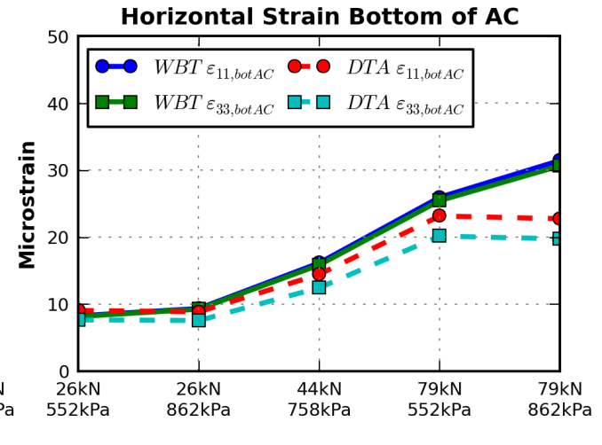

Figure 1. Sample pavement response of thick pavement case

This finding led to the investigation of the **resultant forces** from the calculated contact stresses; the obtained values had a **high discrepancy**, which could be due to the invalid tire geometry assumptions; the tread patterns should be considered non-uniform. To address this concern, the location of the pins as the tire traverses the measuring system must be tracked so that the appropriate and individual pin–tire contact areas can be accurately calculated for each test repetition. The input file-generation Python mesh scripts were modified to generate a new tire imprint mesh suitable for nodal forces. The previous mesh configuration accounted for contact stresses (pressure applied over a given area), whereas the new tire imprint considers nodal forces—simulating how the instrumented pins indirectly measured the contact loads.

* **Pavement sections at Davis were modified** as a result of changes in the Caltrans testing program. The new sections are composed of 270 mm of aggregate base, 250 mm of pulverized/recycled base, and 120 mm of HMA. The location of the instruments has not been modified. Although the tests were completed, data have not been submitted to UIUC.
* **Delay in construction and testing at instrumented sites in Florida, Davis, and Ohio.**  In addition, **loose mix**es were not collected at time of production. Delay of material acquisition was influenced by completion of accelerated testing so pavement cores could be extracted. Cores were received from Florida in August 2013, from California in October 2013, and from Ohio in November 2013.
* Some issues related to the boundary conditions of the FE model have caused short delays in FE analysis. After the results of the initial runs were analyzed, it was found that the dimensions in the plan view and depth of the model were not large enough to satisfy the assumption of infinite half-space. As a consequence, the chosen dimensions have been revisited (mainly for thin pavements) and modified accordingly. Details of the revised FE model are in Quarterly Report 8.

Owing to the aforementioned reasons, an extension of the project timeline (Figure 2) is requested. The yellow highlighted areas indicate the extended time periods being requested.



Figure 2. Updated project schedule

**ACTION PLAN**

As presented in Figure 2, the requested additional 12 months is need to finalize the experimental work of the project, conduct modeling and ANN simulation, and prepare the final report. Each of these activities is associated with a specific task in the original proposal. What follows is a list of the tasks to be completed during the extension, and the specific activities to be performed. The activities expected to be performed in the requested additional 12 months are summarized. In addition, two additional tasks that can be performed if further time and budget are provided.

*Tasks to be completed in the additional 12-months:*

* **Task 2.2: Conduct of Experiments**

The additional time will be allotted to finalize the material characterization and proposed laboratory testing. Samples from Florida DOT, UC-Davis, and Ohio (loose materials) have been collected at ATREL. Cores from Ohio were received in November 2013. Tests are currently underway including dynamic modulus, semi-circular beam, and creep compliance.

* **Task 2.3: Conduct of Modeling**

Finite element analysis has been performed for pavement structures utilizing strongest and weakest layer structural materials and subjected to various loading conditions. However, analysis with various combinations of material properties needs to be performed, and it will be completed during the extension period. 60% of the planned analysis has been completed.

* **Task 2.4: Development of Tool**

Results from finite element model are being utilized to create a neural network prediction tool. Data available until this point is being used to create an initial version of the tool; however, all data needs to be considered in order to obtain a reliable outcome. During the extension period, all results from modeling will be incorporated in the neural network analysis.

In addition, existing data from instrumented sections have been collected and organized. Data from Davis and Florida APT and Ohio instrumented sections are being be filtered, processed, and analysis.

* **Task 2.5: Delivery Phase-II Report and Tool**

All the work will be properly compiled in a final report and submitted to panel chair upon the completion of the aforementioned tasks as indicated in the plans.

* **Task 2.6: Pavement ME Design Adjustment Factor Analysis**

The tool developed in Task 2.4 cannot be used as a design tool for pavements but can provide insight on the behavior of pavements under various tire types and vehicle loads. The analysis method adopted in this research to estimate pavement response is different than that used in the existing Pavement ME Design. Three-dimensional finite element simulations utilizing non-uniform tire-pavement contact stresses allows the introduction of tire type as an impact factor for pavement damage prediction. This prediction may not be considered in the current version of Pavement ME Design. The output from the developed tool is initial pavement responses, whereas Pavement ME Design takes into account the evolution of the responses due to traffic spectra throughout the design period considering seasonal variations. Therefore, the integration of outcome of this study to the M-E design will be done by an ad-hoc approach coupling the outcome of advanced vehicular loading simulations with the Pavement ME Design.

A link between main pavement responses obtained from Pavement ME Design and 3-D FEM will be proposed. For this purpose, additional simulations will be performed, so the outcome of the project can be integrated to the existing Pavement ME Design in the future. The aforementioned link will consist of adjustment factors applied to critical pavement responses. The adjustment factors will be incorporated in the distress-prediction transfer functions. A schematic illustrating the approach to find adjustment factors is shown in Figure 3.

* **Task 2.7: Coordination with Related Technical Groups (JTCop, DarwinME)**

The PI has communicated with Judith Corley-Lay of the Joint Technical Committee on Pavements and tried to communicate with Vicki Schofield of the Darwin Pavement ME Design Committee to explore the feasibility of how the outcome of this study can be incorporated in the Pavement ME Design. He and the research team at UIUC met also with Jagannath (Jag) Mallela of ARA on January 9, 2014. They discussed the possibility of incorporating such adjustment factors and how that could be incorporated in the future in Pavement ME Design.

* **Task 2.8: Present to relevant conferences and symposiums**

Same as in the original proposal.

* **Task 2.9: Prepare article and technical papers**

Same as in the original proposal.

*Other tasks that can be performed with additional time and budget extension:*

* **Task 2.10: Implementation of Adjustment Factor Method in the Darwin M-E Pavement Design**

It is realized that once adjustment factors are introduced to predict changes in the structural response of pavements with realistic tire-pavement interaction, local calibration coefficients may need to be adjusted. Therefore, it is critical to develop step-by-step recommendations for the states who are considering the use Pavement M-E Design that allows the use of tire-pavement interaction. The outcome of this task will be an implementation guidelines for the use of adjustment factors in the calculation of structural response and modification of the local calibration coefficients.

* **Task 2.11: Environmental Impact of Wide-Base Tires Using a Life-Cycle Approach**

Environmental assessment of pavements and tires are influenced by their interaction as well as the amount of input and output that is consumed for raw materials and during their production. Vehicles’ fuel consumption is one of the components contributing to pavements and tires life-cycle assessment individually. This task will aim at identifying pavement-vehicle interaction models to calculate fuel consumption influenced by tires and pavements and establish a combined life-cycle assessment (LCA) for pavement and tires together. The combined LCA will include various life cycle stages of each product (pavement and tires) including material acquisition, production, construction, use-phase and end-of-life. The outcome will include the effects of tires on pavement damage levels in a road network, maintenance/rehabilitation to maintain overall condition of a road network influenced by tires, and environmental impact of tire production, maintenance, and disposal.

**DTA *Pavement ME Design***

* **Linear elastic materials**
* **Vertical and uniform contact stresses**
* **Circular tire-pavement contact area**
* **Static load**
* **Fully-bonded layers**

**DTA *Full FEA***

* **Linear viscoelastic, nonlinear stress dependent, and linear elastic materials**
* **3D nonuniform contact stresses**
* **Accurate contact area**
* **Continuously moving load**
* **Friction between layers**

**WBT *Full FEA***

* **Linear viscoelastic, nonlinear stress dependent, and linear elastic materials**
* **3D nonuniform contact stresses**
* **Accurate contact area**
* **Continuously moving load**
* **Friction between layers**

**ADJUSTMENT FACTOR 1**

**(AF1)**

**Factor accounting for model complexity**

**ADJUSTMENT FACTOR 2**

**(AF2)**

**Factor accounting WBT tire effect**

**Fatigue Cracking**

**Permanent Deformation**

Figure 3. Summary of adjustment factor procedure