TRANSPORTATION POOLED FUND PROGRAM
QUARTERLY PROGRESS REPORT

Lead Agency (FHWA or State DOT): _FHWA______________________________________

INSTRUCTIONS:
Project Managers and/or research project investigators should complete a quarterly progress report for each calendar quarter during which the projects are active. Please provide a project schedule status of the research activities tied to each task that is defined in the proposal; a percentage completion of each task; a concise discussion (2 or 3 sentences) of the current status, including accomplishments and problems encountered, if any. List all tasks, even if no work was done during this period.

Transportation Pooled Fund Program Project #  (i.e, SPR-2(XXX), SPR-3(XXX) or TPF-5(XXX)  TPF-5(279) |  | Transportation Pooled Fund Program - Report Period:  □Quarter 1 (January 1 – March 31)  Quarter 2 (April 1 – June 30)  □Quarter 3 (July 1 – September 30)  □Quarter 4 (October 1 – December 31)
Project Title:
High Performance Computational Fluid Dynamics (CFD) Modeling Services for Highway Hydraulics

Name of Project Manager(s):  Kornel Kerenyi | Phone Number:  (202) 493-3142 |  | E-Mail  kornel.kerenyi@fhwa.dot.gov
Lead Agency Project ID: | Other Project ID (i.e., contract #): |  | Project Start Date:
Original Project End Date: | Current Project End Date: |  | Number of Extensions:

Project schedule status:
On schedule □ On revised schedule □ Ahead of schedule □ Behind schedule

Overall Project Statistics:
Total Project Budget | Total Cost to Date for Project | Percentage of Work  Completed to Date

Quarterly Project Statistics:
Total Project Expenses  and Percentage This Quarter | Total Amount of Funds  Expended This Quarter | Total Percentage of  Time Used to Date

Project Description:

The Federal Highway Administration established an Inter-Agency Agreement (IAA) with the Department of Energy’s (DOE) Argonne National Laboratory (ANL) Transportation Analysis Research Computing Center (TRACC) to get access and support for High Performance Computational Fluid Dynamics (CFD) modeling for highway hydraulics research conducted at the Turner-Fairbank Highway Research Center (TFHRC) Hydraulics Laboratory. TRACC was established in October 2006 to serve as a high-performance computing center for use by U.S. Department of Transportation (USDOT) research teams, including those from Argonne and their university partners. The objective of this cooperative project is to:

- Provide research and analysis for a variety of highway hydraulics projects managed or coordinated by State DOTs.
- Provide and maintain a high performance Computational Fluid Dynamics (CFD) computing environment for application to highway hydraulics infrastructure and related projects
- Support and seek to broaden the use of CFD among State Department of Transportation employees.

The work includes:

- Computational Mechanics Research on a Variety of Projects: The TRACC scientific staff in the computational mechanics focus area will perform research, analysis, and parametric computations as required for projects managed or coordinated by State DOTs.
- Computational Mechanics Research Support: The TRACC support team consisting of highly qualified engineers in the CFD focus areas will provide guidance to users of CFD software on an as needed or periodic basis determined by the State DOTs.
- Computing Support: The TRACC team will use the TRACC clusters for work done on projects; The TRACC system administrator will maintain the clusters and work closely with the Argonne system administrator’s community; The TRACC system administrator will also install the latest versions of the STAR-CCM+ CFD software and other software that may be required for accomplishing projects.

Progress this Quarter (includes meetings, work plan status, contract status, significant progress, etc.):

1: Computational Mechanics Research on a Variety of Projects
1.1: Rockery Design Guidelines for River and Coastal Environments
Gravity dry-stack rockeries are gaining in popularity as retaining structures in a river environment in locations such as narrow mountain canyons. So far no engineering analysis procedures have been available for evaluating the hydraulic stability of such structures when exposed to the various forces acting upon them. Gravity force, lateral earth pressure, buoyancy, hydrodynamic forces and contact/friction forces are the main forces acting on the rocks in a dry-stack rockery in a river environment. While most of these forces can be determined with well-known geotechnical engineering methods, the estimation of hydrodynamic forces can only be performed in scaled laboratory tests or by using advanced, three-dimensional numerical methods. The CFD analysis covers topics such as: resolve all forces acting upon a dry-stack rockery when constructed to function as a river bank protection; conduct a parametric study to identify the geotechnical and hydraulic factors that govern the stability of rockeries and test them over a large range of values to demonstrate robustness of the numerical analysis; identify the potential failure modes of rockeries in the river environment; develop practical, dimensionless equations that will allow rockeries to be designed and/or evaluated for any given set of geotechnical and hydraulic site conditions.

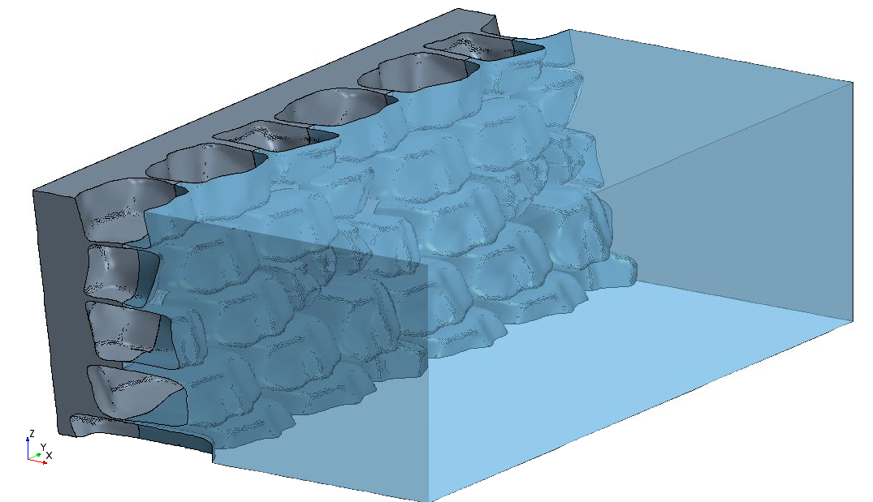
backfill
water
F_{HD}
Figure 1. A computational domain to analyze the driving hydrodynamic forces (F_{HD}) acting on a rockery with backfill in a water environment. The domain represents only half of the channel to save on computational time.

A series of simulations were run with varying channel width, water level, and rockery base width. It was established that the hydrodynamic forces constitute only up to a few percent of the dry weight of the rocks, which doesn’t increase the driving forces significantly. Global stability considerations revealed that a more important factor is the decrease of weight of the rocks due to buoyancy, which translates to a decrease of resisting forces.

1.2: Computational Analysis of Water Film Thickness on Modern Road Geometry During Rain Events for Assessing Hydroplaning Risk
Hydroplaning occurs when a water film exists on the roads or areas of road and vehicles are traveling at a speed that does not provide sufficient time for the tires to push the water film out of the tire path, allowing the tire to maintain contact with the road. Under these conditions, the tires ride up onto the water film, and driver control of the vehicle is lost. Since 1995 states have been raising speed limits above 55 mph. With the higher speed limits, hydroplaning accidents are a potentially significant problem, as highway infrastructure hasn’t been, in general, designed and built to minimize hydroplaning hazards. The water film thickness (WFT) accumulating on the road surface is a key parameter in evaluating hydroplaning risk. The present CFD analysis investigates the WFT on modern road geometries, i.e. highways with four or more lanes in each traffic direction with various cross slopes, longitudinal slopes, rainfall rates, and pavement surface roughness. Another significant geometry variation is whether or not the road side is open so that water flowing down the cross slope can freely flow off the road side or the road side is curbed with drain grates.
(a)
(b)
Figure 1. Water film thickness for road without curbs at no longitudinal slope, (a) varying rainfall rates at 2% cross-slope, (b) varying cross-sectional slope at 10 in/hr rainfall intensity. When a road has a small cross-sectional slope, the flow is very uniform. At higher slopes, >3%, small waves form on the surface.

(a)
(b) 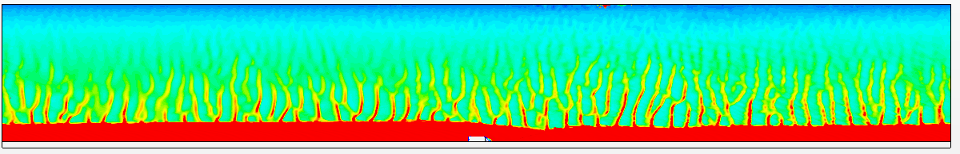
~6.1 ft.
Film Thickness (mm)
Figure 2. Water film thickness on a four lane road with 4% longitudinal and 2% cross-slope at rain intensity 10 in/hr, (a) road without a curb, (b) road with a grate and a 4 inch curb. A water film with thickness greater than 6 mm covers 6.1 ft of the road with curb (more than half lane width).

2: Computational Mechanics Research Support

Argonne Transportation Research and Analysis Computing Center (TRACC) computational mechanics staff ran nationwide videoconferences every other Thursday that were open to state Department of Transportation staff and university researchers supported by the Federal Highway Administration or state DOTs. The videoconferences provide a venue to discuss approaches and issues related to hydraulics modeling projects. Topics during this reporting period included, but were not limited to:
- new methodologies of scour modeling
- recommendations for rockery analysis and design
- approaches to modeling and mitigating hydroplaning risk

3: Computing Support

Routine cluster maintenance including software and hardware upgrades, security patching against cyber threats, and development of custom tools to increase users' productivity. Currently working on upgrading existing TRACC cluster to support the latest scientific and engineering software utilizing industry's best practice guidelines in Open Source software and virtualization.
Anticipated work next quarter:

1: Computational Mechanics Research on a Variety of Projects

- design recommendations for rockeries in river environment
- hydroplaning risk assessment for modern highways
- development of a new methodology for river bed scour

2: Computational Mechanics Research Support

This work will continue.

Task 3: Computing Support

This work will continue.

Circumstance affecting project or budget. (Please describe any challenges encountered or anticipated that
might affect the completion of the project within the time, scope and fiscal constraints set forth in the
agreement, along with recommended solutions to those problems).

None.

Potential Implementation:

