TRANSPORTATION POOLED FUND PROGRAM
QUARTERLY PROGRESS REPORT

Lead Agency: ---- Utah Department of Transportation ----

INSTRUCTIONS:
Project Managers and/or research project investigators should complete a quarterly progress report for each calendar quarter during which the projects are active. Please provide a project schedule status of the research activities tied to each task that is defined in the proposal; a percentage completion of each task; a concise discussion (2 or 3 sentences) of the current status, including accomplishments and problems encountered, if any. List all tasks, even if no work was done during this period.

Transportation Pooled Fund Program Project #  (TPF-5(257) |  | Transportation Pooled Fund Program - Report Period:  _ Quarter 1 (January 1 – March 31)  X_ Quarter 2 (April 1 – June 30)  _ Quarter 3 (July 1 – September 30)  _ Quarter 4 (October 1 – December 31)

Project Title: Evaluation of Spliced Sleeve Connections for Precast RC Bridge Piers

Name of Project Manager(s):  Russ Scovil | Phone Number:  801-965-4097 |  | E-Mail  Rgscovil@utah.gov
Lead Agency Project ID:  5H06604H, UT11.502 | Other Project ID (i.e., contract #):  12-8775 |  | Project Start Date:  3/23/2012
Original Project End Date:  3/30/2013 | Current Project End Date:  6/30/2014 |  | Number of Extensions:  2

Project schedule status:

_ On schedule X_ On revised schedule _ Ahead of schedule _ Behind schedule

Overall Project Statistics:
Total Project Budget | Total Cost to Date for Project | Percentage of Work  Completed to Date
$175,848 | $110,000 | 63%

Quarterly Project Statistics:
Total Project Expenses  and Percentage This Quarter | Total Amount of Funds  Expended This Quarter | Total Percentage of  Time Used to Date
$12,000 / 7% | $12,000 | 56%

Project Description:

Sleeved connections are being considered as one of the methods for connecting precast concrete bridge elements. The purpose of this project is to perform experiments to evaluate the performance of a sleeved connection between a reinforced concrete bridge column and a bridge footing (Type I) or a reinforced concrete bridge column and a bridge bent cap (Type II) in a seismic area. This information is very valuable for construction of bridges using Accelerated Bridge Construction in areas with high seismic activity.

Progress this Quarter (includes meetings, work plan status, contract status, significant progress, etc.):

Project Progress: This quarter the project was focused on building the remaining specimens for the completion of the project. Specifically four specimens were built: one with a modified NMB Type I connection between the column and footing, one with a modified Lenton Interlock Type II connection between the column and bent cap, and two monolithic connections, one for the column to footing connection and one for the column to bent cap connection.
Both sleeved connections were constructed with the mechanical sleeves in the column. However, in both cases there was an innovative detail introduced. This detail is a debonding length of the connecting bars in the footing for the NMB splice connectors (Type I - NMB3) and a debonding length of the connecting bars in the bent cap for the Lenton Interlock connection (Type II – LEN3). Figures 1 and 2 show the debonding of the vertical bars for NMB-3, which was carried out for a length of 8 in. (or 8 bar diameters) from the top of the footing. The details of the reinforcement for the column of NMB-3 are shown in Figure 3.

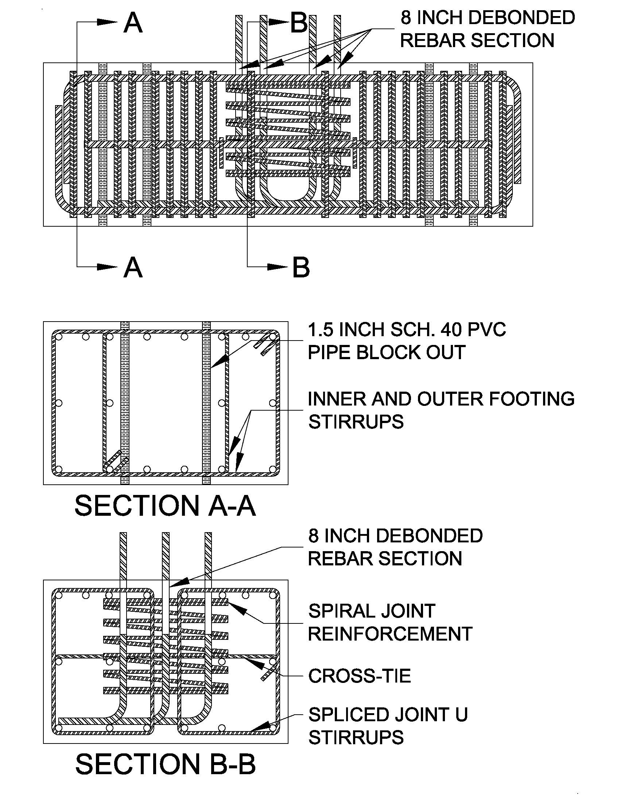
Figure 1. Footing details for NMB-3 connection: six debonded vertical connecting bars for 8 in. length.
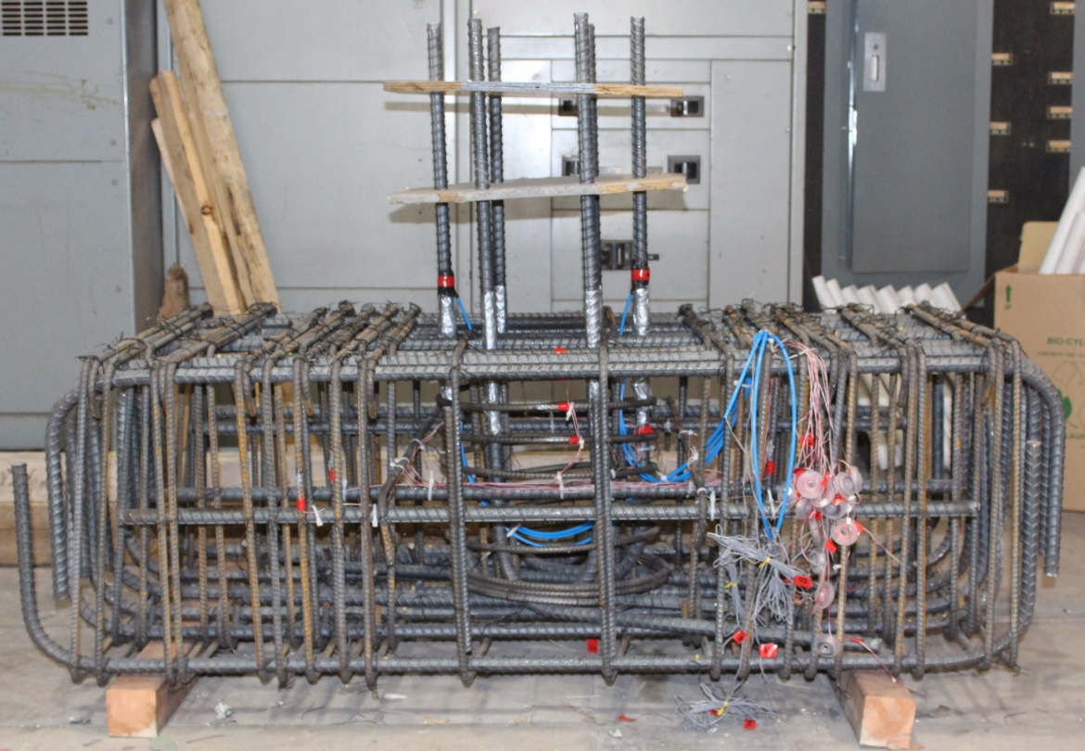
Figure 2. Footing details for NMB-3 connection showing debonded vertical connecting bars.

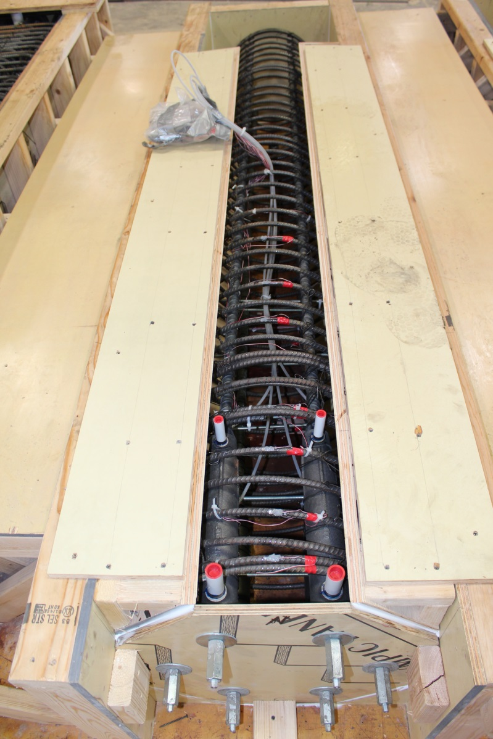
Figure 3. Details of the reinforcement for column of specimen NMB-3.
Figures 4 and 5 show the debonding of the vertical bars for LEN-3, which was carried out for a length of 8 in. (or 8 bar diameters) from the soffit of the bent cap. Details of the reinforcement for the column of LEN-3 are shown in Figure 6.

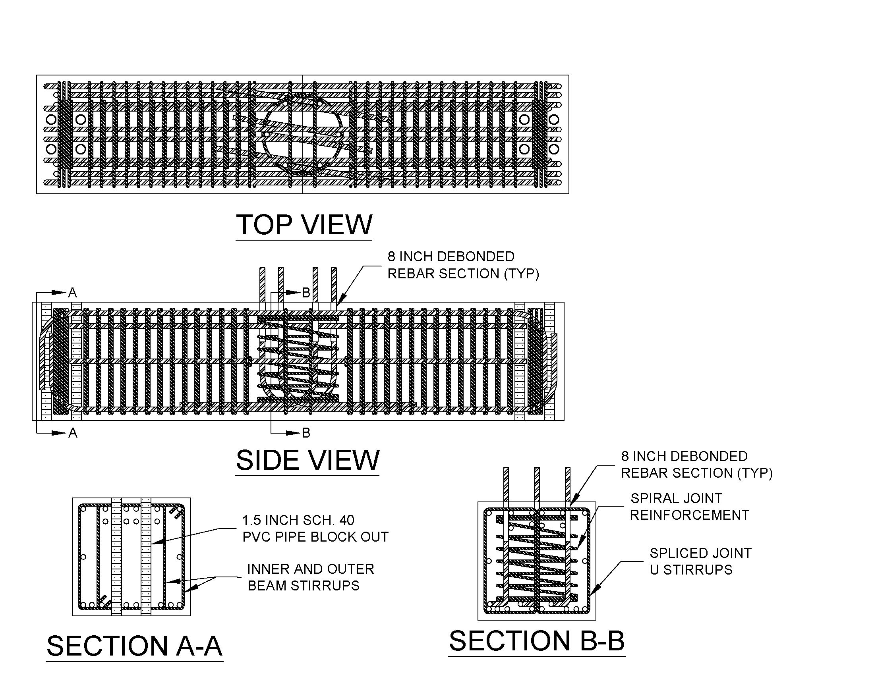

Figure 4. Bent cap details for LEN-3 connection: six debonded vertical connecting bars for 8 in. length.

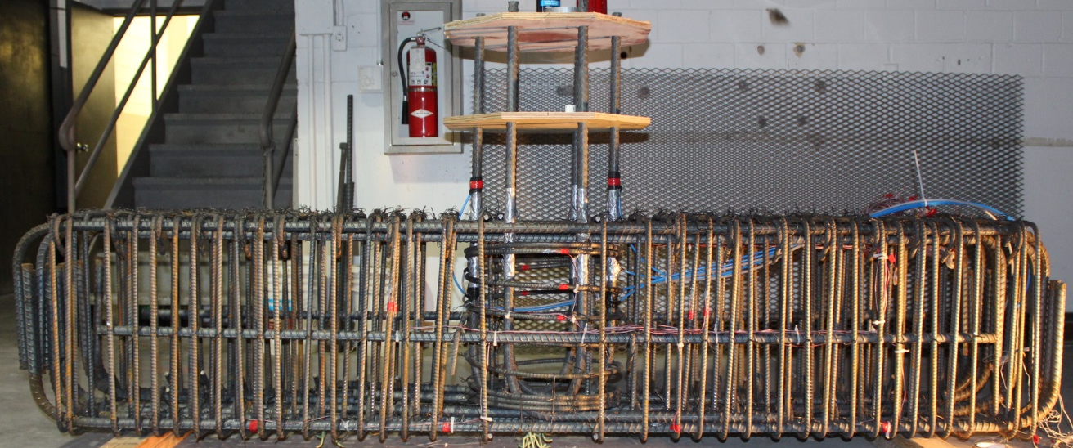
Figure 5. Bent cap details for LEN-3 connection showing debonded vertical connecting bars.
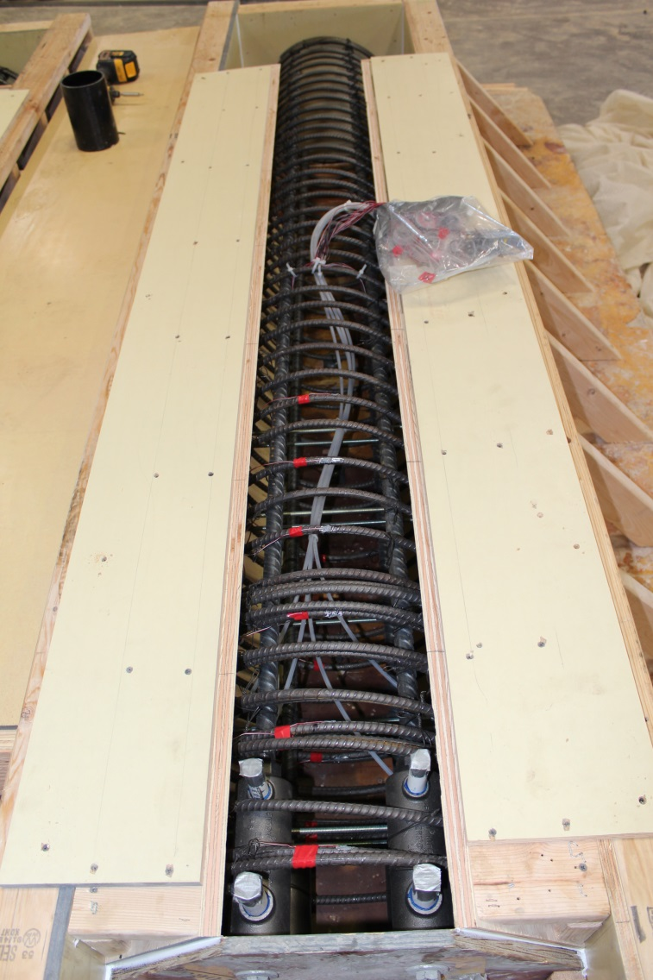
Figure 6. Details of the reinforcement for column of specimen LEN-3.

The Type I and Type II specimens after the grouting operation are shown assembled in Figure 7. The first (foreground) is the column to bent cap connection with six Lenton Interlock connectors (LEN-3) and the second (background) is the footing to column connection with six NMB splice sleeve connectors (NMB-3).

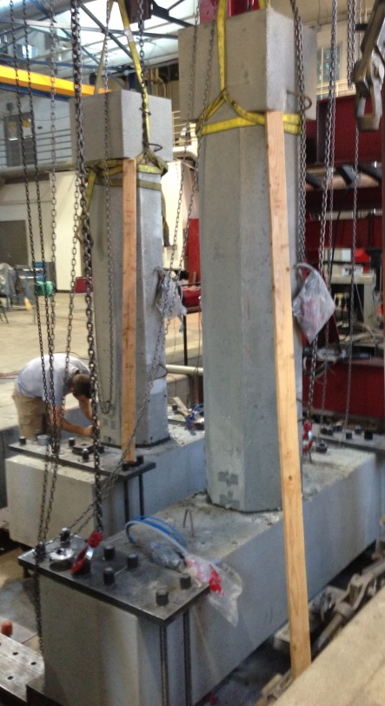
Figure 7. Assembled column to bent cap (LEN-3) and footing to column (NMB-3) specimens.

In addition to the modified NMB Type I connection between the column and footing (NMB-3) and modified Lenton Interlock Type II connection between the column and bent cap (LEN-3), two monolithic connections have been built, one for the column to footing connection and one for the column to bent cap connection. These connections will be tested in order to compare monolithic construction details to the Type I and Type II precast specimens. Reinforcement details for the monolithic column to footing connection are shown in Figure 8, and for the monolithic column to bent cap connection in Figure 9. Pictures of the reinforcement cages for the monolithic column to footing connection are shown in Figure 10(a), and for the monolithic column to bent cap connection in Figure 10(b). The monolithic connection specimens after they were cast are shown in Figure 11.

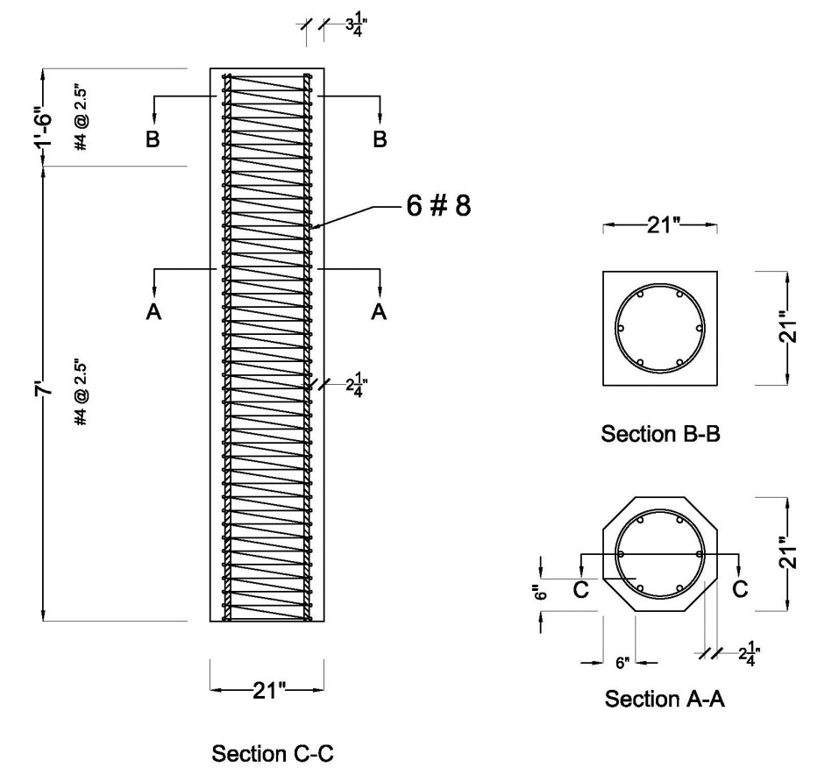
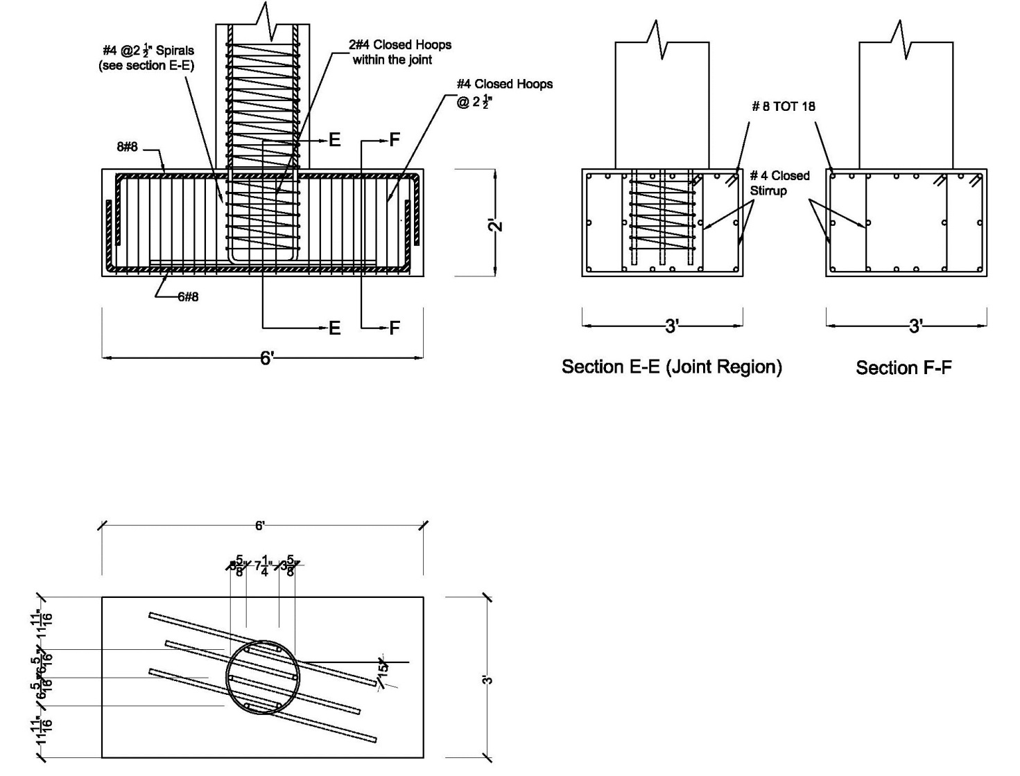

Figure 8. Reinforcement details for monolithic column to footing connection.

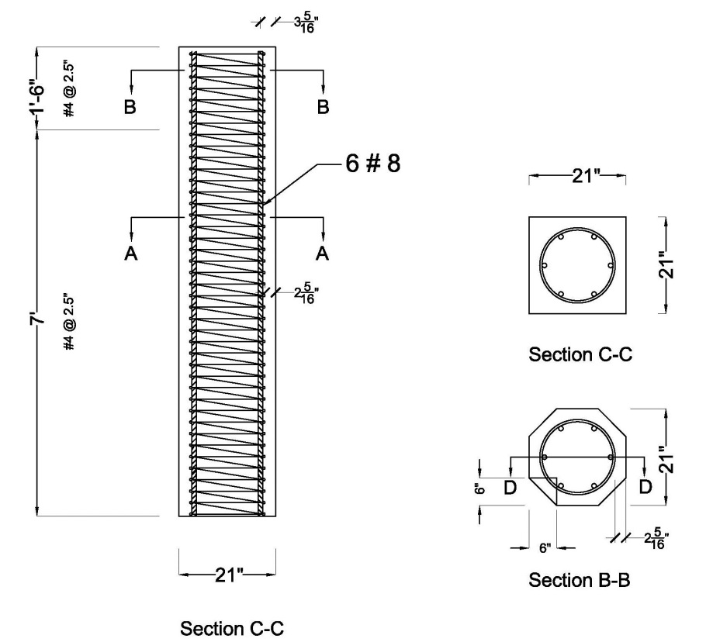
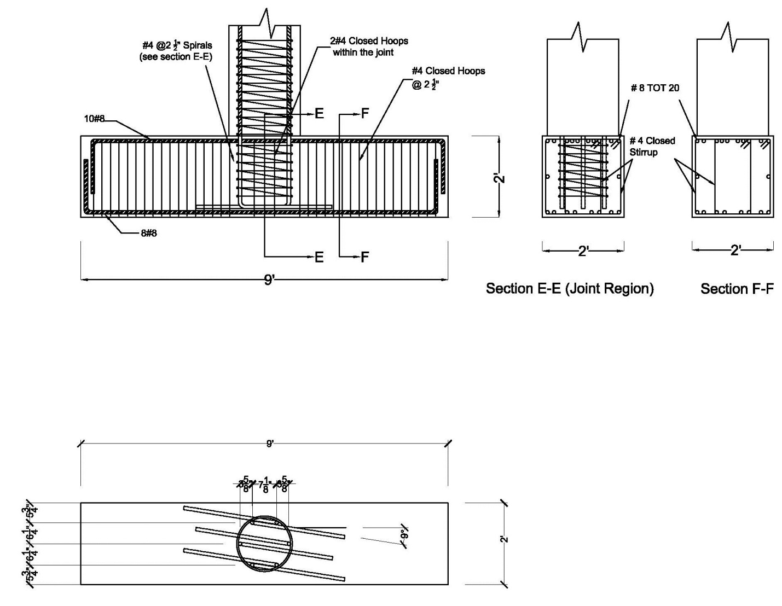
Figure 9. Reinforcement details for monolithic column to bent cap connection.
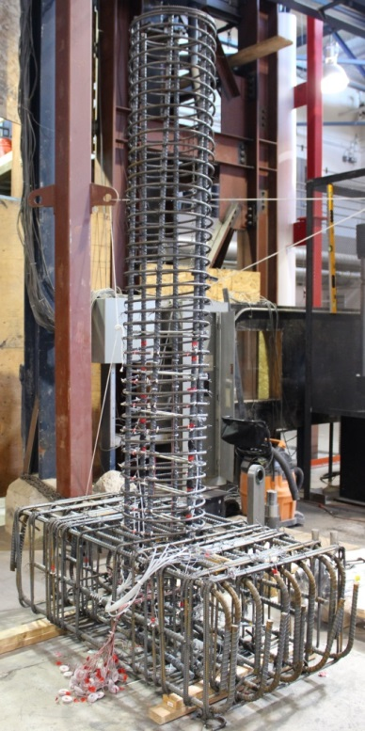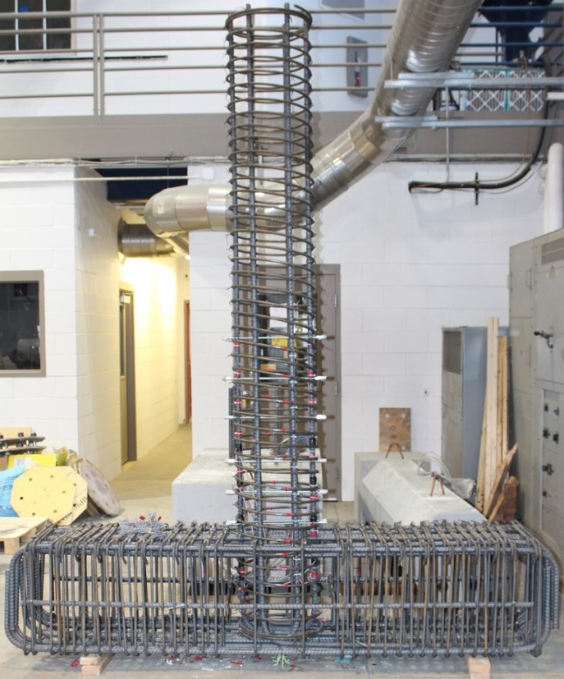
- (b)
Figure 10. Reinforcement details for monolithic connection specimens: (a) column to footing, (b) column to bent cap.

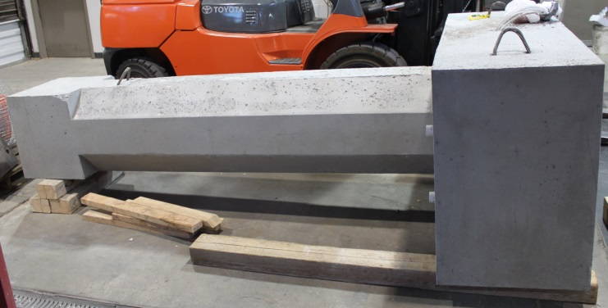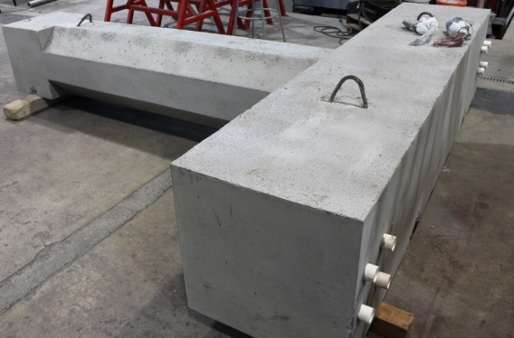
- (b)
Figure 11. Monolithic connection specimens: (a) column to footing, (b) column to bent cap.

Project Status: The project had some delays in construction of the specimens because there was no available space for casting the specimens at Hanson Structural Precast. However, those issues have been resolved and all specimens have
been built. The percentage completion for each task is as follows:

Task 1: Review Existing Experimental Results for Sleeved Connections: 100% Complete
Task 2: Build Precast Columns, Footings and Cap Beams for Tests: 100% Complete
Task 3: Test Column to Footing Connections (Type I): 67% Complete
Task 4: Test Column to Cap Beam Connections (Type II): 67% Complete
Task 5: Test Column to Footing Monolithic Cast-In-Place Connection
and Column to Cap Beam Monolithic Cast-In-Place Connection: 0% Complete

Anticipated work next quarter:

It is anticipated that in Quarter 6, the third set of precast concrete columns, footings, and cap beams (NMB-3 and LEN-3) will be tested.

Significant Results:

The column to footing connection NMB-2 with splice sleeves in the footing (Type I) performed very well up to 6% drift.
The column to bent cap connection LEN-2 with Lenton Interlock connectors in the cap beam (Type II) performed
very well up to 6% drift.

Circumstance affecting project or budget. (Please describe any challenges encountered or anticipated that
might affect the completion of the project within the time, scope and fiscal constraints set forth in the
agreement, along with recommended solutions to those problems).

There was a delay in building the last four specimens but this has been resolved and all connections have now
been built.

Potential Implementation:

It is anticipated that the Utah DOT will implement the findings of this research in Accelerated Bridge Construction (ABC),
once the research project is completed. It is likely that the New York State Department of Transportation and the Texas
Department of Transportation will be able to implement them as well.

