TRANSPORTATION POOLED FUND PROGRAM
QUARTERLY PROGRESS REPORT

Lead Agency: Utah Department of Transportation

INSTRUCTIONS:
Project Managers and/or research project investigators should complete a quarterly progress report for each calendar quarter during which the projects are active. Please provide a project schedule status of the research activities tied to each task that is defined in the proposal; a percentage completion of each task; a concise discussion (2 or 3 sentences) of the current status, including accomplishments and problems encountered, if any. List all tasks, even if no work was done during this period.

Transportation Pooled Fund Program Project #  TPF-5(264) |  | Transportation Pooled Fund Program - Report Period:  _ Quarter 1 (January 1 – March 31, 2014)  x Quarter 2 (April 1 – June 30, 2014)  _ Quarter 3 (July 1 – September 30, 2014)  _ Quarter 4 (October 1 – December 31, 2014)
Project Title:
Passive Force-Displacement Relationships for Skewed Abutments

Name of Project Manager(s):  David Stevens | Phone Number:  801-589-8340 |  | E-Mail  davidstevens@utah.gov
Lead Agency Project ID:  FINET 42051, ePM PIN 10903  UDOT PIC No. UT11.406 | Other Project ID (i.e., contract #):  UDOT Contract No. 138123 |  | Project Start Date:  August 13, 2012
Original Project End Date:  September 30, 2014 | Current Project End Date:  September 30, 2014 |  | Number of Extensions:  1 (scope, budget)

Project schedule status:

_ On schedule _ On revised schedule _ Ahead of schedule X Behind schedule

Overall Project Statistics:
Total Project Budget | Total Cost to Date for Project | Percentage of Work  Completed to Date
$255,000.00 (current contract)  $270,000.00 (total committed) | $139,200.00 | 60%

Quarterly Project Statistics:
Total Project Expenses  and Percentage This Quarter | Total Amount of Funds  Expended This Quarter | Total Percentage of  Time Used to Date
7% | $18,000 | 85%

Project Description:

At present, about 40% of the 600,000 bridges in the FHWA database are constructed at a skew angle (Silas Nichols, Personal Communication). There is considerable uncertainty about the passive force on skewed abutments where the passive force develops at an angle relative to the longitudinal axis of the bridge structure. Although current design codes (AASHTO 2011) consider that the ultimate passive force will be the same for a skewed abutment as for a non-skewed abutment, numerical analyses performed by Shamsabadi et al. (2006) indicate that the passive force will decrease substantially as the skew angle increases. Reduced passive force on skewed abutments would be particularly important for bridges subject to seismic forces or integral abutments subject to thermal expansion. Unfortunately, there have not been any physical test results for skewed abutments reported in the literature which could guide engineers in making appropriate adjustments for skewed conditions. Nevertheless, some field evidence has clearly shown poorer performance of skewed abutments during seismic events and distress to skewed abutments due to thermal expansion (Shamsabadi et al. 2006, Steinberg and Sargand 2010).

This study builds on previous pooled fund testing conducted by Rollins and his students at BYU to evaluate passive force-deflection relationships for non-skewed abutments (TPF-5(122), Dynamic Passive Pressure on Abutments and Pile Caps, Rollins et al, 2010). The test facilities can readily be modified to allow for the test program with relatively small additional costs because of the test fixtures (reaction shafts, reaction walls, and pile supported cap) which are already constructed at the site. Results from this study can be compared with previous testing to assess overall performance.

Four objectives are outlined for this new study:
- Determine static passive force-displacement curves for skewed abutments with and without wingwalls from large scale tests.
- Provide comparisons of behavior of skewed abutments with that of normal abutments.
- Evaluate the effect of wingwalls on skewed abutment response.
- Develop design procedures for calculating passive force-displacement curves for skewed abutments.

The scope of work consists of twelve specific tasks, including new tasks 7 through 12:
- Literature Review and Collection of Existing Test Data
- Perform Laboratory Passive Force-Deflection Tests on 2 ft High Wall with Skew Angles of 0º, 15º, 30º, and 45º
- Perform Field Passive Force-Deflection Tests on 5.5 ft High Wall with Skew Angles of 0º, 15º, and 30º and Transverse Wingwalls
- Perform Field Passive Force-Deflection Tests on 5.5 ft High Abutment with Skew angles of 0º, 15º, 30º and MSE Wingwalls
- Calibrate Computer Model and Conduct Parametric Studies
- Preparation of Final Report
- Perform Additional Field Passive Force-Deflection Tests on 5.5 ft High Abutment with a Skew Angle of 45º with and without MSE Wingwalls
- Perform Field Passive Force-Deflection Tests on 3.0 ft High Unconfined Backfill with Skew Angles of 0º and 30º
- Perform Field Passive Force-Deflection Tests on 5.5 ft High Pile Cap with Concrete Wingwalls and Skew Angles of 0º and 45º
- Perform Field Passive Force-Deflection Tests on 3.5 ft High Unconfined Gravel Backfill with Skew Angles of 0º and 30º
- Perform Field Passive Force-Deflection Tests on 3.5 ft High GRS Gravel Backfill with Skew Angles of 0º and 30º
- Present the Results of the Study at TRB and AASHTO Meetings

Dr. Kyle Rollins of BYU is the Principal Investigator for this research project. Individual task reports will be prepared for Tasks 1 through 5 and 7 through 11 when these are completed. Up to two in-person meetings with the multi-state technical advisory committee (TAC) are planned to be held in Salt Lake City, Utah during the project. Other TAC meetings will be tele-conference or web meetings.

Progress this Quarter (includes meetings, work plan status, contract status, significant progress, etc.):

Task 1 – 100% complete.
Task 2 – 100% complete.
Task 3 – 100% complete.
Task 4 – 100% complete.
Task 5 – 60% complete. BYU continued data analysis and worked on task report.
Task 6 – 10% complete. Combining portions of other task reports for the Final Report.
Task 7 – 80% complete. BYU continued data analysis and worked on task reports.
Task 8 – 80% complete. BYU continued data analysis and worked on task reports.
Task 9 – 80% complete. BYU continued data analysis and worked on task reports. They submitted a preliminary task report, which was shared with the TAC.
Task 10 – 60% complete. BYU continued data analysis and worked on task reports.
Task 11 – 60% complete. BYU continued data analysis and worked on task reports.
Task 12 – 30% complete. Dr. Rollins presented more findings from the study at the June AASHTO SCOBS Meeting, T-3 Committee, in Columbus, OH.
TAC Meetings – None.
Contract – BYU, UDOT, and Wisconsin DOT discussed possible and preferred uses of the Wisconsin funding recently committed and transferred to the project.

Anticipated work next quarter:

Task 1 – None.
Task 2 – None.
Task 3 – None.
Task 4 – None.
Task 5 – BYU will work with Anoosh Shamsabadi of Caltrans to adjust their numerical models and help interpret the results. Complete the task report.
Task 6 – Combining portions of other task reports for the Final Report.
Task 7 – Complete the full task report (the revised Tasks 3 and 4 reports).
Task 8 – Complete the full task report.
Task 9 – Complete the full task report.
Task 10 – Complete the preliminary and full task reports.
Task 11 – Complete the preliminary and full task reports.
Task 12 – Dr. Rollins will prepare and submit a paper highlighting results for the 2015 TRB Annual Meeting. He’ll also share his presentation slides with the TAC from the June 2014 AASHTO SCOBS Meeting.
TAC Meetings – Likely hold a TAC web conference to discuss completed task reports near the end of September.
Contract – UDOT and BYU will amend the contract with the new available funding from Wisconsin to add to Task 5, additional numerical modeling to help quantify issues observed in the Task 9 (wingwall) field test results. The contract schedule and remaining deliverable dates will also be extended.

Significant Results:

During the past quarter work has focused on the analysis of the tests involving the reinforced concrete wingwalls (Task 9). Soil pressure distributions along the wingwalls on both non-skewed and 45° skewed abutments are illustrated in Figure 1 and Figure 2. Soil pressures were approximated using the moments calculated with the strain gauge data and, therefore, follow a similar trend. Significantly higher pressures were observed on the 45° skewed abutment east (obtuse side) wingwall compared to pressures computed on the west wingwall and both wingwalls on the non-skewed abutment. Maximum pressure experienced by the east (obtuse side) wingwall on the 45° skewed abutment, approximately 2400 psf (115 kPa), was six times as large as the maximum pressure experienced by non-skewed wingwalls, approximately 400 psf (19.2 kPa).

Soil pressures were multiplied by tributary areas to compute the total normal force acting on the wingwalls. For the non-skewed test, both east and west wingwalls experienced approximately 3 kips (13.4 kN) of normal force, based on results shown in Figure 1. Wingwall normal forces for the 45° skewed test were computed from results shown in Figure 2. For the 45° skewed abutment, the east wingwall experienced 19 kips (85 kN) compared to 2 kips (9.0 kN) experienced by the west wingwall.

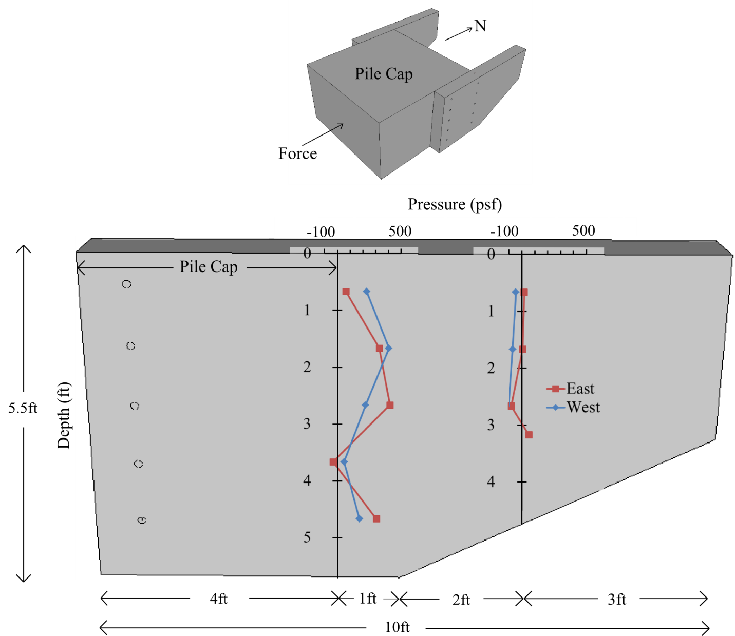

Figure 1 Horizontal pressure distribution along wingwall height at test completion for non-skewed abutment.

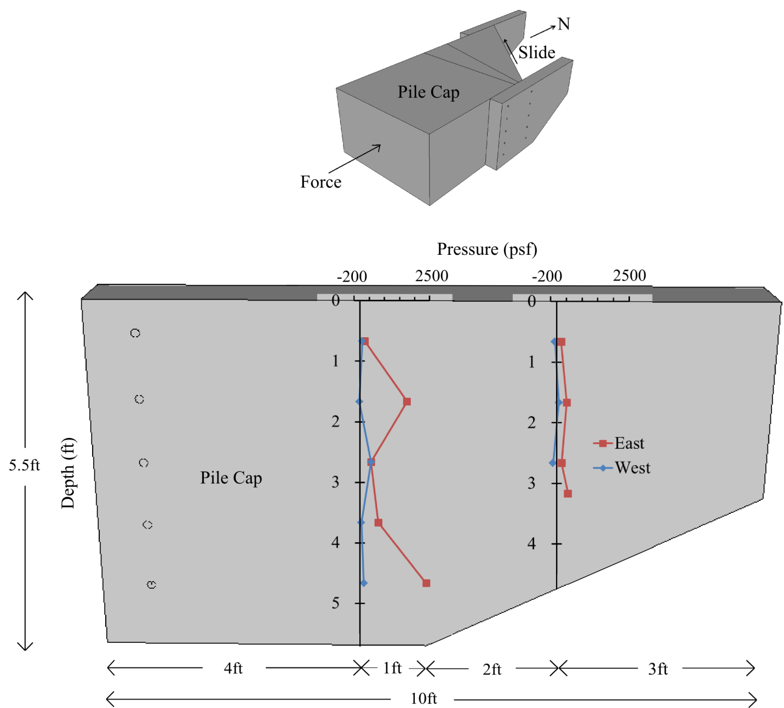

Figure 2. Horizontal pressure distribution along wingwall height at test completion for 45° skewed abutment.

An analysis was performed for the east wingwall (45° skew) to determine the reliability of estimating the passive force development on the wingwall using the abutment backwall passive force-deflection curves. Passive force-deflection curves for non-skewed and 45° skewed abutments were both used for comparison.

For this analysis, the wingwall was divided into three 2-ft (0.61-m) wide segments, shown in Figure 3.. Average deflections in the westward direction (into the backfill) were computed for each segment as the difference between the total abutment movement in the westward direction [0.4 inches (1.0 cm) at the north end] and the deflection at each segment in the eastward direction as measured in the test. Wingwall deflection was computed in this fashion to more accurately represent the actual pressure distribution along the length of the wingwall where higher pressures were measured near the pile cap with lower pressures near the tapered end. The net deflections into the backfill (∆) for each wingwall segment are shown in Figure 3. An average height (H_{av}) was calculated for each segment and was used to compute the ratio of deflection to wall height ∆⁄H_{av}, also shown in Figure 3.

Values of ∆⁄H_{av} were plotted with the normalized passive force-deflection curves in Figure 4 to estimate the percentage of passive force that developed on the wingwall. The normalized passive force-deflection curves in Figure 4 are based on the hyperbolic approximations of passive force development. The peak passive force per unit width for both non-skewed and 45° skewed tests are shown near their respective curves.

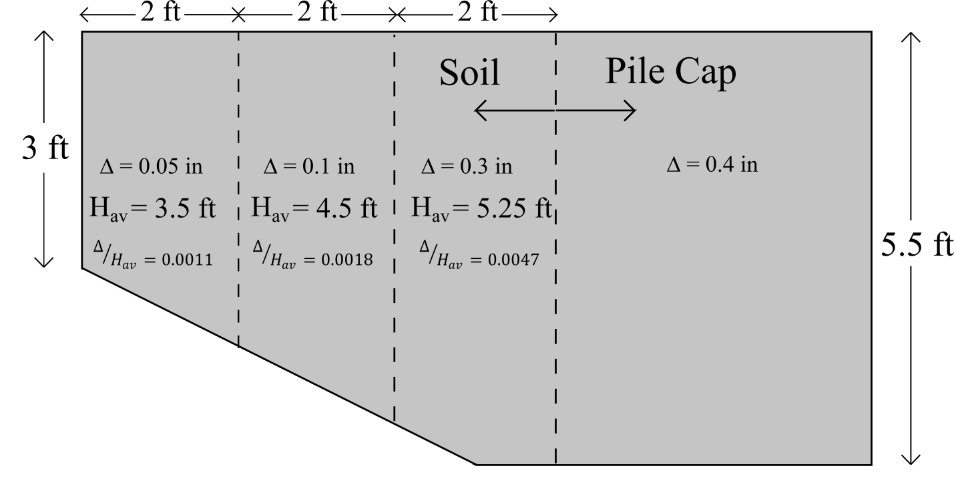

Figure 3. Contact area between soil and wingwall divided into three segments.

Figure 4. Normalized passive force versus deflection-height ratio (Δ/H).

The passive force distribution from this analysis is illustrated in Figure 5, which provided passive forces based on both non-skewed and 45° skewed passive force-deflection curves. The total passive force acting on the wingwall was computed as the sum of the forces from the three segments.

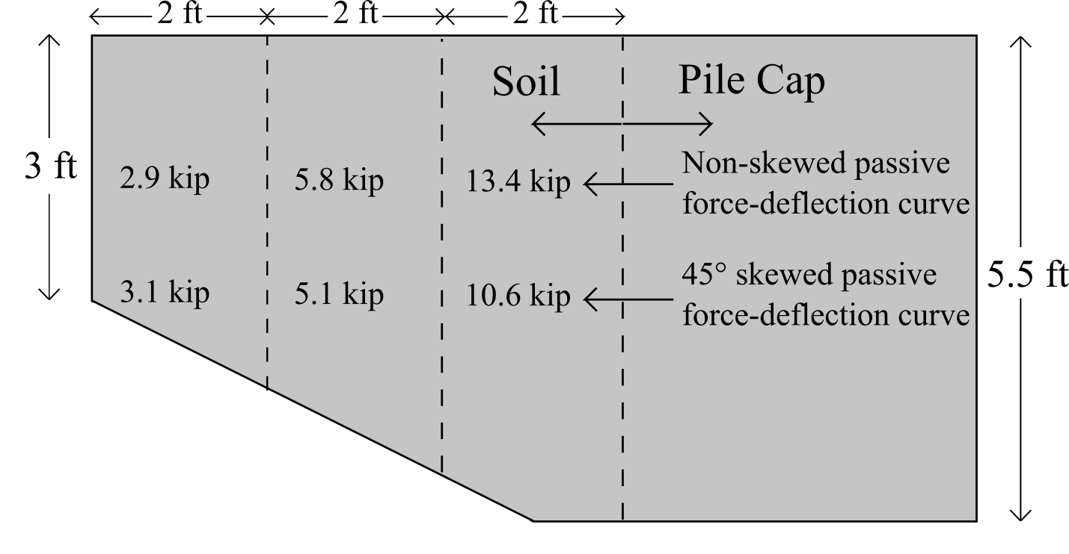

Figure 5. Passive force distribution along wingwall segments.

Using the 45° skew passive force-deflection curve, the total estimated passive force on the east wingwall (45° skew) was 19 kips (85 kN), which is within 1% of the computed passive force from the strain gauge measurements [19 kips (85 kN)]. Using the non-skewed passive force-deflection curve, a total passive force of 22 kips (99 kN) was estimated, which overestimates the passive force from strain gauge measurements by 16%. Total passive forces from this analysis underestimate the passive forces obtained from the Geokon® pressure cells [35 kips (157 kN)] by 46% when using the 45° skew passive force-deflection curve, and by 37% when using the non-skewed passive force-deflection curve. This analysis largely confirms measurements from strain gauges and suggests that the passive force acting normal to the wingwall may be reasonably estimated from the design passive force-deflection curve for the abutment backwall and the anticipated transverse wingwall deflection.

Comparison of Passive Force per Width for Unconfined, MSE and RC Wingwall Tests

Comparisons using total passive force are inadequate for evaluating soil strength because the effective width of the soil failure surface differs with abutment geometry. Effective widths for all the three geometries at both skew angles were estimated based on the location of surface cracks and heave measurements between 0.5 and 0.75 inch (1.3 to 1.9 cm). Effective widths for the non-skewed and 45° skewed geometries are illustrated using a dashed line in Figure 6 and Figure 7, respectively. For 45° skewed unconfined and RC wingwall geometries, projected widths and widths parallel to the skewed backwall are shown for comparison purposes. Projected widths are used as the effective widths.
The unconfined backfills produced the widest effective widths (21 ft [6.4 m] for non-skewed and 17.8 ft [5.5 m] for 45° skewed abutments) compared to MSE and RC wingwall geometries. The passive failure surfaces for the MSE wingwall tests were constrained by the wingwalls, resulting in an effective width of 11.5 ft (3.5 m) (the distance between the walls) for both tests. The surface cracks and heave contours suggest that the RC wingwall passive failure surfaces exhibit characteristics of both the unconfined and MSE wingwall geometries. Effective widths were estimated to be 13.5 ft (4.1 m) for both skew angles. Although shear failure surfaces extend beyond the abutment width (including the wingwalls), the effective widths are only 4% larger than the width of the abutment. The soil at the sloped embankment portion of the backfill could not be compacted as densely as the level backfill within the abutment width because of the presence of the slope, and this may contribute to the narrower failure surface. Because the effective widths for the RC wingwall geometry are essentially equal to the abutment width, the passive failure surface may be better approximated with a 2D geometry rather than a 3D geometry.
Figure 6. Comparison of effective widths for non-skewed test geometries.
Figure 7. Comparison of effective widths for 45° skewed test geometries.

Passive force per width was calculated for all deflection increments using Equation (1).

 | $$Passive force/width=\frac{Total Passive Force}{Effective Width}$$ | (1)
The measured effective widths in Figure 6 and Figure 7 were used in Equation 1. Passive force/width-deflection curves for non-skewed and 45° skewed abutments are shown in Figure 8 and Figure 9, respectively.

Figure 8. Passive force/width-deflection curves for non-skewed abutments.

For the non-skewed case, the MSE wingwall geometry provides an additional 60% passive resistance per width compared to RC wingwall and unconfined geometries. The increased passive resistance is attributed to the smaller effective width from MSE wingwall confinement, the added resistance from grid reinforcements, and the higher plane-strain friction angle $\left(φ_{ps}\right)$ of the soil appropriate for this condition. Kulhawy and Mayne (1990) observed that $φ_{ps}$ is on average 12% higher than the triaxial friction angle $\left(φ_{T}\right)$ for densely compacted material.

At a 45° skew angle, a maximum passive force per width of approximately 8 to 9 kip/ft (117 to 132 kN/m) is achieved regardless of abutment geometry. MSE wingwalls appear to have little effect on passive resistance per width at a 45° skew. This may be due to the fact that the alignment of the skew caused significant pull-out of the MSE wingwalls adjacent to the face of the pile cap. At both 0° and 45° skew angles, abutments with RC wingwall geometry provided similar passive resistance per width as the unconfined backfill geometry.

Figure 9. Passive force/width-deflection curves for 45° skewed abutments.

PYCAP Analysis

Passive force-deflection curves were computed in PYCAP (Duncan and Mokwa, 2001) for unconfined, MSE and RC wingwall geometries at zero and 45° skew angles. Two sets of parameters were used to generate passive force-deflection curves. First, parameters were selected that are consistent with previous large-scale testing and also accurately represent the effective widths measured in this study. Two separate values of skew reduction factors $\left(R_{skew}\right)$ for 45° skew were evaluated to compare with the recommendation by Rollins and Jesse (2012). In addition, reasonable alternative values for friction angle $\left(φ\right)$ and the 3D factor were selected in combination with the reduction factor proposed by Rollins and Jessee $\left(R_{skew}=0.35\right)$ for the 45° skew RC wingwall case. This analysis was done to investigate the effects of increased friction along the east wingwall and increased 3D effects relative to the non-skewed RC wingwall abutment, which led to a higher reduction factor $\left(R_{skew}=0.43 to 0.46\right)$.

Parameter symbols are explained below.
$$b=abutment width$$
$$H=abutment backwall height$$
$$c=cohesion$$
$$φ=friction angle$$
$$δ=wall friction$$
$$E_{i}=initial soil modulus$$
$$γ_{m}=moist unit weight of soil$$
$${D_{max}}/H=movement required to develop full passive resistance$$
$$Note: 3D correction factor is given the parameter \text{"R"} in PYCAP$$

Poisson’s ratio $\left(v\right)$ of the soil was approximated using Equation (6-2) recommended by Duncan and Mokwa (2001).
 | $$v=\frac{1-sinφ}{2-sinφ}$$ | (6-2)

Identical values for $H$, $c$, $δ$/$φ$ and $γ_{m}$ were entered for all three abutment geometries for both sets of parameters to maintain consistency and isolate other parameters that are more affected by abutment geometry. Average field values for $γ_{m}$ were 116.6, 117.3, and 116.0 for unconfined, MSE wingwall, and RC wingwall abutment geometries, respectively. The same parameters used for calibrating non-skewed passive force-deflection curves were evaluated on the 45° skewed abutment case.

Analysis of Unconfined Backfill Test

Parameters used in generating the hyperbolic curve included an initial soil modulus, ($E_{i}=475 ksf (22.9 MPa)$, a cohesion value of $c=100 psf (4.8 kPa)$ and a friction angle of $φ$ = 40 . The Brinch-Hansen 3D correction factor was employed for the unconfined abutment and was computed as $R=1.79$ based on the abutment geometryhe peak passive force was approximated at a deflection 4% of the backwall height (0.04H). Both passive force-deflection curves in Figure 10 generated in PYCAP for non-skewed and 45° skewed abutments show great agreement with the actual test data, and are therefore considered to be best-fit curves as well. PYCAP curves estimate the peak passive force within 2% and 0.05% of the zero and 45° skew tests, respectively.

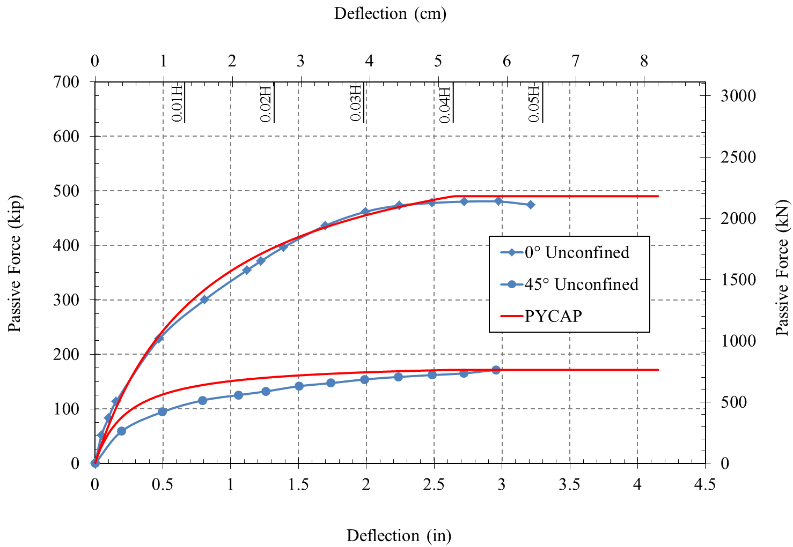
Figure 10. PYCAP hyperbolic approximations for unconfined geometry.

Analysis of MSE Wingwall Test

For developing the hyperbolic curve for the MSE wall geometry, the plane-strain friction angle $\left(φ_{ps}\right)$ was used to account for the plane-strain (2D) conditions provided by the MSE wingwall confinement. A plane-strain friction angle of $φ_{ps}=44.8°$ was used and is approximately 12% higher than the ultimate friction angle $\left(φ\right)$, which is consistent with results by Kulhawy and Mayne (1990). Wall friction was still set as $δ=0.7φ$. Because MSE wingwalls were spaced 11.5 ft (3.5 m) apart, $b=11.5 ft (3.5 m)$was used as the effective abutment width. Initial soil stiffness was lower compared with the unconfined geometry. To reflect the decrease in initial soil stiffness, the initial soil modulus was decreased to $E_{i}=300ksf (14.4 MPa)$. Because the MSE wingwall confinement limited the passive failure wedge from extending beyond the abutment width, the 3D correction factor was set to $R=1.0$ to represent no 3D effects. PYCAP hyperbolic curves for MSE wingwall geometry are shown in Figure 11 and Figure 12. Reduction factor values of $R_{skew}=0.27$ and $R_{skew}=0.35$ were used to generate the 45° skew curves in Figures 11 and 12, respectively.

Although intermediate values of passive resistance are slightly overestimated by PYCAP, the values for peak passive force are within 1% and 0.5% for the zero and 45° skew case, respectively. When the reduction factor recommended by Rollins and Jessee (2012) is used $\left(R_{skew}=0.35\right)$, the peak passive force for the 45° skew is overestimated by 30% but the general shape of the curve is still reasonably well interpreted. These variations in passive resistance are likely associated with scatter about the best-fit curve proposed by Rollins and Jessee.

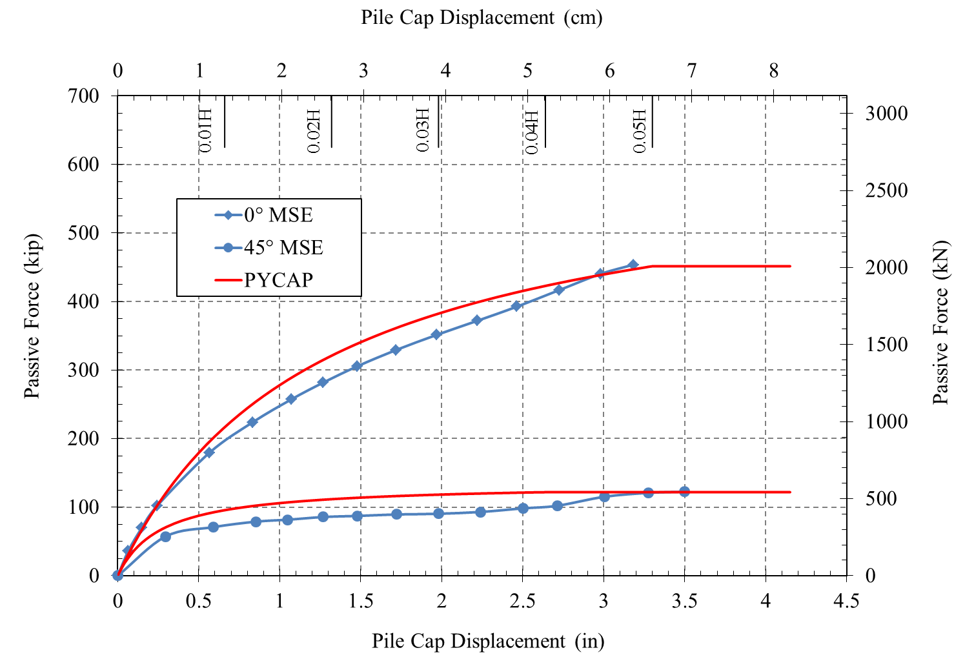
$$R_{skew}=0.27$$
Figure 11. PYCAP hyperbolic approximations for MSE wingwall geometry ($R_{skew}=0.27$ for 45° skew)

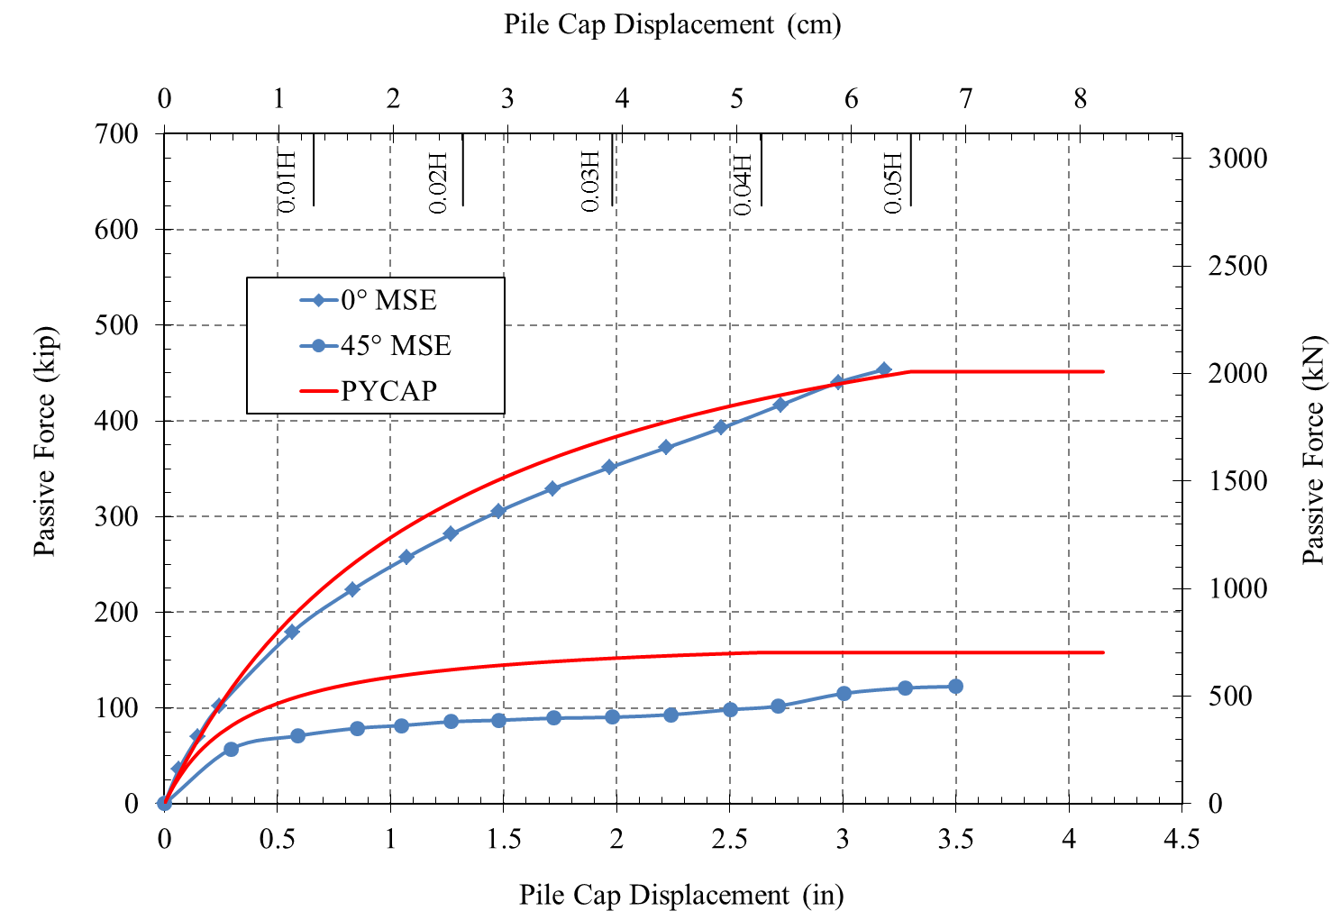
$$R_{skew}=0.35$$
Figure 12. PYCAP hyperbolic approximations for MSE wingwall geometry ($R_{skew}=0.35$ for 45° skew)

Analysis of RC Wingwall Test

For the RC wingwall case, hyperbolic curves were generated using a 2D failure geometry to represent little to no 3D effects observed in the backfill; however, the plane-strain friction angle was not used as the soil was not constricted beyond the end of the wingwalls. A friction angle of $φ=40°$ was used, as was the case for the unconfined abutment geometry. The abutment width of $b=13 ft (4.0 m)$ includes the 1-ft (0.305-m) wide wingwalls on either side of the abutment. PYCAP hyperbolic approximations are shown in Figure 13 and Figure 14. The 45° skew approximation in Figure 13 uses $R_{skew}=0.46$, while Figure 14 uses the recommendation from Rollins and Jessee (2012) $R_{skew}=0.35$.

In Figure 13, peak passive forces predicted by PYCAP are within 10% of the measured values from the zero and 45° skew tests. When the reduction factor of $R_{skew}=0.35$ is used, proposed by Rollins and Jessee (2102) for the 45° skew case, and all other parameters are kept the same, the peak passive force is underestimated by 32%. These results suggest that the proposed reduction factor may be somewhat conservative for this case. Factors that contribute to the higher reduction factor $\left(R_{skew}=0.43 to 0.46\right)$ for the 45° skew include increased passive resistance from increased friction along the east wingwall and somewhat greater 3D effects for the skewed case relative to the non-skewed case. In addition, it has been noted that the pocket formed by the wingwall and the backwall of the abutment may change the effective skew angle for this case to something like 35º, where the reduction factor computed with the Rollins and Jessee curve would be much closer to the back-calculated value.

Overall, the consistency of the computed and measured results suggest that the approach to accounting for the skew effects can be reasonably explained for design purposes if appropriate consideration is given to 3D end effects and the influence of the MSE and RC wingwalls.

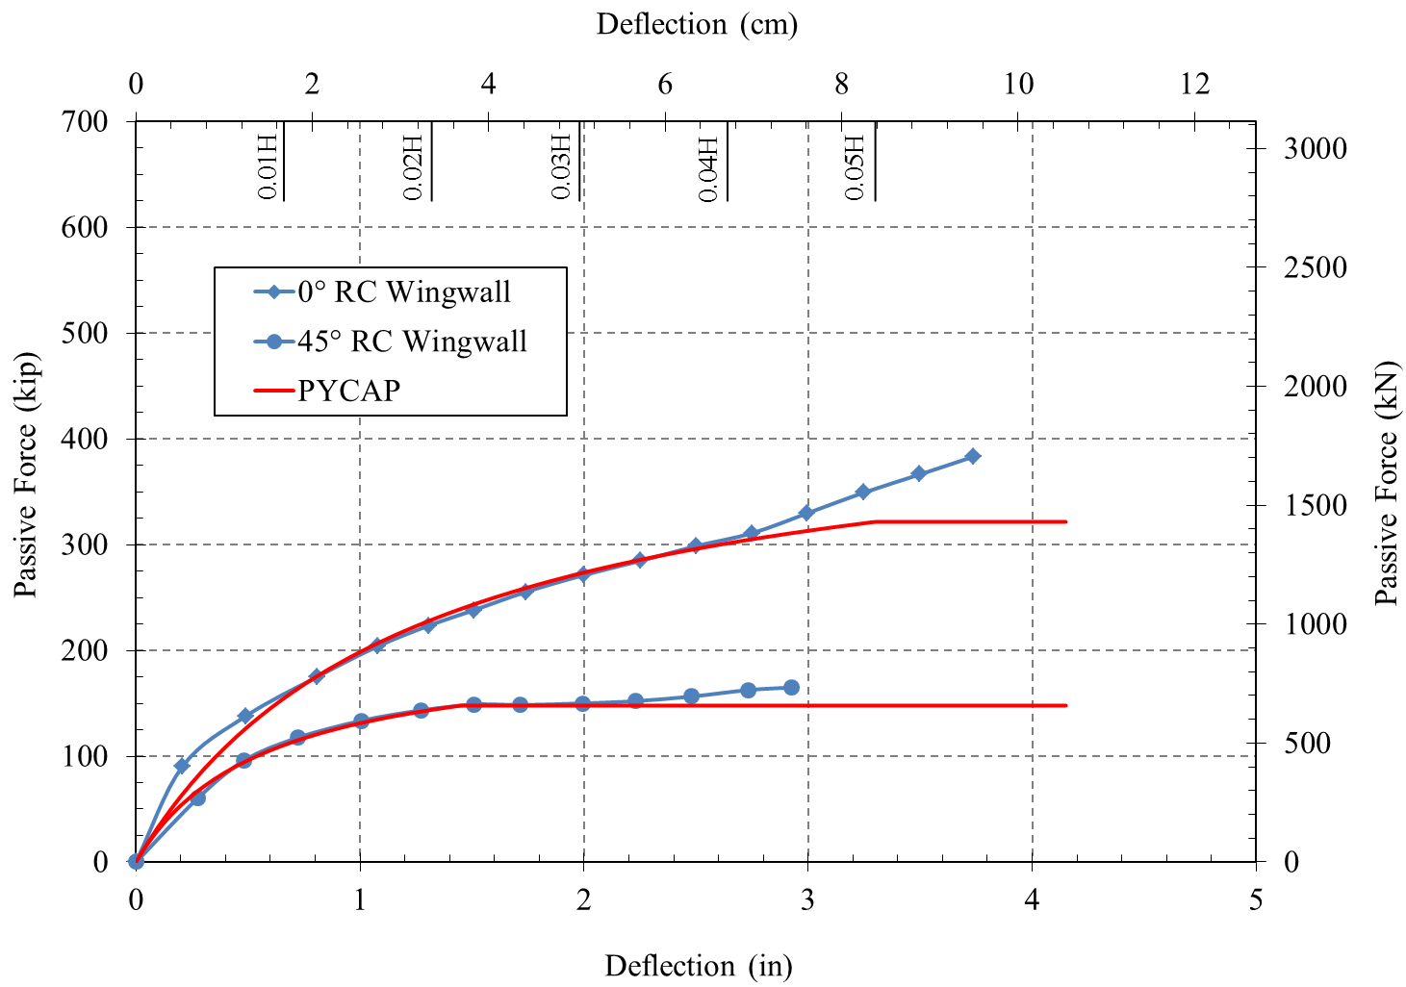
$$R_{skew}=0.46$$
Figure 13. PYCAP hyperbolic approximations for RC wingwall geometry ($R_{skew}=0.46$ for 45° skew).

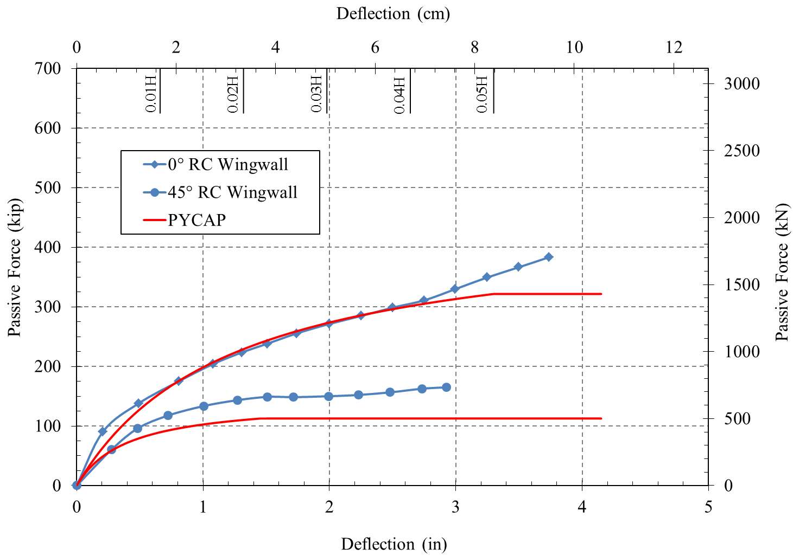
$$R_{skew}=0.35$$
Figure 14. PYCAP hyperbolic approximations for RC wingwall geometry ($R_{skew}=0.35$ for 45° skew).

Circumstance affecting project or budget. (Please describe any challenges encountered or anticipated that
might affect the completion of the project within the time, scope and fiscal constraints set forth in the
agreement, along with recommended solutions to those problems).

Some of the analysis in the newer tasks has taken longer than originally planned. When the newer field testing tasks were added to the contract, the contract end date was not extended. During this next quarter the contract will be amended to reflect a revised schedule to complete all tasks and deliverables by early 2015. It is anticipated the modified scope of work can be completed within the original contract schedule plus approximately 10 months.

Potential Implementation:

UDOT is considering early adoption of the skew reduction factor for passive force based on the laboratory and field test results, but no final decision has been made at this point. In June 2013 and June 2014, Dr. Rollins presented the results of the research to date to technical committees at the AASHTO Subcommittee on Bridges and Structures Annual Meeting in Oregon and Ohio on behalf of the project TAC. This interaction is intended by the TAC and Dr. Rollins to prepare the way for design code revisions once the research is completed. Caltrans is also promoting use of the research results in their design methods.

