TRANSPORTATION POOLED FUND PROGRAM
QUARTERLY PROGRESS REPORT

Lead Agency (FHWA or State DOT): _FHWA______________________________________

INSTRUCTIONS:
Project Managers and/or research project investigators should complete a quarterly progress report for each calendar quarter during which the projects are active. Please provide a project schedule status of the research activities tied to each task that is defined in the proposal; a percentage completion of each task; a concise discussion (2 or 3 sentences) of the current status, including accomplishments and problems encountered, if any. List all tasks, even if no work was done during this period.

Transportation Pooled Fund Program Project #  (i.e, SPR-2(XXX), SPR-3(XXX) or TPF-5(XXX)  TPF-5(279) |  | Transportation Pooled Fund Program - Report Period:  Quarter 1 (January 1 – March 31)  □Quarter 2 (April 1 – June 30)  □Quarter 3 (July 1 – September 30)  □Quarter 4 (October 1 – December 31)
Project Title:
High Performance Computational Fluid Dynamics (CFD) Modeling Services for Highway Hydraulics

Name of Project Manager(s):  Kornel Kerenyi | Phone Number:  (202) 493-3142 |  | E-Mail  kornel.kerenyi@fhwa.dot.gov
Lead Agency Project ID: | Other Project ID (i.e., contract #): |  | Project Start Date:
Original Project End Date: | Current Project End Date: |  | Number of Extensions:

Project schedule status:
On schedule □ On revised schedule □ Ahead of schedule □ Behind schedule

Overall Project Statistics:
Total Project Budget | Total Cost to Date for Project | Percentage of Work  Completed to Date

Quarterly Project Statistics:
Total Project Expenses  and Percentage This Quarter | Total Amount of Funds  Expended This Quarter | Total Percentage of  Time Used to Date

Project Description:

The Federal Highway Administration established an Inter-Agency Agreement (IAA) with the Department of Energy’s (DOE) Argonne National Laboratory (ANL) Transportation Analysis Research Computing Center (TRACC) to get access and support for High Performance Computational Fluid Dynamics (CFD) modeling for highway hydraulics research conducted at the Turner-Fairbank Highway Research Center (TFHRC) Hydraulics Laboratory. TRACC was established in October 2006 to serve as a high-performance computing center for use by U.S. Department of Transportation (USDOT) research teams, including those from Argonne and their university partners. The objective of this cooperative project is to:

- Provide research and analysis for a variety of highway hydraulics projects managed or coordinated by State DOTs.
- Provide and maintain a high performance Computational Fluid Dynamics (CFD) computing environment for application to highway hydraulics infrastructure and related projects
- Support and seek to broaden the use of CFD among State Department of Transportation employees.

The work includes:

- Computational Mechanics Research on a Variety of Projects: The TRACC scientific staff in the computational mechanics focus area will perform research, analysis, and parametric computations as required for projects managed or coordinated by State DOTs.
- Computational Mechanics Research Support: The TRACC support team consisting of highly qualified engineers in the CFD focus areas will provide guidance to users of CFD software on an as needed or periodic basis determined by the State DOTs.
- Computing Support: The TRACC team will use the TRACC clusters for work done on projects; The TRACC system administrator will maintain the clusters and work closely with the Argonne system administrator’s community; The TRACC system administrator will also install the latest versions of the STAR-CCM+ CFD software and other software that may be required for accomplishing projects.

Progress this Quarter (includes meetings, work plan status, contract status, significant progress, etc.):

1: Computational Mechanics Research on a Variety of Projects
1.1: CFD-DEM Onset of Motion Analysis for Application to Bed Scour Risk Assessment
This study was done as a part of the FHWA’s effort to improve scour design procedures. The Computational Fluid Dynamics-Discrete Element Method (CFD-DEM) model was used to model separate sediment grains and spherical particles laying on the bed with the aim to analyze their movement due to flow conditions. Critical shear stress causing the incipient movement of the sediment around a cylindrical pier was determined from advanced DEM simulations and compared to the available experimental data. Various depths of the scoured bed and flow conditions were taken into account to gain a better understanding of the erosion forces existing around bridge foundations. The decay of these forces with increasing scour depth was quantified with a ‘decay function’, which shows that particles become increasingly less likely to be set in motion by flow forces as a scour hole increases in depth.
(a) 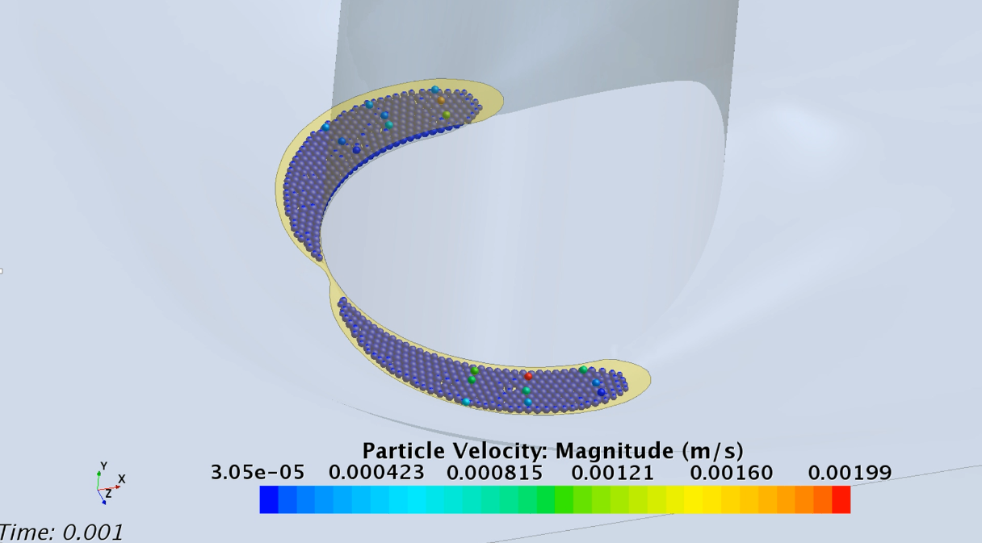
(b) 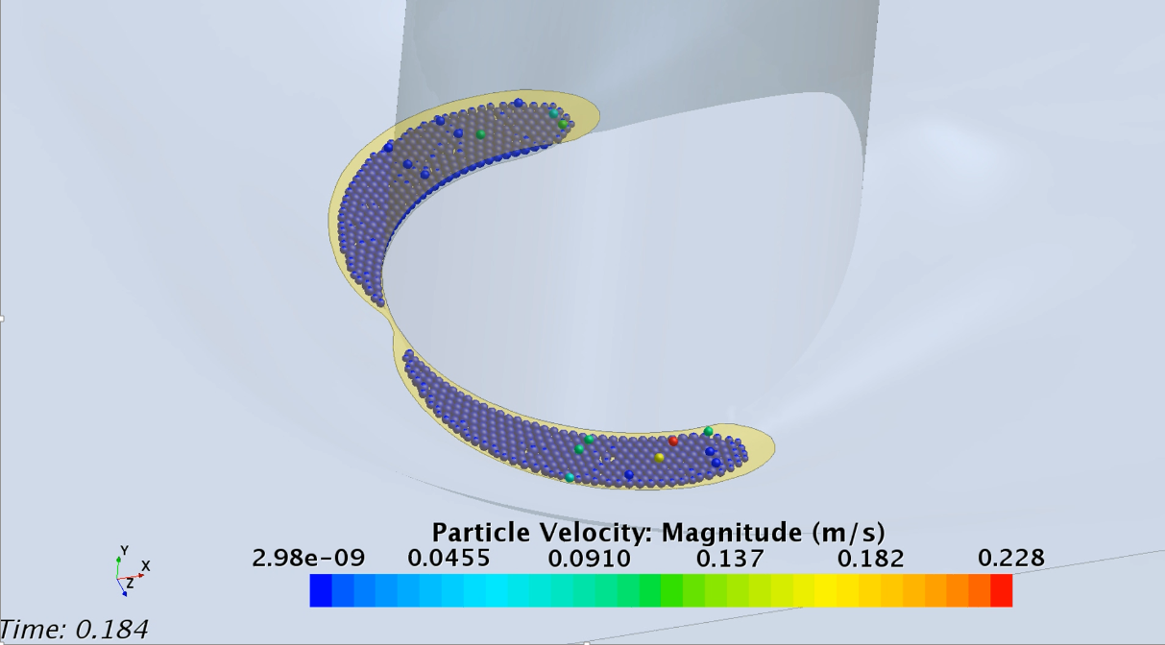
Figure 1. Particles of different densities were placed on a rough bed at chosen locations around a circular pier. The particles were monitored to see which of them would move due to the flow forces and which would stay in the start position. Figure 1(a) shows the positions at the beginning of a simulation, Figure 1(b) shows the locations after 0.184 sec of simulation time. Limit values of densities were established for a set of scour hole depths.

Figure 2. Onset of motion particle density vs. relative depth of a scour hole around a cylindrical pier for computational bed contour. The plots are a graphical representation of a ‘decay function’ obtained from the computations for a scoured bed geometry and a flat bed, at different depths. The particles become increasingly less likely to be set in motion by flow forces as a scour hole increases in depth.

1.2: Influence of Extreme Weather Events on Stream Stability
The Maple River in western Iowa is a laterally active channel flowing through agricultural land that has migrated several hundred feet in recent decades and is currently within approximately 100 feet of the Highway 175. The study focuses on the use of advanced 2D and 3D CFD techniques to enhance the assessment of increased risks to stream stability of a section of the river.
(a)  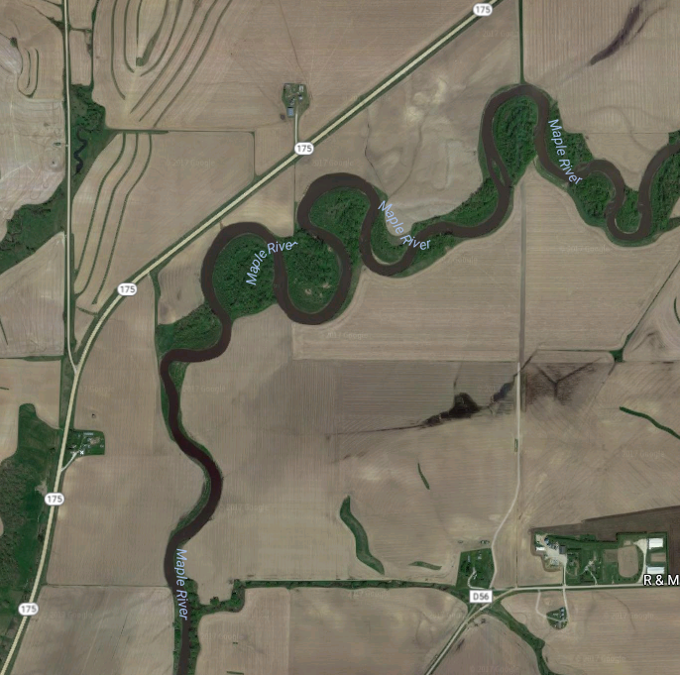 | (b)  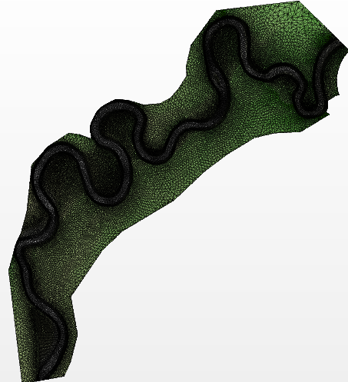
Figure 3. The aerial view of a section of Maple River (a) and the triangularized surface used in the computations (b).

The 3D simulations are used to assess the flow velocity and bed shear stress for a series of flow rates, from a normal stream flow up to flood conditions, which cause water to spread into the surrounding area, forming vast flood plains.
(a)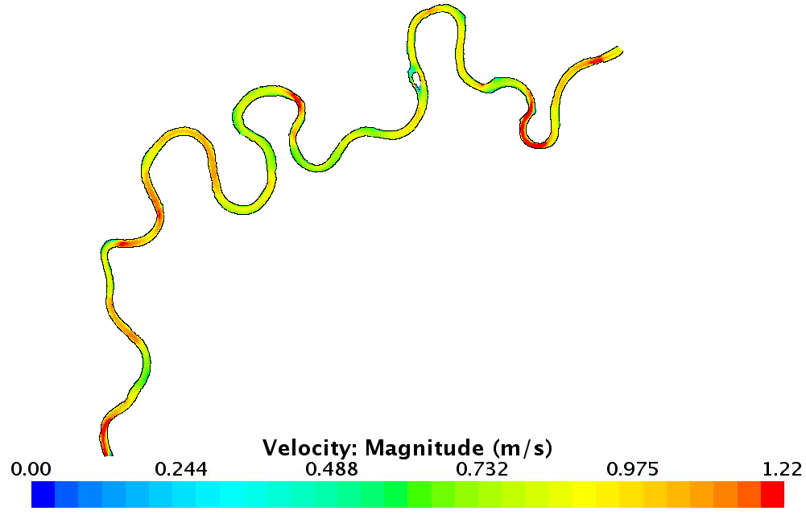 | (b)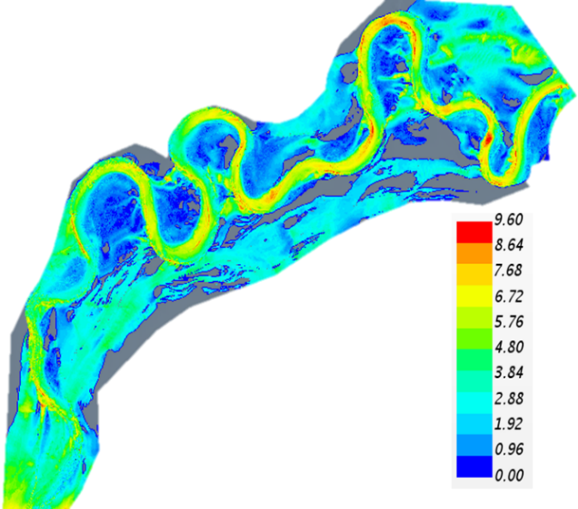
Figure 4. Surface velocity magnitude distribution for two of the computational models at an inlet flow of (a) 1000 cfs, and (b) 15000 cfs.

2: Computational Mechanics Research Support

Argonne Transportation Research and Analysis Computing Center (TRACC) computational mechanics staff ran nationwide videoconferences every other Thursday that were open to state Department of Transportation staff and university researchers supported by the Federal Highway Administration or state DOTs. The videoconferences provide a venue to discuss approaches and issues related to hydraulics modeling projects. Topics during this reporting period included, but were not limited to:
- Computational Fluid Dynamics (CFD) modeling study on rockery design for river and coastal environments
- CFD modeling of extreme weather events on stream stability based on the example of Maple River, near Danbury, Iowa
- computational approach to analyze water film thickness on various road geometries during rain events for assessing hydroplaning risk

3: Computing Support

Routine cluster maintenance including software and hardware upgrades, security patching against cyber threats, and development of custom tools to increase users' productivity. Currently working on upgrading existing TRACC cluster to support the latest scientific and engineering software utilizing industry's best practice guidelines in Open Source software and virtualization.
Anticipated work next quarter:

1: Computational Mechanics Research on a Variety of Projects

- hydroplaning risk assessment for different road geometries
- continued work on the ‘Influence of Extreme Weather Events on Stream Stability’ study, to establish stream power relation to stream migration risk
- CFD modeling of rockeries in river environment
2: Computational Mechanics Research Support

This work will continue.

Task 3: Computing Support

This work will continue.

Significant Results:

- a CFD-DEM analysis of the onset of motion of particles of varied density resulted in a graphical representation of the decay of erosion forces with increasing scour hole depth
- CFD models of a section of Maple River were developed and used to simulate flood conditions and determine shear stresses on the banks

Circumstance affecting project or budget. (Please describe any challenges encountered or anticipated that
might affect the completion of the project within the time, scope and fiscal constraints set forth in the
agreement, along with recommended solutions to those problems).

None.

Potential Implementation: The DEM onset of particle motion study is being used to develop better methods to assess scour risk. The stream stability study is focused on developing a better method to predict stream migration risk and rates from rainfall rates over long periods of time.

